Title I, Part A
Guidance Document
2022-2023
Division of Curriculum, Instructional Improvement and Professional Learning
Title I Program Improvement and Family Support Office
Title I, Part A Guidance Document
Table of Contents

General Questions and Answers 4
Preliminary 2022-2023 Title I, Part A Calendar of Document Due Dates 7
Attestation Section 1112 12
A. STAFF CREDENTIALS AND CERTIFICATIONS 14
Staff Credentials and Certification: Types of Certificates and Glossary of Terms 18
Example Principal Attestation (Assurance 1) 20
Example Confirmation of Teacher and Paraprofessional Qualifications (Assurance 1 and Assurance 3) 22
Example Certification Plan (Assurance 1 and Required Attachment 3) 23
Example Inter-Departmental Memorandum of Understanding with Human Resources 24
Disparity Chart Examples (Assurance 4) 25
B. SCHOOLWIDE PROGRAMS 29
Schoolwide Program Plan Components Checklist 33
C. TARGETED ASSISTANCE SCHOOLS 34
Year Long Planning Process Option to transition from an existing Title I Targeted Assistance School Program (TAS) to a Title I Schoolwide (SW) Program 36
MSDE Guidance for an Abbreviated (Less Than One Year) Schoolwide Planning Process 37
Targeted Assistance Schools Program Checklist 39
D. PARENT AND FAMILY ENGAGEMENT 40
Title I District Level Parent and Family Engagement Policy/Plan Requirements - Section 1116 41
Title I School Level Parent and Family Engagement Plan and School Parent Compact Checklist 45
E. PARTICIPATION OF CHILDREN ENROLLED IN PRIVATE SCHOOLS 48
Equitable Services Topics of Consultation 50
Affirmation of Consultation 51
Intent to Participate Form 53
F. EDUCATION FOR HOMELESS CHILDREN AND YOUTH 55
G. SUPPORT FOR FOSTER CARE STUDENTS 57
H. ENGLISH LEARNERS 64
MSDE: ESSA Title I and Title III Questions and Answers 64
I. SCHOOL IMPROVEMENT: TARGETED SUPPORT AND IMPROVEMENT (TSI) 67
Understanding Maryland’s Targeted Support and Improvement (TSI) Schools 68
J. FISCAL GUIDANCE 73
Detailed Budget Description 75
Federal Cost Principles Maryland State Department of Education Guidelines for Decision-making about Title I Expenditures 78
Supplement not Supplant (Section 1118(b)(1)) 80
Fiscal Tables Instructions and Guidance 83
Federal Cost Principles Chart 97
Progress Monitoring Addendum – Examples 107

ESSA Law and Non-Regulatory Guidance Links
- Every Student Succeeds Act
- ESSA Transition FAQs
- ESSA Early Learning Guidance
- ESSA Equitable Services (UPDATED)
- ESSA Schoolwide Guidance
- ESSA Supplement not Supplant
- ESSA Within District Allocations (Draft for Public Comment)
- Evidence Guidance
- Foster Care Guidance
- Homeless Student Guidance
- High School Graduation Rate
- State and Local Report Cards
- Title I, Part A Final Regulations
- ESSA Title III Guidance – English Learners

General Questions and Answers
KEY: Question – Black Font, Answer – Blue Font

CARES Act:
- There is no supplement vs supplant for CARES funds but will CARES funds be evaluated during the Supplement not Supplant test on the Program Review. Will the LEA have to show that CARES funds used a Title I Neutral methodology?
Answer: The CARES Act funds are not Title I Funds; the distribution methodology used Title I allocations to States as well as the allocations from States to local school systems. Recipients are offered a broad range of options for using the funds, including any allowable use under any of the federal titled programs in ESEA, IDEA, and Perkins. There is no supplement, not supplant requirement in the CARES Act and because they are Federal funds, not State and local funds, the LEA will not have to demonstrate a Title I Neutral methodology. There are reporting requirements and there will be monitoring of the CARES Act funds, but neither will not coincide with the Title I program monitoring.

General Questions
- Is there a rubric or criteria for “other documentation to support…” that is mentioned in numerous sections?
Answer: Yes, the criteria to support the statement “other documentation to support the LEA has implemented its written process, if applicable” is each LEA’s specific written process for that assurance. Any assurance that aligns with a written process has this statement. It is the expectation that each LEA provides evidence of implementation to support implementation of their written process (that will be approved as part of the application process). While the evidence of implementation column covers many of the items that should be included as outcomes of the written process, the LEA may need to provide additional documentation based on the specifics of their written processes.
- When will the obligation of Department Directors (i.e., Human Resources, Special Education, Student Services, Curriculum and Instruction, etc.) to be an active ongoing partner and the new requirements be shared with various LEA Directors? Please share the date and time that that will occur for our reference for the beginning of the collaboration.
Answer: Each LEA has their own written processes for collaboration amongst various offices. Using the structures for collaboration and communication within those processes, each LEA is required to share this information with various LEA offices. In developing revisions and updates to the Title I application, the MSDE Office of Title I - Program and Improvement and Family Support collaborated with various MSDE offices, including Certification, Title III, CTE, Comprehensive Planning, and Student Services.
- Are all forms and charts in the appendices required or suggested? (i.e. Disparities Chart – Is this the chart that HR will have to use and submit to Title I?)
Answer: The various forms, charts, and checklists in the appendices are provided as suggested tools and templates. As shared previously and noted in the application, the MSDE has provided sample forms and charts that may be used in the required attachments. These sample data charts and forms are provided in the appendix of the application. If a LEA chooses to use their own data collection tools, charts, or forms, they must contain all of the information referenced in the examples and within the specified required attachment.

- Are the tables and charts in the appendices created in coordination with other departments to prevent the duplication of work? (i.e., HR completes a table to meet their requirements, and then Title I completes the table to meet Title I requirements)
Answer: Collaboration does occur across offices during the updating and revision to the Title I application each year. Examples of the various MSDE offices consulted for this year’s revisions include Certification, Title III, CTE, Comprehensive Planning, and Student Services. The requirements within the Title I application, including the tables and charts in the appendices, reflect and are specific to Title I, Part A requirements and are aligned with ESSA law citations for Title I, Part A.
- Will there be full monitoring even if school systems are low risk?
Answer: This information will be shared later as part of the discussion around monitoring processes.
Feedback Timeline
- How long is the estimated time from submission to feedback on our applications?
Answer: The internal MSDE Review and Approval process and timeline is still under development. Information regarding a feedback timeline will be shared by the MSDE Title I Director later.
- In the Submission Instructions, it says, “All subsequent submissions will be through the Local ESSA Consolidated Strategic Plan Submission.” Does this mean that if MSDE requests any additional changes, we submit through the LEA Office of Strategic Planning and not directly to the MSDE Title I Office?
Answer: The MSDE may request additional changes until conditional approval is granted for the application. The instructions have been updated accordingly to reflect: Upon receipt of conditional approval, all subsequent submissions will be through the Local ESSA Consolidated Strategic Plan Submission.
SANE Guidance
- What recommendations are being provided for handling the need for physical sign-in sheets, if the LEA is continuing with virtual meetings? Sign In: Digital signatures are still ok?
Answer: Yes, per the instructions given in the Title I Director’s Updates sent on 04/27/2020, it indicates: The expectations for participation in all meetings that occur in Title I schools during and after teacher work hours remain consistent with the expectations previously stipulated including sign-in, agenda, evaluations and notes (SANE). The expectations for participation must be clearly communicated in writing regarding participation and articulated at the beginning of each session. Please remember that Title I professional learning stipends can only be used to pay attendees above and beyond their regular work day for participating in a Title I activity. It is the responsibility of the LEA Title I Coordinator to monitor and collect evidence of implementation of these procedures.
If schools are conducting a Title I Virtual Professional Learning remotely, they still need to maintain sign-in/out sheets to document attendance notes, evaluations and other supporting documents.
In addition, a signed attestation from the Principal stating “I certify that this activity (i.e., collaborative planning, virtual professional learning) was completed outside of the teachers’ contracted instructional work minutes and office hours ” and can attest to their participants' attendance and completion of any task required as a result of their participation. This should accompany any documentation submitted to the LEA Title I office for approval and processing. It is the responsibility of the LEA Title I Coordinator to monitor and collect evidence of implementation of the attestation.
Below are some sign-in/out options for your consideration:
- OPTION 1:
  - Disseminate electronic version of the sign-in/out sheet for the specific training to each expected participant
  - After the PD, have each attendee submit to you their sign-in/out form electronically in order to receive payment.
- OPTION 2:
  - Create a google or DocuSign sign-in form, make sure that all of the required information is included on the sign-in form and provide the link at the beginning of the training.
  - In this case, you would probably also want to have the participants complete a google sign-out form since it is not easy to change entries once they are entered. If you do that, you could provide the sign out form link (with all the same information required to sign-ins) at the end of the training.
The advantage with Option 2 is that all attendees will be signed in and signed out on one form, so you know who attended the training, and google forms have time stamps, so you know what time people signed in and signed out. Schools will still need to complete the required documents.

Preliminary 2022-2023 Title I, Part A Calendar of Document Due Dates
Title I, Part A is a federal program that provides financial assistance to local school systems and schools with high percentages of poor children to support the academic achievement of disadvantaged students. All twenty-four local school systems in Maryland receive Title I funds. These funds provide additional academic support and learning opportunities to help low-achieving children who attend Title I schools to master challenging curricula and meet state standards.

The Preliminary 2022-2023 Title I, Part A Calendar of Document Due Dates provides the Local Educational Agencies (LEAs) an overview of Title I, Part A documents and events, along with their due dates. This information is provided for Title I, Part A, and Parent and Family Engagement. Information pertinent to other Title I Grant programs will be provided at a later time directly to the LEAs to which the information applies.

Programs Included:
- Title I, Part A
- Parent and Family Engagement
TITLE I, PART A (Paula M. Harris, Director & MSDE Points of Contact)
Document or Event | Description | Format | Notes | Date due to MSDE
Title I Application for SY 2022-2023 | Title I, Part A provides funds to LEAs to support the academic needs of students that reside in high poverty schools. |  | MSDE will accept Application Submissions  MSDE Title I Points of Contact will provide written and verbal feedback to the LEA regarding sufficiency of the submission.  The FINAL LEA signed copy of the approved application must be submitted to your  Point of Contact. | First Submission  August 1 - August 30,2022  Submission for Conditional  Approval:  September 30, 2022  First submission  through the Local ESSA  Consolidated Strategic Plan:  October 15, 2021  Final submission  through the Local ESSA  Consolidated Strategic Plan:  November 15, 2021
Comparability Report | Federal law requires that all LEAs document that the services provided with state and local funds in Title I schools are comparable to those provided in non-Title I schools in the LEA. | Signed hard copy report and electronic version sent to Title I Manager | Form A with signatures, and appropriate Title I schools comparisons to non-Title I schools forms as outlined in the guidance. Forms must be submitted along with evidence of change. | December 1, 2022
Grant Amendments | Grant Forms can be accessed here. |  | For all grants | Amendments must be submitted at least 45 days prior to the end of the grant period.
Title I, Part A - Carryover Report for SY 2021-2022 | Section 1127(a) of ESEA permits a school system to carryover not more than 15% of Title I funds from one fiscal year to the next. |  |  | December 17, 2022
Title I, Part A Interim Report | LEA interim progress report |  |  | October 29, 2022
Title I Final Fiscal Report | LEA final fiscal report |  |  | December 31, 2023
Participation Report for  SY 2021-2022 | Data collected on student and school demographics, compiled, and sent in the Consolidated State Performance Report and EdFacts/Education Data Exchange Network (EDEN) files to USDE. | Excel data collection tool updated annually | LEA also prepares Excel student level files for upload to the SST: Private, TAS, SWP 0-2, and Local Neglected. These are used to verify data in the aggregate report. | August 19, 2022
2022-2023 Title I, Part A Administrative Meetings | The MSDE Office of Title I – Program Improvement and Family Support convenes LEA Title I Staff periodically throughout the year to provide updates, technical assistance, and professional learning experiences in order to provide LEAs the tools to support the academic needs of students that reside in high poverty schools. | TBD – Virtual and/or Face-to-Face meetings |  | Fall: October 20, 2022 and October 21, 2022  (Note: if the meeting is face-to-face it will be one full-day and if the meeting is virtual will be two half-days)  Winter (Virtual): January 20, 2023 ( if needed; topics to be determined)  Spring: May 24, 2023 and May 25, 2023  (Note: meeting length and format will be determined a later time)

Attestation Section 1112

Component | Guiding Questions
Attestation Section 1112 | - How does the LEA collaborate across offices? What structures for collaboration already exist? What structures for collaboration are needed?  - How do the written processes in other components define the collaboration between Title I and other pertinent LEA offices, such as human resources, finance, and instruction?  - How does the LEA Title I office document the collaboration with other offices?  - How does the LEA Title office document the written processes that define collaboration across offices?  - How does the LEA involve stakeholders and provide opportunities for input into the Title I application, including initiatives and spending? What strategies are used to gather feedback?  - How does the LEA document the involvement and input from stakeholders?

Questions and Answers

- Section 1112 Attestation - Assurance 2: Is this assurance specifically around the application process and no other?
Answer: Yes, per the law citation included below, the LEA must have a plan/application that is developed with timely and meaningful consultation with specific stakeholders.
  - Citation: 1112(a)(1)(A), the law states: SUBGRANTS.—A local educational agency may receive a subgrant under this part for any fiscal year only if such agency has on file with the State educational agency a plan, approved by the State educational agency, that—
    - (A) is developed with timely and meaningful consultation with teachers, principals, other school leaders, paraprofessionals, specialized instructional support personnel, charter school leaders (in a local educational agency that has charter schools), administrators (including administrators of programs described in other parts of this title), other appropriate school personnel, and with parents of children in schools served under this part;

- Are parents expected to be involved in the process for the entire Title I application or a specific component of the application that is directly applicable to parents & families? If so, what recommendations will MSDE be providing to make the consultation process and tool parent-friendly? What recommendations are being provided for involving parents in a forum for consultation due to current safe distancing mandates?
Answer: Yes. As referenced in the response to question one, the law states that the LEA must have a plan/application that is developed with timely and meaningful consultation of stakeholders. The stakeholder list includes “parents of children in schools served under this part.”
Some examples of how to engage parents and families virtually include virtual meetings, surveys (electronic or paper), or questionnaires disseminated via email.

A. STAFF CREDENTIALS AND CERTIFICATIONS
Resources:
- COMAR 13A.12.01.14 Waivers and Special Certification Provisions
- MSDE Educator Certification Website
- Teacher Staffing Report: See pages 2-3 for list of critical shortage areas
- Maryland Educational Equity Guidebook Focus 4: Educator and Staff Capacity

Component | Guiding Questions
A: Staff Credentials and Certification | - How does the LEA monitor to ensure that, in schoolwide schools, all teachers meet state certification and licensure requirements and all paraprofessionals are qualified? How does the LEA ensure that, in Targeted Assistance Schools, all Title I funded teachers meet state certification and licensure requirements, and all Title I funded paraprofessionals are qualified?  - How does the LEA (Human Resources, Title I Office, and Title I School) monitor teachers who are in danger of losing their state certification and licensure requirements and inform LEA teachers about the consequences of not maintaining state certification and licensure requirements?  - How does the LEA ensure that, in schoolwide programs, all instructional paraprofessionals, and, in targeted assistance schools, all Title I funded instructional paraprofessionals work under the direct supervision of and in close and frequent proximity with a teacher that meets state certification and licensure requirements?  - What direction has been given to principals and teachers regarding this requirement?  - How does the LEA ensure Title I schools are not using their instructional paraprofessionals as classroom substitutes? How does the LEA ensure that Title I teachers in targeted assistance schools are not being used as classroom substitutes?  - How has the LEA gathered data to identify and address any disparities that result in low-income students and minority students being taught by ineffective, inexperienced, or out-of-field teachers at higher rates than other students? What processes are in place to address any disparities?

Questions and Answers
- Attachment 2 in Staff Credentials and Certification asks for Listing of the percentage and number of teachers who have not met licensure and certification status in each Title I School including the area of certification. What date do we use for this data? Is it based on last year (SY 20-21) or (SY 21-22)? We are still hiring in August, so it would be difficult for HR to have this data for the application submission in August.
Answer: The application has been updated with more details pertaining to this new required attachment. The application now states:
- Listing of the percentage and number of teachers who have not met licensure and certification status for the 2022-2023 school year in each Title I School including the area of certification. If applicable, provide a written action plan for teachers who meet conditional certification status with timeline to complete certification requirements.*
*The data will be submitted on the September 30th submission for Conditional Approval and updated, as needed, for the Final Submission with the Local ESSA Consolidated Strategic Plan on November 15th.

- Will a formal plan of action be needed for conditional certification in critical shortage areas or for conditional certs in non-critical shortage areas?
Answer: A certification plan including a timeline is needed for any teacher that has a conditional certificate. It is imperative that each teacher with a conditional certificate has a written plan including a timeline to meet the requirements to obtain a Standard Professional Certificate. The plans should be periodically reviewed and monitored by the LEA to ensure the teacher is on track to obtain their Standard Professional Certificate.
- Attachment 3: What date do we use for this data? Is it based on last year (SY 20-21) or (SY 21-22)? We are still hiring in August, so it would be difficult for HR to have this data for the application submission in August
Answer: The application has been updated with more details pertaining to this new required attachment. The application now states:
- Listing of the percentage and number of paraprofessionals who have not met qualification status for the 2022-2023 school year.*
*The data will be submitted on the September 30th submission for Conditional Approval and updated, as needed, for the Final Submission with the Local ESSA Consolidated Strategic Plan on November 15th.
- Attachment 4: Can the letter come from our student management group? Human Resources cannot link the student group data to the teacher. Our system accountability has both data sets. Can we have a letter from that office that confirms the data?
Answer: The purpose of the letter is to confirm that the official disparity data included in the application regarding ineffective, inexperienced, and out-of-field teachers was received from pertinent LEA offices, and not generated by the LEA Title I Office. It is acceptable for the letter to be from the LEA office that handles the data request. Examples of offices that the letter may be from include, but are not limited to, Human Resources, Accountability/Data, Research/Assessment, etc.
- Attachment 4: Will communication be required from other offices than just Human Resources or should Human Resources verify that data came from multiple offices? Our data comes from a combination of departments (i.e. Research and Assessment).
Answer: The purpose of the letter is to confirm that the official disparity data included in the application regarding ineffective, inexperienced, and out-of-field teachers was received from pertinent LEA offices, and not generated by the LEA Title I Office. It is acceptable for the letter to come from Human Resources verifying that the data was generated by multiple offices.
- For clarity in Assurance 4 in the Staff Credentials component: Is the evidence that is being collected referring to evidence to demonstrate that the said procedure was implemented the prior year?
Answer: The disparity data is from the previous school year; however, the written process addresses how disparities will be identified and addressed for the current school year.
- Required Attachment 4: When utilizing the disparities chart shared during the webinar, are teachers in the three categories divided by race?
Answer: Based on LEA feedback, the disparities chart shared during the webinar has received minor revisions and instructions. Per ESSA, LEAs must identify and address any disparities that result in low-income students and minority students being taught at higher rates than other students by ineffective, inexperienced, or out-of-field teachers. The data collected in the chart is related to the number and percent of ineffective, inexperienced, and out-of-field teachers. The required attachment language has also been updated to make this clearer. It indicates the data must include the number and percentage of inexperienced, ineffective, and out-of-field teachers teaching low-income & minority students. The data will be disaggregated for low income (Title I and non-Title I schools) and for minority students (major racial/ethnic groups: American Indian/Alaska Native, Asian, Black/African American, Hispanic, Multiple, Native Hawaiian/Pacific Islander, and White).
- Documentation required in Staff Credentials for Assurances 2 and 4 are very similar. Is there a way that these can be combined?
Answer: While the documentation to support Assurance 2 and Assurance 4 will include evidence of collaboration with the LEA Human Resources Office, the assurances focus on two different areas in which collaboration is needed. Assurance 2 focuses specifically on certification and licensure, while Assurance 4 focuses on disparities. While the critical topics may be covered in the same meetings with Human Resources, the assurances align with two separate portions of the law.
- Assurance 5 Parents Right to Know: Will the following section not be part of the monitoring since state assessments were not administered? “Evidence that parents have been provided information on the level of achievement and academic growth on State academic assessments of their students.”
Answer: Section 1112(e)(1)(B)(i) of ESSA states that a school that receives funds under this part shall provide to each individual parent of a child who is a student in such school, with respect to such student— (i) information on the level of achievement and academic growth of the student, if applicable and available, on each of the State academic assessments required under this part.

The law explicitly states that this information should be provided if applicable and available; therefore, since State assessments were not given in the 2020-2021 school year, this specific portion under “right to know” would be N/A for the 2021-2022 school year.

- This question references the * referencing “multiple.” When it says documentation, regular collaboration, planning, interim checks and analysis of outcomes. How will you check the analysis of outcomes? Is that an end of year analysis outcome? Do you want outcomes for each activity and analyze as they are completed? Also, define timeline and expectation for collaboration.
Answer: The MSDE Title I office has defined “multiple” to mean regular ongoing collaboration throughout the year, including planning, interim check-in, and analysis of outcomes. The analysis of outcomes is an important part of a Cycle of Continuous Improvement and the specific outcomes for analysis would be defined by the LEA’s written process. For example, was the purpose or goal of the collaboration achieved? The LEA’s written process will define the specifics of the collaborative process across LEA offices.
At a minimum, collaboration meetings should be held at different times throughout the year. The specific frequency will be defined by the LEA’s written process (i.e. - monthly, quarterly, etc.). At a minimum, meetings should demonstrate that planning, interim check-ins, and analysis of outcomes have occurred. Again, the LEAs written process will define the specifics of the collaborative process across LEA offices.

- Assurance 2: Consider accepting email as part of multiple dated communication instead of just SAN. It could be a combination of SAN and email. The LEA does a lot of collaboration through email, especially with telework. It is not always prudent to have SAN/SANE documents (i.e. HR Director sends an email).
Answer: Written communication is also an important part of collaboration and communication and is now reflected in the evidence of implementation column for assurance 2 and 4 in Staff Credentials and Certification. Based on the provided definition of multiple, the dated communications and/or meetings should be held at different times throughout the year. The specific details about the collaboration and communication between Human Resources, the Title I Office, and school administration will be defined by the LEA’s written process.

Staff Credentials and Certification: Types of Certificates and Glossary of Terms
Types of Certificates
There are three professional certificates: Professional Eligibility Certificate (PEC); Standard Professional (I & II) SPC; and Advanced Professional Certificate (APC).
The Resident Teacher Certificate (RTC) is granted to individuals completing a Resident Teacher Certificate Program, Maryland's alternative certification program; this certificate is issued only at the request of a local school superintendent.
The Conditional Certificate is issued only at the request of a local school system on behalf of an employee who has not yet met the requirements for professional certification. For the duration of the conditional certificate, the individual is considered to hold state certification; however, the conditional certificate is not a professional certificate. This certificate is issued to someone by a local school system when they cannot fill the position with a professionally certified educator and the individual must work towards the requirement of the professional certificate while on the conditional.
Guidance regarding flexibilities and/or extensions for teachers obtaining certification during the Covid-19 pandemic
Per the Governor’s Executive order, the provisions from the state of emergency, including the extension of expired educator certificates, expired on August 15, 2021. All pre-pandemic requirements for certification and licensure are in effect for Title I schools.
Glossary of Terms
- Ineffective teacher – An educator who is deemed unsuccessful by a State approved local evaluation model.
- Out-of-field teacher – Teachers teaching in a subject that they are not certified to teach.
- Inexperienced teacher – Inexperienced teachers in the first year include teachers with a year of experience or less. Inexperienced teachers 1-3 years include teachers with one to three years of experience.
- Low-income student – Maryland uses the Free and Reduced Price Meal (FARMS) data and ranks the schools based on the percentage of those students within each school in MD from low to high. Each school is designated as either an elementary or a secondary school. One calculation includes all elementary schools in the state and the other includes all the secondary schools in the state. The quartiles are determined as two distinct calculations. Quartiles are assigned with the first quartile being lowest poverty (non-poor) and the fourth quartile being highest poverty (poor). Each quartile contains the elementary schools in that quartile and the secondary schools in that quartile.
- Minority student – Maryland defines minority students as those in all racial categories with the exception of white, to include Hispanic/Latino of any race, American Indian or Alaska Native, Asian, Black or African American, Native Hawaiian or Other Pacific Islander, and Two or more Races. Quartiles are assigned with the first quartile being low minority and the fourth quartile being high minority.
- Certified teachers – Teachers holding a certification other than a Conditional Certification or a Provisional Certification. These certifications are Professional Eligibility Certificate (PEC). Standard Professional I Certification (SCPI), Advanced Professional Certificate (APC), or Resident Teacher Certificate (RTC).
- Disparity Data – Using the definitions provided and data demonstrate whether low-income and minority students enrolled in schools that receive funds under Title I, Part A are taught at disproportionate rates by ineffective, out-of-field, or inexperienced teachers compared to non-low-income and non-minority students enrolled in schools note receiving funds under Title I, Part A. Per the Maryland ESSA Consolidated Plan, LEAs will be expected to address the data with a specific focus on how the support will differ for schools that receive Title I, Part A funds. Maryland uses a gap and threshold model to identify gaps. Any gap greater than 5% or any individual category that is over 5% is considered to have disparities.

Example Principal Attestation (Assurance 1)
NOTE: This is one example of a principal attestation. LEAs should create a principal attestation that aligns with both the requirements of assurance 1 in the application and their internal processes and procedures.
Source: Harford County Public Schools, Office of Title I

VERIFICATION OF COMPLIANCE ATTESTATION
To Whom It May Concern:

In keeping with the requirement of the Every Student Succeeds Act (ESSA),

- The principal of each school operating a program under 1114 (SW) or 1115 (TA) is required to attest annually in writing as to
whether such school is in compliance with the requirements of this section.
- Copies of attestations shall be maintained at each school operating a program under 1114 or 1115 and the main office of the LEA.
- Shall be available to any member of the general public on request.

I hereby attest to the following:
Teachers
Yes No
• • All teachers hired to this school since the enactment of the Every Student Succeeds Act (ESSA) and supported with Title I funds meet state standards for credentials and certification.
Paraprofessionals
• • All paraprofessionals working in a program supported with Title I funds, regardless of their hiring date, have earned a secondary school diploma or its recognized equivalent.
• • All paraprofessionals working in a program supported with Title I funds shall have:
- Completed at least 2 years of study at an institution of higher education;
- Obtained an associate’s (or higher) degree; or
- Met a rigorous standard of quality and can demonstrate, through a formal State or local academic assessment, knowledge of, and the ability to assist in instruction reading, writing, mathematics, or reading readiness, writing readiness and mathematics readiness.
• • Paraprofessionals working in a program supported with Title I funds may be assigned to:
- Provide one-on-one tutoring for eligible students, if the tutoring is scheduled at a time when a student would not otherwise receive instruction from a teacher;
- Assist with classroom management, such as organizing instructional and other materials;
- Provide assistance in a computer laboratory;
- Conduct parental involvement activities;
- Provide support in a library or media center;
- Act as a translator; or
- Provide instructional services to students working under direct supervision of a teacher

Principal’s Signature: ________________________________________ Date: _______________________

Example Confirmation of Teacher and Paraprofessional Qualifications
(Assurance 1 and Assurance 3)
NOTE: This is one example of a confirmation of teacher and paraprofessional qualification tracker. LEAs could create a tracker that aligns with both the requirements of assurance 1 and assurance 3 in the application.

Confirmation of Teacher and Paraprofessional Qualifications
School Name: ____________________________ School Year: _________________
As required by Section 1111(g)(2)(J) of the Elementary and Secondary Education Act (ESEA), amended by the Every Student Succeeds Act (ESSA), [Section 1112], the undersigned verifies the following:
YES NO
All teachers teaching in a program supported by Title I, Part A funds meet the certification and licensure requirements of the State of Maryland.

If “no”, how many teachers do not meet the requirements_________
 | Teacher’s Name | Teaching Assignment
All Title I, Part A paraprofessionals with instructional duties and teaching in a program supported by Title I, Part A funds, have a high school diploma or its equivalent and meet Title I, Part A qualifications based on their (1) completion of 2 years of education at an institution of higher education, or (2) earning an associate’s (or higher ) degree, or (3) having met a rigorous standard of quality through a formal local academic assessment that assesses the knowledge of and the ability to assist in instructing reading readiness, writing readiness, and mathematics readiness, as appropriate. Paraprofessionals in Title I, Part A programs providing instructional services to students are working under the direct supervision of a teacher .who meets applicable State certification requirements.

If “no”, how many paraprofessionals do not meet the Title I, Part A qualifications? ______
 | Paraprofessional’s Name
Duplicate this form if you need to list additional staff
Principal: ___________________________ Principal’s Signature________________________ Date: ____________

Title I Office Revised: SY19

Example Certification Plan
(Assurance 1 and Required Attachment 3)
_____________County Public Schools
Title I Office
Certificate and Licensure Teacher Plan

□ is not seeking State certification and licensure status
(Name) (No further information is needed. Please sign and return to Title I)

OR

□ is seeking State certification and licensure
(Name) (Please complete the form in its entirety, sign, and return to Title I)

EIN: _______________________ Title I School: ________________________________________

Degree: ________________________________________ (Level and subject/major – i.e. BS in Education/Math)

Area or Field Currently Certified by MSDE: _______________________________________________

Subject(s) Taught: _______________________________________ Grade Level(s): _____________

Please list the requirement(s) needed to fulfill certification eligibility, as provided by the Certification Office/HR or the State.
__________________________________________________________________________________________________________________________________________________________________________
Outline the requirements (with timelines) which you have been provided for meeting certification. Please attach a copy of the requirements.
__________________________________________________________________________________________________________________________________________________________________________
What has the Certification Office/HR communicated will happen if the requirements are not met according to the necessary required timeline?
__________________________________________________________________________________________________________________________________________________________________________
Signature: ______________________________________ Date: ______________________
Teacher

Principal: Please keep a copy of this document in your Title I accountability binder
(Revised SY 2018)

Example Inter-Departmental Memorandum of Understanding with Human Resources
NOTE: This is one example of collaboration between the LEA Title I Office and the LEA Human Resources Office. LEAs should collaborate with Human Resources in order to meet the requirements of assurances 2 and 4 in the application.
Source: Harford County Public Schools, Office of Title I

Memorandum of Understanding (MOU) Inter-Departmental
Harford County Public Schools
"Title I Staff Certification and Licensure Management"
2022-2023

Purpose:
- To support inter-departmental partnerships that work to improve outcomes for children and families in Harford County Public Schools.
- This MOU sets forth the conditions of the collaborative relationship between and among departments.

Parties of the Memorandum of Agreement: Within Harford County Public Schools (HCPS):
- Human Resources- Senior Manager
- Office of Title I -Supervisor

In order to provide inter-departmental support of the Title I grant management, the above departments agree to the following:
- To work together effectively to manage and maintain Staff Certification and Licensure Management requirements under the Title I grant.
- To communicate on an as needed basis with topics or issues related to the management of Staff Certification and Licensure under the Title I grant.
- To ensure that 100% of Title I teachers and paraprofessionals meet the Staff Certification and Licensure requirements.
- To coordinate services and eliminate barriers to the Staff Certification and Licensure Management process.
- To identify and disseminate opportunities for shared information.
- To continue and enhance partnerships through joint services, meetings, and facilitation.
- To continue to strive for program enhancements and improvements that will benefit the Title I Staff Certification and Licensure Management process.

Memorandum of Understanding between the following departments collaborating in Harford County Public Schools to support Title I grant management.

Department: Human Resources

Senior Manager – Office of HR:
Date:
Supervisor – Office of Title I:
Date:

Disparity Chart Examples
(Assurance 4)
Disparities of low-income & minority students being taught by inexperienced, ineffective, and out of field teachers
Instructions: Provide data used to identify disparities (2020-2021). The data must include the number and percentage of inexperienced, ineffective, and out-of-field teachers teaching low-income & minority students. The data will be disaggregated for low income (Title I and non-Title I schools) and for minority students (major racial/ethnic groups: American Indian/Alaska Native, Asian, Black/African American, Hispanic, Multiple, Native Hawaiian/Pacific Islander, and White).
Inexperienced Teachers – Sample 1
 | Inexperienced teachers teaching Minority Students |  | Inexperienced teachers teaching non-Minority
 | # | % | # | %
Title I
Non-Title I
Difference
Inexperienced Teachers – Sample 2
 | Inexperienced teachers teaching Minority Students |  | Inexperienced teachers teaching non-Minority |  | Inexperienced teachers teaching Black/African American students |  | Inexperienced teachers teaching Hispanic students |  | Inexperienced teachers teaching Multiple Race students |  | Inexperienced teachers teaching Native Hawaiian/Pacific Islander students |  | Inexperienced teachers teaching White students
 | # | % | # | % | # | % | # | % | # | % | # | % | # | %
Title I
Non-Title I
Difference
Ineffective Teachers – Sample 1
 | Ineffective teachers teaching Minority Students |  | Ineffective teachers teaching non-Minority
 | # | % | # | %
Title I
Non-Title I
Difference
Ineffective Teachers – Sample 2
 | Ineffective teachers teaching American Indian/ Alaska Native students |  | Ineffective teachers teaching Asian students |  | Ineffective teachers teaching Black/ African American students |  | Ineffective teachers teaching Hispanic students |  | Ineffective teachers teaching Multiple Race students |  | Ineffective teachers teaching Native Hawaiian/Pacific Islander students |  | Ineffective teachers teaching White students
 | # | % | # | % | # | % | # | % | # | % | # | % | # | %
Title I
Non-Title I
Difference

Out of Field Teachers – Sample 1
 | Out-of-field teachers teaching Minority Students |  | Out-of-field teachers teaching non-Minority
 | # | % | # | %
Title I
Non-Title I
Difference
Out of Field Teachers – Sample 2
 | Ineffective teachers teaching American Indian/ Alaska Native students |  | Ineffective teachers teaching Asian students |  | Ineffective teachers teaching Black/ African American students |  | Ineffective teachers teaching Hispanic students |  | Ineffective teachers teaching Multiple Race students |  | Ineffective teachers teaching Native Hawaiian/Pacific Islander students |  | Ineffective teachers teaching White students
 | # | % | # | % | # | % | # | % | # | % | # | % | # | %
Title I
Non-Title I
Difference

Points of Clarification
LEAs who only have Title I Schools in a grade span will compare disparities of ineffective, inexperienced, and out-of-field teachers across grade levels and/or core subject areas in order to work towards closing achievement gaps.

LEAs who only have Title I Schools in a grade span must describe how they will identify and address disparities in their written process using the example methodologies above.

Points of Clarification
- If an LEA is found to be out of compliance in the area of paraprofessionals, one or more of the following corrective actions will be required immediately:
  - The LEA will immediately remove/reassign each non-qualified paraprofessional from instructional assignments in a Title I school until he/she meets the qualifying requirements.
  - The LEA will report to MSDE and reimburse the Federal Program with State or Local Funds, the amount of Title I funds that have been expended on salaries, wages, fringe benefits, etc. for any paraprofessional identified as not qualified in a Title I school.
  - The LEA will release the paraprofessional from employment.
- Exceptions of non-instructional staff may include:
  - One-on-one special education paraprofessionals
  - Recess monitor

Maryland Educational Equity Guidebook Focus 4: Educator and Staff Capacity
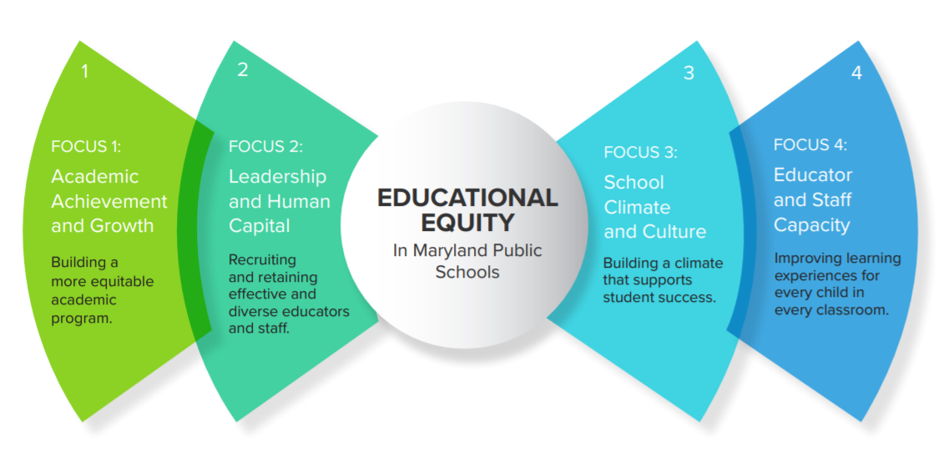

B. SCHOOLWIDE PROGRAMS
Resources:
- Schoolwide Non-Regulatory Guidance
Early Learning
- Non-Regulatory Guidance: Early Learning in the Every Student Succeeds Act
- Head Start Act
- Head Start Act: Section 641A
- National Head Start Association – Education Toolkit
- New Early Childhood Coordination Requirements in the Every Student Succeeds Act (ESSA)
Career and Technical Education (CTE)
- MSDE CTE Publications
- MSDE CTE Career Development: (21st Century Workplace) addresses how elementary school is the foundation
- MSDE CTE Technology Education

Component | Guiding Questions
B. Schoolwide Programs | - How does the Title I Office monitor the implementation and effectiveness of the four components of the schoolwide plan throughout the school year?  - What assistance does the LEA provide to schools for improving the ongoing quality of their schoolwide programs?  - How does the LEA ensure that schools annually review and revise their schoolwide plans with parents and representatives of the school community?  - How does the LEA and schools use student achievement and other school-level data to make decisions about the implementation of the schoolwide plan, including decisions about instructional changes, professional development, and the consolidation and use of Title I funds with other Federal, State, and Local funds to support the schoolwide program plan?

Webinar Questions and Answers

- Can you clarify the use of the term ‘equity lens’? Is there a definition MSDE is using for this process or is it for the LEA to define?
Answer: Definitions from Equity and Excellence: A Guide to Educational Equity in Maryland (p. 17)
Educational Equity: Granting every student access to the opportunities, resources, and educational rigor they need throughout their educational career to maximize academic success and social and emotional well-being, and viewing each student’s individual characteristics as valuable.
Equity Lens: For any program, practice, decision, or action, the impact on all students is addressed, with strategic focus on marginalized student groups. Individual characteristics include:
  - Ability (cognitive, social/ emotional, and physical)
  - Ethnicity
  - Family structure
  - Gender identity and expression
  - Language
  - National origin
  - Nationality
  - Race
  - Religion
  - Sexual Orientation
  - Socioeconomic Status

- Schoolwide Component: Assurance 2 - How will the Schoolwide Plans be “selected” and what are the criteria for selection?
Answer: This information will be shared later as part of the discussion around monitoring processes; however, it will be a data-driven collaborative decision between the LEA and the MSDE POC.
- Assurance 3: Documentation required demonstrating how the LEA review processes are added at the school. What does this mean? Is this in reference to the MSDE monitoring process or the LEAs monitoring of the schools?
Answer: Assurance 3 in schoolwide pertains to the LEA monitoring of school-level plans. The evidence of implementation item indicating “documentation demonstrating how findings for the LEA annual review process are addressed at the school level (samples).” The LEA should provide evidence that any findings from the LEA’s monitoring of Title I schoolwide schools are addressed at the school.
- Assurance 7: Written process for CTE per section 1112(b)(12) if deemed appropriate by the LEA. Please indicate how LEAs that only have elementary Title I schools determine and indicate that this is not appropriate for them.
Answer: If determined appropriate through a written process, local educational agencies with only elementary schools as Title I schools may include coordinated instructional strategies that promote career and technology education content. Other documentation to support the LEA has implemented its written process, if applicable, may include:
- experiences that provide students in depth interaction with industry professionals, i.e. elementary career and technology events
- experiential learning opportunities, i.e. STEM events or extended day programs
- Have the CTE and Student Services requirements been shared by MSDE with district level leadership in those departments and Superintendents?
Answer: The revision of the Title I, Part A application and monitoring tool is an annual activity as part of the MSDE’s overall process for updating the Local ESSA Consolidated Strategic Plan. We collaborate with the Office of Strategic Planning to meet State-level requirements for this process. Each year the contents of the Local ESSA Consolidated Strategic Plan, including the Title I application, is shared in a variety of ways.

Points of Clarification
State definition of well-rounded education (definition from the Maryland Report Card)
There are three components based on grade span:
Elementary schools: The percentage of 5th graders enrolled in science, social studies, fine arts, physical education, and health
Middle schools: The percentage of 8th grade students enrolled in fine arts, physical education, health, and computational learning
High schools: The percentage of graduating students or students exiting high school with a certificate of program completion who met at least one of the following criteria during high school (grades 9-12):
- enrolled in an Advanced Placement or International Baccalaureate course,
- participated in dual enrollment, or
- enrolled in state-approved career and technical education (CTE) program at the CTE concentrator level or higher
For students pursuing a certificate of program completion, enrollment in a general education course meets the requirement for access to a well-rounded education
The access to a well-rounded education measure will account for 10% of the total accountability score for all schools.
Federal Definition Section 8101(52)
(52) WELL-ROUNDED EDUCATION.—The term ‘‘well-rounded education’’ means courses, activities, and programming in subjects such as English, reading or language arts, writing, science, technology, engineering, mathematics, foreign languages, civics and government, economics, arts, history, geography, computer science, music, career and technical education, health, physical education, and any other subject, as determined by the State or local educational agency, with the purpose of providing all students access to an enriched curriculum and educational experience.

Points of Clarification
Section 1112(c)(7)
If a LEA chooses to use funds under this part to provide early childhood education services to low-income children below the age of compulsory school attendance, ensure that such services comply with the performance standards established under section 641A(9a) of the Head Start Act.
(See links in Resource section for more information)
Points of Clarification
1119(a)IN GENERAL.—Each local educational agency receiving assistance under this part shall carry out the activities described in subsection (b) with Head Start agencies and, if feasible, other entities carrying out early childhood development programs. Each local educational agency shall develop agreements with such Head Start agencies and other entities to carry out such activities. (See links in Resource section for more information)

Points of Clarification
According to Schoolwide Programs Section 1114 (a)(1)(B)
- Exception: A school that serves an eligible school attendance area in which less than 40 percent of children are from low-income families, or a school for which less than 40 percent of the families enrolled in the school are from such families, may operate a Schoolwide Program under this section if the school receives a waiver from the State Educational Agency to do so, after taking into account how a Schoolwide program will best serve the needs of the students in the school under this part in improving academic achievement and other factors.
- LEAs may request a waiver with the State to operate a Schoolwide Program in any school with less than 40 percent poverty if the LEA and school deem a Schoolwide Program will best serve the needs of the students.
_____________________________________________________________________________

Evidence Based Intervention Strategies
*MSDE’s Title I Office strongly encourages LEAs to implement “evidence-based” interventions/ strategies/activities/programs, Tiers 1-3. At minimum the interventions/strategies/ activities/ program for non-CSI schools should demonstrate a rationale that meet the “Demonstrate a Rationale” requirement. (Level 4)
To demonstrate a rationale, the intervention should include: 1) A well-specified logic-model that is informed by research or an evaluation that suggests how the intervention is likely to improve relevant outcomes; and 2) An effort to study the effects of the intervention, ideally producing promising evidence or higher, that will happen as part of the intervention or is underway elsewhere (e.g., this could mean another SEA, LEAs, or research organization is studying the intervention elsewhere), to inform stakeholders about the success of that intervention. (Non-Regulatory Guidance: NRG: Using Evidence to Strengthen Education Investments (September 16, 2016)

Schoolwide Program Plan Components Checklist
[Schoolwide Components ESSA Section 1114 (b)(1)(A-J)]: An eligible school operating a schoolwide program shall develop a comprehensive plan that must include the following components in their plan.
1. Comprehensive Needs Assessment of the entire school that takes into account information on the academic achievement of children in relation to the challenging State academic standards, particularly the needs of children who are failing, or at-risk of failing, to meet the challenging State academic standards and any other factors as determined by the local educational agency; [1114(b)(6)]  Things to consider:  - What types of qualitative and quantitative data are being collected?  - Examples include culture/climate, demographics, student performance, student attendance, behavior, and family and community involvement.  - Where necessary, a school should attempt to engage in interviews, focus groups, or surveys, as well as review data on students, educators, and schools to gain a better understanding of the root causes of the identified needs.  - What are the strengths of students, teachers, school and community? What are their needs?  - What are the contributing factors to academic strengths and needs?  - How is the data being used by administration, teachers and parents to guide decisions and instruction?  - How is data being reviewed in a disaggregated format to look at progress and needs of all student groups?  - How is the needs assessment used for a cycle of ongoing continuous improvement engaging all stakeholders? | 2. Schoolwide Reform Strategies that address school needs including a description of how strategies will:  - Provide opportunities for all children, including each of the subgroups of students as defined in Section 1111(c) (2) to meet the challenging State academic standards; (1114(b)(7)(A)(i);  - Use methods and instructional strategies that strengthen the academic program, in the school, increase the amount and quality of learning time and help provide an enriched and accelerated curriculum, which may include programs, activities and courses necessary to provide well-rounded education; (1114(b)(7)(A)(ii)  - Address the needs of all children in the school, but particularly the needs of those at risk of not meeting the challenging State academic standards that may include (1114(b)(7)(A)(iii)  - Counseling, school-based mental health programs, specialized instructional support services;  - Preparation for and awareness of opportunities for postsecondary education and the workforce;  - Schoolwide tiered model to prevent and address problem behavior;  - Professional development and other activities for teachers;  - Strategies to assist preschool children in transition  Things to consider:  - How do the schoolwide reforms increase the quality and quantity of instruction using evidence-based methods and strategies?  - How do the reform strategies align with the needs assessment and address the needs of all students including low achieving, accelerated, etc.  - What evidence is being collected to demonstrate the effectiveness of reforms? | 3A. Parent, Family and Stakeholder Involvement - developed with the involvement of parents and other members of the community to be served and individuals who will carry out such plan, including teachers, principals, other school leaders, paraprofessionals, the LEA, and, if appropriate, specialized instructional support personnel, technical assistance providers, school staff, if the plan relates to a secondary school, students, and other individuals determined by the school. 1114(b)(2)  3B. Strategies to Increase Parent and Family Engagement (Section 1116)  Things to consider:  - How will parents, families, and community members be involved in developing the schoolwide plan?  - How will teachers, principals, and other school staff be involved in developing the schoolwide plan?
4. Coordination and Integration of Federal, State, and local services and programs - If appropriate and applicable, is developed in coordination and integration with other Federal, State, and local services, resources and programs, such as programs supported under this Act, violence prevention programs, nutrition programs, housing programs, Head Start programs, adult education programs, career and technical education programs, and schools implementing comprehensive support and improvement activities or targeted support and improvement activities under Section 1111(d). 1114(b) (5)
Things to consider:
- Identify all federal, state, and local programs and services.
- How are federal, state, and local resources braided to maximize the impact of the schoolwide plan?

C. TARGETED ASSISTANCE SCHOOLS

Component | Guiding Questions
C: Targeted Assistance Schools | - How will the LEA Title I Office verify that each School Plan includes and addresses the required elements of Targeted Assistance Programs?  - How will the LEA Title I Office monitor the implementation of the Targeted Assistance Programs in each school? (Staffing, student eligibility, professional development, Parent and Family Engagement, etc.)  - How does the LEA Title I Office ensure that principals do not require Title I teachers and paraprofessionals to substitute in regular classrooms when there is a need?  - How does the LEA Title I Office ensure Targeted Assistance School principals and Targeted Assistance School Teachers understand all Targeted Assistance School requirements?  - How does the LEA Title I Office maintain copies of LEA guidance or communications to schools and parents about Targeted Assistance School requirements?  - How do the LEA Title I Office and Title I Targeted Assistance Schools maintain samples of training materials, agenda, or schedules of local or school-specific professional development to help schools to build their capacity to plan and implement Targeted Assistance School Programs?  - How does the LEA Title I Office ensure that all Title I funded equipment and materials are only used by Title I teachers/paraprofessionals with Title I students for the Targeted Assistance School Title I program?  - How do the LEA and Targeted Assistance School use student achievement and other school-level data to make decisions about the implementation of the Targeted Assistance School Plan, including decisions about effective instructional methods and strategies, professional development, and coordination with the regular education programs?

Webinar Questions and Answers

- Required Attachments: Please clarify exactly what the LEAs with no Targeted Assistance are supposed to have in this section.
Answer: The LEAs with no Targeted Assistance Schools will need to complete the following within this component:
- Respond to each assurance.
- Submit a response to required attachment #2, which indicates: A written process for developing, implementing, and monitoring requirements.

Points of Clarification
In Maryland, eligible students are the students that are identified to be served as participating students from the eligible population.

For the purpose of the document, eligible students will refer only to participating students.

Points of Clarification

State definition of well-rounded education (definition in the Maryland Report Card):

There are three components based on grade span:
Elementary schools: The percentage of 5th graders enrolled in science, social studies, fine arts, physical education, and health
Middle schools: The percentage of 8th grade students enrolled in fine arts, physical education, health, and computational learning
High schools: The percentage of graduating students or students exiting high school with a certificate of program completion who met at least one of the following criteria during high school (grades 9-12):
- enrolled in an Advanced Placement or International Baccalaureate course,
- participated in dual enrollment, or
- enrolled in state-approved career and technical education (CTE) program at the CTE concentrator level or higher
For students pursuing a certificate of program completion, enrollment in a general education course meets the requirement for access to a well-rounded education
The access to a well-rounded education measure will account for 10% of the total accountability score for all schools.
Federal Definition Section 8101(52)(52) WELL-ROUNDED EDUCATION.—The term ‘‘well-rounded education’’ means courses, activities, and programming in subjects such as English, reading or language arts, writing, science, technology, engineering, mathematics, foreign languages, civics and government, economics, arts, history, geography, computer science, music, career and technical education, health, physical education, and any other subject, as determined by the State or local educational agency, with the purpose of providing all students access to an enriched curriculum and educational experience.
Points of Clarification
- Based on the identified needs of the school, schools with Targeted Assistance programs may implement a schoolwide tiered model to address behavior such as:
  - PBIS
  - Restorative Practice
  - Restorative Justice
  - Mentor Based Support such as Big Brother Big Sister Programs
  - Social Emotional training programs
  - Social Skills trainings
  - Proactive classroom management
  - Other evidence-based strategies and/or programs

Points of Clarification
- Multiple Selection Criteria for students from preschool through grade 2 must include data from current pre-assessment or baseline data utilized in the LEA for preschool through grade 2 (i.e. KRA, DIBELS, etc.).

Maryland State Department of Education (MSDE)
Office of Title I Program Improvement and Family Support

Year Long Planning Process Option to transition from an existing Title I Targeted Assistance School Program (TAS) to a Title I Schoolwide (SW) Program

- The Local Education Agency (LEA) discusses with their Maryland State Department of Education (MSDE) Point of Contact (POC) the school(s) interested in transitioning from a TAS to SW and provides a rationale for each school that explains why the school is ready to transition to SW.
- The LEA submits a letter of intent notifying MSDE of its plan to transition a TA School(s) to SW at the start of SY 2021-22 (including data and rationale to demonstrate readiness to plan) to the MSDE Office of Title I – Program Improvement and Family Support by October 30, 2021.
- The LEA receives a letter of notification from the MSDE Title I Director acknowledging the LEA’s intent to undergo a yearlong planning process to transition the Targeted Assistance School(s) to SW.
- With the support of the LEA, each TAS develops a transition plan and timeline, which includes all four SW components as well as input and support from parents, staff and the community and submits it to their MSDE POC.
- With support and oversight from the LEA, the TAS implements the transition plan and maintains documentation during the year of planning to transition to SW.
- The TAS presents documentation demonstrating the implementation of their transition plan (including evidence of stakeholder buy-in) and readiness to transition to the LEA.
- Upon approval of the TAS’s readiness from the LEA, the LEA reviews with their MSDE Title I POC the documentation from the year of planning to determine if the school is ready for approval to transition to SW by March 31, 2022.
- MSDE will submit a letter to the LEA that acknowledges the proposed school(s) will become Schoolwide beginning in the 2022-2023 school year. MSDE may provide recommendations for implementation enhancements or additional planning and implementation requirements.
If there is evidence that the implemented transition plan does not meet evidence of readiness, based on the LEA’s submitted planning document a school may not become a Schoolwide program.

MSDE Guidance for an Abbreviated (Less Than One Year) Schoolwide Planning Process
This guidance addresses the School Year 2021-2022 abbreviated process, a new MSDE option, to transition to a Title I Schoolwide Program. The procedures listed may be used for a current Title I Targeted Assistance School Program (TAS) to transition to a Title I Schoolwide Program (SW) and for a newly entering Title I School to enter Title I status as a Schoolwide Program beginning in the 2022-2023 School year.
- The Local Education Agency (LEA) Title I Director discusses with their MSDE Point of Contact (POC) their intent regarding the school(s) that the LEA would like to become Schoolwide Title I school(s) in the 2022-2023 school year. The LEA may propose an existing TAS school or a school it expects to enter Title I in the 2022-23 school year (No later than January 15, 2022).
  - For both a current TAS school and a school that will enter Title I status beginning in the 2022-2023 school year, the LEA will discuss evidence that the school(s) being proposed meet the 40% poverty threshold to become a Schoolwide Program (ESSA, Section 1114 (a)(1)(A). (NOTE: If the 40% poverty threshold is not met, the LEA must request a waiver as described in ESSA, Section 1114 (a)(1)(B) )
  - The LEA should discuss a rationale for each school it proposes that explains why the school is ready to plan and transition to a Schoolwide program, including readiness for all four SW Components.
- The LEA submits a Letter of Intent for each proposed school to begin planning to transition to a Schoolwide Program to the Director of the MSDE Office of Program Improvement and Family Support by January 30, 2022.
  - This letter should provide a strong rationale about why becoming a Schoolwide Program will be in the best interests of the students, especially students most at risk of failing to meet State academic standards, any available data, as well as evidence of support from the school staff and parents for undertaking a Schoolwide planning process. A copy of the planning process should be included, also.
- The MSDE will send notification to the LEA Title I Director that acknowledges that the LEA will begin the Schoolwide planning process for the identified school(s).
- With the support of the LEA, each school will develop its planning timeline for the four SW components. Documentation of the plan must include the names and positions of the planning team, SAN/SANE, show meaningful involvement of parents, the whole school community, the School Improvement Team, and local community members. (1114(b)).
- The LEA will submit to MSDE each school’s written documentation that demonstrates the implementation of their transition plan. This documentation must include a written statement signed by the local Title I Director and each school’s planning team members with a recommendation that the school is ready to become a Schoolwide Program (No later than April 15, 2022).
- The MSDE will submit a letter to the LEA that acknowledges the proposed school(s) intent to become Schoolwide beginning in the 2022-2023 school year. The MSDE may provide recommendations for implementation enhancements or additional planning and implementation requirements. If so, these recommendations will be monitored during the school year.
If there is evidence that the implemented plan does not meet evidence of readiness, based on the LEA’s submitted planning document a school may not become a Schoolwide program.

NOTE: If the LEA has a specific circumstance for a school transitioning from a Targeted Assistance School to a Schoolwide Program that is not defined by these two processes, the LEA Title I Coordinator should contact the MSDE Title I Director.

Targeted Assistance Schools Program Checklist
1115. TARGETED ASSISTANCE SCHOOLS (b) Targeted Assistance School Program- To assist targeted assistance schools and local educational agencies to meet their responsibility to provide for all their students served under this part the opportunity to meet the State's challenging student academic achievement standards in subjects as determined by the State, each targeted assistance program under this section shall:
Eligible Children
Selection for eligible students. (Section 1115 (c)(1)(B))
Eligible children are children identified by the school as failing; or most at risk of failing, to meet academic standards on the basis of multiple educationally related objective criteria established by the local educational agency and supplemented by the school, except that children from preschool through grade 2 shall be selected solely on the basis of criteria, including objective criteria established by the local educational agency and supplemented by the school.

Seven Components of a TAS Program (1115 (b)(2)(A-G)) | Check
(A) use such program's resources under this part to help eligible children meet such State's challenging academic standards, which may include programs, activities, and academic courses necessary to provide a well-rounded education;
(B) use methods and instructional strategies to strengthen the academic program of the school through activities, which may include-
(i) extended learning time, before- and after-school, and summer programs and opportunities; and
(ii) a schoolwide tiered model to prevent and address behavior problems, and early intervening services, coordinated with similar activities and services carried out under the Individual with Disabilities Education Act (20 U.S.C. 1400 et seq.);
(C) coordinate with and support the regular education program, which may include services to assist preschool children in the transition from early childhood programs such as Head Start, the Literacy program under subpart 2 of part B of title II, or State-run preschool programs to elementary school programs;
(D) providing professional development with resources provided under this part, and, to the extent practicable, from other sources, to teachers, principals, other school leaders, paraprofessionals, and if appropriate, specialized instructional support personnel, and other school personnel who work with eligible children in programs under this section or in the regular education program;
(E) implementing strategies to increase the involvement of parents of eligible children in accordance with section 1116;
(F) if appropriate and applicable, coordinating and integrating Federal State and local
services and programs such as programs supported under this Act, violence prevention programs supported, nutrition programs, housing programs, Head Start programs, adult education programs, career and technical education programs, and
comprehensive support and improvement activities or targeted support and improvement activities under section 1111(d);
(G) provide to local educational agency assurances that the school will-
(i) help provide an accelerated, high quality curriculum;
(ii) minimize the removal of children from the regular classroom during regular school hours for instruction provided under this part: and
(iii) on an ongoing basis, review the progress of eligible children and revise the targeted assistance program under this section, if necessary, to provide additional assistance to enable such children to meet the challenging State academic standards.

D. PARENT AND FAMILY ENGAGEMENT

Component | Guiding Questions
D: Parent and Family Engagement | - How does the LEA monitor and provide technical assistance to schools on:  - School Level Parent and Family Engagement Plan;  - Parent involvement programs and activities;  - School-Parent Compact; and  - Spending of the 90% of the 1% parent involvement fund  - How does the LEA use the MSDE “Parent and Family Engagement Checklist” for the District Level Policy, School Level Plan, and the School-Parent Compact?

Title I District Level Parent and Family Engagement Policy/Plan Requirements - Section 1116: Check list
LEA: ______________ Reviewer: ____________________ Date Reviewed: ________
The LEA has a current year parent and family engagement plan/policy. Yes ___ No ___Section 1116 (a)(2)

A. Written Policy (Section 1116 (a)(1)(2) | Evidence of Implementation
- In consultation with parents of participating children, the LEA conducts outreach to all parents and family members of participating children, and implements programs, activities, and procedures for the involvement of parents and family members. Section 1116 (a)(1) | - Input from parents/families  - SANE from parent meetings  - Announcements/Fliers  - Parents feedback  - Translated documents  - Receipts for accommodations/ interpreters
- LEA’s establishes expectations and objectives for meaningful parent and family involvement  Section 1116 (a)(1)(2) | - Translated documents Evidence in LEA plan  - SAN from meeting discussing expectations and objectives
- Parent and family member input:  - Jointly developed a written parent and family engagement policy that is agreed on with, and distribute to parents and family members of participating children. Section 1116 (a)(2)  - Jointly developed the local educational agency plan under section 1112, and the development of support and improvement plans under paragraphs (1) and (2) of section 1111(d).  Section 1116 (a)(2)(A)  - Involved in the decisions regarding how funds reserved under subparagraph (A) are allotted for parental involvement activities. Section 1116 (a)(3)(A) | - SAN from parent meetings with agendas that identify specific topics for input.  - Example of how the Plan is distributed and available for parents and community may include:  - District/school website  - Student handbook  - School newsletters  - Plans and compact sent home via backpack/ orientation packet  - SAN from parent meetings specific to Section 1112.  - SAN from parent meetings specifying agenda item on Title I PFE funds  - Announcements/Fliers for meetings.
- Provides coordination, technical assistance, and other support necessary to assist and *build the capacity of all participating schools within the LEA in planning and implementing effective parent and family involvement activities to improve student academic achievement and school performance. (This may include meaningful consultation with employers, business leaders, and philanthropic organizations, or individuals with expertise in effectively engaging parents and family members in education). Section 1116(a)(2)(B) | - SANE or other evidence that the LEA provides coordination, technical assistance. See building capacity section (B).
- Coordinates and integrates parent and family engagement strategies with other relevant Federal, State, and local laws and programs, to the extent feasible and appropriate. Section 1116(a)(2)(C) | - Evidence in LEA plan  - SANE or other evidence of coordinated activities with Federal, State, and local programs, including Judy Centers, Head Start, Title III, Special Education, etc.to the extent feasible and appropriate.
- Conducts with the involvement of parents an annual evaluation of the content and effectiveness of parent involvement policy addressing: (Sec. 1116 (a)(2)(D)(E)  - barriers to greater participation by parents;  - the needs of parents and family members to assist with the learning of their children, including engaging with school personnel and teachers;  - strategies to support successful school and family interactions;  - used findings from evaluation to design/revise the policy/plan incorporating evidence-based strategies for more effective parental involvement. | - Completed district level evaluations/surveys addressing:  - barriers to greater participation by parents;  - the needs of parents and family members to assist with the learning of their children, including engaging with school personnel and teachers;  - strategies to support successful school and family interactions; and other support to school.  - used findings from evaluation to design/revise the policy/plan incorporating evidence-based strategies for more effective parental involvement.  - Communication/outreach regarding evaluation/survey of LEA Parent and Family Engagement Plan  - Results of data/feedback  - Revisions to policy/plan are made, based on evaluation, if applicable  - SAN with meeting notes, if applicable  - Evidence supporting the development of the evaluation tool, distribution and collection of parent surveys, if applicable.
- The LEA’s policy/plan includes at least one of the following strategies:  - Supporting schools and nonprofit organizations in providing professional development for the LEA and school personnel regarding parent and family engagement strategies.  - Supporting programs that reach parents and family members at home, in the community, and at school.  - Disseminating information on best practices focused on parent and family engagement.  - Collaborating or providing subgrants to schools to collaborate, with community-based or other organizations or employers with a record of success in improving and increasing parent and family engagement.  - Engaging in any other activities and strategies the LEA determines are appropriate and consistent with such agency’s parent and family engagement policy/plan. | - Evidence in LEA plan  - SANE or other evidence supporting strategies - i.e. working with nonprofit organizations, home visits, LEA guide on best practices for schools, subgrants to schools for PFE, LEA’s outreach to parents/families supporting activities in the LEA PFE Plan.
B. *Building Capacity: Section 1116(a)(2)(B)  The Plan describes how the LEA will build the schools’ and parents’/families capacity for parental involvement | Evidence of Implementation may include:
- Provide assistance to parents/families in understanding the State academic standards, State and local academic assessments, and how to monitor a child's progress, and how to work with educators to improve the achievement of their children. Section 1116 (e)(1) | - SANE from parent meetings, outreach or events with topic specific agenda items.  - Announcements/Fliers for outreach/events  - Handouts/resources from parent outreach/events, staff development, etc., as appropriate  - Translated documents  - Receipts for accommodations/ interpreters
- Provide materials and training to help parents work with their children to improve academic achievement, such as literacy training and using technology. Section 1116 (e)(2) | - SANE from parent meetings, outreach or events with topic specific agenda items.  - Announcements/Fliers for outreach/events  - Handouts/resources from parent outreach/events, staff development, etc., as appropriate  - Translated documents  - Receipts for accommodations/interpreters
- Educate school personnel (teachers, specialized instruction support personnel, principals and other school leaders) with parental assistance on how to work with parents as equal partners in their child’s educational process. Section 1116 (e)(3) | - SANE from parent meetings, outreach or events with topic specific agenda items.  - Announcements/Fliers for outreach/events  - Handouts/resources from parent outreach/events, staff development, etc., as appropriate  - Translated documents  - Receipts for accommodations/interpreters
- To the extent feasible and appropriate, coordinate and integrate parental involvement programs and activities with other Federal, State, and local programs, including public preschool programs, and conduct other programs such as parent resource centers.  Section 1116 (a)(2)(C) and (e)(4) | - SANE or other evidence of coordinated activities with Federal, State, and local programs, including Judy Centers, Head Start, Title III, Special Education, etc.to the extent feasible and appropriate.  - SANE from parent meetings, outreach or events with topic specific agenda items.  - Announcements/Fliers for outreach/events  - Handouts/resources from parent outreach/events, staff development, etc., as appropriate  - Translated documents  - Receipts for accommodations/interpreters
- Ensure information related to school and parent/family programs, meetings, and other activities is shared with parents in a format and, to the extent practicable, in a language the parents can understand. Section 1116 (e)(5) | - Announcements/Fliers for outreach/events  - Handouts/resources from parent outreach/events, staff development, etc., as appropriate  - Translated documents  - Receipts for accommodations/ interpreters
- Provide such other reasonable support (provide literacy training, pay reasonable and necessary expenses associated with local parental involvement activities, including transportation and child care costs, provide a variety of meeting times and locations) for parental involvement activities as parents may request. Section 1116 (e) (14) | - Announcements/Fliers for outreach/events  - Handouts/resources from parent outreach/events, staff development, etc., as appropriate  - Translated documents  - Receipts for accommodations/ interpreters
- Accessibility: Section 1116 (f) | Evidence of Implementation
To the extent practicable, provide full opportunities for the participation of parents with limited English proficiency, parents with disabilities, and parents of migratory children. Section 1116 (f) | - SANE from LEA technical assistance to schools  - Translated documents  - Receipts for accommodations/interpreters

Title I School Level Parent and Family Engagement Plan and School Parent Compact Checklist

Section 1116
LEA: _________________________ School: __________________________ Date __________________
Does the school have a current year school parent and family engagement plan and school parent compact? Yes or No____ Meets Requirements (M) _____ Does not meet the requirement (NM)

- General Requirements: Section 1116 (b) (d) | Evidence of Implementation
- Jointly developed, and distributed, to parents of participating Title I students in a format and written in a language parents/families can understand. Section 1116 (b) and (d)  - Parent and Family Engagement Plan  - Date Reviewed for input: _______  - Date distributed: _____________  - School-Parent Compact  - Date Reviewed for input: _______ | - SAN(E) from parent input meetings  - Announcements/Fliers  - Parents feedback  - Translated documents, if applicable  - Receipts for accommodations/interpreters, if applicable  Examples of how the school level Plan is distributed may include:  - School website  - Student handbook  - School newsletters  - Plans sent home via backpack/ orientation packet
- Parents of participating Title I students are involved in the decisions regarding the spending of the parent involvement fund. Section 1116 (3)(B) | - SAN(E) from parent meetings specifying agenda item on Title I PFE funds  - Announcements/Fliers for meetings  - Parents feedback
- Policy Involvement: Section 1116 (c) | Evidence of Implementation
- Schools convene an annual meeting, at convenient times, to inform parents of the school’s role and requirements in implementing Title I, and the right of parents to be involved. Sec.1116 (c)(1) | - SAN(E) from annual meeting(s) specifying information about Title I and parents rights to be involved  - Announcements/Fliers of outreach/events  - Translated documents, if applicable  - Receipts for interpreters, transportation, or other accommodations, if applicable
- Schools offer a flexible number of meetings, such as morning and evening. Section 1116 (c)(2) | - Evidence showing flexible meeting times  - Announcements/Fliers of outreach/events
- Involve parents of participating Title I students in an ongoing and timely way in the program planning, review, and improvement of the: Section 1116 (c)(3)  - School Parent and Family Engagement Plan  - Schoolwide plan | - SAN from parent meetings specifying agenda item for review and input on  - School Parent and Family Engagement Plan  - Schoolwide plan  - Announcements/Fliers for meetings  - Parent feedback
- Parents/families will be provided timely information about school programs. Sec. 1116 (c)(4)(A)
- The Parent and Family Engagement Plan advises that if the schoolwide program plan (1114) is not satisfactory to parents, submit any parent comments on the plan when the school makes the plan available to the local educational agency. Section 1116 (c)(5) | - How parents are informed about the SW plan and can make comments if plan is not satisfactory
- Shared Responsibility: Section 1116 (d) (School-Parent Compact) | Evidence of Implementation
- The school-parent compact outlines how parents/families, school staff, and students share responsibility for improved student academic achievement? Section 1116 (d)
- School Responsibilities: Describe how the school will:  - Provide high-quality curriculum and instruction that enables children to meet the State's academic achievement standards and a supportive and effective learning environment that enables children to meet the State's academic achievement standards. Section 1116 (d)(1)  - Conduct annual parent-teacher conferences in elementary schools during which the compact is discussed as it relates to a child's achievement. Section 1116 (d)(2)(A)  - Provide frequent reports to families on their child's progress. Section 1116 (d)(2)(B)  - Provide reasonable access to staff including opportunities to volunteer and participate in the child's class and observation of classroom activities. Section 1116 (d)(2)(C)  - Ongoing basis, ensuring regular two-way, meaningful communication between home and school and in a language the family members can understand. Section 1116 (d)(2)(D) | - Completed MSDE PFE school level checklist for compact showing all components are addressed  - SANE from parent meetings specifying agenda item for review and input on the school-parent compact  - Announcements/Fliers for meetings  - Parent feedback  - Translated school-parent compacts, if applicable  - SANE from sharing school-parent compact with parents and family members
- Parent Responsibilities: Describe how parents/families will be responsible for their child’s learning (i.e., classroom volunteering, participating in decision-making, and use of extracurricular time.) Section 1116 (d)(1)
- Student Responsibilities: Describe ways students will support their own academic achievement. Section 1116 (d)
- Building Capacity: Section 1116 (e)  The Plan describes how the school will build the schools’ and parents’/families’ capacity for parental involvement | Evidence of Implementation may include:
- Provide assistance to parents/families in understanding the State academic standards, State and local academic assessments, and how to monitor a child's progress, and how to work with educators to improve the achievement of their children  Section 1116 (e)(1) | - SANE from parent meetings, outreach or events with topic specific agenda items.  - Announcements/Fliers for outreach/events  - Handouts/resources from parent outreach/events, staff development, etc., as appropriate  - Translated documents  - Receipts for accommodations/ interpreters
- Provide materials and training to help parents work with their children to improve academic achievement, such as literacy training and using technology.  Section 1116 (e)(2) | - SANE from parent meetings, outreach or events with topic specific agenda items.  - Announcements/Fliers for outreach/events  - Handouts/resources from parent outreach/events, staff development, etc., as appropriate  - Translated documents  - Receipts for accommodations/ interpreters
- Educate school personnel (teachers, specialized instruction support personnel, principals and other school leaders) with parental assistance on how to work with parents as equal partners in their child’s educational process. Section 1116 (e)(3) | - SANE from parent meetings, outreach or events with topic specific agenda items.  - Announcements/Fliers for outreach/events  - Handouts/resources from parent outreach/events, staff development, etc., as appropriate  - Translated documents  - Receipts for accommodations/ interpreters
- To the extent feasible and appropriate, coordinate and integrate parental involvement programs and activities with other Federal, State, and local programs, including public preschool programs, and conduct other programs such as parent resource centers.  Section 1116 (a)(2)(C) and (e)(4) | - SANE or other evidence of coordinated activities with Federal, State, and local programs, including Judy Centers, Head Start, Title III, Special Education, etc.to the extent feasible and appropriate.  - SANE from parent meetings, outreach or events with topic specific agenda items.  - Announcements/Fliers for outreach/events  - Handouts/resources from parent outreach/events, staff development, etc., as appropriate  - Translated documents  - Receipts for accommodations/ interpreters
- Ensure information related to school and parent/family programs, meetings, and other activities is shared with parents in a format and, to the extent practicable, in a language the parents can understand. Section 1116 (e)(5) | - Announcements/Fliers for outreach/events  - Handouts/resources from parent outreach/events, staff development, etc., as appropriate  - Translated documents  - Receipts for accommodations/ interpreters
- Provide such other reasonable support (provide literacy training, pay reasonable and necessary expenses associated with local parental involvement activities, including transportation and child care costs, provide a variety of meeting times and locations) for parental involvement activities as parents may request.  Section 1116 (e)(14) | - Announcements/Fliers for outreach/events  - Handouts/resources from parent outreach/events, staff development, etc., as appropriate  - Translated documents  - Receipts for accommodations/ interpreters
- Accessibility: Section 1116 (f) | Evidence of Implementation
To the extent practicable, provide full opportunities for the participation of parents with limited English proficiency, parents with disabilities, and parents of migratory children. Section 1116 (f) | - SANE from LEA technical assistance to schools  - Translated documents  - Receipts for accommodations/ interpreters

E. PARTICIPATION OF CHILDREN ENROLLED IN PRIVATE SCHOOLS

Resources:
- MSDE Equitable Services State Ombudsman – Resource Page
- Title I, Part A of the Elementary and Secondary Education Act of 1965, as Amended by the Every Student Succeeds Act: Providing Equitable Services to Eligible School Children, Teachers, and Families October 7, 2019
- Ensuring Equitable Services to Private School Children: A Title I Resource Toolkit

Component | Guiding Questions
E: Equitable Services to Students in Private Schools | - How does the Title I Office ensure that it has conducted timely and meaningful consultation, and has discussed all required topics?  - How does the Title I Office determine that only eligible private school children are receiving Title I services?  - How does the Title I Office ensure that the Title I services are supplemental, and that they are being provided by a state certified teacher highly qualified LEA employee, or through a contractor?  - How does the LEA assess the Title I program and the achievement of participating students against agreed-upon standards?  - How does the Title I Office regularly supervise and monitor its Title I program being provided to eligible private school children?  - How does the Title I Office maintain control of the Title I program, including the Title I funds, materials, equipment and property that support services to private school children?  - How does the LEA ensure that contracts with third party contractors to provide services to private school children and the administrative costs for the contractor are taken “off the top?  - How does the LEA ensure that services to private school children are being implemented at the beginning of the school year?

Webinar Questions and Answers
- No questions submitted by LEAs

Points of Clarification
Examples of Title I services that may be provided include:
- Counseling
- One-on-one tutoring
- Educational radio and television
- Dual or concurrent enrollment
- Mentoring
- Mobile educational equipment
- Computer equipment and technology
Points of Clarification

- The results of agreements following consultation must be transmitted to the SEA’s equitable services Ombudsman. The Ombudsman should establish a process for receiving documentation of agreements from each LEA.
Points of Clarification
- In general, an LEA must obligate the funds allocated for equitable services under all applicable programs in the year for which they are appropriated. This provision helps to ensure that an LEA uses the funds available under Title I to provide equitable services in the fiscal year for which the funds were appropriated so that eligible students, teachers and other educational personnel, and families receive the services to which they are entitled in a timely manner. It reinforces the requirement that an LEA conduct timely consultation with private school officials to design appropriate equitable services so that those services can begin at the beginning of the school year for which the funds are appropriated.
Points of Clarification
- Special Note: If an LEA is skipping schools, equitable services must still be calculated (if applicable) and reported on the Title I allocation worksheet. Refer to the Skipped Schools’ Addendum document for additional directions.

Points of Clarification
- The goal of consultation is to reach agreement between the LEA and appropriate private school officials on how to provide equitable and effective programs for eligible private school children. The written affirmation that consultation has occurred must provide the option for private school officials to indicate that such officials’ belief that timely and meaningful consultation has not occurred or that the program design is not equitable with respect to eligible private school children.

Equitable Services Topics of Consultation
Below are topics that should be discussed in consultation for each Title program. Please mark if topics have been addressed:
Section 1117(b)(1) | Consultation Topic
 | - How the children’s needs will be identified.
 | - What services will be offered.
 | - How, where, and by whom the services will be provided.
 | - How the services will be academically assessed and how the results of that assessment will be used to improve those services
 | - The size and scope of the equitable services to be provided to the eligible private school children, teachers, and other educational personnel, the proportion/amount of funds that are allocated for such services, and how that proportion/amount of funds is determined
 | - The method or sources of data that are used to determine the number of children from low-income families in participating school attendances areas who attend private schools
 | - How and when the LEA will make decisions about the delivery of services to such children, including a thorough consideration and analysis of the views of the private school officials on the provision of services through a contract with potential third-party providers
 | - How, if the LEA disagrees with the views of the private school officials on the provision of services through a contract, the LEA will provide in writing to such private school official an analysis of the reason why the LEA has chosen not to use a contractor
 | - Whether the LEA shall provide services directly or through a separate government agency, consortium, entity, or third-party contractor
 | - Whether to provide equitable services to eligible private school children (1) by creating a pool or pools of funds with all of the funds allocated based on all the children from low-income families in participating school attendance area who attend private schools or (2) in the LEA's participating school attendance area who attend private schools with the proportion of funds allocated based on the number of children from low-income families who attend private schools
 | - When, including the approximate time of day, services will be provided
 | - Whether to consolidate and use funds provided in coordination with eligible funds available for services to private school children under application programs

The goal of reaching agreement between a local education agency (LEA) and appropriate private school officials is grounded in timely, meaningful, and open communication on key issues that are relevant to the equitable participation of eligible private school students, teachers and other educational personnel, and families in programs under the Every Student Succeeds Act (ESSA).

PART I: CONTACT INFORMATION

LEA INFORMATION | CONTACT INFORMATION
NAME OF LEA: | TELEPHONE NUMBER:
LEA REPRESENTATIVE & TITLE: | EMAIL ADDRESS:

PRIVATE SCHOOL INFORMATION | CONTACT INFORMATION
NAME OF PRIVATE SCHOOL: | TELEPHONE NUMBER:
PRIVATE SCHOOL REPRESENTATIVE & TITLE: | EMAIL ADDRESS:
☐ Our organization represents a consortium of schools and will represent our schools. A formal letter will be provided.

PART II: INDICATE FEDERAL PROGRAM PARTICIPATION (Programs covered under ESSA Section 1117 and Section 8501)
Title I, Part A ☐  ( ESSA Sect. 1117) | Title I, Part C ☐  (ESSA Sect. 8501) | Title II, Part A ☐  (ESSA Sect. 8501) | Title III, Part A ☐ (ESSA Sect. 8501) | Title IV, Part A ☐  (ESSA Sect. 8501) | Title IV, Part B ☐  (ESSA Sect. 8501)

PART III: CONSULTATION TOPICS COVERED UNDER ESSA SECTION 1117 AND SECTION 8501

- How the children’s needs will be identified;
- What services will be offered;
- How, where, and by whom the services will be provided;
- Timelines and due dates for all time sensitive information will be shared including signed affirmation and intent to participate forms as well as program applications as appropriate.
- How the services will be [academically] assessed and how the results of that assessment will be used to improve those services; NOTE: [language of “academically” only applies to Title I]
- The size and scope of the equitable services to be provided to the eligible private school children, teachers, and other educational personnel, as applicable, and the proportion of funds that is allocated for such services, and how the proportion of funds allocated for equitable services is determined;
- How and when the LEA, consortium, or entity will make decisions about the delivery of services to such children, including a thorough consideration and analysis of the views of the private school officials on the provision of services through a contract with potential third-party providers;
- Whether to provide equitable services to eligible private school children –
  - by creating a pool or pools of funds with all of the funds allocated under subsection (a)(4)(A) based on all the children from low-income families in a participating school attendance area who attend private schools; or
  - in the LEA’s participating school attendance area who attend private schools with the proportion of funds allocated under subsection (a)(4)(A) based on the number of children from low-income families who attend private schools;
- If applicable, total carryover funds available for the provision of equitable services under the respective program(s) and in determining how carryover funds will be used, the LEA must consult with the appropriate private school officials.
- Whether the LEA, consortium, or entity shall provide services directly or through a separate government agency, consortium, entity, or third-party contractor;
- How, if the LEA disagrees with the views of the private school officials on the provision of services through a contract, the LEA will provide in writing to such private school officials an analysis of the reasons why it has chosen not to use a contractor;
PART IV: ADDITIONAL CONSULTATION TOPICS COVERED UNDER ESSA SECTION 1117 ONLY

- The method or sources of data that are used under subsection (c) and section 1113(c)(1) to determine the number of children from low-income families in participating school attendance areas who attend private schools TITLE I ONLY
- When, including the approximate time of day, services will be provided; TITLE I ONLY
- Whether to provide services to eligible private school children by consolidating and using funds in coordination with eligible funds available for services to private school children under programs covered by Section 8501(b)(1). TITLE I ONLY
- *Administrative costs of providing equitable services including Indirect costs, as applicable. TITLE I ONLY
- *Transferring funds from Title II, Part A or Title IV, Part A into Title I, Part A, as applicable. TITLE I ONLY
(*Revised as of 6/10/2021)
PART V: AFFIRMATION OF CONSULTATION

The goal of consultation is agreement between the LEA and appropriate private school officials on how to provide equitable and effective programs for eligible private school children (ESSA sections 1117(b)(1) and 8501(c)(1)(5)).
By signing this form, we agree that:
- timely and meaningful consultation occurred prior to the LEA making any decisions which affected the participation of eligible private school children in the program.
- we participated in meaningful and timely discussion(s) on each Title program and have chosen to participate in the program(s) indicated above in Part II.
- timely and meaningful consultation will continue throughout the school year to discuss implementation and assessment of services provided under these Title programs.
LEA REPRESENTATIVE SIGNATURE: | DATE:
PRIVATE SCHOOL REPRESENTATIVE SIGNATURE: | DATE:

ONLY SIGN BELOW IF YOU BELIEVE THAT TIMELY AND MEANINGFUL CONSULTATION HAS NOT OCCURRED OR THAT THE PROGRAM DESIGN IS NOT EQUITABLE WITH RESPECT TO ELIGIBLE PRIVATE SCHOOL STUDENTS.

PRIVATE SCHOOL REPRESENTATIVE SIGNATURE: | DATE:

Please share any Comments or Requests for Further Consultation

Each program must maintain a copy of this form in its records for program monitoring purposes. In addition, this form reflects the results of agreement between the LEA and private school official and must be transmitted to the MSDE’s Equitable Services Ombudsman (ESSA Section 1117(b)(1)) by including it in the Equitable Services Section of the Local ESSA Consolidated Strategic Plan.

Maryland State Department of Education

Intent to Participate Form
Federal Programs Under ESSA

Please complete the following Intent to Participate form no later than ________________, and submit to:
Name
LSS
Mail/Email Address

Name of Non-Public School/Address:
Name:

Address:

The school’s business model is: ☐ Non-profit ☐ For-profit (not eligible for equitable services)

Non-Public School Representative:
Name: | Title:
Phone: | Email:

☐ We do not intend to participate in any equitable services programs for the school year of 20XX-XX. (please sign form below)
☐ We intend to participate in the following 20XX-XX equitable services programs identified below:(please sign form below)
☐ Title I-A ☐ Title I-C ☐ Title II-A ☐ Title III-A ☐ Title IV-A ☐ Title IV-B (21st CCLC)
Complete (current) Grades/Enrollment at Non-Public School:
PK |  |  | 2 |  |  | 5 |  |  | 8 |  |  | 11
K |  |  | 3 |  |  | 6 |  |  | 9 |  |  | 12
1 |  |  | 4 |  |  | 7 |  |  | 10

Signatures:
LEA Representative Signature: | Date:
Private School Representative Signature: | Date:

Please share any Comments or Requests for Further Consultation:

F. EDUCATION FOR HOMELESS CHILDREN AND YOUTH
Resources:
- Education for Homeless Children and Youths Program Non-Regulatory Guidance

Component | Guiding Questions
F: Education for Homeless Children and Youth | - How does the LEA ensure Title I, Part A set-aside funds are used for homeless children who do not attend participating Title I schools including educationally related support services to children in shelters and other locations where children experiencing homelessness may live?  - How often are expenditures monitored with the McKinney-Vento Homeless Education Coordinator?  - Does the LEA have a written process for determining the set-aside amount for children and youth experiencing homelessness?

Webinar Questions and Answers
- Attachment #4: Provide a list of active shelters. Does this have to be updated annually?
Answer: Yes, the list of active shelters should be updated and provided annually. The Director of Student Services and/or the McKinney-Vento Coordinator should be able to provide this information.

Points of Clarification
Title I funds provide educationally related support services in a coordinated effort in the LEA, to address the needs of homeless students, in accordance with the McKinney-Vento Homeless Education Act. (1113(c)(3)(A)(i)

Examples, but not limited to –
- Conducting a LEA needs assessment to look at homeless student enrollment averages or trends in the district;
- Review/discussion of other factors such as, state and federal education grants that can provide the same or similar services;
- A review/discussion of available community resources;
- Review/discussion of what is necessary and reasonable for each student to fulfill the purposes of the Title I and McKinney-Vento programs in the LEA;
- Effectiveness of past activities in accomplishing the goals of both programs for individual students as well as the overall programs;
- Ensuring the LEA liaisons attend Title I conferences/in-service PD days and Title I coordinators attend homeless education conferences and in-service PD days;
- Sharing Title I and Homeless Education handbooks with other program staff;
- Leading district-wide efforts to make organizational accommodations for eligible students in such areas as transportation, remaining in the school of origin, records transfer, class scheduling, and special services that will help them enroll, attend, and succeed in school;
- Ensuring that the needs of highly mobile students are included in the school improvement plans and not addressed as a separate issue;
- Including homeless parents in Title I parental involvement policies and creating opportunities for homeless parents to be involved.

Points of Clarification
Title I, Part A funds may be used to provide a wide variety of services to students experiencing homelessness. Title I, Part A funds may be used to provide services to homeless students in Title I schools only the services are not ordinarily provided to other Title I students. (ESEA Section 1113(c)(3)(C)(ii).

Examples, but not limited to -
- Items of clothing necessary to meet a school’s dress or uniform requirement;
- Clothing and shoes necessary to participate in physical education classes;
- Student fees that are necessary to participate in the general education program;
- Personal school supplies such as backpacks and notebooks;
- Birth Certificates, Immunizations, Food, Medical and dental services, eyeglasses and hearing aids;
- Counseling services to address anxiety related to homelessness that is impeding learning;
- Outreach services to students living in shelters, motels, and other temporary residences;
- Extended learning time (before and after school, Saturday classes, summer school)to compensate for lack of quiet time for homework in shelters or other overcrowded living conditions;
- Tutoring services, especially in shelters or other locations where homeless students live;
- Parental involvement specifically oriented to reaching out to parents of homeless students; and
Fees for AP and IB testing, college entrance exams such as SAT or ACT, and GED testing for school-age students.

The LEA must reserve sufficient Title I funds to provide services to homeless students who attend non-Title I schools that are comparable to those provided to students in Title I schools. (ESEA Section 1113(c)(3)(A))
Title I, Part A reserved funds may be used to fund all or part of the LEA’s Homeless liaison’s salary. In addition, if an LEA is using Title I to fund an additional staff as necessary, (e.g. case manager) those duties must be specifically related to the strategies, activities and requirements under the McKinney-Vento Education for Homeless Children and Youth Program.

G. SUPPORT FOR FOSTER CARE STUDENTS
Resources:
- Non-Regulatory Guidance: Ensuring Educational Stability for Children in Foster Care

Component | Guiding Questions
G: Support for Foster Care Students | - Does the LEA have a written process for ensuring educational stability for children in foster care?  - How does the LEA document collaboration efforts?

Webinar Questions and Answers
- No questions submitted by the LEAs.

The new foster care provisions under Title I of the ESEA as amended by the ESSA are intended to minimize disruptions for children in foster care by requiring the SEA and LEA to collaborate with child welfare agencies to ensure educational stability for children in foster care (ESEA Section 1111(g)(1)(E)). These provisions build upon the existing educational stability provisions and the emphasis on cross-agency collaboration in the Fostering Connections to Success and Increasing Adoptions Act of 2008 (Fostering Connections Act).

An LEA that receives Title I funds is to assure in its local plan that it will develop and implement clear written procedures, in collaboration with the State. The LEA Foster Care Point-of-Contact (POC) and local child welfare agency, govern how transportation to maintain children in foster care in their school of origin when in the best interest will be provided, arranged, and funded for the duration of a child’s time in foster care (ESEA Section 1112(c)(5)) by December 10, 2017.

Points of Clarification
Some examples of the potential role or responsibilities of the LEA Foster Care POC are:
- Coordinating with the corresponding child welfare agency POC on the implementation of the Title I provisions;
- Leading the development of a process for making the best interest determination;
- Documenting the best interest determination;
- Facilitating the transfer of records and immediate enrollment;
- Facilitating data sharing with the child welfare agencies, consistent with FERPA and other privacy protocols;
- Developing and coordinating local transportation procedures;
- Managing best interest determinations and transportation costs disputes, if any;
- Ensuring that children in foster care are enrolled in and regularly attending school; and
- Providing professional development and training to school staff on the Title I provisions and educational needs of children in foster care, as needed.
Points of Clarification
COLLABORATION:
Some examples of LEA collaboration with the child welfare and other relevant agencies include:
- Ensuring that all school staff are sensitive to the complex needs of foster youth, informed about the impact that trauma has on a child’s ability to learn, appropriate interventions and strategies are in place to support them to succeed in school;
- Training school staff including principals, teachers, school counselors, school social workers, and school enrollment personnel about the needs of children in foster care and background information about the child welfare system;
- Training on the importance of maintaining children in their schools of origin, understanding the process and factors involved in making a best interest determination, coordinating transportation plans, protecting student privacy, and maintaining accurate education records for children in foster care; and
- Raising awareness and increasing knowledge about child welfare policies, (e.g. case plan requirements and other state laws pertaining to the education of children in foster care).

LEAs and child welfare agencies may choose to establish a structure to facilitate their collaboration, such as, a work group, task force, or interagency committee, customized to the needs of the local community, community stakeholders such as representatives from the court, community providers, education advocacy groups and parent mentor groups. LEAs should maintain sign-in, agendas, notes, evaluation (SANE) for meetings.

1. The LEA ensures it collaborates with the State and local child welfare agency (DSS) to develop and implement clear written procedures and practices to ensure educational stability for children in foster care.

Points of Clarification
The procedures/process shall include how the LEA will establish and maintain this collaborative work and transportation to maintain children in foster care in their school of origin, when in their best interest, will be provided, arranged, and funded for the duration of the time in foster care.

Excerpt from Non-Regulatory Guidance: Ensuring Educational Stability for Children in Foster Care

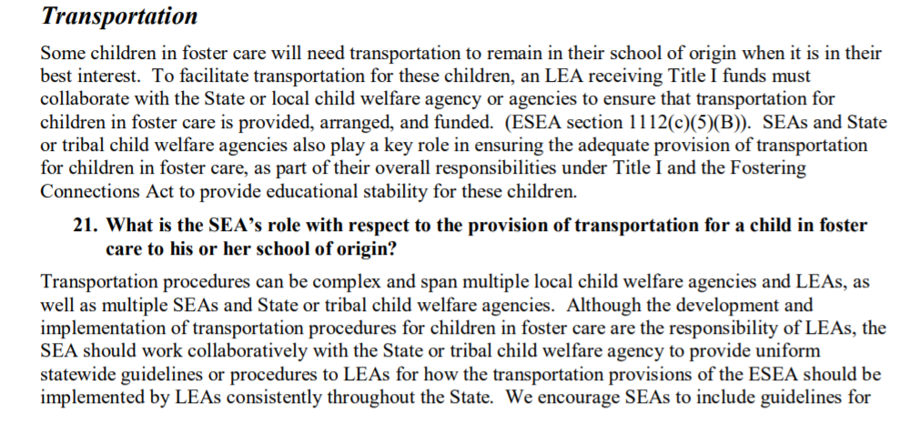
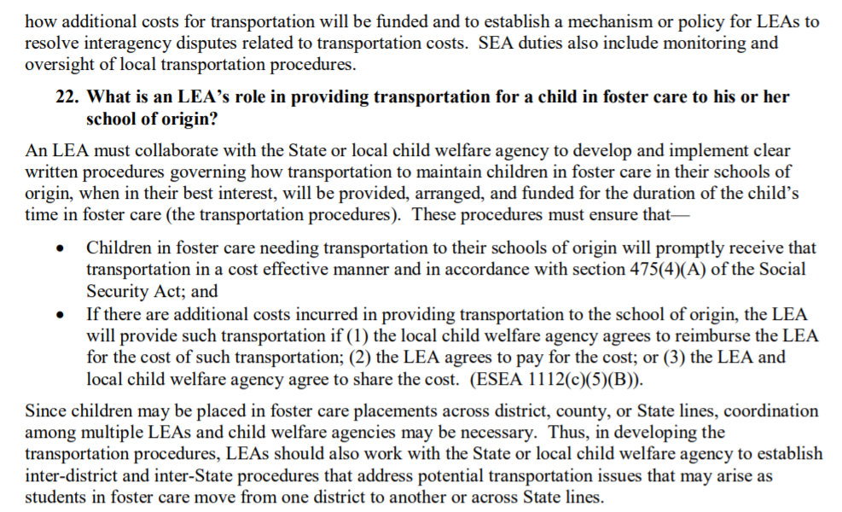
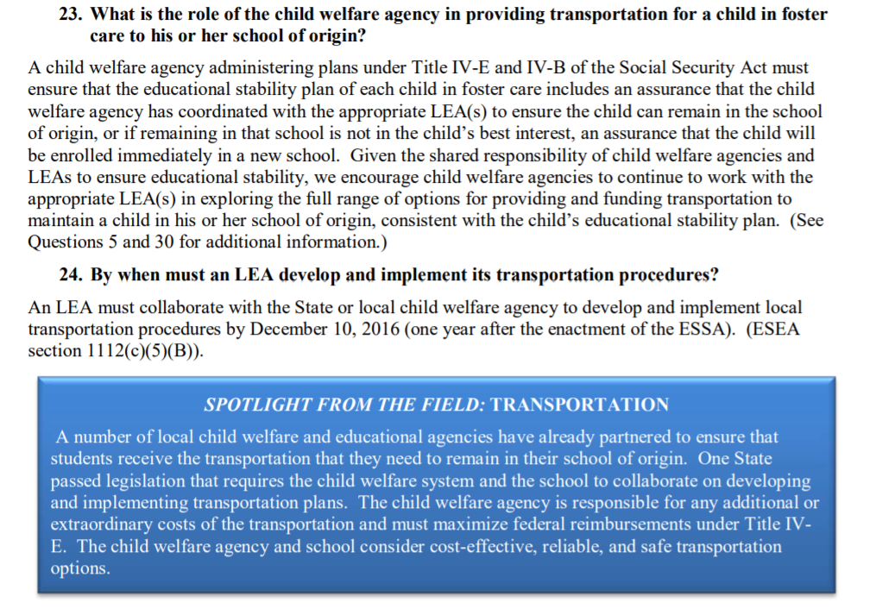
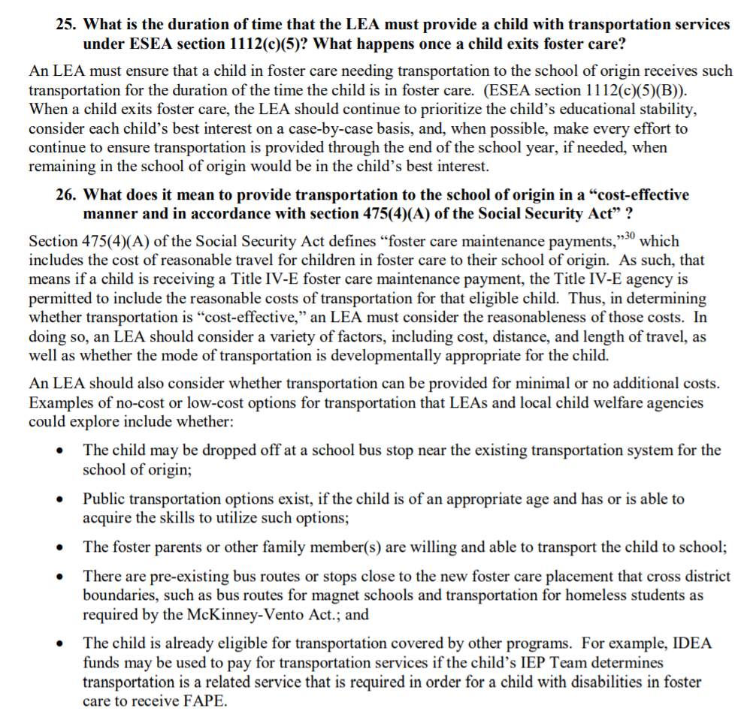
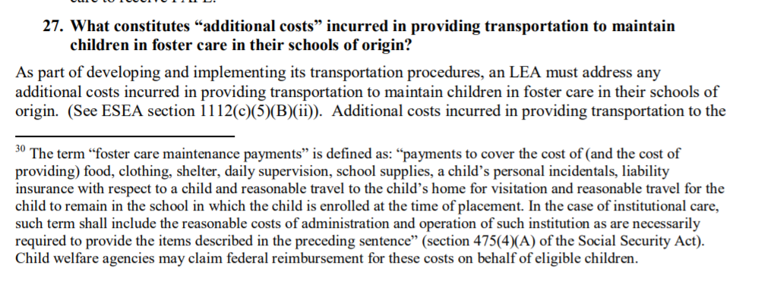
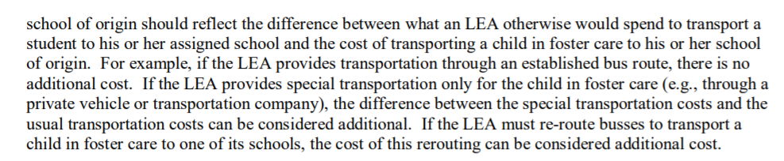
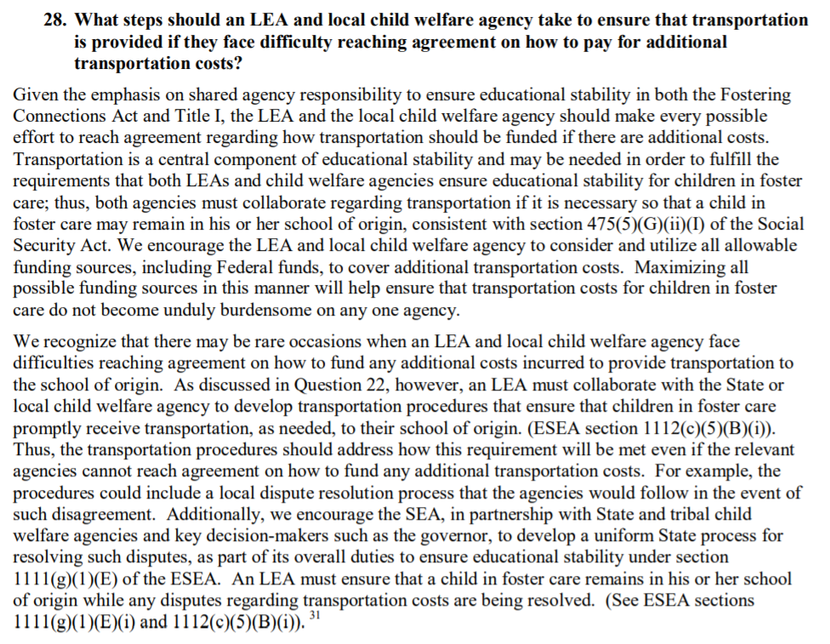
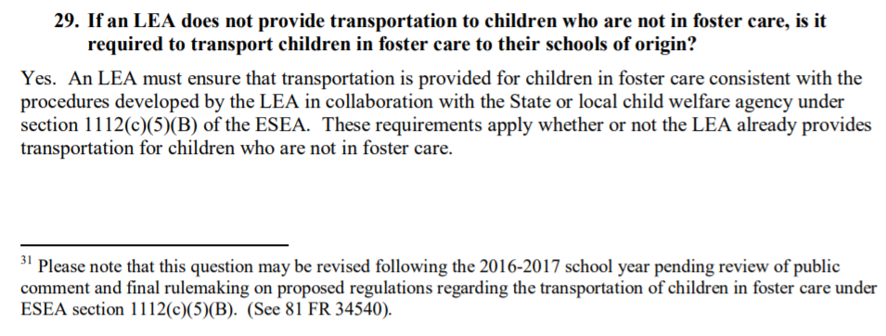
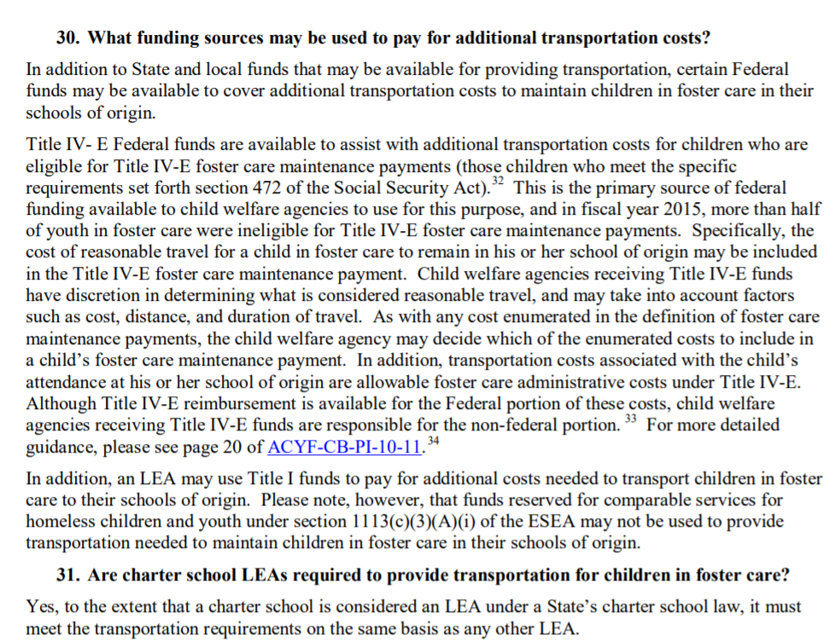
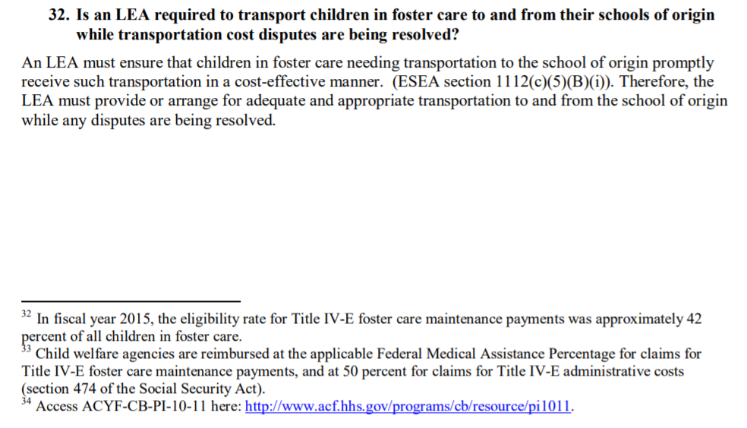

H. ENGLISH LEARNERS
Resources:
- MSDE Title III Website
- TITLE III – LANGUAGE INSTRUCTION FOR ENGLISH LEARNERS AND IMMIGRANT STUDENTS
- English Learners: Eligibility, Guidance, and Laws
- Parent Notification Letter with Translations
- Dear Colleague Letter: English Learner Students and Limited English Proficient Parents (1/7/15)
- Information for Limited English Proficient (LEP) Parents and Guardians and for Schools and School Districts that Communicate with Them
Title III is a part of the Elementary and Secondary Education Act of 1965 (ESEA), as amended by the Every Student Succeeds Act of 2015 (ESSA). The purpose of Title III funds is to help ensure that English learners (ELs), including immigrant children and youth, attain English language proficiency and develop high levels of academic achievement in English; to provide professional development to teachers and school leaders to best meet the academic and language needs of ELs; and to deliver activities that promote EL parent, family, and community engagement. The SEA receives a grant from USDE and 95 percent of the grant is allocated to eligible LEAs with ELs, including immigrant children and youth. LEAs may receive one or two types of subgrants: EL formula subgrants and/or immigrant children and youth subgrants. Under ESSA, several pieces that were required under Title III have been transitioned to Title I.

Points of Clarification
Provisions moved from Title III to Title I
- EL parental notification regarding LIEPS and related information (1112(e)(3))
- Parental participation (regular EL parent meetings) (1116(f))
- Reporting to the State on the number and percentage of ELs achieving ELP (1111(h)(2))

MSDE: ESSA Title I and Title III Questions and Answers

Question | Answer
- If a Local Education Agency (LEA) has Title I Targeted Assistance Schools (TAS), what funds should be used to send the parent notification letter to English learners (ELs)? Would the school use Title I funds only to include ELs that come up in the Title I ranking process? | For TAS, Title III funds will continue to pay for expenses associated with the parent notification letter for all ELs.
- Regarding the parent notification letters: ESOL teachers have always been responsible for those, and will continue to be so. Do we have to send the parent notification letter twice or can the ESOL office give a copy to the Title I office? | As the requirement of sending the parent notification letter to parents/guardians of ELs has been moved from Title III to Title I, the two offices in the LEA must collaborate. ESOL teachers can still be responsible for actually sending the letter and the copy of the parent notification letter must be kept in the student’s cumulative folder in the school. Title I will pay for expenses associated with sending the parent notification letter to ELs in all Title I Schoolwide schools, and Title III will continue to pay for expenses associated with the parent notification letter for ELs in TAS and non-Title I schools.
- How do we ensure that the Lau v. Nichols requirements are being met before Title I or Title III funds can be used? | Per the 1970 Memorandum and Lau v. Nichols, LEAs must take affirmative steps to provide meaningful language instruction educational programs to ELs such as ESOL and ESL. Therefore, LEAs should have procedures in place for identifying and assessing ELs, implement an EL curriculum, and allocate an appropriate number of teachers per EL enrollment. These activities should be conducted using local funds. The MSDE (Title I and Title III offices) will conduct monitoring visits to ensure local funds are being used to meet the Lau v. Nichols as well as Office of Civil Rights (OCR) requirements.
- What are the academic guidelines that we should follow in order to implement supplemental academic supports for ELs? | ELs must be serviced or instructed by certified ESOL teachers (with the exception of some ELs receiving services through Dual Language Immersion Programs¹) through locally funded English language development program services such as ESOL and ESL. If an LEA has a large number of ELs in Title I schools, the LEA may hire additional ESOL teachers to provide extra hours of services, hire ESOL tutors, and/or implement afterschool programs.
- We only use local money, not Title I or III, for paperwork and interpretation. Is that OK? | Yes, that is OK, but because the LEA has been using local funding for interpretation and translation, the LEA cannot use Title I or Title III funds to conduct such activities in the future.
- For the ELP indicator, if ELs are in ESOL, they have not met the state exit criteria yet, so how am I providing this data to our Title I supervisor? | The school-level ELP results will be shared with LEAs from both the Title I and Title III offices. The information can also be accessed on mdreportcard.org website.
- Can ELs receive their services through an ELD program not led by a certified ESOL teacher? | No. In Maryland, we have a certification program for ESOL teachers; therefore, all ELs must receive direct instructional support from certified ESOL teachers. The only exception to this requirement is ELs who are enrolled in a Dual Language Immersion Program that serves as the ELD program for ELs.

I. SCHOOL IMPROVEMENT: TARGETED SUPPORT AND IMPROVEMENT (TSI)

Resources:
The live links below are provided to guide Local School Systems in completion of the Targeted Support and Improvement component of the Title I, Part A Application process.
- Maryland's TSI Understanding Document- Summary of the TSI program requirements and the MSDE resources available to support TSI implementation.
- Maryland ESSA Consolidated State Plan (pages 41-48) - Describes how MSDE will implement TSI requirements under USDE’s approved state plan.
- Maryland Resource Hub (TSI Schools) - Tools, resources, and guides to unpack what TSI means.

Webinar Questions and Answers
- Is this information already included in the LEAs Master Plan?
Answer: The Local ESSA Consolidated Strategic Plan asks a few questions about all TSI schools in a LEA, mainly questions that identify the schools and student groups. The new program component in the Title I application and monitoring tool asks how the LEA is, or plans to implement the requirements for TSI schools found in ESSA and Maryland's approved ESSA plan, but only for Title I TSI schools. The fiscal section of the application asks for information about how Title I TSI schools are being supported.
- Not clear if this is the responsibility of Title I or LEA. Is this level of documentation required for all TSI schools of just Title I?
Answer: The State has responsibility for oversight for all programs and activities that receive Title I funding. The monitoring of how Title I TSI schools are adhering to the law's provisions does not limit the LEA's role in oversight for all its TSI schools.
- Assurance 1: Root cause analysis tool is recommended. Please provide a template.
Answer: Information and tools for conducting a root cause analysis can be found on the MSDE Resource Hub. The link to the root cause analysis information is can be found here.
- Assurance 1: Analysis of resource inequities – define resource inequities – provide an example.
Answer: As part of the LEA's role to determine identified student group needs and address them in TSI schools' plans, Section 1111(d)(2)(C) requires that, in each TSI school's intervention plan, LEAs "shall also identify resource inequities (which may include a review of local educational agency and school level budgeting), to be addressed through implementation of the plan."

ESSA does not define resource inequities. Further, the Maryland Consolidated State Plan indicates “a review of resource allocation, including identification of resource inequities, will be a part of the root cause analysis and monitoring process. Local school superintendents will be held accountable for developing and implementing strategies to address resource inequalities in the CSI and TSI schools.”

In short, the LEA will define the resource inequities that affect low performance of identified student group(s) in each of its TSI schools. Targeted Support and Improvement Schools are the topic for the Office Hours on July 14th. The team will discuss resource inequities with interested LEA staff during the Office Hour session.
- Assurance 1: Documentation for monitoring and TSI School Plans – provide a template. Identify roles and responsibilities for other departments (i.e., Special Education).
Answer: With the application, the LEA is responsible for submitting a written process describing how the LEA will carry out responsibilities under Section 1111(d). This includes the LEAs processes for approving and monitoring school-level TSI plans. The template for monitoring should be developed based on the LEA written process.

The roles and responsibilities for other departments and offices within a LEA would be defined by the LEA’s written process and would vary based on the student groups (and their needs) that are identified.

Understanding Maryland’s Targeted Support and Improvement (TSI) Schools

The Maryland State Department of Education (MSDE) has designed this document to assist local school systems in understanding Maryland’s TSI identification, local accountability, exit criteria, supports, and resources.

IDENTIFICATION

The Every Student Succeeds Act of 2015 (ESSA) has revised how states design their accountability systems and provide supports aimed at improving academic outcomes in their lowest-performing schools. The Maryland State Department of Education (MSDE) has established a set of indicators to measure school performance, as defined by the new State Accountability System. Performance of schools is based on available data from the 2016-2017 and 2017-2018 school years. The Maryland Targeted Support and Improvement (TSI) schools will include schools in which one or more specific student groups are low-performing or consistently underperforming.
Schools with one or more student groups performing below the summative performance on all indicators of the “all students” student group in any of the lowest performing five percent of Title I schools will be identified as low performing student group TSI schools. Low performing student group TSI schools will be identified at least once every three years. These schools may be Title I or non-Title I.

Schools with one or more underperforming student groups, defined as a group that does not meet its school level annual targets over two years, based on all applicable indicators in the State accountability system, will be identified as consistently underperforming student group TSI schools. Student groups included for identification are students from racial and ethnic groups (disaggregated as American Indian/Native American, Asian, Native Hawaiian or Other Pacific Islander, Black/African American, Hispanic/Latino of any race, White, or Two or more races), and students who are economically disadvantaged, students with disabilities, and English learners (ELs). The State added “gifted and talented students” as an additional student group, and this group will be reflected as a student group for future identification of TSI schools. The consistently underperforming student group TSI schools will be identified annually beginning in the 2019-2020 school year. The consistently underperforming student group TSI schools include both Title I and non-Title I schools.

In Maryland, Title I TSI schools that do not make improvements after three years will be considered chronically low-performing and these schools will be reclassified as chronically low performing
Comprehensive Support and Improvement (CSI) schools. Chronically low performing student group CSI schools will be identified at least once every three years. Maryland anticipates identifying its first cohort of chronically low performing student group CSI schools during the 2021– 2022 school year.

LOCAL ACCOUNTABILITY

A school identified for TSI must develop an Intervention Plan that addresses the needs of the identified student group(s). There must be involvement of local school central office personnel, the principal, other school leaders, teachers, parents, and community stakeholders in the development of the Intervention Plan.

All Intervention Plans must address identified TSI student groups and include a needs assessment, specific and measurable goals related to the needs of the student group(s), evidence-based strategies aligned with the identified needs, evaluation metrics and methods, and timelines. Local Education Agencies (LEAs) are held accountable for developing and implementing strategies to address resource inequities in TSI schools. All TSI schools will submit their Intervention Plans to their LEA for approval. The CSI template, a TSI template, and other resources to assist local school systems with assessing the needs of the schools, identifying resource inequities that affect the performance of student groups that cause the schools to be identified as TSI schools, intervention planning, intervention plan approval and selecting evidence-based strategies are available on the Maryland State Department of Education’s School Improvement Resource Hub, and can be modified by all local school systems.

The LEA monitors the carrying out of the TSI Intervention Plans for Title I and non-Title I TSI schools to ensure successful implementation. The LEA is expected to collect data regularly to evaluate the academic progress of the student groups that caused their schools to be identified as TSI schools. In addition, the LEAs that have TSI schools will be required to support these schools to ensure effective standards-based instructional practices to improve student learning outcomes for all students.

LEAs with Title I TSI schools may apply to set aside funds from their Title I, Part A allocation to support improvement activities in their Title I TSI schools.
- Set-aside funds will go to the LEA’s Title I office, and may be used for any activities, strategies, and interventions allowable under Title I, Part A.
- Set-aside funds must be used in collaboration with support from other LEA departments (e g., Special Education, English Learners, Student Services).
- Set-aside funds may not be used for administrative costs.
- The use of Title I funds to support Title I TSI schools will be monitored during the Title I Program Review and other monitoring, as applicable.

LEAs that have non-Title I TSI Schools with underperforming ELs may set aside funds from their Title III, Part A allocation to provide additional support to improve ELs’ performance and reduce the achievement gap.
- Set-aside funds may be used for any activities, strategies, and interventions allowable under Title III, Part A.
- Set-aside funds may not be used for administrative costs.
- The use of Title III, Part A funds to support non-Title I TSI schools will be monitored during the EL/Title III Program Review and other monitoring, as applicable.

EXIT CRITERIA

All TSI schools that no longer meet identification criteria, as established by Maryland’s accountability system, will be eligible to exit. In preparation for exiting, all TSI school Intervention Plans are to contain measurable benchmarks in order to measure progress towards meeting exit criteria. TSI schools must demonstrate that significant progress has been made toward meeting annual targets for two consecutive years prior to exiting. Additionally, each TSI school will be required to develop a sustainability plan and have it approved by the LEA prior to exiting TSI status.

Low Performing Student Group Title I TSI schools that fail to meet the State’s exit criteria in three years will be reclassified as Comprehensive School Improvement schools (CSI). Consistently Underperforming Student Group TSI schools that fail to exit after two years will be subject to more rigorous interventions by their LEA.

MARYLAND’S SCHOOL IMPROVEMENT FRAMEWORK

The type of support Maryland provides is informed by data and grounded in the Four Domains for Rapid School Improvement: A Systems Framework (2017), which was developed by the Center on School Turnaround at WestEd. The MSDE will provide information for using the Four Domains of Rapid School Improvement. The four domains include turnaround leadership, talent development, instructional transformation, and culture shift—areas that have been identified as critical for successful school improvement. Within this framework, there is an ongoing focus on the Cycle of Continuous Improvement.

Each of the four domains emphasizes community partnerships to promote student academic success and well-being. This framework embraces and expands the concept of community schools by identifying actions at the State, Local School System, and school level for community involvement in school improvement. This framework allows for a coordinated and strategic approach to technical assistance for school improvement.
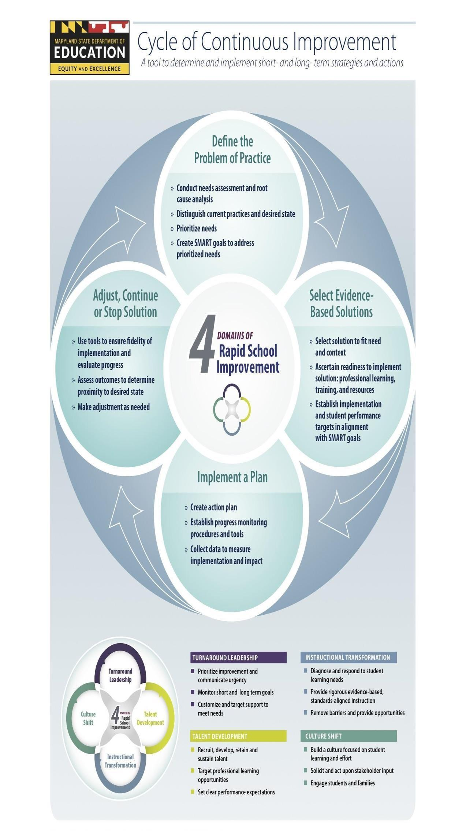
Graphic developed for the Maryland State Department of Education by Mid-Atlantic Comprehensive Center at WestEd

ADDITIONAL SUPPORT AND RESOURCES FOR TSI SCHOOLS AND LOCAL SCHOOL SYSTEMS

MSDE will identify and share resources with TSI schools and LEAs that include:
- Access to the Maryland School Improvement Resource Hub. This electronic portal provides a variety of information and tools for school improvement including, but not limited to:
  - Cycle of Continuous Improvement;
  - Evidence-Based Interventions;
  - Four Domains of Rapid School Improvement;
  - Needs Assessment, Root Cause Analysis an Action Plan Tools;
  - Communication Resources for School Improvement; and
  - MSDE Curriculum Vetting.

- MSDE Professional Learning Opportunities to include:
  - Program Improvement Workshops and Presentations;
  - Content Specific Professional Learning;
  - Regional Presentations for Local School Systems;
  - Collaborative Learning Experiences with LEA Staff;
  - Specialized EL-Focused Instructional Strategies on Working with Culturally and Linguistically Diverse Populations;
  - Materials and Training for Parent and Family Engagement;
  - Differentiated Technical Assistance (TA) Supported by Inclusive Professional Learning (e.g., Special and General Educators, IEP Chairs, Related Service Providers, School Administration), with Coaching;
  - Accountability Resources and Tools to Develop, Implement, and Evaluate Standards-Aligned Individualized Education Programs (IEPs) for Specially Designed Instruction; and
  - Braiding of Federal Funds to Support Local Implementation of Specially Designed Instruction.

The contents of this document reflect the Maryland Every Student Succeeds Act (ESSA) Consolidated State Plan (pages 41-48).

J. FISCAL GUIDANCE
Resources:
- Supplement not Supplant Non-Regulatory Guidance
- Within-District Allocations Non-Regulatory Guidance (Draft for Public Comment)
- Electronic Code of Federal Regulations

Component | Guiding Questions
J. Fiscal | - Does the LEA have written job descriptions on file with Human Resources that accurately reflect the duties of administrative personnel charged to Title I?  - Does the LEA have a written procedure for reporting time and effort, maintaining Personnel Activity Reports? Who reviews them? How often are adjustments made to actual distribution?  - How does the LEA determine if school purchases made with Title I funds are allocable and allowable, reasonable and necessary and that they supplement, not supplant?  - How often are expenditures monitored by the LEA? Who monitors the expenditures?  - How does the LEA monitor inventoried equipment, including location of equipment and use (Schoolwide Programs, Targeted Assistance Schools and private schools)?  - How does the LEA monitor the required reservations? (spend down of expenses and usage)  - How does the Title I Office collaborate with the Finance Department to make certain that findings in areas such as personnel, time and effort, inventory, written financial procedures, and written procurement procedures are shared?  - How does the Title I Office ensure that Title I School Spending Plans (school allocations and parent involvement) comply with federal requirements and regulations?  - How does the Title I Office maintain documentation to support purchases that are reasonable and necessary and are supplemental and not supplanting?  - Does the Title I office process budget/program amendments according to MSDE guidelines?  - Are schools and central office following the LEA procurement procedures/policies?

Webinar Questions and Answers
- Is the expectation that the LEA does the detailed budget for each school or central initiatives? For larger districts, the detailed budget description explained during the webinar will be a cumbersome task for a LEA with a large number of Title I schools. What differentiated support will be provided for a LEA with more than 50 schools?
Answer: It is the expectation that the detailed budget description guidelines are used for any table that contains this column. The detailed budget description guidelines apply to tables 7-8, 7-9.1, 7-9.2, 7-9.3, 7-9.4 and the TSI District-level Set Aside table, all which contain the detailed budget description column.

It is the expectation that the detailed budget description guidelines are used for any table that contains this column. The detailed budget description guidelines apply to tables 7-8, 7-9.1, 7-9.2, 7-9.3, 7-9.4 and the TSI District-level Set Aside table, all which contain this column. If customized or differentiated support is needed by a LEA for any reason, including the number of schools serviced, they should contact their POC for technical assistance and/or submit their need for consideration for the upcoming PLC meetings, where “alike” LEAs are grouped together for collaboration. LEAs may submit a sample detailed budget description for review to their POC prior to Application submission for review and feedback.

- The MSDE is really focusing on necessary, reasonable, allowable and allocable. What should our documentation look like? What is MSDE looking for from us to show that the LEAs are assessing these factors? Does every single expenditure need to have supporting documentation along with it? What is the plan?
Answer: Fiscal responsibility is a critical part of the Title I, Part A grant program. The new required attachment number 8 requires the LEAs to include a written process for documenting and monitoring the school-level use of Title I funds and Title I funded positions, including:
- School-level Fiscal responsibility
- Approval of school-level expenditures that are reasonable, necessary, allowable, and allocable
- Appropriate use of school-level Title I funded positions based on approved job descriptions
- Roles and responsibilities of paraeducators
This required attachment aligns with assurance one in the application, which states: The LEA ensures that all Title I, Part A expenditures are aligned with the Federal Cost Principles (reasonable, necessary, allowable, and allocable), including the use of school-level Title I funds and all Title I funded positions.

Evidence of Implementation for this assurance includes:
Documentation supporting the implementation of the written process, which must include:
- Systems and structures for monitoring and approving school-level fiscal responsibility
- Systems and structures for monitoring and approving school-level expenditures that are reasonable, necessary, allowable, and allocable
- LEA monitoring of the appropriate use of school-level Title I funded positions based on approved job descriptions
- LEA monitoring of the appropriate use of Title I funded paraeducators, including roles and responsibilities.
- Other documentation to support the LEA has implemented its written process, if applicable.
Each LEA should have documentation available to support that they have implemented their written process for approving and monitoring of school-level expenditures.

Detailed Budget Description
Detailed Budget Description Guidelines
- The detailed budget description guidelines apply to tables 7-8, 7-9.1, 7-9.2, 7-9.3, 7-9.4 and the TSI District-level Set Aside table, all which contain this column.
- The detailed budget description column, must include:
  - Identification of the Specific Line Item (i.e. what is being purchased?)
  - Description
    - Description of the proposed expenditure, which must include details such as number of hours, hourly rate, number of people, and/or frequency and duration of services
    - Provide a brief, budget description that explains how the funds will be used to support each activity.
    - Amounts including how, where, and for what purpose funds were reserved
- The calculation column must include a calculation for the proposed expenditures, include a cost breakdown.
- The total column must include a total for the proposed expenditure based details shared in the calculation column. It must align directly with the calculation (i.e. the calculation must yield this total).
Detailed Budget Description Example
Detailed Budget Description | Calculation | Total
Workshop stipends: $125/day stipend for Facilitators at Four Regional Meetings with Four Breakout sessions at each meeting (16 facilitators total).  Duration of services:  6 hours per day throughout the 2021-2022 school year  Facilitators will facilitate Parent and Family Engagement Capacity Building events at Regional Workshops | $125/day stipend X 4 regional meetings X 4 facilitators at each meeting | $2,000.00
Substitute stipends: $100/reading intervention workshop stipends for Five (5) substitute teachers at each of eight (8) quarterly reading intervention workshops  Duration of services:  6-hour reading intervention workshops throughout the 2021-2022 school year. | $100/reading intervention workshop X Five (5) substitute teachers x eight (8) quarterly workshops | $4,000.00
Instructional supplies for math initiative (academic manipulatives, scissors, paper, markers, folders, etc.) in Title I classrooms | Estimated costs include:  50 scissors x $1.00= $50.00  20 pack of manipulatives x $5.00=$100.00  50 packs of markers x $3.00= $150.00  50 folders x $1.00=$50.00  Approx. $350 for 60 schools | $21,000
Title I Supervisor  To ensure compliance with Title I, Part A grant. Oversee Title I office staff. | 1.0 FTE Mid-level Salary | $85,000
Fixed Charges for Title I Supervisor - FICA, Worker’s Comp, Retirement, and Health | 1.0 FTE Fixed Charges | $33,000
Technology - Materials and Supplies to replace old, obsolete Chromebooks in the Central Office | Replacement of computer or laptop for Title I Central Office staff. 1 laptop X 1,000= 1,000 | $1,000
Office Supplies for Title I Central Office | Various office supplies to support the Title I Central Office staff employees and activities.  FedEx cost for MSDE mailings. $25 per mailing X 8 reports/ amendments= $200  Materials include :  2 cases of copier paper $100,  25 pack of pens @ 3.00 each = $75.00  10 pack poster board @ $20.00 = $200.00  $475 | $475
Conferences/Professional Learning  8 Classroom teachers and 2 Title I tutors to participate in one two-day professional development conference that increases the capacity of teachers in the area of academic need of Title I students for approximately 10 teachers at $400 each to cover registration, meals and mileage.  Duration of services:  Two-day professional development conference in February 2021 | Number of staff attending; registration, hotel, transportation; mileage, and meals  8 classroom teachers + 2 Title I tutors x $400 each  Registration = $200  Hotel = $100 per night (one night each)  Mileage and meals = $100 (0.575/mile and meals at approved per diem rate) | $4,000
Contracted Services/Consultant/Vendors  Social Emotional Learning Programming  11 Title I schools identified in their Comprehensive Needs Assessment additional supports and techniques were needed in the area of social-emotional learning. These 11 schools will receive focused instruction directed toward mindfulness, self-regulation, and breathing techniques through the SEL Program. Evidence based research finds that a social emotional learning practice decreases stress and anxiety, increases attention, improves interpersonal relationships, strengthens compassion, and many other benefits. | Planning with Schools: 2 hours per school x 11 schools = 22 hours x $70/hour = $1,540  Sessions: 24 hours a week x $70/hour = $1,680 x 16 weeks = $26,880  Total = $28,420 | $28,420

Federal Cost Principles
Maryland State Department of Education Guidelines for Decision-making about Title I Expenditures
Requirements for grantees
- Responsibility for the efficient and effective administration through the application of sound management practices;
- Responsibility for administering an award in a manner consistent with underlying agreements, program objectives, and the terms and conditions; and
- Responsibility for employing sound organization and management techniques to assure proper and efficient administration
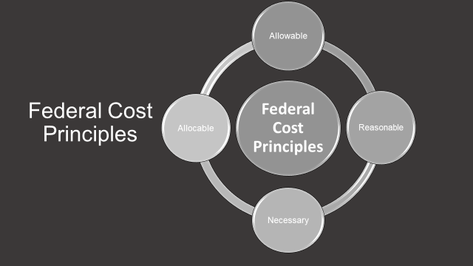
LEA and school leaders are responsible for managing, and documenting the uses of these funds so all expenditures are made in accordance with the same laws, regulations, and guidance. Before consulting the Cost Principles list, it is important to understand that all other fiscal provisions under ESSA must be met. Those details are discussed in the forthcoming fiscal guidance document.
Additional principles must be applied when determining if a cost can be charged to a Title I program budget. LEAs must determine if the cost is reasonable, necessary, allowable and allocable.
Allowable Cost Principle
General Considerations in Determining Allowability:
- Is the cost reasonable and necessary for the program?
- Is the expense in compliance with laws, regulations and grant terms?
- To what extent is the expense allocable to the grant?
- Is the cost adequately documented?
- Is it consistent with guidance that applies to federally funded activities?
Necessary Cost Principle
- Necessary costs are those costs that are essential to accomplish the objectives of the grant project. All items requested must be allowable expenditures under the authorizing program statutes, regulations, and rules.
- Funds must first be allowable under Title I, Part A statute.
- All goods must be received and all services must be provided or delivered in time to benefit substantially the population being served in the current grant period.
- Is the purchase required to carry out the intent and purpose of the Title I, Part A program?
- Is the purchase needed to carry out the program properly?
Reasonable Cost Principle
A cost is reasonable if, in its nature and amount, it does not exceed that which would be incurred by a prudent person under the circumstances prevailing at the time the decision was made to incur the cost.
- Consideration: Do sound, reasonable practices support the expenditure?
- Is the purchase consistent with sensible/wise/prudent business practices and of comparable current market value?
- Reasonableness must also take into account the quantity of an item to be purchased.
Allocable Cost Principle
- Allocable means the good or service can be assigned to an award or cost objective in accordance with the relative benefit achieved.
- Is the expenditure chargeable or assignable in accordance with the relative benefits received?
  - For example, there should be evidence that a Resource Teacher who is budgeted at 75% time is providing 75% of her time conducting Title I instruction related duties.
- If a cost benefits two or more projects, activities, or programs in proportions that can be determined without undue effort or cost, the cost should be allocated to the projects based on the proportional benefit.
- Expenditures should be aligned with generally accepted accounting principles (GAAP), adequately documented, and budgeted within the LEA grant.
Management of Your Title I Budget: The Why of Title I Spending Decisions
When considering whether Title I, Part A funds are allowable and can be approved for use at the LEA level or in schools, Local Title I Directors, in collaboration with other relevant staff, (e.g., Fiscal officers, HR staff,) should also ask—
- How are expenditures aligned with relevant Title I, Part A applications and plans (e.g., the LEA’s Annual LECS Plan Application, Schoolwide Program Plans, Targeted Assistance Program Plans)?
  - Whether for a district initiative or school activity, costs must be aligned with approved activities in the Title I, Part A Annual Application. Remember, when monitoring local Title I, Part A programs, Federal auditors and State staff regularly review the Title I, Part A Application to assess whether budget expenditures align with approved activities. So, LEA staff should be prepared to explain how spending aligns with the LEA and each school’s Title I, Part A plan.
- Regarding both Schoolwide and Targeted Assistance Program budget items, expenses must be aligned with the findings of the school’s needs assessment. Auditors review plans for both kinds of Title I programs to ensure costs charged for Title I, Part A activities align with the needs identified in the school’s approved plan. If they do not, charges may not be allowed.
- Do not forget to align program and budget to outcomes. Title I Directors should plan for how expenditures, especially for interventions and strategies, will be evaluated to measure impact on student achievement.
If you need to discuss these principles or the approval of specific expenditures listed in the attached Guide, please contact your MSDE Title I Point-of-Contact.

Supplement not Supplant (Section 1118(b)(1))
Supplement not Supplant Non-Regulatory Guidance
As shared in the non-regulatory guidance, “in order to comply, a school district need only show that its methodology to allocate State and local resources to schools does not consider a school’s Title I status—for example, by using a weighted student funding formula. For many school districts, this requirement can be met using the school district’s current methodology for allocating State and local resources. This change will help foster more effective spending across all funding sources. No longer should any school district feel pressure to use Title I funds on only those items or services that seem “extra” in an effort to reduce audit risk. Instead, every school district can effectively use its Title I funds as part of a comprehensive system of support that spans multiple funding sources in order to help the students most in need.”
Key Points of Supplement Not Supplant:
- The LEA must allocate State and local funds to schools using a methodology that is Title I neutral, meaning State and local funds are allocated without regard for Title I status.
- The LEA’s allocation of State and local funds is examined as a whole to ensure that Title I, Part A funds supplement, and do not supplant, State and local funds.
- Each Title I school must receive all of the State and local funds it would otherwise receive if it were not receiving Title I, Part A funds.
- A title I neutral methodology demonstrates that a LEA did not reduce the State and local funds made available to a Title I school because the school is also receiving Title I, Part A funds.
- Section 1118(B)(3)(A) previously applied only to a schoolwide program school; however, it now applies to ALL Title I schools, including targeted assistance schools.
- Title I neutral describes an allocation methodology that allocates State and local funds to schools without regard for a school’s Title I status.
- If a LEA is using a weighted PPA methodology, the methodology should not use a “proxy for Title I status such as a school’s number of percentage of student in poverty or vague terms such as “educational need” that would result in Title I schools receiving fewer State or local funds that it would receive if it were a non-Title I school.”
- A LEA may exclude from a supplanting determination the supplemental State and local funds for programs that meet the intent and purposes of Title I, Part A, pursuant to ESEA section 1118(d). This allows a LEA to take a school’s Title I status into account if allocating to schools supplemental State and local funds for programs that meet the intent and purposes of Title I, Part A, as permitted by the exclusion.
- A LEA may not use actual per-pupil expenditures data to demonstrate compliance with supplement not supplant. The compliance demonstration for the supplement not supplant requirement is based on the methodology by which State and local funds are allocated to schools.
- The MSDE does not approve the methodology of a LEA. The MSDE will review to ensure the methodology is Title I neutral. The MSDE does have the responsibility to monitor and ensure compliance by seeking evidence of implementation of a Title I neutral methodology.
- Title I, Part A funds must only be used for allowable activities given that no LEA may be required to demonstrate that individual costs are supplemental.
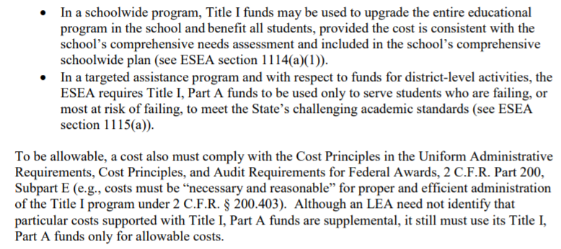
Supplement not Supplant - Special Rule
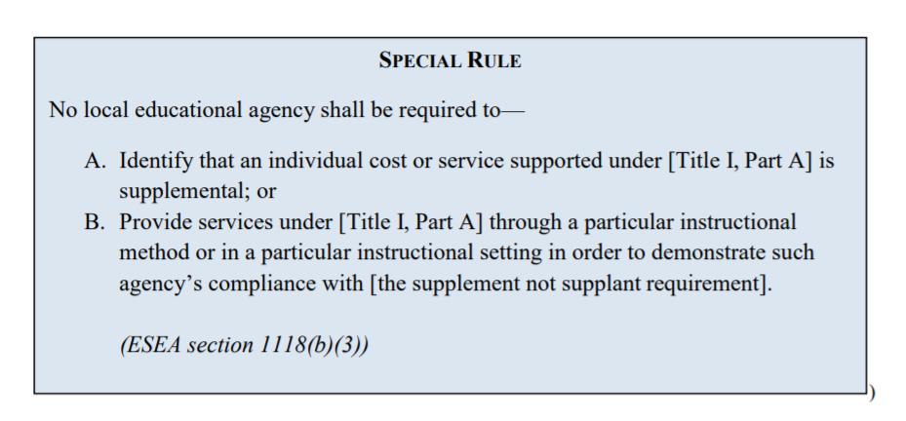
Supplement Not Supplant - Methodology Examples
Methodology Example #1 - from the Non-Regulatory Guidance
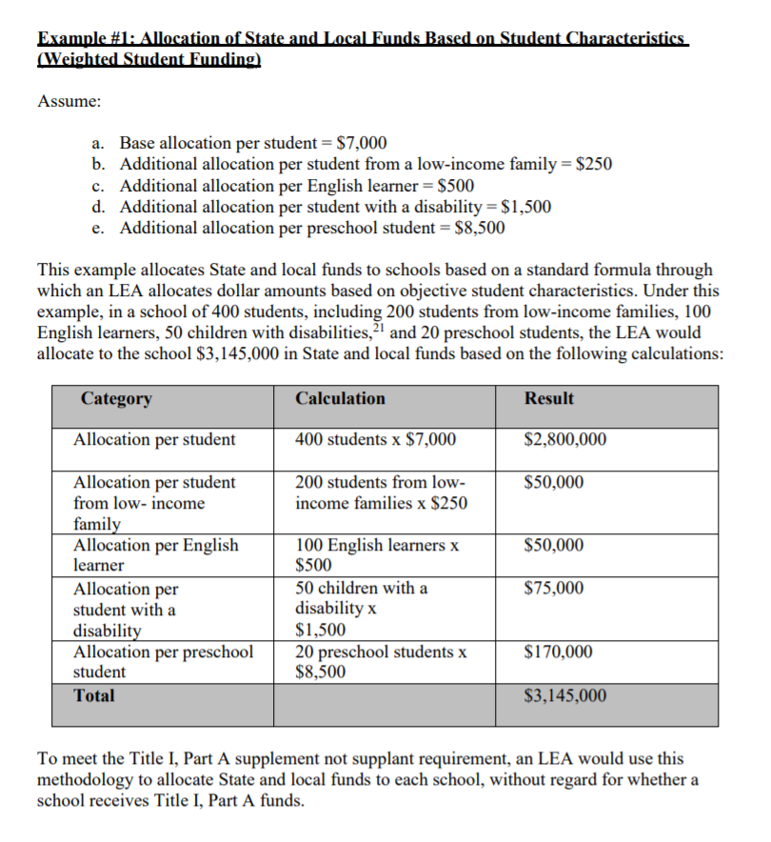

Methodology Example #2 - from the Non-Regulatory Guidance
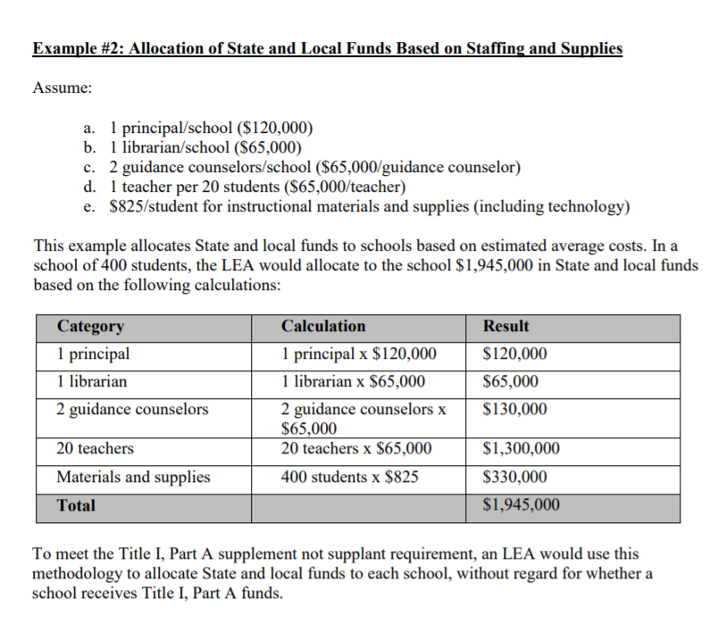

Fiscal Tables Instructions and Guidance
Allocation Worksheet
The Allocation Worksheet and Instructions had minor changes due to ESSA. The dates have been updated for 2021-2022 Title I Application. These should be completed as in past years. The formulas to calculate are the same and should not be changed/removed.
Directions for the Completion of the Excel Title I Allocation Worksheet
- Fill in the LEA name and submission date in the upper left hand corner of the Worksheet.
- Notations: First column place an N for schools NEW to Title I; S if the school is Skipped (must have prior State approval); and C for Charter School. The Priority and Focus School Notations have been removed. Please use CSI or TSI for schools designated as such. Leave blank if none of the above.
- Notations: Second column designate SW for Schoolwide or TAS for Targeted Assistance School.
- Column D: Report MSDE official school ID number for each school. This number can be found on MSDE’s www.mdreportcard.org. Please report the 4-digit number (including leading "0s").
- Column E: List the Title I public schools (use the official school name) in rank order by Percent of Poverty. Approved Skipped Schools must appear on the allocation worksheet and complete Columns: D, E, F, G, H, I, J (if CEP), N, O, and P.
- Column F: Report the specific (numeric) grade levels served in the school.
- Column G: Designate Y for CEP School or N for Non-CEP School.
- Column H: Report the 9/30/19 official public school enrollment number.
- Column I: Report the 10/31/19 official number of low income public school children (free/reduced or free lunch or CEP as calculated in column K and based on the data source indicated in Table 7-1) Note: if the CEP school's number in (K) is greater than the school's total enrollment (H), enter the total enrollment number in Column I for the number of low income public school children. (Do not round up). If using a different poverty metric please notify your MSDE POC. If you choose to use Direct Certification only and not use the multiplier (only available for LEAs where all schools are CEP) then use the number in column J to populate Column I.
- Column J: Report the official number of CEP Direct Certification Children (as of 10/31/17) for CEP schools. For Non-CEP, schools put N/A.
- Column K: Automatic calculation: of CEP children in column J multiplied by the 1.6 multiplier. Enter in column I, however if greater than column H then enter the number in column H into column I. (Do not round up)
- Column L: Report the FTE for low-income public school children. (For any approved Skipped School enter 0 in column L)
- Reminder: Count 1/2 day Pre-K children as .5 FTE. Count should be the Low Income students. The LEA will need to provide documentation regarding the count for Low Income Pre-K as the MSDE does not have those data.
- Column M: The Percent of Poverty for each school in rank order based on the calculation of columns I/H. If several schools rank the same percent of poverty, within that range sort by the total number of poverty students (when using FARMS data) and the percentage of Direct Certification when ranking using the 1.6 multiplier in CEP schools.
- Column N: Report the number for low-income private school children residing in the Title I school attendance area (Including the private school children residing in any approved Skipped School attendance area. Private school children who reside in this attendance area and are from low-income families generate Title I funds.
- Column O: Report the FTE for low-income private school children residing in the Title I school attendance area. Reminder: Count 1/2 day Pre-K children as .5 FTE. The LEA will need to provide documentation regarding the count for Low Income Pre-K as the MSDE does not have those data.
- Column P: Provide per pupil allocation, PPA may be the same for all schools or different amounts but must be descending order. (Approved Skipped Schools must provide the same PPA for private school children as calculated in the skipped school allocation worksheet where the public school received a PPA with local compensatory funding).*
- Column Q: Automatic calculation of the school's Title I allocation. Complete the chart – Excel will automatically do the calculations for columns K, M, and Q. The totals from Q must equal Line 7 in Table 7-10. Do not alter or override formula columns.
- If there is a need to insert additional rows, be sure to copy all formulas into new cells, as appropriate.
- Contact your local Excel expert for additional help.

* Under 34 C.F.R. 200.78(c), a LEA is not required to allocate the same per-pupil amount to each participating school. If the LEA allocates different PPAs to participating schools, the LEA must allocate a higher PPA to schools with higher poverty rates that it allocates to schools with lower poverty rates. The LEA has the option to determine allocations within grade spans (see page 13, table 7 in the non-regulatory guidance). This includes the flexibility not to serve a grade span. A LEA may use its flexibility to allocate a higher PPA to one grade span over another. This is allowable, per the non-regulatory guidance (page 14) because when a LEA allocates Title I funds by grade span, rules such as 34 C.F.R. 200.78 apply within each grade span, not across grade spans (34 C.F.R. 200.78(a)(3).

Removed Title I Schools

Table 7-1 and 7-2
Directions:
These tables are all on the same tab in the tool. The guidance has changed in the application by the following addition: Note: Because census data are generally not available at the school level, if an LEA uses this measure, it would most likely be part of a composite with one or more of the above measures. Counted by the LEA using a composite of any of the above measures. Please place an X for the appropriate data sources for both Public and Private School children for determining Title I Eligibility in tables 7-1. For table 7-2, please place an X to indicate which method the school system is using to qualify attendance areas.
Guidance:
Table 7-1
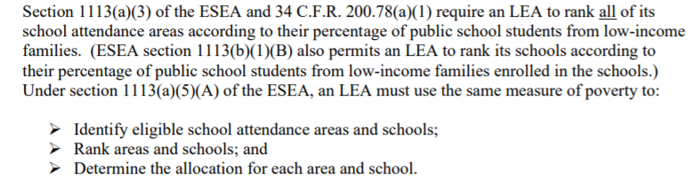

Table 7-2
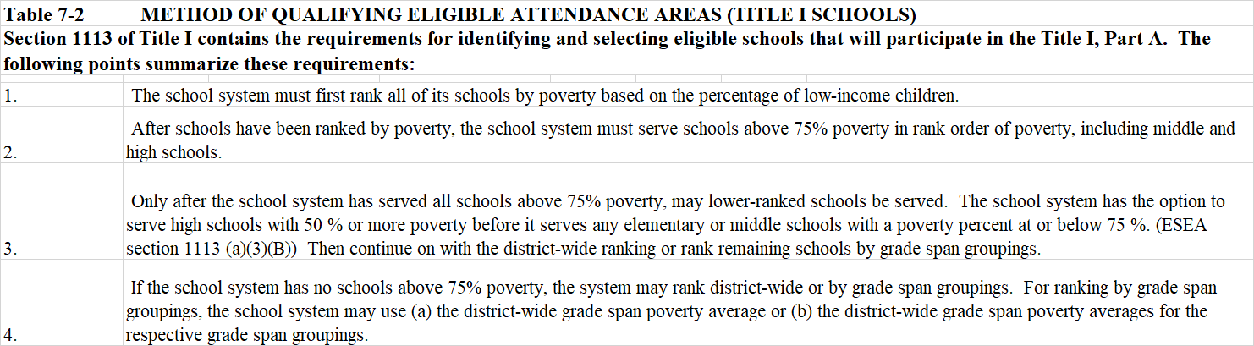
Table 7-3, 7-4, and 7-5
Directions:
These tables are all on the same tab in the tool and the guidance remains the same. In Table 7-3 please provide the counts as described to calculate the district wide percentage of low income children in the LEA. Remember that PreK children are counted as one child. In Table 7-4, please provide the counts as described to calculate the grade span percentage of low-income children in the LEA. In Table 7-5, where applicable, LEA's serving schools below 35% District Wide poverty (125% rule) should provide the allocation and counts as described to provide the minimum per pupil allocation.
Guidance:
Table 7-3
The LEA may rank schools using the district wide poverty average or the district-wide grade span poverty averages for the respective grade span groupings. Based on the data source(s) noted in Table 7-1, CALCULATE the district-wide average of low-income children below. Use the official number of students approved for FARM as of October 31, 2019 to complete this table along with the September 30, 2019 enrollment data.
Per the non-regulatory guidance (p. 8), meeting the eligibility criteria does not guarantee that a school will receive Title I funds from its LEA.
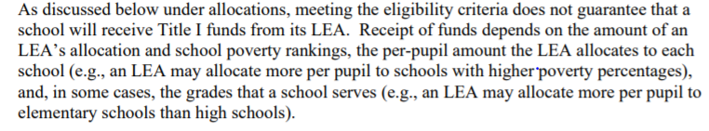
Based on rank order, schools fall into three categories:
- Eligible and served
- Eligible and not served
- Ineligible
The non-regulatory guidance (pages 6 through 14) has step-by-step detailed examples with information about determining eligibility.
Before a LEA can decide how to determine eligibility for any school with a poverty percentage below 75 percent, it must allocate funds to all schools above 75 percent poverty. After funds are allocated to schools above 75 percent poverty, LEA have several options to distribute funds, as outlined below.
Table 7-4
DISTRICT-WIDE GRADE SPAN POVERTY AVERAGES OF LOW INCOME CHILDREN BY GRADE SPAN GROUPINGS: Grade span groupings are determined by how the school system organizes its schools. For example, if the district has elementary schools serving grades PreK-5, middle schools serving grades 6-8, and high schools serving grades 9-12, the grade span groupings would be the same. To the extent a school system has schools that overlap grade spans (e.g. Prek-6, K-8, 6-9) the school system may include a school in the grade span in which it is most appropriate. Based on the data source(s) noted in Table 7-1 and the district wide average in Table 7-3 INDICATE below the district-wide grade span poverty averages for each grade span groupings.

Per the non-regulatory guidance (p. 9):
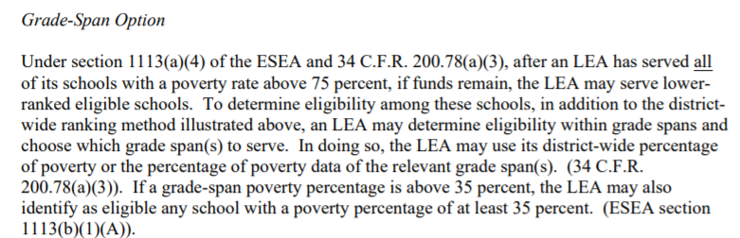

Under 34 C.F.R. 200.78(c), a LEA is not required to allocate the same per-pupil amount to each participating school. If the LEA allocates different PPAs to participating schools, the LEA must allocate a higher PPA to schools with higher poverty rates that it allocates to schools with lower poverty rates. The LEA has the option to determine allocations within grade spans (see page 13, table 7 in the non-regulatory guidance). This includes the flexibility not to serve a grade span. A LEA may use its flexibility to allocate a higher PPA to one grade span over another. This is allowable, per the non-regulatory guidance (page 14) because when a LEA allocates Title I funds by grade span, rules such as 34 C.F.R. 200.78 apply within each grade span, not across grade spans (34 C.F.R. 200.78(a)(3).
Table 7-5
CALCULATING THE MINIMUM ALLOCATION-- FOR SCHOOL SYSTEMS THAT SERVE SCHOOLS BELOW 35% DISTRICT -WIDE POVERTY (125% RULE)
“125 percent rule”: If an LEA serves any school below 35 percent poverty, section 1113(c)(2)(A) of the ESEA requires the LEA to allocate an amount for each low-income child in each participating Title I school that is at least 125 percent of the LEA’s allocation per low-income child, except that the per-pupil amount for the served school with the lowest poverty rate may be less due to the amount of funds remaining.
The non-regulatory guidance provides a detailed example on pages 14 and 15 of how the 125% should be used if a LEA serves any school below 35 percent poverty.
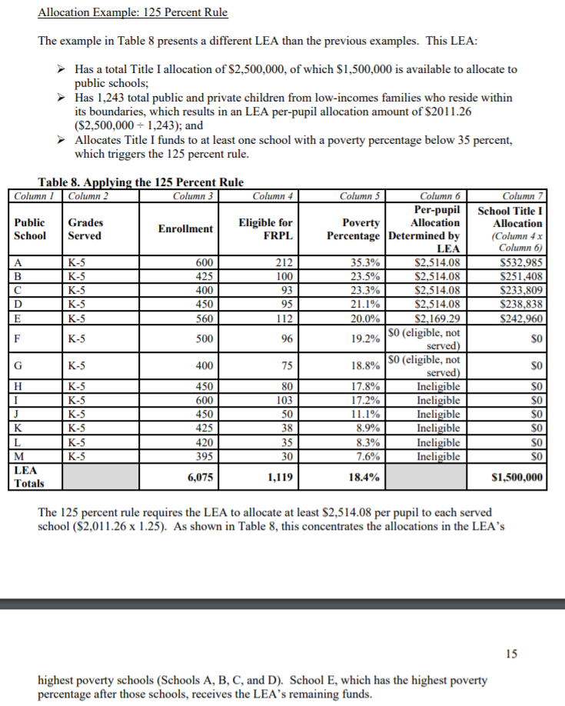
Table 7-6.1, 7-6.2, and 7-6.3
Directions:
These tables are all on the same tab in the tool and the guidance remains the same. In Table 7-6.1, please list the schools that meet the eligibility requirements for Continued Eligibility based on Section 1113(b)(1)(C) that the LEA would like to serve. In Table 7-6.2, please list the eligible high schools the LEA would like to serve and include in the ranking of schools based on Section 1113(a)(3)(B). If applicable, in Table 7-6.3, list the Charter Schools that the LEA is choosing to serve under this exception. The LEA must determine such a school’s Title I allocation based on current year data and provide the school its allocation within five months of the school’s opening or expansion. (ESEA section 4306(a); 34 C.F.R. 76.792(a)).
Guidance:
Continued Eligibility - Grandfather Clause
As shared on page 16 of the non-regulatory guidance, it states:
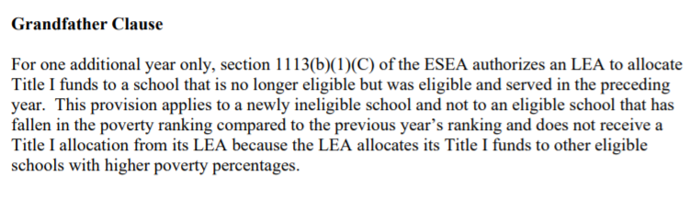
Note that the Continued Eligibility Provision or Grandfather Clause applies to schools that are ineligible (in contrast to schools that are eligible and not served). See the detailed examples regarding eligibility in the non-regulatory guidance for more information.
Option for Certain High Schools
After serving all schools above 75 percent poverty, if funds remain, a LEA may choose to serve high schools with a poverty percentage between 50 and 75 percent in rank order of poverty. Note, per the non-regulatory guidance, the implementation of this option occurs before serving any other grade span.
New Charter School - Data Exception
As shared on pages 5 and 6 of the non-regulatory guidance, it states:
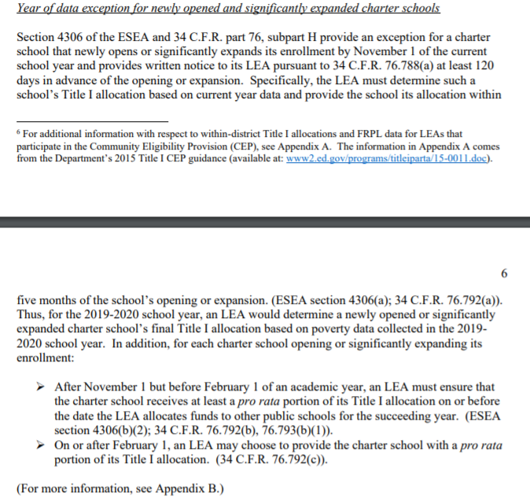
Table 7-7 (including Skipped Schools Addendum and Skipped Schools Allocation Worksheet)
Directions:
In Table 7-7, please provide the number of schools that the LEA intends to skip based on Section 1113(b)(1)(D). The school(s) must meet the qualifying conditions shown on the tab, as well as provide a copy of the approved request letter. The LEA must include a completed Skipped School Addendum and a Skipped School Allocation Worksheet, which are on the tabs that follow tab 7-7 Skipped Schools.
The Skipped School Addendum can be found here.
Guidance:
In reference to the additional allocation flexibilities provided by ESSA, the non-regulatory guidance also discusses information related to the Skipped School Provision on pages 15 and 16. NOTE: if a LEA skips a school under section 1113(b)(1)(D), the LEA is still required to use Title I funds to provide equitable services to eligible students who reside in the attendance area of the skipped school (Section 1113(b)(2)).
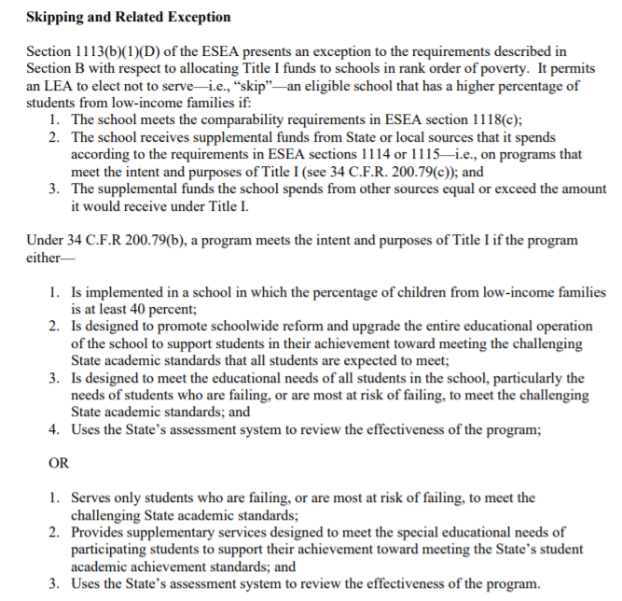
Table 7-8 - Equitable Services
Directions:
In Table 7-8, complete the worksheet to identify monies allocated for equitable services to private school participants, their families, and their teachers (see Section 1117(a) of ESSA and Sec 200.64 & 200.65 in 34CFR). The formulas should not be changed. Totals will be pre-populated. Please also complete the budget table at the bottom of the worksheet to provide detail regarding spending of funds.
Guidance:
As shared on page 2 of the non-regulatory guidance, it states:
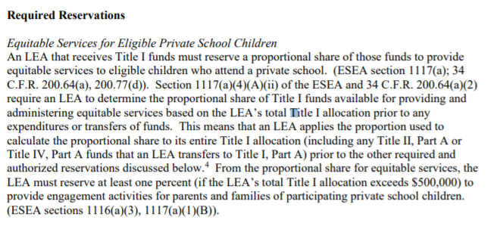
Table 7-9 - LEA Reservations from Title I Allocations
Table 7-9.1 - Mandatory Set-asides
Directions:
In Table 7-9.1 provide (calculate) the amount of funds the district will reserve from the Title I allocation for required (mandatory) and authorized activities. Provide a brief budget description that explains how the reserved Title I funds will be used to support each activity. All fixed charges and fringe benefits must accompany the salaries and wages on whatever line they might appear in Table 7-9. The formulas should not be changed. Totals will be pre-populated. All of the categories on this tab are mandatory set-asides except for the Equitable Services, which was calculated in Table 7-8.
Table 7-9.2 Districtwide Initiatives
Directions:
In Table 7-9.2 provide (calculate) the amount of reservations the district will set-aside from the Title I allocation for District-wide activities authorized by ESEA. LEAs may reserve funds for district wide instructional and professional development programs. Provide a brief budget description that explains how the reserved Title I funds will be used to support each district-wide activity. All fixed charges and fringe benefits must accompany the salaries and wages on whatever line they might appear in Table 7-9. The formulas should not be changed. Totals will be pre-populated. The categories for District-wide include Instructional and Professional Development.

Table 7-9.3 Administration
Directions:
In Table 7-9.3 provide (calculate) the amount of reservations the district will set-aside from the Title I allocation for administration as authorized by ESEA. Provide a brief budget description that explains how the reserved Title I funds will be used to support the Administration reservation. All fixed charges and fringe benefits must accompany the salaries and wages on whatever line they might appear in Table 7-9. The formulas should not be changed. Totals will be pre-populated. The categories for Administration categories include management and staff.
Table 7-9.4 Low Performing School Support
Directions:
In Table 7-9.4 provide (calculate) the amount of any additional funds (OPTIONAL) the district may set-aside from the Title I allocation for Comprehensive Support and Improvement (CSI) Schools or Targeted Support and Improvement (TSI) School as authorized by ESEA. If applicable, attach the Required Attachment with a detailed bulleted budget description of how the reserved Title I funds will be used to support each school. All fixed charges and fringe benefits must accompany the salaries and wages on whatever line they might appear in Table 7-9. The formulas should not be changed. Totals will be pre-populated.
Table 7-9 Guidance (pertains to 7-9.1, 7-9.2, 7-9.3, and 7-9.4):
Mandatory Set-asides include:
- Table 7-8: Proportional Share for Equitable Services
- Table 7-9.1:
  - Parent and Family Engagement
  - Services to Neglected Children
  - Education of Homeless Children and Youth - Educationally Related Support Services
Additional Optional Set-asides and Authorized Reservations include:
- Table 7-9.1:
  - Education of Homeless Children and Youth - Homeless Liaison
  - Education of Homeless Children and Youth - Transportation
  - Education for Foster Children - Transportation
- Table 7-9.2:
  - District-wide Instructional Programs
  - District-wide Professional Development
- Table 7-9.3:
  - Administration
- Table 7-9.4:
  - LEA Reservations for CSI and Title I TSI Schools from Title I Allocation
The 7-9.1 includes required reservations as defined on pages 2 and 3 of the non-regulatory guidance. The non-regulatory guidance also includes information on additional authorized reservations that a LEA may reserve funds for. See pages 3 and 4 of the non-regulatory guidance for an example about reserving mandatory set aside funds. KEY POINT: Section 1113(C)(3)(B) of ESSA requires a LEA to base the mandatory set aside reservations on its total Title I allocation.
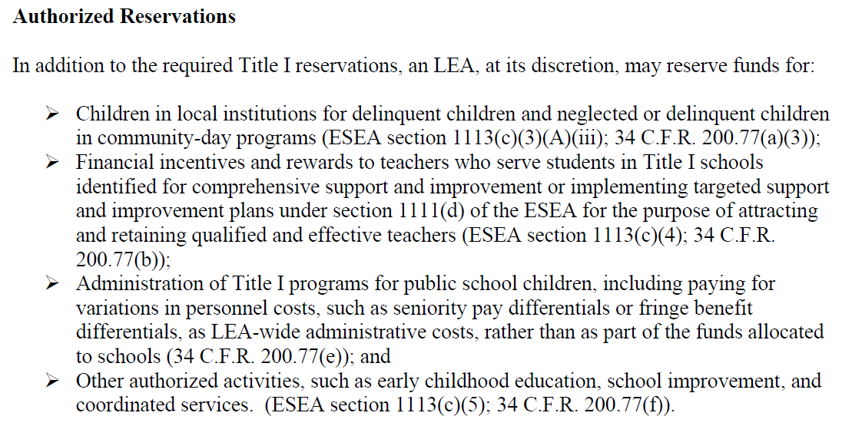
Example from the non-regulatory guidance
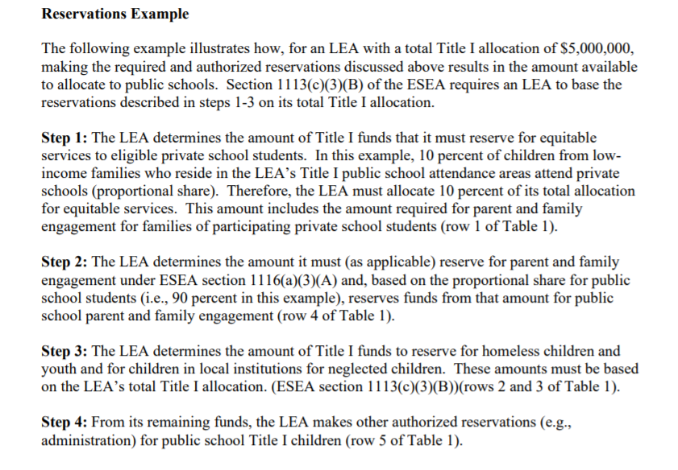
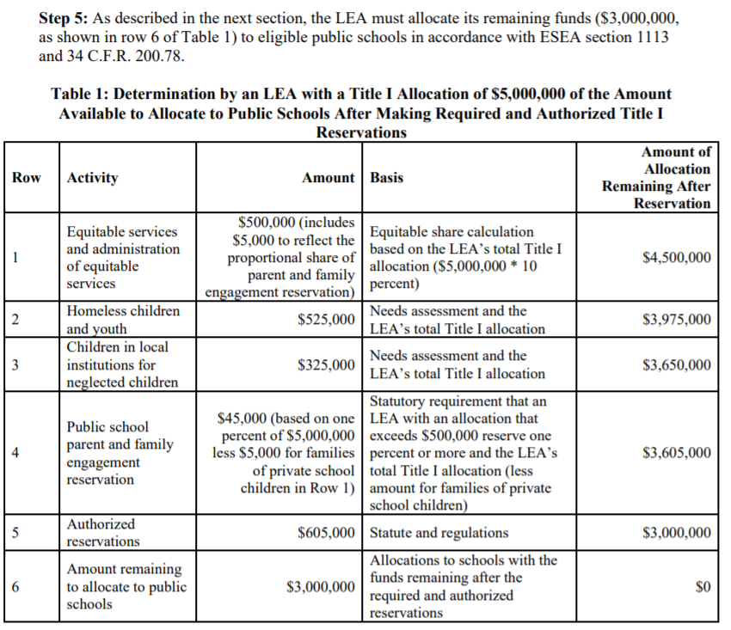
Table 7-10 Budget Summary
Directions:
In Table 7-10 provide (calculate) the amount of Per Pupil Allocation (PPA) the LEA will have remaining to provide to Title I Schools after the reservations have been subtracted. Totals will be pre-populated from earlier worksheets.
Table 7-11 Carryover Estimate
Directions:
In Table 7-11 provide (calculate) the estimated carryover. Section 1127(a) of ESEA permits a school system to carryover not more than 15% of Title I funds from one fiscal year to the next. The amount of carryover is calculated based on the initial 15-month expenditure period (e.g., July 1, 2020-September 30, 2021). The LEA needs to request a waiver if carryover will exceed 15%. An LEA may not request a waiver more than once every three years. The estimate is provided with the Title I Application.
C-1-25
Directions:
The LEA should complete the C-1-25 and provide it with the Title I Application. A signed hard copy should also be provided through the submission of the Local ESSA Consolidated Strategic Plan. The LEA may link the Budget Narrative up with the C-1-25 so that totals can be pre-populated. All categories and totals should align with the Budget Narrative.
Budget Narrative Template
Directions:
The LEA should complete a Budget Narrative for expenditures. School-level budget details should not be included in this submission. Please note that the tab following the Budget Narrative Template labeled "Category and Option Codes" provides codes needed to complete the budget narrative.
CSI 7% Set-Aside
Directions:
Provide the list of Comprehensive Support and Improvement (CSI) Schools and the amount of the allocation provided for each school as authorized by ESEA, if applicable. Totals will be pre-populated.
TSI District level Set Aside (Not Federal Funds)
Directions:
Provide the list of Targeted Support and Improvement (TSI) Schools and the amount of LEA set aside provided for each school as authorized by ESEA, if applicable. Totals will be pre-populated. These are not Title I funds.

Federal Cost Principles Chart
MSDE List of Allowable and Unallowable Title I Expenditures
This list is not all-inclusive and is subject to change.
For a comprehensive list of federal requirements, reference the Electronic Code of Federal Regulations. This information is an excerpt from EDGAR, Part E of Federal Uniform Grant Guidance, and Title I Allowable Expenditures Guidelines. For questions about State policies and procedures, you may contact the Title I Program Improvement and Family Support Office at title1.msde@maryland.gov.
Purchase | Allowable | Allowable with  Conditions | Unallowable
Advertising and Public Relations 200.421  Allowable for programmatic purposes including:  - Recruitment  - Procurement of goods  - Disposal of materials  - Program outreach  Allowable with Conditions:  - Public Relations (Communications informing parents of school achievement, programs, rules, etc.) | X | X
Advisory Councils 200.422  Costs incurred by advisory councils or committees |  |  | X
After School Programs/Clubs  If reasonable and necessary to meet the federal grant’s/SIP goals and objectives. |  | X
Alcohol beverages 200.423 |  |  | X
Alumni Activities 200.424 |  |  | X
Athletic Programs  Programs that require purchase of uniforms, equipment, uniforms or spirit wear for staff and/or students. |  |  | X
Audit Services 200.425  Audit fees and expenses are allowable only when the audit is required by and performed in accordance with the Single Audit Act Amendment of 1996 (31 U.S.C. 7501-7507). |  | X
Awards and Incentives for Recognition and/or  Participation  Certificates, plaques, ribbons, small trophies, or instructionally related items (bookmarks, pencils, etc.) connected to instructional strategies and classroom use are acceptable, if the cost is reasonable.  The following items may be donated by others but may not be purchased with Federal grant funds:  - Gifts (cash, gift cards, etc.)  - Souvenirs, memorabilia, or promotional items (T-shirts, caps, tote bags, etc.)  - Door prizes, movie tickets, gift certificates, passes to amusement parks, raffles, etc.  - Incentives/gifts/recognition (luncheon) for parents |  | X | X
Bad Debts 200.426  Bad debts (uncollectable debts), including losses (whether actual or estimated) arising from uncollectable accounts and other claims, are unallowable. Related collection costs, and related legal costs, arising from such debts after they have been determined to be uncollectable are also unallowable. |  |  | X
Cards  Bereavement or congratulatory cards, flowers and/or gifts |  |  | X
Cellular Telephones  A cellular telephone for personal use |  |  | X
Ceremonies, Commencements, Banquets or Celebrations 200.429  Costs associated with ceremonies, commencements banquets, entertainment, recreation, social events or celebrations |  |  | X
Collections of Improper Payments 200.428  Costs incurred to recover improper payments are allowable as either direct or indirect costs. Amounts collected may be used in accordance with cash management standards set forth in §200.305 Payment. | X
Compensation – Personal Services 200.430  See Code of Federal Regulations |  | X
Compensation – Fringe 200.431  See Code of Federal Regulations |  | X
Conferences 200.432  A meeting, retreat, seminar, symposium, workshop or event whose primary purpose is the dissemination of technical information and is necessary and reasonable to meet programs goals and objectives. Allowable conference costs paid by the entity as a sponsor or host of the conference may include rental of facilities, speakers' fees, costs of meals and refreshments, local transportation, and other items. As needed, the costs of identifying, but not providing, locally available dependent-care resources are allowable. |  | X
Conflict of Interest  Any purchase or expenditure that would pose a conflict of interest, either real or perceived |  |  | X
Consultants 200.459  You shall not use or pay to any consultant if the services to be rendered by such consultant could have been rendered by your employees.  If purchased, you must select consultants based on demonstrated competence, qualifications, and experience and on the reasonableness of the proposed fee. Document that you have researched at least 3 bids from comparable services. |  | X | X
Donations and Contributions 200.434  Donations/contributions including cash, services and property to other organizations, entities or to other units within the grantee organization |  |  | X
Employees  Incentives, recognition gifts or service awards  Salaries for core instructional staff  Salaries are allowable for staff that work directly with federal grant activities, goals and objectives. Time and effort reports are completed, maintained and submitted in accordance with federal cost principles.  Health and Welfare Costs 200.437 incurred in accordance with the entity's documented policies for the improvement of working conditions, employer-employee relations, employee health and employee performance. | X  X | X | X
Entertainment Costs 200.438  Costs of entertainment, including amusement, diversion, and social activities and any associated costs are unallowable. (Any exceptions require a programmatic purpose as well as written prior approval from the Federal awarding agency). |  |  | X
Facilities, Equipment and Other Capital Expenditures 200.439  Furniture/Appliances: Stoves, desks, chairs, refrigerators, microwaves, coffee makers, etc. (funds may be used to purchase furniture for Parent Resource Centers (PRCs) if reasonable and necessary to support goals of the center)  Maintenance: construction, repairs, remodeling, renovations, etc. are not allowed, unless specifically authorized in the program statute.*  Land Purchase/Improvements: purchase and improvements to land are not allowable costs, unless specifically authorized in the grant program statute and specifically approved in the grant application* |  |  | X  X*  X*
Family Engagement  Activities to support and develop family engagement  (activities that support learning at home and beyond). | X
Family/Parent training, educational services, academies  Workshops and academies such as tutoring, attendance, monitoring student performance, communicating with child’s teacher/school, understanding student agendas, supporting learning at home, child advocacy, etc. | X
Field Trips  If specified in the grant, educational field trips are allowable under certain circumstances:  - Learning experiences on trip are difficult to duplicate in a classroom setting.  - Learning experiences are meaningful and connected to learning standards.  - Cost of the trip is reasonable and accomplishes goals of the grant objectives.  - Lessons plans indicate pre and post-learning activities connected to the objectives of the trip and grant program.  - Documentation must be kept for audit purposes including: destination of trip, cost associated with trip, outcomes to be accomplished which are aligned with grant program, lesson plans and written approval from Title I Director.  - No over-night trips. No amusement or water parks. Trips taken during non-school periods require the approval of Risk Management. |  | X
Fines, Penalties, Damages and Other Settlements 200.441 |  |  | X
Food for staff activities  Food and beverages must be reasonable in cost and necessary to accomplish goals of grant program. Cost is limited to light working meals, as noted on meeting agenda, and is implemented to shorten the meeting time and to facilitate accomplishment of the grant objectives. The cost of the meal should not exceed $20 per attendee and documentation shows comparable costs with at least 3 sites and identifies positive impact on grant goals. |  | X
Food for parent and/or student activities  Food/beverages are allowable if the cost is necessary and reasonable and there is a connection to a programmatic purpose or successful performance of the federal grant. In addition, the following is allowable:  - Nutritional snacks for extended day/after school grant programs/activities.  - Nutritional snacks for children in child care while parents are participating in parent engagement grant activities.  - Food necessary to conduct nutrition education programs for families as outlined in grant goals.  - Grant activities in which snacks are necessary to encourage participation.  The following are unallowable:  - Full meals, exceeding $20 per individual  - Food not reasonable or necessary to meet the objectives of the grant program |  | X | X
Fundraising Activities 200.442  Costs of organized fund raising, including financial campaigns, endowment drives, solicitation of gifts and bequests, and similar expenses incurred to raise capital or obtain contributions are unallowable. |  |  | X
Gifts/gift cards |  |  | X
Graduation materials and activities |  |  | X
Homeless  Supplies, activities, transportation, etc. as outlined in  Sub-Grant |  | X
Instructional Materials/Programs/Supplies  Materials that supplement, have research to show a positive impact on student achievement, are necessary to meet goals and objectives of grant program.  Supplies necessary to support, enhance instructional program.  Licenses for software or curriculum programs are allowable if necessary to meet the above-mentioned requirements for instructional materials. |  | X  X  X
Insurance and Indemnification 200.447  Costs of insurance required or approved and maintained, pursuant to the Federal award, are allowable. | X
Lobbying 200.450  The cost of certain influencing activities associated with obtaining grants, contracts, cooperative agreements, or loans are an unallowable cost. |  |  | X
Lodging for In-State and Out of State Travel  Meeting, conference, training or professional development is necessary to carry out the grant program’s goals and objectives. |  | X
Office Supplies  Calendars to manage personal activities, lease/purchase of copiers, postage meters, other office equipment. |  |  | X
Mailings  Information to parents (invitations to parent engagement programs, programs, notifications and testing dates, newsletters) | X
Maintenance and Repair Costs 400.452  Costs incurred for utilities, insurance, security, necessary maintenance, janitorial services, repair, or upkeep of buildings and equipment (including Federal property unless otherwise provided for) which neither add to the permanent value of the property nor appreciably prolong its intended life, but keep it in an efficient operating condition, are allowable. | X
Materials and Supplies 200.453  Costs incurred for materials, supplies, and fabricated parts necessary to carry out a Federal award are allowable. | X
Memberships, Subscriptions and Professional Activity  Costs 200.454  - Costs of the non-Federal entity's membership in business, technical, and professional organizations  - Costs of the non-Federal entity's subscriptions to business, professional, and technical periodicals  - Costs of membership in any civic or community organization are allowable with prior approval by the Federal awarding agency or pass-through entity | X  X  X
Printing Costs  Printing costs (in black and white and color) are allowable when documentation demonstrates that they are reasonable and necessary to carry out the objectives of the grant program. Documentation must be maintained demonstrating that costs are reasonable and necessary. |  | X
Publication and Printing Costs 200.461  Publication costs for electronic and print media, including distribution, promotion, and general handling are allowable. If these costs are not identifiable with a particular cost objective, they should be allocated as indirect costs. | X
Registration Fee for Trainings, Meetings, Conferences or Professional Development  Must be necessary to carry out grant program’s goals and objectives. Follow policy for approval and reimbursement. |  | X
Professional Development  For a school wide program, the professional development must align with goals of the grant program | X
Security Costs 200.456  Necessary & reasonable expenses incurred for protection and security of facilities, personnel, and work products are allowable. Costs include, but are not limited to, wages and uniforms of personnel engaged in security activities; equipment; barriers; protective (non-military) gear, devices, and equipment; contractual security services; and consultants. | X
Substitute Teachers  Hiring substitute teachers is allowable if it is necessary to carry out instructional/grant goals and objectives. |  | X
Student Activity Costs 200.469  Costs incurred for intramural activities, student publications, student clubs, and other student activities, are unallowable, unless specifically provided for in the Federal award. |  |  | X
Technology Devices  Computers, iPads, laptops, etc. for classroom and student use. Device must be connected to program’s goals and objectives and the cost must be reasonable and necessary  Technology devices for personal use |  | X | X
Training and Education Costs 200.472  The cost of training and education provided for employee development is allowable. | X
Transportation Costs  The cost of transporting students and/or parents (if approved, outlined in grant application and necessary for the success of the grant program) to or from extracurricular grant activities is an allowable expenditure. (Contact Director of Title I before planning)  Transporting students and/or parents to and from school. |  | X | X
Travel Cost for Employees 200.474  Cost for employees to travel outside the city is allowable if the training/meeting is necessary to carry out the goals/objectives of the grant program. Follow policy for approval and reimbursement. |  | X
Tuition/Course Work  If purchase includes coursework costs for an individual teacher, the coursework must meet the following criteria:  - course taken is directly related to the teacher’s assignment  - course is related to instructional strategies to meet the needs of struggling students |  | X
Tutoring  Teachers may be paid to provide tutoring for students before or after school. | X
Yearbooks |  |  | X

Progress Monitoring Addendum – Examples
Section 1112(a)(3)(B)(i)
(B) APPROVAL.—The State educational agency shall approve a local educational agency’s plan only if the State educational agency determines that the local educational agency’s plan—(i) provides that schools served under this part substantially help children served under this part meet the challenging State academic standards;
Addendum: Progress Monitoring through Growth Measures and Outcomes
PROGRESS MONITORING REQUIRED ATTACHMENT
The LEA must include a written process for analyzing State and District Level area(s) of academic growth measures, which must include the following criteria for Districtwide Initiatives, Districtwide Parent and Family Engagement Activities and Districtwide Targeted Support and Improvement Activities: Growth Target, Goals/Objectives, Rationale using an equity lens, Implementation Strategies/Evidence-based strategies, Timeline and Monitoring Dates, List of Funding Sources to include Title I, Part A, Metric used to Measure Growth, Progress Monitoring Measures, Interval Checks, Baseline Data, and Outcomes related to strategies. The LEA may use the chart provided or a LEA-level data tracking system that contains all of the requirements above.
PROGRESS MONITORING EVIDENCE OF IMPLEMENTATION
Documentation supporting the implementation of the written process for analyzing State and District Level area(s) of academic growth measures
- Analyzed area(s) of academic growth measures
  - data charts, tables, and tools
  - data analysis summary to include baseline and final outcome measures, were goals met, were outcomes achieved
- Sign-in, Agendas, and Notes from data analysis meetings
- Growth Targets, Objectives/Goals
- Progress monitoring timelines, interval checks
- List of funding sources
- Metrics used
- List of Evidence Based Strategies/Interventions
- Other documentation to support the LEA has implemented its written process for analyzing State and District Level area(s) of academic growth measures, if applicable

Title I, Part A Application 2021-2022 Program Strategies and Evidence-based intervention(s) Growth Measures and Outcomes
Use for Districtwide Initiatives, Districtwide Parent and Family Engagement Activities and Districtwide Targeted Support and Improvement Activities
Based on the analysis of State and local data, identify the area where growth is needed for Title I, Part A schools in the local education agency (areas where Title I, Part A is performing below expectations). In the response, provide the rationale for selecting the district-wide area of need based on the needs assessment. Include the implementation of strategies and/or evidence-based interventions paid for by Title I, Part A to support student achievement and growth. Describe priority strategies and/or evidence-based interventions to address disparities in achievement and to improve student performance. Then report the outcomes related to the strategies and interventions implemented and whether the goals set were attained.
If you have already included some areas of focus in your LEA Consolidated Strategic Plan that are funded by Title l, Part A, they should be incorporated here.
Area of Growth for Title I, Part A- Needs assessment driven for English Language Arts
Does the LEA have any districtwide initiatives, districtwide parent and family engagement activities or districtwide Targeted Support and Improvement School activities related to English Language Arts?
☒ YES ☐ NO
If Yes, complete the table below:
Districtwide Strategies and Evidence-based interventions | Goals | Provide Rationale-through an equity lens | Timeline and monitoring dates | List Funding Source(s) to include Title I, Part A funding | Metric used to measure growth | What measures will be used at intervals to check for progress | Baseline and final outcome measures. Were goals met, was strategy effective.
Teachers will utilize Note and Notice strategies to teach close reading  Fundations will be used with fidelity for all students in grades PK-2  Students will participate in rigorous on-line learning opportunities  School staff will  participate in cultural  proficiency training  School leaders will create action steps to address achievement gaps through the Performance Academy | Increase the  percentage of students  who are reading on  grade level by the end  of third grade | This focus area is in alignment with Board Policy ABA Foundations and Basic Commitments: Educational Equity which states that the Board of Education is committed to providing every student with equitable access to high quality, culturally relevant, instruction, curriculum, academic support, and extracurricular opportunities. Further, the policy states that academic disparities in student groups will be identified and addressed. | 2019-2023 | Title I, Part A  Local Funding | Fundations and MCAP | Fundations | 80% of 3rd graders will achieve a 4  or 5 on MCAP.  80% of 3rd graders will achieve an  80% or higher on CBA (Local).  80% of 3rd graders will be reading  on grade level according to SRI  (Local).

Area of Growth for Title I, Part A- Needs assessment driven for Mathematics
Does the LEA have any districtwide initiatives, districtwide parent and family engagement activities or districtwide Targeted Support and Improvement School activities related to Mathematics?
☒ YES ☐ NO
If Yes, complete the table below:
Districtwide Strategies and Evidence-based interventions | Goals | Provide Rationale-through an equity lens | Timeline and monitoring dates | List Funding Source(s) to include Title I, Part A funding | Metric used to measure growth | What measures will be used at intervals to check for progress | Baseline and final outcome measures. Were goals met, was strategy effective.
Partner with Achievement Network to provide coaching support at specific schools. Coaches will provide professional development that assists school teams with data analysis, instructional walks, and teacher planning. | The district will achieve a median student growth percentile of above 50 on PARCC math. | - Honoring Culture, Experiences, & Humanity of Students, Families, & Community.  - Ensuring Access & Representation in Academic Programming  - Building Staff Capacity for Equity-based Teaching & Learning  Policy alignment to support academic growth is found in the commitment to provide holistic instruction & opportunities to apply learning that is tailored to the assets of student racial,  geographic, and socioeconomic realities; alongside equitable access to curriculum & materials which honor those experiences as well as instruction and assessment that is culturally relevant.  Policy also requires specialized programming & support models to create opportunities for  historically oppressed learners.  Finally, policy requires the disaggregation of data to analyze trends, identify gaps, and develop  racial equity priorities to ensure the growth gap narrows. | Yearlong, with monthly checkpoints aligned to each professional learning event | Title I, Part A | Math team members will participate in coaching sessions. Feedback will be gathered from school teams to determine the effectiveness of the ANet coaching sessions. Additionally, math interim assessment data will be analyzed to determine the impact of coaching on student performance | Math team members will participate in coaching sessions. Feedback will be gathered from school teams to determine the effectiveness of the ANet coaching sessions. Additionally, math interim assessment data will be analyzed to determine the impact of coaching on student performance
Area of Growth for Title I, Part A Needs assessment driven for School Quality and Student Success
Does the LEA have any districtwide initiatives, districtwide parent and family engagement activities or districtwide Targeted Support and Improvement School activities related to School Quality and Student Success?
☒ YES ☐ NO
If Yes, complete the table below:
Districtwide Strategies and Evidence-based interventions | Goals | Provide Rationale-through an equity lens | Timeline and monitoring dates | List Funding Source(s) to include Title I, Part A funding | Metric used to measure growth | What measures will be used at intervals to check for progress | Baseline and final outcome measures. Were goals met, was strategy effective.
Provide professional learning to all staff in each site in SEL and/or Restorative Practices.  Support the equipping and smooth functioning of “student wholeness rooms” in 41 intensive learning sites to provide students with a safe, calming space.  Provide training, support, and supervision to 41 Student Wholeness Specialists, . | LEA percent of students not chronically absent will increase from 58.2% in SY 18-19 to 65% in SY 19-20 | To improve school culture and climate, address concerns about school safety, as well as build positive relationships and address behavioral challenges, the LEA will deepen staff and student awareness and focus on social-emotional (SEL) competencies in 56 schools designated as Student Wholeness Intensive Learning Si Provide professional learning to all staff in each site | SY 2019-2020 | Title I, Part A  Title IV, Part A  IDEA  Local Funding  Other Funding Source | We will assess the quality of each session through a survey of participants. Learning outcomes over time will be evaluated through surveys, focus groups, and interviews conducted in partnership with Hanover Research (for SEL outcomes) and Johns Hopkins University (for RP outcomes). When possible, feedback responses from students will be disaggregated by student sub-groups.  We will track and analyze monthly as well as BoY/MoY/EoY data on wholeness room usage. In partnership with Hanover Research, we will also gather evaluation data on student, staff, and family perceptions of the wholeness room. When possible, feedback responses from students will be disaggregated by student sub-groups. | Surveys, Focus Groups, Interviews

Area of Growth for Title I, Part A Needs assessment driven for Parent and Family Engagement
Does the LEA have any districtwide initiatives, districtwide parent and family engagement activities or districtwide Targeted Support and Improvement School activities related to Parent and Family Engagement Activities?
☐ YES ☒ NO
If Yes, complete the table below:

Districtwide Parent and Family Engagement Activities | Goals | Provide Rationale-through an equity lens | Describe the process for building strong parent partnerships | Timeline and Progress Check dates | List Funding Source(s) to include Title I, Part A funding | Metric used to measure growth (i.e. surveys, program evaluation, attendance) | What measures will be used at intervals to check progress | Baseline and final outcome measures. Were goals met, was strategy effective.

This decision will be determined on a case-by-case basis in consultation with MSDE’s EL/Title III Office.

