GRANT RENEWAL APPLICATION
Fiscal Year 2023 (Year Two)
Public School Opportunities
Enhancement Professional Learning Program

PR
Maryland State Department of Education
200 West Baltimore Street
Baltimore, Maryland 21201

Deadline
January 16, 2023
No later than 5:00 p.m. EST

MARYLAND STATE DEPARTMENT OF EDUCATION
Mohammed Choudhury
State Superintendent of Schools
Secretary-Treasurer, Maryland State Board of Education
Dr. Sylvia Lawson. Ph.D.
Deputy Superintendent for Organizational Effectiveness
Mary L. Gable
Assistant State Superintendent, Division of Student Support, Academic Enrichment, and Educational Policy
Larry Hogan
Governor

Clarence C. Crawford
President, Maryland State Board of Education
Susan J. Getty, Ed.D. (Vice President)
Shawn D. Bartley, Esq.
Gail Bates
Chuen-Chin Bianca Chang
Charles R. Dashiell, Jr., Esq.
Vermelle Greene, Ph.D.
Jean C. Halle
Dr. Joan Mele-McCarthy
Rachel L. McCusker
Lori Morrow
Brigadier General Warner I. Sumpter (Ret.)
Holly C. Wilcox, Ph.D.
Merin Thomas (Student Member)
MARYLAND STATE BOARD OF EDUCATION

Table of Contents
Program Description 4
Name of Grant Program 4
Authorization 4
Purpose 4
Dissemination and Deadline 4
Grant Period 4
Funding Amount 5
Grant Awards 5
Program Contact 5
Eligible Applicants 6
Use of Funds 6
Program Requirements 6
Performance Goals and Indicators 6
Implementation and Governance Plan 8
Steering Committee Description 8
Management Plan 8
Partners 10
Evidence of Impact 12
Program Accountability……………………………………………………………………………………………………………………………12
Leveraging Private and Existing Funding Sources 12
Budget and Adequacy of Resources 12
Budget Worksheet and Narrative Template 13
Conflict of Interest 14
Customer Service Session ……………………………………………………………………………………………………………………….15
Awarding of Funds 15
Denial of Grant Application 15
Reasons for Denial 15
Non-Discrimination Statement 15
Attachment 1: PSOEPLP Performance Report and Renewal Application Form 16

Program Description

Name of Grant Program
The Public School Opportunities Enhancement Professional Learning Program (PSOEPLP) grant program is designed to assist with the recruitment, selection, and training of new teachers for placement in schools serving low-income students. Teach for America (TFA) was awarded the PSOEPLP grant in fiscal year (FY) 2022.
TFA is requested to complete the Grant Renewal Application to provide programmatic and fiscal outcome data for the 2021-2022 grant award period and a 2022-2023 grants management plan for review in consideration for year two funding. The subgrantee is requested to submit the data electronically through accessing the PSOEPLP Grant Renewal Application form. The details of the e-application are included in Attachment 1. Upon submission, the Maryland State Department of Education (MSDE) will review the provided Grant Renewal Application and the year one performance data which includes but is not limited to: (1) end-of year report, (2) timely reimbursement invoice submissions, and (3) total number of amendments. Upon review, subgrantees approved for year two funding will receive a risk assessment level of 1-5 that will be reflected on the Year II Notification of Grant Award (NOGA).

Authorization
The Public School Opportunities Enhancement Program (PSOEP) was introduced as House Bill 1402 during the 2016 legislative session and enacted under Article II, Section 17(b) of the Maryland Annotated Code - Chapter 32, established a PSOEP grant to be administered by MSDE. Pursuant to Section § 7-1701 through 1706 of the Education Article of the Annotated Code of Maryland, the PSOEP grant was amended to include the authorization of the MSDE to award a grant of $500,000 to a nonprofit organization to support existing educational programming during the school day, including the recruitment, training, and ongoing professional development of new teachers.

PURPOSE
The purpose of the PSOEPLP is to provide a grant to a non-profit organization to support existing educational programming during the school day, including the recruitment, training, and ongoing professional learning of new teachers.

DISSEMINATION AND DEADLINE
The renewal application was released on December 26, 2022. The deadline for application submission is Friday, January 13, 2023.

GRANT PERIOD
Length of Grants: Four years
The period of availability for year two is July 1, 2022, through June 30, 2023. The MSDE will award the PSOEPLP for a total of 48 months which is subject to funding and successful completion of grant requirements. Following the initial award, subsequent award years will be contingent upon:
- Availability of funding from the specific funding authority;
- Satisfactory performance by the grantee as evaluated by the MSDE; and
- Compliance with all grant requirements and meeting all conditions set forth within the PSOEPLP proposal.

FUNDING AMOUNT
Total Funds Available: $500,000 (FY 23)

GRANT AWARDS
The MSDE will use the standards in the Uniform Guidance to impose specific or “high risk” conditions on applicants selected for funding, including but not limited to applicant or recipient history or failure to comply with the general or specific terms and conditions of the grant, failure to meet expected performance goals and may impose additional specific award conditions as needed (See Uniform Guidance section 200.207). The MSDE will assess the risks facing the applicant entity as it seeks to achieve its objectives. This assessment will provide the basis for determining awards to high-risk applicants.
Each year, the PSOEPLP grant award will be funded at one hundred percent of the original award contingent on the availability of funding and satisfactory performance. The program will be level funded the same amount for all four years of programming unless a lesser amount is specified for subsequent years. In those cases, the lesser amount will be awarded. In addition, the award may be reduced based on the grantee’s inability to meet the goals and performance measures set forth in this grant. This includes participation numbers consistently lower than projected in the bidder’s application. The award may also be reduced based on fiscal or programmatic concerns or findings during the grant period. Any award reductions will be discussed with the subgrantee in advance of the reduction.
The MSDE reserves the right to continue or discontinue the program for the reasons defined in 2 CFR § 200.208 and for non-compliance of the requirements listed below:
- Demonstrate adequate progress toward achieving all measurable objectives;
- Submit required documentation in a timely manner during the project year as requested and/or required by MSDE, such as:
  - Monitoring components (Interim Report, End of Year Report, Grant Renewal Application)
  - Monthly Reimbursement Expenditure Report submission
- Comply with all applicable state statutory and regulatory requirements.
Grant funds must be expended in the grant year they were awarded. Any funds not expended prior to the expiration of such funds will no longer be available to the grantee. The MSDE does not allow PSOEPLP grant funds to be carried over into the following grant year. Final expenditure reports are due 60 days after the end of the grant period. Expenditure reports submitted more than 60 days after the end of the grant period will not be processed.

PROGRAM CONTACT
Reginald Burke
Director, Youth Development Branch
Maryland State Department of Education
reginald.burke@maryland.gov
410-767-0313 (office)

Eligible Applicants
This competition is open only to nonprofit [501(c)(3)] organizations that will target local education agencies (LEAs) with at least fifty percent of public school students that qualify for free lunch under the National School Lunch Program.

Use of Funds
The eligible organization must use funds to provide activities that support existing educational programming during the school day, including the recruitment, training, and ongoing professional learning of new teachers.

Program Requirements

PERFORMANCE GOALS AND INDICATORS
Annual renewal requires subgrantee reflection and analysis of performance outcomes (see Attachment 1). Evaluative findings and programmatic practice drive informative and systematic changes that enhance implementation. Subgrantees are to apply the programmatic and evaluative findings to their succession planning for year two implementation and therefore, conduct a review and revision of the original exhibits included in the RFP. The exhibits required as a part of the Grant Renewal include: (1) Performance Goals and Indicators, (2) Management Plan, and (3) Partner Plan. Final documents are to be submitted as a part of the Grant Renewal Application by email to psoeplprfp2021.msde@maryland.gov by December 5, 2022.

Performance Goals and Indicators
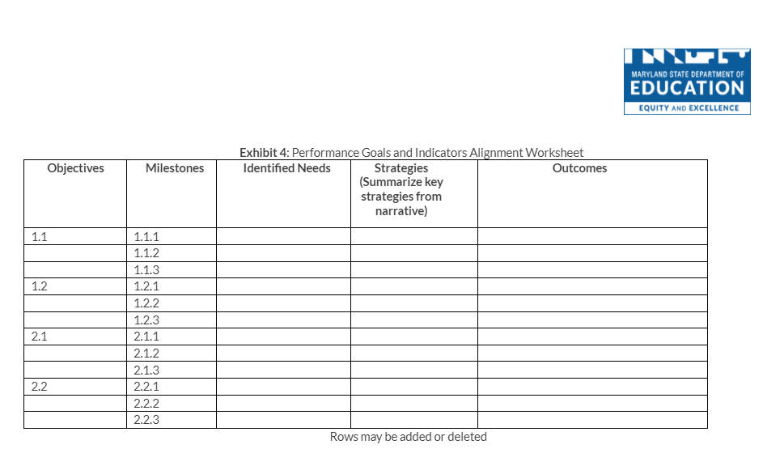

Implementation and Governance Plan

Steering Committee description
The project must have a steering committee to govern the project consisting of major stakeholders and grant project directors. Duties of the steering committee include establishing major program policies, reviewing quarterly milestones and annual evaluation reports, and making recommendations for programmatic change. Steering committee members should represent the major stakeholders in the project (e.g., project partners, parents, students, principals, Board of Education members). Project directors should act as advisors to the committee. The duties, members, and meeting dates of the committee should be identified in this section of the grant renewal application and in the Management Plan.

Management PLan
The Management Plan section describes how and by whom the program will be managed to ensure project success. This section must:
- Describe how, when, and by whom the program’s implementation will be monitored, including starting the project on time.
- Describe how the program will be integrated into the existing academic day.
- Describe when professional learning will be scheduled for new teachers.
- Describe the mechanisms by which the project will clearly define and hold partners accountable to specific roles, responsibilities, contributions, and deliverables, e.g., contracts or Memoranda of Understanding.
The Management Plan Worksheet details the major management actions and the timeframe and specific persons responsible for each action. The worksheet supports the proposed plan of operation, but includes only management actions, not direct service activities. Examples of management actions are hiring of staff, ordering equipment, and developing curricula. Meetings with the evaluator and holding steering committee meetings must occur within 30 days of the Notice of Grant Award.
On the Management Plan Worksheet, in chronological order, the grantee is required to list all major management Specific, Measurable, Attainable, Relevant, and Time-based (SMART) actions necessary to implement the project during the second year of funding. The worksheet should include the responsible party for each measurable outcome, and an approximate date for each action. If the action is ongoing, indicate the range of dates over which it will be implemented. The MSDE reporting requirements should also be included in the management plan.

Management Plan
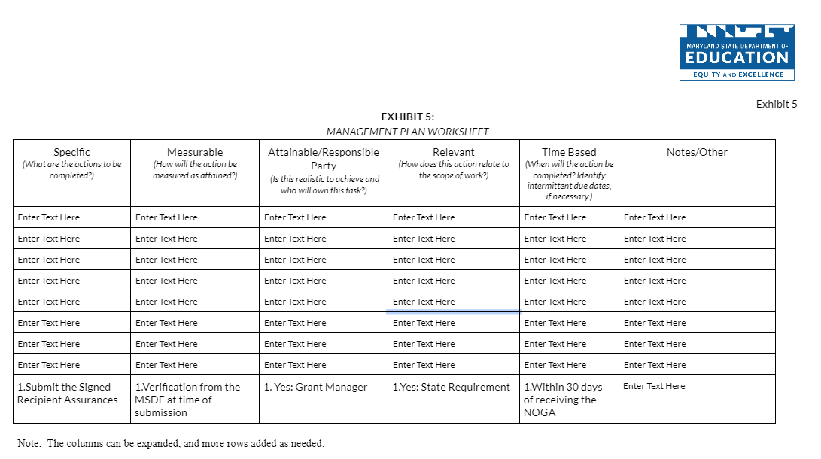

Partners
A partner is any organization other than the grantee that will actively contribute to the project. This includes the LEA(s) being served, institutions of higher education, private sector business, and other nonprofit [501(c)(3)] organizations and foundations. Partners include subcontractors or organizations that are under contract with the grantee to provide grant-funded activities or services. If renewed, all subgrantees must ensure the MSDE team has a record of the current contract/Memorandum of Understanding (MOU). New or revised contracts are to be submitted with the FY23 budget documents for the MSDE review and approval. Contracts require review and approval before funds will be released for reimbursement. Funds paid to partners by the subgrantee without an approved contract are subject to non-reimbursement.
The Partners Plan Worksheet (Exhibit 6) shows the project’s partners, the respective roles in the project, the benefits each expects to receive, and the specific contributions each partner will make to the project in the form of financial support, equipment, personnel, or other resources. The grantee should include which objectives their services will help to achieve, as well as evaluation dates to reflect on progressing and/or achieved outcomes.

Partners Plan

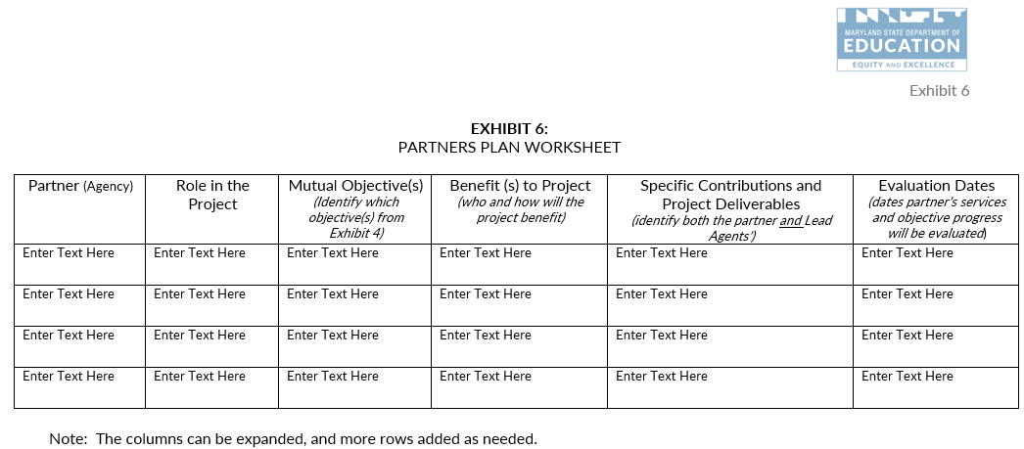

Evidence of Impact
Describe how the proposed plan and strategies being implemented are evidence-based and will lead to the desired impact. Include a description of the organization’s experience in terms of effective practices (research-based strategies) leading to the desired outcomes. Demonstrate how continued investment in the grant program is justified by initial outcome data from the program.

Program Accountability
TFA must include a plan for a professional assessment of the program. Program assessment must be conducted quarterly with interim goals and benchmarks, culminating in a summative evaluation reflecting the entire project. This section must include the strategy, description of proposed data instruments, collection processes and analytic methods to show how the program:
- Integrated an educational component that assisted new teachers to assist their students in meeting academic requirements on grade level (for during day programs);
- Integrated into the existing professional learning plans for the school/LEA;
- Integrated into the new teacher’s class schedule;
- Enhanced the educational purpose of the school; and
- Leveraged private and existing funding sources.
This section must reflect a plan to assess progress toward objectives, milestones, and anticipated outcomes. In addition, this section must show how the assessment will be an integral element in the project’s planning, design, and implementation, and explain how the evaluation will enable project managers to determine which strategies and activities have been successful, and those that need to be revised.

Leveraging Private and Existing Funding Sources
The MSDE encourages applicants to illustrate the ability to leverage private and existing funding sources. If applicable, subgrantees should include on the Budget Worksheet and Narrative how private and existing funding sources will be combined or coordinated with the proposed grant funding to illustrate the effective use of resources.

Budget and Adequacy of Resources
The PSOEPLP award is a cost reimbursement grant, whereby the program incurs costs and then invoices MSDE for those charges. The grantee must have sufficient cash flow to operate the PSOEPLP program continuously while awaiting reimbursement receipt, which normally takes approximately six to eight weeks. Interest expense or other debt services costs cannot be charged to the PSOEPLP grant. Check cashing fees cannot be charged to the grant. If unallowable costs are reimbursed during the grant period, corrective actions will be provided and require the funds to be repaid to the MSDE.
The grant budget consists of two components:
- The Budget Worksheet and Narrative (Exhibit 8); and
- The approved MSDE Grant Budget Forms (C-1-25).

The budget objects are: (1) Salaries & Wages; (2) Contracted Services; (3) Supplies & Materials; (4) Other Charges; (5) Equipment; and (6) Transfers. The budget object totals in the Budget Worksheet and Narrative must align with the totals identified on the MSDE Grant Form C-1-25.

BUDGET WORKSHEET AND NARRATIVE TEMPLATE
The budget narrative is a part of the Budget Worksheet and Narrative Template (Exhibit 8). The Budget Narrative must:
- Describe a clear relationship between the activities described in the application and the proposed allocation of grant funds;
- Address the necessity and rationale of proposed costs;
- Demonstrate that there are sufficient resources to successfully implement the proposed program as described in the project narrative, including, but not limited to, instructional staff, curricular materials, evaluation, professional development, background checks, and transportation, if necessary; and
- List all budgetary costs based upon the narrative components and program design and ensure the budget includes a line-item description for every allowable cost necessary to carry out the goals and objectives of the proposed program.
The budget must:
- Detail the year of the project in an itemized budget;
- Itemize general expenses into specific line items. For example, “Meeting Expenses” can be itemized to include, “room rental” and “photocopying;”
- Clearly identify the requested funds and in-kind contributions; and
- Identify the source of each in-kind contribution, if applicable.
Identify reasonable and allowable expenses aligned with the United States Department of Education (USDE) Uniform Grant Guidance, 2 C.F.R. Part 200, (2 CFR § 200). The Electronic Code of Federal Regulations (E-CFR) is accessible at: https://www.ecfr.gov/cgi-bin/text-idx?tpl=/ecfrbrowse/Title02/2cfr200_main_02.tpl. Utilize The Maryland Financial Reporting Manual as an additional resource when categorizing allowable expenses. Utilize the Bureau of Labor and Statistics National Occupational Employment and Wage Estimates database to identify reasonable and allowable wages.
Adhere to the following guidelines when proposing expenses in the specified budget objects.
- Salaries and Wages: Expenditures incurred for personnel on the payroll.
  - Specify and detail how the expense was calculated for each line item. The calculation column must include hourly rate of pay provided based on the reasonable and allowable rates of pay aligned with the U.S. Bureau of Labor and Statistics (BLS), number of hours billed to the project, percentage of time billed to the project;
  - Program staff identified under Salaries/Wages and Contractual Services must remain in that budget object for the remainder of the grant year;
  - The budget must include a position or contracted services expense for a finance agent/bookkeeper; and
  - Program staff identified under Salaries/Wages must include paycheck withholding as supporting documentation when submitting reimbursement invoices.
- Contracted Services: Expenditures for services performed by persons who are not on the payroll.
  - Specify and detail how the expense was calculated for each line item. The calculation column must include hourly rate of pay based on the reasonable and allowable rates of pay aligned with the U.S. Bureau of Labor and Statistics, administrative fees, and number of hours billed to the project. Please provide the following in the calculation column and embed the hyperlink to the BLS reference;
  - Vendors that provide direct services to students must submit a proposed MOU outlining the deliverables and breakdown of expenses to include hourly rates and administrative costs for all providers. The MSDE acknowledges that MOUs may not be finalized at the time of the application; however, a proposed agreement is required that outlines the details of partnership; and
  - The external evaluator cost cannot exceed seven percent of the Total Requested.
- Supplies and Materials: Refer to 2 C.F.R. Part 200, The Maryland Financial Reporting Manual, Appendix D for a definition. The total object cannot exceed eight percent of the Total Requested.
  - Specify and detail how the expense was calculated for each line item. The calculation column must include quantity and cost per item.
- Equipment: Refer to 2 C.F.R. Part 200, and The Maryland Financial Reporting Manual, Appendix D for a definition. The total object cannot exceed three percent of the Total Requested.
- Other Charges: May include expenses such as travel, conferences, fringe, etc. (not an inclusive list). The total object cannot exceed 36 percent of the Total Requested.
  - Professional Development:
    - Include funds to cover travel and lodging expenses for at least two key personnel to attend one national and two regional training activities during each year of the project (actual attendance will be contingent on MSDE approval).
    - Include funds for the project director to attend three state grantee networking meetings; and
    - Include funds for the project director to attend one two-day state grantee retreat.
- Transfers: The total object cannot exceed 13 percent of the Total Requested.
- Indirect Cost Rate:
  - Indirect Costs cannot exceed 10 percent of the Total Direct Cost for Non-LEAs; and
  - Refer to Section 5.0.5 Indirect Costs for calculation guidance.

Both requested and in-kind funds must be reasonable with current market prices. Grant funds cannot be used to purchase food, facilities, vehicles, or support new construction.

Conflict of Interest
All potential conflicts of interests should be avoided. According to the general procurement standards, the non-Federal entity must maintain written standards of conduct covering conflicts of interest and governing the actions of its employees engaged in the selection, award, and administration of contracts. No employee, officer, or agent may participate in the selection, award, or administration of a contract supported by a Federal award if he or she has a real or apparent conflict of interest. Such a conflict of interest would arise when the employee, officer, or agent, any member of his or her immediate family, his or her partner, or an organization which employs or is about to employ any of the parties indicated herein or has a financial or other interest in or a tangible personal benefit from a firm considered for a contract. The officers, employees, and agents of the non-Federal entity may neither solicit nor accept gratuities, favors, or anything of monetary value from contractors or parties to subcontracts. The standards of conduct must provide for disciplinary actions to be applied for violations of such standards by officers, employees, or agents of the non-Federal entity. (EDGAR 2 CFR §200.318)
Within the PSOEPLP program, conflicts of interest could include:
- Employing immediate family members as contract labor for services;
- Having a program employee serve as a vendor; and
- Purchasing supplies from a company in which a program employee has a financial interest.

Customer Service Support Session
The MSDE Team will hold a virtual customer service support session to provide support and answer questions regarding completing the application. Registration for the sessions with the dates and a video call link will be provided in a separate communication.

Awarding of Funds
The MSDE will initiate notification of grant awards via email no later than January 20, 2023

Denial of grant application
Each applicant whose application is denied will receive a Denial Notice that explains the reason for the denial after final award decisions are made.

Reasons for DEnial
Applicants may be denied funding for failure to meet the requirements listed under the Funding and Length of Grant section in this document.

NON-DISCRIMINATION STATEMENT
The Maryland State Department of Education does not discriminate on the basis of age, ancestry/national origin, color, disability, gender identity/expression, marital status, race, religion, sex, or sexual orientation in matters affecting employment or in providing access to programs and activities and provides equal access to the Boy Scouts and other designated youth groups.
For inquiries related to Department policy, please contact:
Equity Assurance and Compliance Office
Office of the Deputy State Superintendent for Operations
Maryland State Department of Education
200 W. Baltimore Street – 2nd Floor
Baltimore, Maryland 21201-2595
410-767-0123 - voice
410-767-0431 – fax
410-333-6442 - TT

Attachment 1: PSOEPLP Performance Report and Renewal Application Form
The details of the e-application are included in Attachment 1. Please submit the data electronically through accessing the PSOEPLP Performance Report and Renewal Application Form.
Upon submission, the MSDE will review the provided data:
- Submitted via this report (GRA);
- Year one performance data which includes, but is not limited to, the: (1) End-of the year report;
- (2) Timely reimbursement invoice submissions, and (3) Total number of amendments; and
- 2022-2023 grants management plans consisting of: (1) Performance Goals and Indicators, (2) Management Plan, and (3) Partner Plan. Final documents are to be submitted as a part of the Grant Renewal Application by email to psoeplprfp2021.msde@maryland.gov by January 13, 2023.
A risk assessment level of 1-5 will be generated and issued on the Year II Notification of Grant Award (NOGA).

PROGRAM Information
Provide the lead agency’s information including the type of organization, address, grant program name, grant number, organizational unique entity identifier, and grant manager’s contact information, as well as a summary of the project’s design.
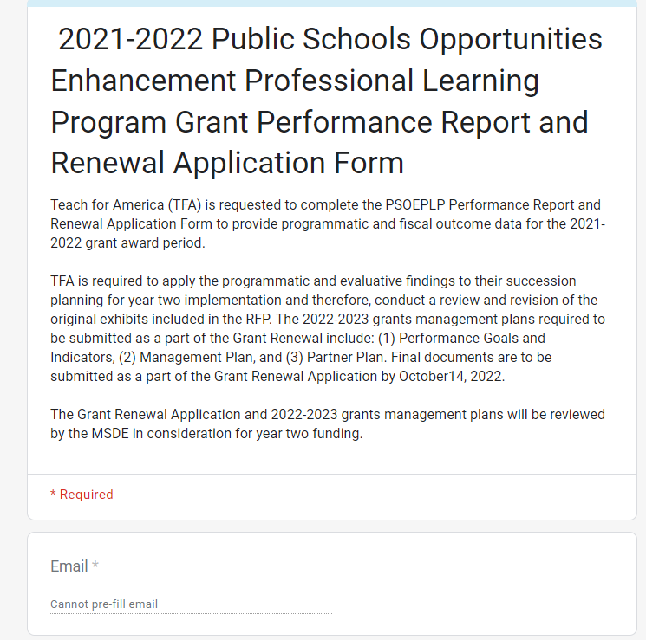

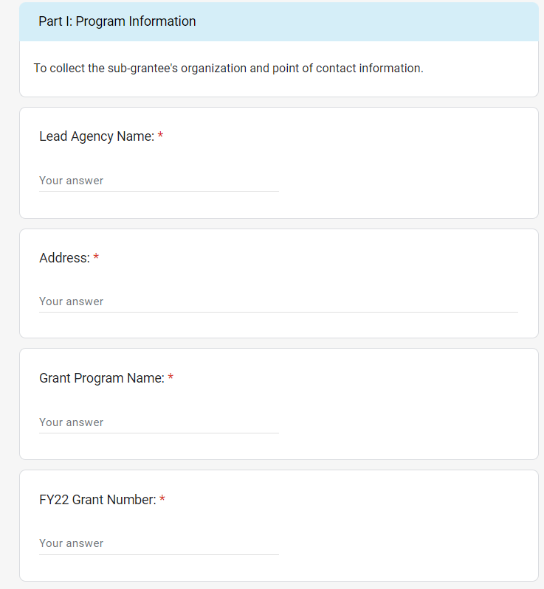
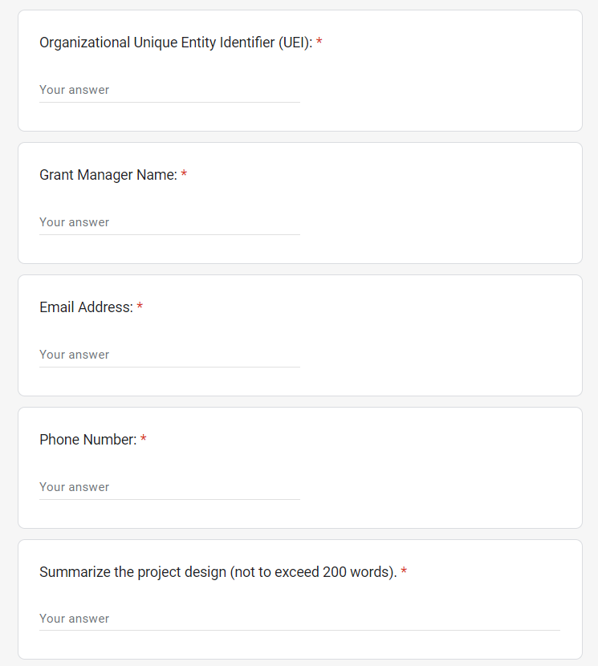

Teacher Recruitment 2021-2022
The teacher recruitment efforts for Baltimore City Public Schools and Prince Georges County Public Schools are reported in this section.

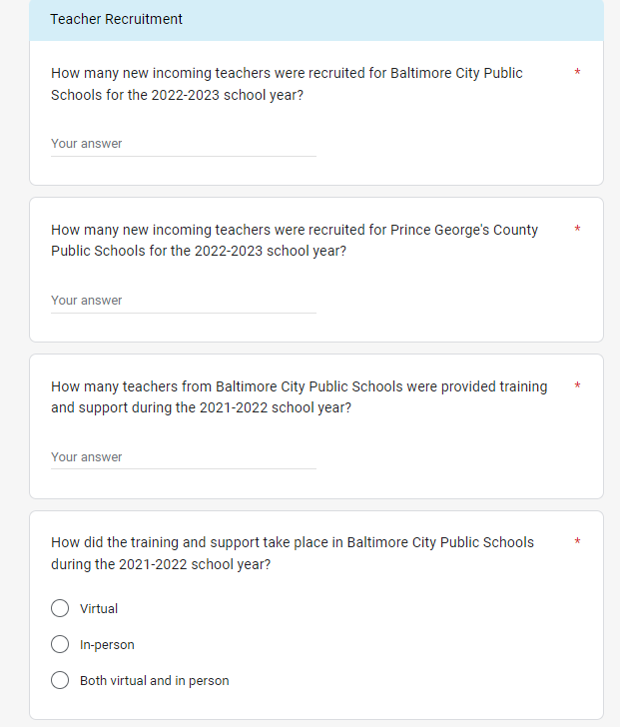

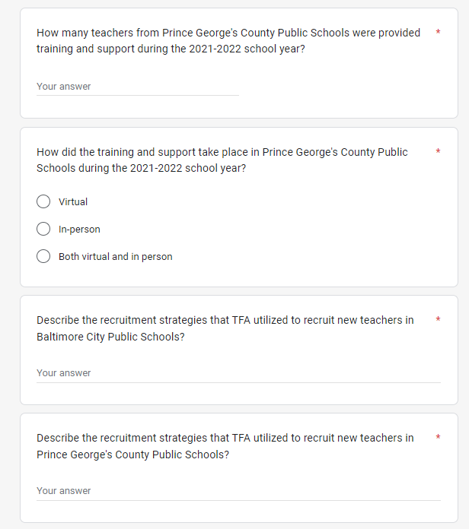

teacher development
Information on the development of teachers is reported

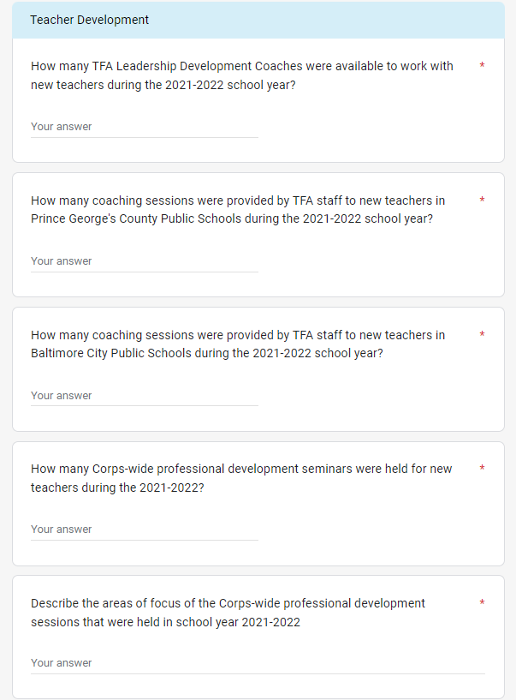

Teacher retention
Strategies to retain teachers in the served LEAs are reported here.

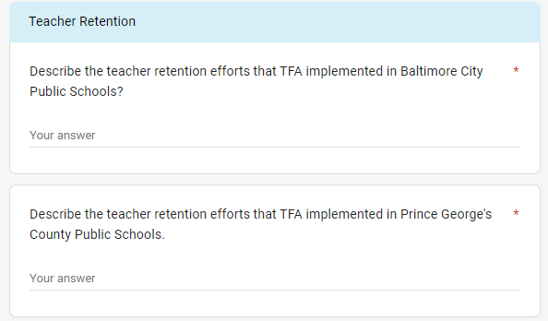

Goals, objectives, milestones, and anticpated outcomes
TFA will update progress on meeting the identified goals, milestones, and anticipated outcomes that were listed in the original grant proposal.

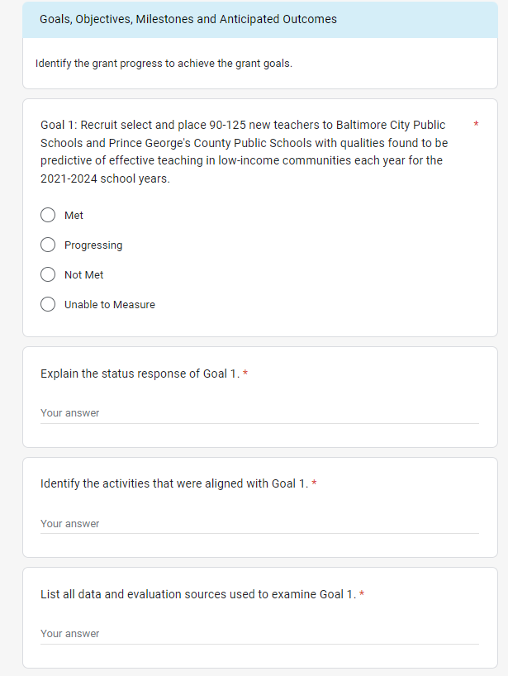

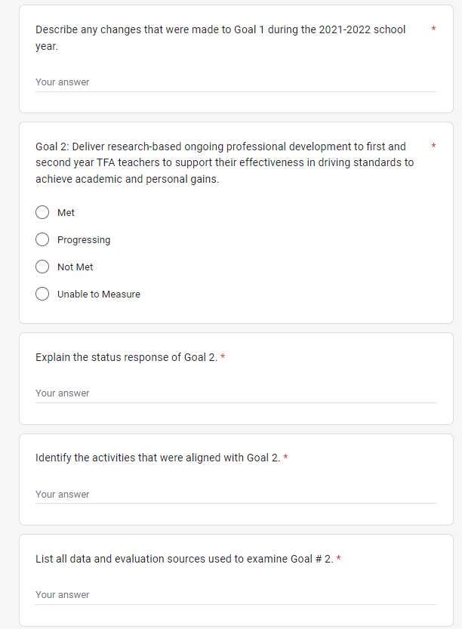

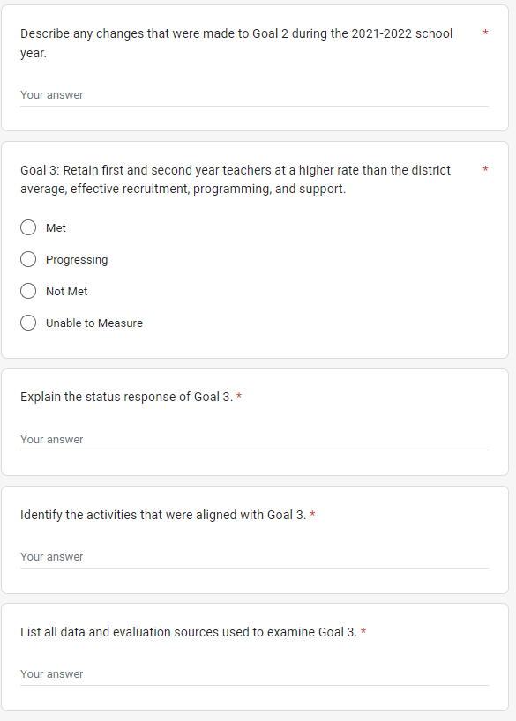

Program Accountability
The grant program must include a plan for a professional assessment of the program.

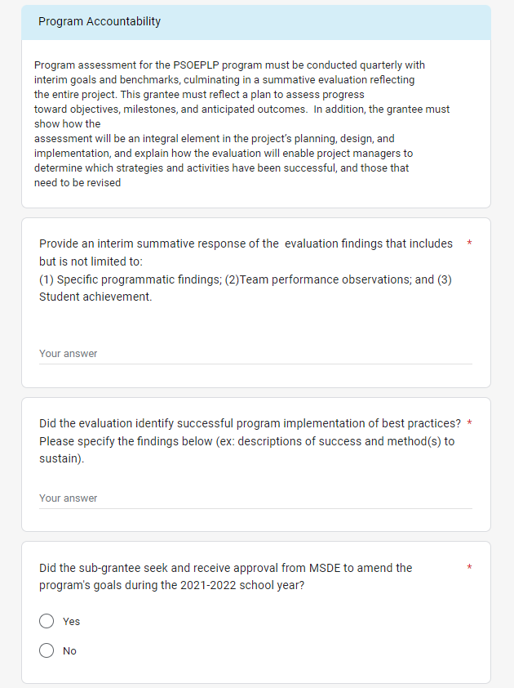

evidence of Impact
The applicant is required to report evidence-based strategies, impact, and effective practices.
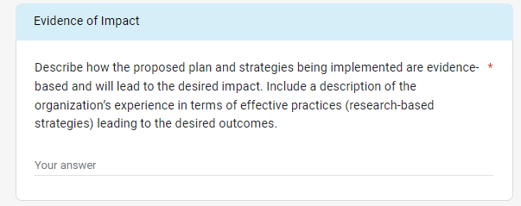

rEQUESTED REVISIONS TO PERFORMANCE GOALS
The TFA identified performance goals to evaluate the effectiveness of the PSOELP grant programs. Within this section, the subgrantee can report on revisions to the alignment of the performance goals as aligned with the original approved Performance Goals and Indicators.

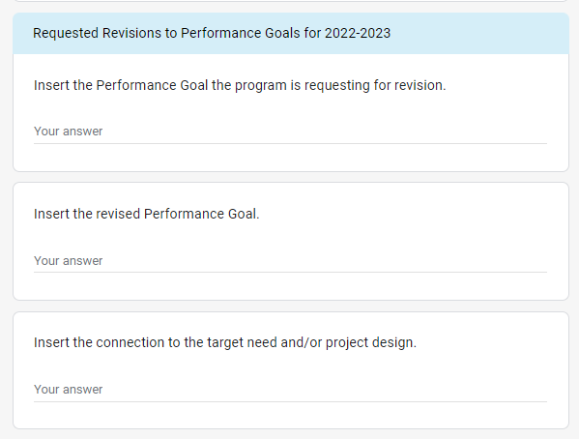

COLLABORATION REFLECTION AND UPDATES
An annual reflection of the leadership team, steering commitment, and partnership with LEAs is reported in this section.

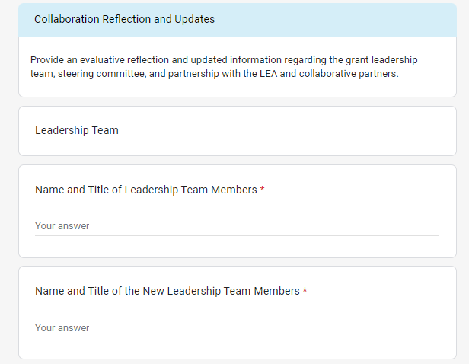
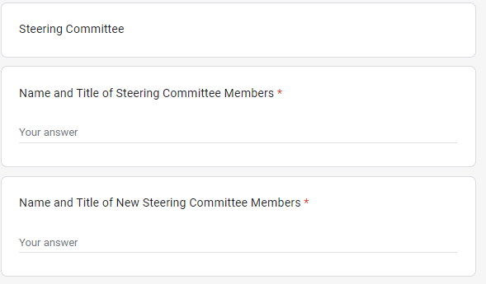
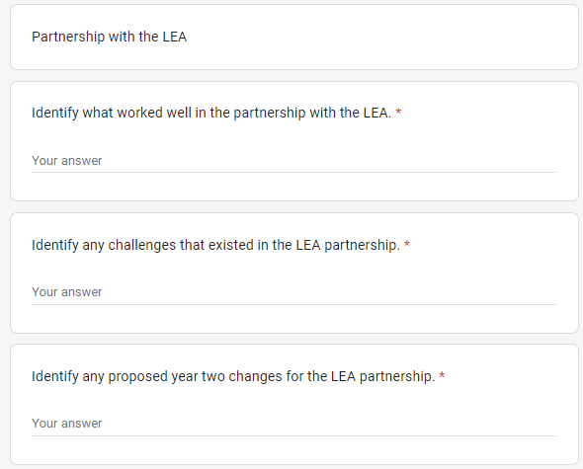
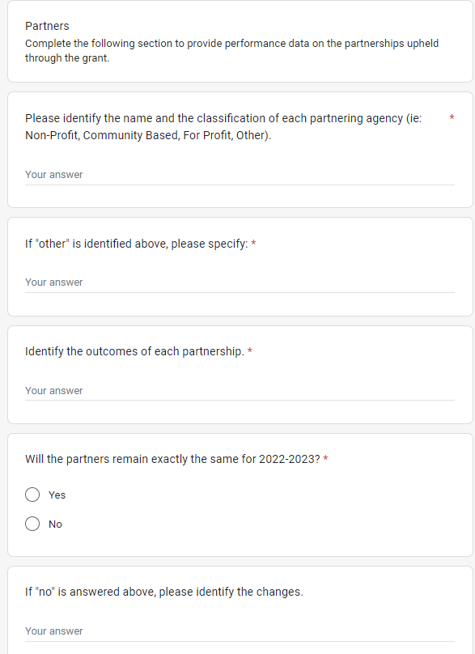

pRIVATE AND EXISTING FUNDING SOURCES
The MSE encourages applicants to leverage private and existing funding sources as sustainability practice.
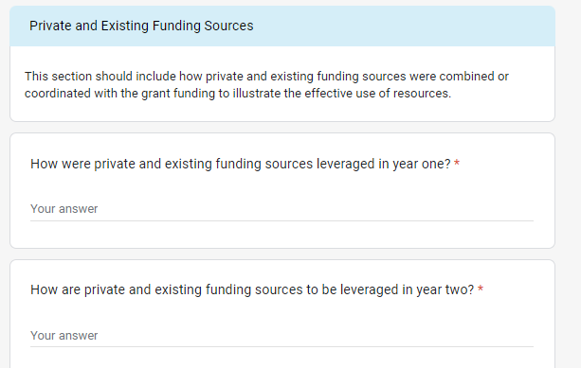

GRANT BUDGET DOCUMENTS (YEAR II)
Please provide a detailed description of the requested funds that will be spent by using the categories listed below. Add more rows if needed. An MSDE Grant Budget C-1-25 form and Budget Worksheet and Narrative must also be completed, signed, and submitted. Refer to the PSOEP Fiscal Grants Guidance: Budget Worksheet and Narrative for additional information.
