Technical Assistance Bulletin
Division of Early Intervention and Special Education Services | Bulletin # 19-01
Birth – Age 4 Birth – K Age 3 – K Birth – 21 Age 3 – 21
Date: Revised November 2019

Improving Outcomes for Students with Disabilities
CURRICULUM, INSTRUCTION, AND ASSESSMENT

The focus of this technical assistance bulletin is the interdependency of curriculum, instruction, and assessment to deliver specially designed instruction to students with disabilities within an Integrated Tiered System of Supports framework (ITSS). Each of these components has both Federal and State compliance requirements, which, if implemented effectively, result in positive outcomes for students with disabilities. As illustrated below, a standards aligned curriculum is the foundation of Maryland’s educational framework and informs what is taught as well as what is assessed. Students with and without disabilities are assessed on their achievement of academic content standards; student performance informs instruction which is aligned with the core curriculum (Maryland College and Career Ready Standards, or MCCRS); instruction is differentiated based on student performance; and student assessment results indicate the extent to which schools are effectively educating students to reach the expected State standards. For students with disabilities, both general and specialized education are required. A culture of high expectations must exist to prepare all students to succeed in college, career, and community life.

Refer to A Guide for Implementing Specially Designed Instruction within an Integrated Tiered System of Supports to support the implementation of curriculum, instruction, and assessment.

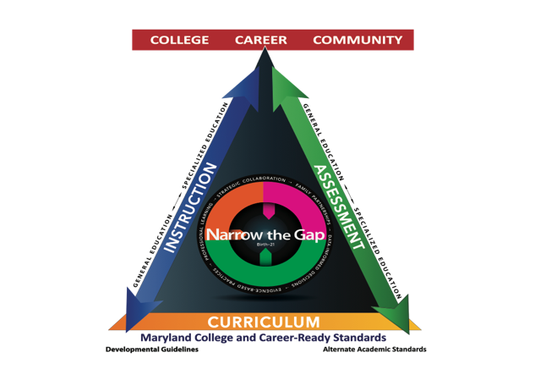
For students with disabilities, the Individualized Education Program (IEP) provides the diagnostic-prescriptive tool to implement specially designed instruction. The IEP process and document is developed, implemented and evaluated through the collaborative effort of all adults who support the child, including the family. The IEP team makes critical decisions to design goals and services that are intended to address the unique needs that result from a student’s disability and enable the child to make progress in the general education curriculum. Specially designed instruction (SDI) should narrow the gap in the performance of students with disabilities compared with their same age peers. In the Endrew, F. v. Douglas County School District (2017) decision, the Supreme Court clarified that IEPs must be “reasonably calculated to enable a child to make progress” appropriate in light of their circumstances, and that while the child’s goals may be different, “every child should have the chance to meet challenging objectives.”

IEP teams should consider:
- a child’s previous rate of academic growth (using trend data);
- whether the child is on track to achieve or exceed grade level proficiency;
- any behaviors interfering with the child’s progress; and
- additional information and input provided by the child’s parents.

Developing the IEP is a collaborative process, whereby general education classroom teachers, special education teachers, related service providers, parents, and, in many cases, the student work together to design the special education and related services that the student will receive, the goals and objectives the student will achieve, and the means for measuring progress toward goal and objective achievement. Considerations include the knowledge/skillset of the IEP team members, the past progress and rate of growth of the student, the past delivery of specially designed instruction, interventions, and services or supports that the student has received, and the effectiveness of past services.

The IEP team must ultimately consider how special education and related services, implemented through an effective IEP, can change the trajectory of a student’s growth to reduce or close the gap.

This technical assistance bulletin highlights critical points about specially designed instruction, including requirements for IEP teams to:
- Develop, as appropriate, IEP goals that are:
- Aligned to academic content standards of grade level enrollment, and
- Aligned to academic content standard from earlier in the learning progressions, or
- Aligned to age/grade appropriate functional skills impacted by the disability and interfere with, prevent, or affect communication and interpersonal interactions, participation in school and learning activities, and independence in school and potential post-school settings.
- Implement evidence-based instructional practices and strategies or approaches that have proven to be effective in leading to desired outcomes;
- Analyze trend data in order to reasonably calculate student progress toward grade level standards and set ambitious IEP goals;
- Regularly review student data to monitor student progress and make data informed decisions about adjustments to instruction and interventions; and
- Consider the information and training needs of parents and school personnel.

The Law
The Individuals with Disabilities Education Act (IDEA) requires that each IEP include, among other things, a statement of measurable annual goals, including academic and functional goals, designed to meet the student’s needs that result from the student’s disability and enable the student to be involved in and make progress in the general education curriculum (20 U.S.C. § 1414).
IDEA defines the general education curriculum as “the same curriculum” used for nondisabled students (34 CFR § 300.320). However, in November 2015 the United States Department of Education, Office of Special Education and Rehabilitative Services (OSERS) issued significant guidance in the form of a “Dear Colleague” letter that interprets the general education curriculum as “the curriculum that is based on a State’s academic content standards for the grade in which a child is enrolled.”
Using the general education curriculum as the reference point for IEP goals is critical to maintaining high expectations and setting ambitious, meaningful, and achievable goals for students with disabilities, considering their unique circumstances. In developing an IEP, the IEP team considers how a student’s disability impacts their ability to make progress toward grade level standards during the period covered by the IEP; in many cases – especially if the student is more than two years or more behind grade level – the student may be able to make more than a year’s progress in acquiring content skills, and in doing so may narrow the gap in their current performance to that of their grade level peers.
If a student is performing significantly below grade level, the IEP team should determine annual goals that are ambitious but achievable for that student. While annual goals need not necessarily result in the student attaining grade level proficiency within the year covered by the IEP, the goals should be sufficiently ambitious to help close or reduce the achievement gap. The IEP team must also, when appropriate, consider goals that target critical age/grade appropriate skills essential to facilitate student independence and enable them to access and participate in grade level instructional and social activities, and make progress toward achieving grade-level standards.
To meet its substantive obligation under IDEA, the IEP team must offer an IEP that is “a fact-intensive exercise (that) will be informed not only by the expertise of school officials, but also by the input of the child’s parents.” Endrew F. v. Douglas County School District, 580 U.S. (2017).
A very small number of students with the most significant cognitive disabilities, who have been determined eligible for participation in the Alternate Educational Framework, must also have goals aligned with the MCCRS. These standards must clearly relate to grade level content, although they may be restricted in scope or complexity, or take the form of introductory or pre-requisite skills. Thus, while the MCCRS are the starting point for all students, the IEP team must make an individualized decision as to whether the significance of the student’s disability requires that his or her annual IEP goals align with the Maryland Alternate Academic Standards (MAAS) applicable to their grade of enrollment.

Implementation
In order to develop ambitious and achievable IEP goals, IEP team members must first have a firm grasp of the age and grade appropriate skill expectations outlined in the Maryland College and Career Ready Standards, the Maryland Early Learning Standards or the Core Content Connectors for students with the most significant cognitive disabilities who have been found eligible for and whose parents have consented to participation in the alternate learning framework and/or alternate assessment. Second, they must review the student’s present levels of academic and functional performance (PLAAFP) in light of the grade level standards as well as those unique needs that result from their disability. This knowledge allows the IEP team to analyze the gaps between current skills and the expectations of the grade level standards, and allows the IEP team to identify the behaviors and skills that are needed for active participation in school as a learner and for the future as an employee, family and community member.

The Maryland Curriculum Frameworks can help the IEP team identify the essential skills and pinpoint areas of student need. The IEP goal(s) should be aligned to academic content standards of grade level enrollment, and/or academic content standards from earlier in the learning progressions, and/or align to age/grade appropriate functional skills impacted by the disability and interfere with, prevent, or affect communication and interpersonal interactions, participation in school and learning activities, and independence in school and potential post-school settings. Priority is given to skills that support the achievement of multiple standards and/or the student’s access to grade level content in multiple areas. The following guiding questions may be useful to consider as IEP teams collaborate to identify the most important age appropriate and grade level standards for a student to learn to make progress in the curriculum and to narrow or close the achievement gap and demonstrate functional skills for access and independence.

- Based on progress monitoring, what gains did the student make during the last IEP? For children transitioning from early intervention, what gains were made during the last IFSP?
- In what content areas did the student make progress and how much progress was made?
- What supports, strategies, and specially designed instruction were implemented and how did the student respond?
- What factors influenced progress?
- What changes could be made to increase the rate of learning?
- What skills underlie multiple standards?
- What data must be collected for ongoing progress monitoring?
Once the IEP team has identified the priority skills and an appropriate target, they set goals that are estimates of the student’s anticipated growth that would result from receiving specially designed instruction. Goals are measurable, ambitious, and achievable.
For example:
By (date/within a year), given problems involving fractions with unlike denominators, the student will use manipulatives to calculate equivalent fractions with like denominators and solve the problems, scoring at least 80% on two classroom assessments.

Goals and Objectives describe:
- The conditions under which the skill will be demonstrated;
- A behavioral description of the skill to be observed;
- The criteria for measuring achievement of the skill;
- The method of measurement; and
- The time frame by which the goal or objective will be achieved.

Objectives reflect sequential targets of increasing proficiency, accuracy, complexity - or reduced supports - across the time period covered by the IEP or list the component skills, which when combined, lead to the achievement of a goal. The number and content of the objectives is based on the needs of the student and how he or she will demonstrate progress toward achieving the IEP goal.

For example:

Objective 1: By the end of the first quarter, when given a process chart, manipulatives and problems involving fractions with like denominators, the student will solve the problems with 80% accuracy on two classroom assessments.

Objective 2: By the end of the second quarter, when given a process chart, manipulatives and fraction expression, the student will generate an equivalent fraction for both fractions in 8 out of 10 trials.

Objective 3: By the end of the third quarter, when given manipulatives and a fraction expression, the student will create a visual model and solve the problem in 8 out of 10 trials.

In summary, the task of the IEP team is to use data to inform decisions about which grade level standard(s) the student is not on track to achieve and why. The IEP team backward maps the development of academic content standards and age appropriate functional skills to isolate the component(s) or underlying skill(s) that are needed to access and make progress in the general education curriculum.

These goals will:
- Align with the academic/content standards of the grade in which the student is enrolled to enable the student to make progress toward grade-level performance and reduce or close the achievement gap; and/or
- Align with the academic/content standards of below-grade level performance in which the student is missing critical skills that are important for current and future grade level skill development to reduce or close the achievement gap; and/or
- Address age/grade appropriate functional skills that are impacted by the student’s disability and interfere with, prevent, or affect communication, interpersonal interactions, self-determination, and self-management, all of which are needed for meaningful participation in life, learning, and work.

Frequently Asked Questions
- Are all students expected to meet age appropriate or grade level standards within the period covered by the IEP? No. The expectation is that the IEP team develops appropriate annual IEP goals that are aligned with grade level standards, then calculates the growth the student can be expected to achieve based on the student’s present levels of performance, previous rate of growth, and the special education services that have been provided to the student. The annual IEP goals need not necessarily result in the student’s reaching grade level within the year covered by the IEP but should be sufficiently ambitious to help close the gap. The IEP should represent progress in light of the student’s unique circumstances.
- Does the IEP team follow the same process for students on alternate academic standards? Yes. The process is the same, except that the annual IEP goals are aligned to alternate achievement standards aligned with the grade in which the student is enrolled. The alternate academic standards – called Core Content Connectors – are derived from the general education curriculum. Given the unique needs of students with the most significant cognitive disabilities, who may be working toward alternate achievement standards, the IEP team may also consider including IEP goals for communication and interpersonal interactions, participation in school and learning activities, or independence in the school and potential post-school environments.
- Should the IEP goals address all grade level standards? No. The student should receive instruction, including supports according to his or her IEP, on all grade level standards, but the IEP goals should reflect skills that the IEP team identifies as essential and require specially designed instruction to learn. The IEP goals focus instruction and progress monitoring on the critical skills that will enable the student to meet grade level standards. The standards themselves are not the IEP goal.
- If the IEP team determines that alternate academic standards are appropriate, does the student have to change school placement or enter a self-contained classroom?
No. Decisions about the appropriate curriculum for instruction and assessment are separate from decisions about placement. To the maximum extent appropriate, students with disabilities must be educated with students who are nondisabled and only removed for instruction in separate settings if the IEP goals cannot be achieved in the general education classroom even with supplementary aids and services. Although the curriculum may be substantially modified for students with the most significant cognitive disabilities, teachers can adapt the lesson for meaningful participation and learning

INSTRUCTION

The Law
The hallmark of special education is specially designed instruction. IDEA defines specially designed instruction as adapting, as appropriate to the needs of a student, the content, methodology, or delivery of instruction to: address the unique needs of the student that result from the student’s disability; and ensure access to the general education curriculum so that the student can meet the educational standards that apply to all students (34 CFR § 300.39). The IEP identifies accommodations that are needed by the student to access general education environments and activities. See Appendix B for definitions and Appendix C for the 5-step process for determining accommodations. The IEP document must also identify the special education and related services and supplementary aids and services needed to promote participation in the general education curriculum with peers without disabilities. Additionally, the IEP includes program modifications and supports for personnel implementing the IEP. These strategies must be based on peer-reviewed research (to the extent practicable) according to IDEA and State law (e.g., COMAR 13A.05.01.09A(1)(c)).
A focus on the use of evidence-based practices and supports is also emphasized in the Every Student Succeeds Act (ESSA) which requires the implementation of evidence-based practices, strategies, and approaches that have proven to be effective in leading to desired outcomes, namely improving student achievement. Sample supplementary aids, services, program modifications and supports are provided in Appendix D. Supplementary aids, services, program modifications, and supports are provided in all education-related settings, and in extracurricular and nonacademic settings, to enable students with disabilities to be educated with nondisabled students (34 CFR § 300.42).

Implementation
When schools have a strong integrated tiered system of supports (ITSS), the foundation is laid for teaching to the diverse needs of a variety of learners who may enter the school house doors. An effective tiered framework employs evidence-based screening, standards aligned curricula, team-based collaborative planning, and a strong evidence-based instructional approach that is based on universal design for learning (UDL) principles and differentiated instruction (DI) to address the individual characteristics of the students in each class. UDL and DI serve as the instructional base for all students, including students with disabilities.
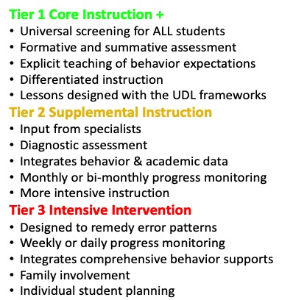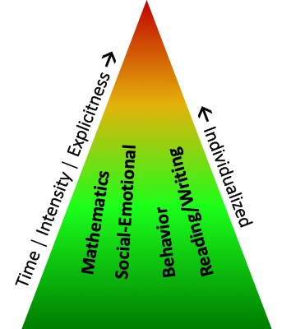
In “advanced” tiers of more intensive instruction and interventions, assessment occurs on a more frequent basis, instruction supplements core instruction and is designed for student groups based on their learning deficits, and collaborative teams review data to inform changes to interventions and supports. All students have access to more intensive instruction when they are at risk for failure or are performing below benchmark targets. Entry and exit decisions are based on student performance and growth or lack of growth in the curriculum.

Specially designed instruction (SDI) is most powerful when delivered within an Integrated Tiered System of Supports, as it provides students with disabilities the opportunity for more intensive instruction in areas of skill deficits, alongside their peers with similar learning needs. However, a student with a disability, and unique learning needs stemming from that disability, will require specially designed instruction to make progress in the curriculum. A student’s unique SDI is based on individual learning characteristics and combines evidence-based practices, intensive instruction, accommodations, supplementary aids and services, program modifications, and personnel support. The following chart describes the qualities that distinguish SDI.
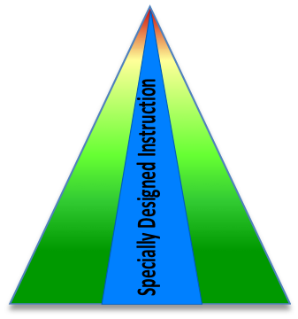
Specially Designed Instruction
IS | IS NOT
Only students with IEPs | All students
A service provided to a student | A place a student goes
In addition to the core instruction (supplemental) | In place of core instruction (supplant)
What the instructional team does | What a student does
Specific to the student, based on the impact of the disability | A schedule
Instruction that allows a student to make progress  in the enrolled grade level standards AND changes  the trajectory of growth to narrow/close the gap | Setting low expectations or teaching  ONLY below grade level skills
An individually and intentionally designed plan of services and supports | A replacement for Universal Design for Learning (UDL) or Differentiated Instruction (DI)
Uniquely designed instruction that is designed  to promote progress toward IEP goal(s) | A commercial program without individually designed supports and services
Based on individual learning characteristics and combines evidence-based practices, intensive instruction, intervention, accommodations, supplementary aids, program modifications and support to personnel | Only available in tier 2 small group,  or tier 3 one-to-one instruction
Co-planned, co-implemented, and co-evaluated  by a collaborative IEP team | Planned, implemented, and evaluated solely  by a special educator
The frequency (how often a service is provided) and intensity (the duration of each session) of special education and related services are important determinations for the IEP team. While the appropriate amount is student-specific, there should be a relationship between the specially designed instruction provided to the student and the IEP goals to be achieved, the gap from the student’s current performance, and the grade level standards such that the student can be expected to make reasonable progress in the general education curriculum. The table below (adapted from Fuchs, Fuchs, & Malone, 2017) illustrates dimensions of interventions that can be intensified to accelerate student progress.

STRENGTH | Effectiveness/Evidence that it works
DOSAGE | Number of opportunities to respond and receive feedback and amount of time engaged in instruction specific to target skill area
ALIGNMENT | Match to the targeted skills (goals) and grade-appropriate standards
TRANSFER/ GENERALIZATION | Connections between the intervention focus and skills learned in other contexts and environments
COMPREHENSIVENESS | Comprehensive array of explicit instruction principles
BEHAVIORAL SUPPORT | Strategies that support students with self-regulation, motivation, or externalizing behaviors that impact their ability to learn
INDIVIDUALIZATION | Ongoing use of progress monitoring data and diagnostic data sources to intensify and individualize the intervention based on student need

The following guiding questions may assist IEP teams when calculating the appropriate frequency and intensity of services:
- Do the services support the implementation of all the outcomes or goals and objectives?
- Do the services take into account the student’s history and progress with previous general education, special education, and related services?
- Do the services address the nature of the student’s needs, including the gap between the student’s grade level and performance level?
- Do the services support the student’s cultural and linguistic background?
- Do the services support an accelerated rate of learning?
The IEP team should carefully consider how specially designed instruction can change the trajectory of the student’s growth. Accelerating the student’s rate of learning is critical to reduce or close the gap. The chart on the next page demonstrates the relationship among UDL, DI, and SDI to support teams in the implementation of SDI within an ITSS framework.

 | CONTENT | METHODOLOGY | DELIVERY
Definition | The target skills: what will be learned by ALL students, some students, and only a few students. | The research-based and evidence-based instructional strategies and interventions that result in learning academic and behavioral skills. | The personnel, environment, and activity configuration that enable the school staff to deliver the instruction.
Universal Design for Learning  UDL – Proactive planning for ALL students | Instructional goals are the same for all students. The content is available through a variety of options for gaining information through visual, auditory, or other sensory inputs. | Some learners may express themselves in written text but not speech, and vice versa. Teachers provide options for action and expression. Teachers create strategies for ways to engage student interest, persistence, and self-regulation. | Activities are designed for some learners to work alone, while others work with their peers. Teachers offer multiple means for communicating ideas and scaffold information in a variety of methods.
Differentiated Instruction  DI –  Reactive adjustments for specific student/  group | Based on assessed student interests, talents, and current learning performance, teachers vary the content of instruction to increase meaningful connections for students to what they are learning. | Teachers use tiered and scaffolded activities to engage a variety of learners based on their assessed interests, talents, and learning needs. Materials are modified or created to promote engagement and learning. | The learning environment or method of teaching may be modified to allow students varying means for engaging in learning, acquiring information, and demonstrating knowledge/skill. Students have opportunities for flexible learning groups.
Specially Designed Instruction  SDI –  Specific adjustments based on student IEP | Based on the current performance of a student with a disability, the instructional goal will reflect prioritized skills leading to the grade level standards not yet achieved. Goals may also include functional non-academic skills to enable the student to self-advocate, communicate, self-manage or otherwise participate in learning. | Research-based and evidence-based strategies and instruction, intensive intervention, instructional and assessment accommodations, supplementary aids and program modifications are designed to individually implement SDI to enable access to and progress in the general curriculum and school environment. | Aspects of instruction that can be varied based on individual need include:  - instructional routines and activities (teacher guided, explicit instruction)  - the instructional team (special educator, general educator, related service provider, paraeducator)  - environment (with peers, during small group instruction)

Frequently Asked Questions
- Can the IEP include goals for areas other than English/language arts and mathematics? Do those goals need to be aligned to specific academic content standards?
Yes. The IEP should meet the student’s needs resulting from their disability to enable the student to be involved in and make progress in the general education curriculum and participate in extracurricular and other nonacademic activities
(34 CFR § 300.320).
  - As appropriate for the individual student, goals and objectives are written for curricular areas other than English/language arts and mathematics and/or for skills including communication, behavior, social interaction, self-management, and self-care in order to promote engagement, independence, and progress in the student’s education.
  - Such goals should be based on age/grade appropriate expectations and do not need to be aligned to specific academic content standards. In addition, beginning no later than age 14, the IEP should consider the student’s desired post-school outcomes and develop transition goals, as appropriate, to prepare the student for postsecondary education, employment, and life in the community (COMAR 13A.05.01.09A(3)(a)). These goals should be based on the student’s priorities and needs for post-school success and do not need to be aligned to particular academic standards.

- Who can deliver specially designed instruction?
Teachers certified in special education, in collaboration with general educators, can deliver specially designed instruction. SDI can also be delivered by teachers certified in elementary, secondary, or subject areas, in collaboration with special educators and related service providers with specialization in the area of the student’s need. Substitute plans should include information about specially designed instruction and long-term substitutes are engaged in the collaborative development, implementation and evaluation processes.

- Does this mean a general education teacher can deliver SDI?
Yes. When a general education teacher collaborates with a special educator and/or related service provider who is qualified in the area of the student’s need, the general educator is capable of and qualified to deliver SDI. In fact, sharing responsibility for ALL students is a critical component for a school-wide systemic approach that ensures all students in a school receive the instruction that they need, including specially designed instruction for students with disabilities.

- What about paraprofessionals? Can they deliver SDI?
No, not as the sole provider of SDI. However, yes, if they are trained in the specific SDI and are supporting or reinforcing instruction that was delivered by a qualified educator. Paraprofessionals can assist in the delivery of SDI, however only under the direct supervision of a qualified teacher. This supervision is reflected in schedules lesson plans, notes, and other documentation.

Assessment

The Law
All students with disabilities must be included in all general State and local assessments with appropriate accommodations and supports, as necessary, as indicated in their IEP (34 CFR § 300.160(a)). If the IEP team determines that a student can participate in the general assessments, then it must determine what, if any, accommodations may be necessary to meet that student’s individual needs and must include a statement of any appropriate individual accommodations that are needed to measure the student’s academic achievement and functional performance (COMAR 13A.05.01.09A(1)(f)). If the IEP team determines that a student cannot participate in the general assessments, even with accommodations, only then should the IEP team consider that student for the alternate assessments.

The alternate assessments are only for students with the most significant cognitive disabilities.

The IEP document must explain why the general assessments are not appropriate for the student, how the student will be assessed, and why the alternate assessments are appropriate (COMAR 13A.05.01.09A). Poor performance on the general assessments, by itself, does not make a student eligible for the alternate assessments. The alternate assessments are only for students with the most significant cognitive disabilities for whom the general assessments have been determined to be inappropriate.

Consistent with that principle, the Every Student Succeeds Act (ESSA) requires that the number of students assessed in each subject using the alternate assessments not exceed one percent of the total number of all students in the State assessed in each subject (20 U.S.C. § 6311(b)(2)(D)). If a local school system administers the alternate assessments to more than one percent of its students, it must submit a justification and will be subject to appropriate oversight.

Assessment decisions have clear consequences for graduation. To earn a Maryland High School Diploma, a student must, among other things, meet the general assessment requirements (i.e., achieve a passing score, achieve a combined passing score, or complete the requirements of the Bridge Plan for Academic Validation) (COMAR 13A.03.02.09B). A student with a significant cognitive disability may not meet high school graduation requirements if that student participates in the alternate assessments based on alternate academic achievement standards and continues to receive instruction based on those standards through high school (COMAR 13A.03.02.09E (4)). In that case, the student would be eligible for a Maryland High School Certificate of Program Completion, instead of a diploma.

Participation in the alternate educational framework does not necessarily preclude a student from working to complete the requirements for a Maryland High School Diploma. As a practical matter, the likelihood of earning a diploma decreases as instruction and assessment continue to be based on the alternate academic achievement standards. Therefore, the IEP team should consider multiple data sources when making this decision and must determine eligibility for the alternate assessment each year. Given that the appropriate assessment may change in light of student progress, the final decision to award a student with a Maryland High School Certificate of Program Completion is not made until after the beginning of the student’s last year in high school (COMAR 13A.03.02.09E (3)).

Informed consent is a critical component of the alternate assessment. Under federal law, if the IEP team proposes to assess a student using the alternate assessments, the IEP team must inform the parent that satisfactory performance on the general assessments – not the alternate assessments – will qualify the student for a regular high school diploma (34 CFR § 300.160(d)). Additionally, under Maryland law, the IEP team must obtain written consent from the parent to identify a student for the alternate framework and/or the alternate assessment (Md. Code Ann., Educ. § 8-405(f)). Given the interdependency of curriculum, instruction, and assessment, the parental consent provision in Maryland law has extensive impact.

Assessment is not limited to end-of-year, cumulative State assessments or standardized tests. It also involves ongoing progress monitoring, which assesses whether the specially designed instruction is effective and whether sufficient progress is being made to meet annual IEP goals. In addition to progress monitoring tools included with curricula, intervention packages, and teacher-created tracking methods, the Maryland Online IEP and Student Compass offers several options to track progress on goals and on particular interventions. Such ongoing assessment facilitates the regular adjustment of instructional targets and methods.

Implementation
The role of the IEP team will generally be to determine how, not whether, each student will participate in assessments. Accommodations that the IEP team determines are appropriate for the student for participating in assessments should also be provided during instruction. The IEP team should consult the Maryland Assessment, Accessibility & Accommodations Policy Manual to be sure that it identifies, for each assessment, only those accommodations that do not invalidate the score (34 CFR § 300.160(b)). If it is determined that the general assessments are inappropriate even with accommodations, the IEP team should consult the Maryland Guidance for IEP Teams on Participation Decisions for the Alternate Assessments to verify that the student has a “significant cognitive disability” and meets the specific eligibility criteria for the alternate assessment.
A well-written IEP provides a framework for monitoring progress by breaking goals into measurable components. Teachers and related service providers should track progress on instructional targets that will lead to the achievement of objectives/benchmarks and the annual goal, not just the goal itself. The nature and frequency of progress monitoring will depend on the skill in question and the needs of the student. In general, the more intensive the supports and/or the larger the gap between the student’s present levels of performance and age appropriate or grade level standards, the more frequently data needs to be collected and analyzed. Determination of achievement of IEP goals should be based on objective data of student performance.
The frequency of collecting and reporting objective data is determined by the gap between present levels of performance and grade level skills, such that a student with a larger gap would have more frequent progress monitoring and adjustment to instructional interventions than a student with a lesser gap. A formal progress reporting on IEP goals is typically shared quarterly with the student’s family, consistent with the timeframe for district reports on the performance of all students. These progress reports should be based on data collected from standard and curriculum assessments, rubrics of performance, and structured observations. If the IEP team is not seeing growth, the IEP team may need to review and revise the IEP.
There are a number of aspects that should be considered as the IEP team determines the reason(s) for lack of progress. These include, but are not limited to:
- Implementation of the components of specially designed instruction with fidelity;
- Appropriateness of the goals;
- The student’s social/emotional needs and behavioral concerns;
- Student-specific factors, such as health, attendance, etc.;
- Appropriateness of the instructional program or intervention for the student;
- Implementation of interventions, instructional techniques, and evidence-based practices with fidelity; and
- Skills that are needed by staff for consistent implementation with integrity.

Summary
Specially designed instruction is most effective when delivered within an Integrated Tiered System of Supports framework, giving students with disabilities the opportunity to make progress toward grade level content standards to narrow the gap.

SDI, as determined by the IEP team, is implemented in each tier of instruction/intervention, and is in addition to, not a replacement for, the proactive planning that incorporates Universal Design for Learning for ALL students, and/or the reactive adjustments that are supported for select students through Differentiated Instruction. Consequently, SDI serves to complement the existing tiered framework and supports the formula for success, where each student is provided a continuum of supports through one, effective system for all.

The co-development, co-implementation, and co-evaluation of SDI is reliant on the collection and analysis of data attributed to student growth over time; data that originates as part of the general education framework, where high expectations drive results. In order for IEP teams to make informed decisions about how to reduce or close the gap, support attainment of grade level standards, and accelerate student growth, the IEP team is responsible for developing the SDI that supports positive outcomes.

The diagram in Appendix A reflects a conceptualization of the process recommended by the Division of Early Intervention and Special Education Services to develop specially designed instruction that addresses the student’s individual needs and supports attainment of grade level standards. This process requires strong collaboration by all IEP team members, including general and special educators and family members, as they co-develop, co-implement, and co-evaluate the IEP. The Maryland IEP Learning Modules (see Appendix F: Resources), including interactive learning activities and case studies, provide additional information on IEP development and progress monitoring.
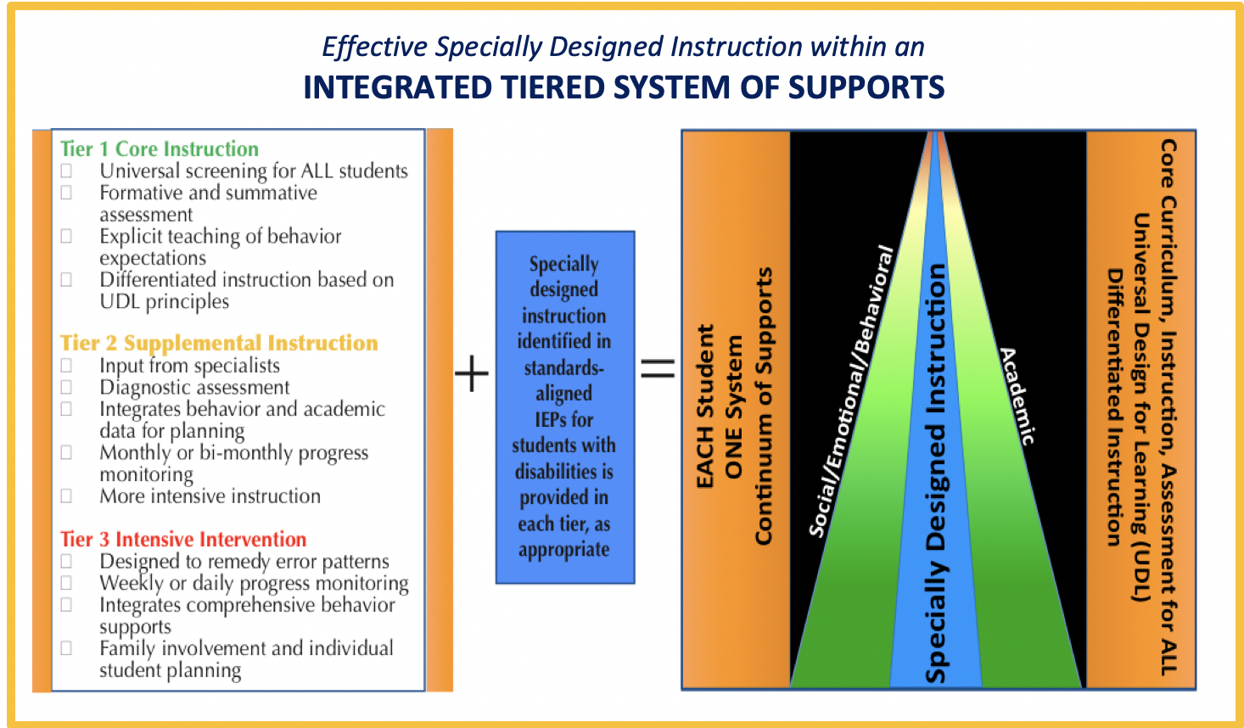

APPENDIX A
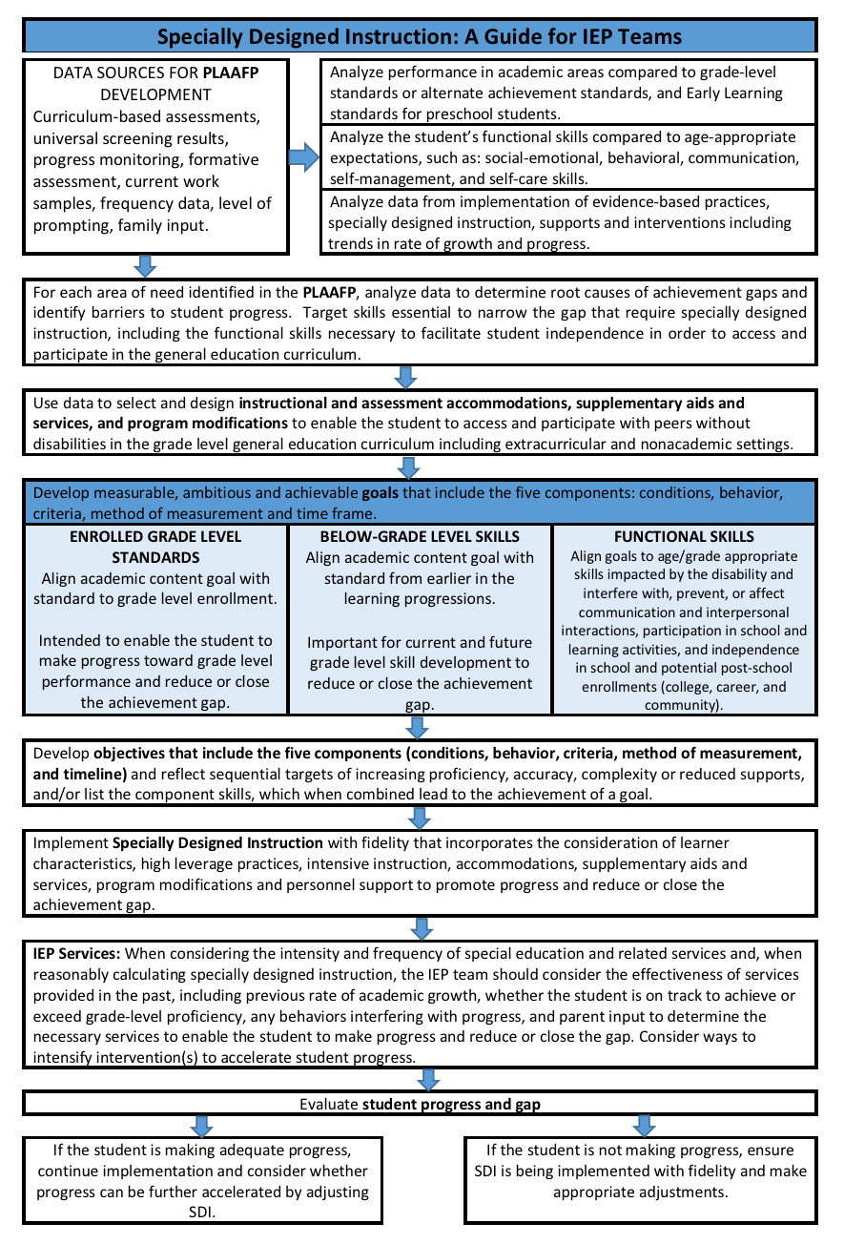

APPENDIX B
Definitions for Clarification
- Access: Access to the curriculum occurs when students participate in the learning activities designed to teach the general education curriculum, so that they make progress toward grade level standards. This is accomplished when students are valued learners in the school community and provided with instructional tools, environments, supports, and services that are customized to their abilities and unique learning needs.

- Accommodations: Accommodations are practices and procedures that provide students with disabilities equitable access during instruction and assessment in the areas of: presentation of content, student response, setting for instruction, and schedule. Examples include communicating through oral speech or a communication device instead of writing, extra time to complete assignments or tests, or reduced distractions in the classroom. The student is expected to demonstrate the same knowledge and skills as other students.

- Adapted Content means that the targeted content when teaching a student with a disability is different from the instructional targets of other students, based on the learning needs posed by the student’s disability. The instructional content for a student with an IEP is aligned with grade level standards and is intended to help the student move toward that standard.

- Adapted Delivery means that the way in which instruction is delivered is different than what is provided to typically developing peers. This may mean reducing instructional group size, using alternative language (e.g., sign language or alternative communication system), or using material or equipment that are different than that offered to all students, even when UDL and differentiated instruction are in place.

- Adapted Methodology means that different or adapted instructional strategies and approaches are being used to teach skills to the student with a disability. Some evidence-based interventions have been demonstrated to be effective in teaching specific reading, math, or behavioral skills. These may be offered to any student though a tiered system of supports. Other specific interventions, such as the Orton-Gillingham Reading Method, are demonstrated through research to teach skills that are affected by a child’s disability. Strategies that are designed to address the learning challenges of a specific disability in addition to the schools tiered intervention system, are modified methods.

- Differentiated Instruction: Differentiated instruction is the way in which a teacher anticipates and responds to a variety of students' needs in the classroom. To meet students' needs, teachers differentiate instruction by modifying the content (what is being taught), the process (how it is taught), and the product (how students demonstrate their learning).

- Disproportionality: Disproportionality occurs when there is an over-representation or under-representation of a specific group of students relative to the presence of this group in the overall student population. This may be influenced by differences in access to, or inequitable opportunity for: intervention services, resources, programs, rigorous curriculum and instruction, environments, or treatment when compared to other groups.

- Equity: An equitable education exists when supports and services are intentional, student and family-centered, and applied differentially to ensure equal opportunity and outcomes. Supports and services are based on individual need, to enable students to achieve similar post-school outcomes regardless of wealth, home language, zip code, gender, sexual orientation, race, or disability. Creating equitable access for students with disabilities involves making content accessible, designing activities that foster student engagement, and ensuring that students can communicate their knowledge and skills.

- Integrated Tiered System of Supports: An Integrated Tiered System of Supports (ITSS) is a school-wide system to provide an equitable education to ALL students in a school community. Through tiered instruction, students who are at risk for academic or behavioral problems, as well as students with extraordinary abilities, are provided interventions that allow them increased opportunities for success. Schools identify and develop evidence-based instructional strategies and interventions, based on valid assessment of student performance that will help each and every student to succeed. Schools implement supplemental and individually designed interventions and monitor the fidelity of implementation of those practices and their impact on student progress. In a school-wide tiered system of support framework, there are effective collaborative teams that use integrated data sources for evaluating the impact of evidence-based interventions. Data decision cycles are in place, according to best practices for integrating academic and behavioral supports in a framework to promote student success.

- Modifications: Modifications change what a student is taught or expected to learn. Examples of modifications may include lowering the reading level of text, simplifying questions on assessments, or reducing the range of skills taught. Modifications may limit the student's ability to master grade level standards and ultimately meet graduation standards. Consequently, IEP teams should carefully consider their impact on student progress.

- Reasonably Calculated: Developing a "reasonably calculated" IEP requires a prospective judgement by the IEP Team. School personnel will make decisions informed by their own expertise, the child's progress, the child's potential for growth and the input provided by the child's parents. IEP Team members consider how or if special education and related services have been provided to the child in the past and consider the effectiveness of specific instructional strategies, supports and services used with the student. To determine whether an IEP is reasonably calculated to enable the child to make progress, the IEP Team considers the child's previous rate of growth, whether the child is on track to achieve or exceed grade-level proficiency, any behaviors interfering with the child's progress and any additional information provided by the child's parents.

- Specially Designed Instruction: Specially designed instruction, or SDI, means adapting, as appropriate to the needs of a child with a disability, the content, methodology, or delivery of instruction to:
  - address the unique needs of the child that result from the child’s disability;
  - ensure access of the child to the general curriculum; and
  - enable the child to meet the educational standards that apply to all children.
SDI is planned, organized and meaningful. It is an intentional and systematic process to address the student's needs based on their current performance and the unique impact of their disability on learning. (34 CFR §300.39 (b)(3)).

- Universal Design for Learning: Universal Design for Learning, or UDL, is an instructional framework that focuses on teaching learning processes in a way that will serve the needs of the greatest number of students in an educational setting regardless of their learning characteristics and/or perceived abilities. The UDL framework for teaching and learning includes proactive planning of curricula (goals, assessments, methods, and materials) and takes into account the variability of all learners and is based on research from the learning sciences (e.g., education, psychology, neuroscience). UDL has three guiding principles: engagement, representation, and action and expression (www.cast.org):
  - Engagement: Offer flexible options to engage learners in the learning environment.
  - Representation: Present information in multiple ways.
Action and expression: Provide students a variety of opportunities and avenues to express what they know.

APPENDIX C
The Five-Step Process for Selecting Accommodations
for Students with Disabilities

Selecting, implementing, and evaluating accommodations for student use
in instruction and assessment involves a five-step process.
1) | Start with a mindset of high expectations. Students with disabilities should be expected to achieve grade level academic content standards.
2) | Educators should be familiar with the intention of each accommodation and with Maryland policy regarding accommodations during instruction and assessment.
3) | The process of making decisions around the selection of accommodations starts with gathering and reviewing information about the student’s disability and present level of academic achievement and functional performance in relation to State and local academic standards. The process of making decisions about accommodations is one in which IEP team members work to provide the student with equitable access to the general education curriculum.
4) | Accommodations are intended to reduce or eliminate the effects of a student’s disability. The accommodations provided to students must be the same for classroom instruction, classroom assessments, district assessments, and where allowable, on State assessments. The administration of an assessment should not be the first time the accommodation is introduced to the student. It should be noted that, although some accommodations may be appropriate for use in instruction, some accommodations may not be appropriate for use in a Statewide standardized assessment.
5) | Accommodations must be selected on the basis of the individual student’s strengths and needs. Data on the use, impact, and effectiveness of individual accommodations should be gathered and evaluated regularly. These data drive evidence-based decision making for the selection of, or elimination of, accommodations.
Best practice includes ongoing professional learning to support the appropriate selection, implementation, and evaluation of instructional and assessment accommodations for general and special education staff, including IEP team chairpersons and families, as appropriate.

Source: Maryland Assessment, Accessibility, and Accommodations Policy Manual, October 2017

APPENDIX D
Individualized Supplementary Aids, Services,
Program Modifications, and Supports

SAMPLE

“Supplementary aids, services, program modifications, and supports” means aids, services, and other supports that are provided in general education classes, other education-related settings, including extracurricular and nonacademic settings, to enable a student with a disability to be educated with students without disabilities.

Equipment

Wheelchair or adapted chair

Computer access, special software

Assistive communication device, voice generating device

Specialized utensils, cups, plates, pencils

Adapted toilet

Hearing aids, FM system

Braille writer

Audio-books

Subtitles/Closed-captioned videos

Materials

Scanned tests and notes into a computer

Shared note-taking by peer or instructional assistant

Large print or Braille

Highlighting tape

Graphic organizers

Modified assignment work sheets (e.g., fewer problems, graphics added)

Visual / picture schedule on wall

Personal schedule for self-monitoring

Manipulative items for math or calculators

Color code materials (folders, papers, markings)

Environmental Supports

Preferential seating in the classroom, at lunch, and in other locations

Altered physical arrangement of desks, chairs, or other material and equipment

Reduced sound or lighting

Adapted Assignments

Shorter assignments

Recorded lessons

Less complex assignments

Alternate methods of demonstrating knowledge through assignments

Instructional Modifications

Altered or modified assignments

Additional time to complete work

Chunking of text

Pre-teach vocabulary/ content

Re-teach concepts taught

Targeted instruction for specific skills

Social Supports

Advance preparation for schedule change

Encourage student to ask for help, when needed

Direct instruction in social interactions

Educator Knowledge and Skill Development

Specific interventions and instructional strategies

Use of special equipment and materials

Adapting materials and modifying lessons

Understanding the student’s disability

Delivery of specially designed instruction

Data collection and progress monitoring

APPENDIX E
High Leverage Practices for Inclusive Classrooms
(Adapted from McLeskey, et al., 2019)
Collaboration  - Collaborate with professionals to increase student success.  - Organize and facilitate effective meetings with families.  - Collaborate with families to support student learning and secure needed services.  Assessment  - Use multiple sources of information (data) to develop a comprehensive understanding of student strengths and needs.  - Interpret and communicate assessment information with stakeholders to collaboratively design and implement educational programs.  - Use student assessment data, analyze instructional practices and make necessary adjustments to improve student outcomes.  Social-Emotional  - Establish a consistent, organized and respectful learning environment.  - Provide positive and constructive feedback to guide students’ learning and social behavior.  - Teach social behaviors.  - Conduct functional behavior assessments to develop individual student behavior support plans. | Instruction  - Identify and prioritize long-and short-term learning goals.  - Systematically design instruction toward a specific learning goal.  - Adapt curriculum tasks and materials for specific learning goals.  - Teach cognitive and metacognitive strategies to support learning and independence.  - Provide scaffolding supports.  - Use explicit instruction.  - Use flexible grouping.  - Use strategies to promote student achievement.  - Use assistive and instructional technologies.  - Provide intensive intervention.  - Teach students to maintain and generalize new learning across time and settings.  - Provide positive and constructive feedback to guide students’ learning and behavior.

To access a comprehensive guide of high leverage practices, visit
https://highleveragepractices.org/

APPENDIX F
Resources

General Information
- Maryland Learning Links: A dynamic website developed by the Division of Early Intervention and Special Education Services that provides stakeholders, including families and professionals, with current educational information, guidance about the IEP process and the provision of special education and related services, best practices, and other special education related resources. https://marylandlearninglinks.org/

Standards
- Core Content Connectors: Maryland’s alternate achievement standards for English/language arts and mathematics for students with the most significant cognitive disabilities. https://wiki.ncscpartners.org/index.php/Core_Content_Connectors
- Essential Elements for Science: Maryland’s alternate achievement standards for science for students with the most significant cognitive disabilities. http://dynamiclearningmaps.org/sites/default/files/documents/Science/Science_EEs_Combined_final_Sept_2017.pdf
- Maryland Content Standards: Maryland College and Career Ready Standards for English/Language Arts and Mathematics, as well as previously adopted standards for other content areas. http://mdk12.msde.maryland.gov/instruction/commoncore/
- Maryland Curriculum Frameworks: Descriptions of the component skills required for students to master the standards, which may be used to scaffold goals and develop objectives. English language arts http://mdk12.msde.maryland.gov/instruction/curriculum/reading/index.html and mathematics http://mdk12.msde.maryland.gov/instruction/curriculum/mathematics/index.html
- Maryland Early Learning Standards: Key aspects of development and learning for the youngest learners (birth through age 8), which may be used to align goals for preschool students. http://earlychildhood.marylandpublicschools.org/node/284
- Next Generation Science Standards: Maryland standards for science. https://www.nextgenscience.org/
Standards Aligned IEPs
- Hedin, L., & DeSpain, S. (2018). SMART or Not? Writing Specific, Measurable IEP Goals. Teaching Exceptional Children, 51(2), 100–110.
- Maryland State Department of Education: Maryland Assessment, Accessibility & Accommodations Policy Manual. http://www.marylandpublicschools.org/programs/Pages/Special-Education/info.aspx
- McLaughlin, M. (2009). Keys to creating standards-based IEPs. Special EDge Newsletter: Article describing the need for and strategies for developing IEPs aligned to state content standards. http://www.educationcoordinatingcouncil.org/ECC_DOCS/Links_Docs/EDge_fall_09.pdf
- Standards aligned IEP modules. https://marylandlearninglinks.org/online-iep-learning-modules/
- U.S. Department of Education, 2004. Individuals with Disabilities Education Act (IDEA) (2004): US Department of Education resource site including the text of IDEA and related documents and guidance. http://uscode.house.gov/view.xhtml?path=/prelim@title20/chapter33/subchapter2&edition=prelim
- U.S. Department of Education (Dec. 7, 2017). Questions and Answers (Q&A) on U. S. Supreme Court Case Decision Endrew F. v. Douglas County School District Re-1. Interpretation of the impact of the recent US Supreme Court decision on goals and programs for students with disabilities. https://www2.ed.gov/policy/speced/guid/idea/memosdcltrs/qa-endrewcase-12-07-2017.pdf
- Yudin, M. and Musgrove, M. (2015, Nov. 15). Dear Colleague Letter. Washington DC: United States Department of Education, Office of Special Education and Rehabilitative Services. Guidance from OSEP on the alignment of IEPs to state content standards. https://www2.ed.gov/policy/speced/guid/idea/memosdcltrs/guidance-on-fape-11-17-2015.pdf

Alternate Assessment
- Maryland Guidance for Individualized Education Program Teams on Participation Decisions for the Alternate Assessments: Information, tools, and frequently asked questions to assist IEP teams in determining whether or not a student should participate in the alternate assessment. Use of Appendix A is mandatory in determining eligibility for participation in the alternate assessments and alternate educational framework. http://marylandpublicschools.org/programs/Documents/Special-Ed/PSTA/DEISESAltAssessmentParticipationGuidance_04-2019.pdf
- National Center and State Collaborative website contains information for parents and professionals relating to the alternate assessment system and related content to assess the English Language Arts and Mathematics achievement of students with the most significant cognitive disabilities. http://www.ncscpartners.org/

Family Engagement
- Building IEPs With Maryland Families: What a Great IDEA! A family-friendly resource on the IEP team process.http://olms.cte.jhu.edu/olms2/data/ck/sites/315/files/BuildingIEPswithMarylandFamilies_WebVersion(1).pdf
- MSDE DSE/EIS Parental Consent Under Maryland Law Technical Assistance Bulletin, November, 2017- Guidance on complying with the new requirements for parental consent for certain IEP team decisions. http://www.marylandpublicschools.org/programs/Documents/Special-Ed/TAB/MDTABulletinParentalConsentUnderMdLaw112017.pdf
- MSDE DSE/EIS Native Language Technical Assistance Bulletin, November 7, 2016 – Guidance on complying with requirement to make special education documents available to families in their native languages. http://marylandpublicschools.org/programs/Documents/Special-Ed/TAB/MDTABulletinNativeLanguage.pdf
- A Parent’s Guide to Understanding Your Individualized Education Program (IEP) Rights and Responsibilities in MD. http://marylandpublicschools.org/programs/Documents/Special-Ed/IEP/ParentsGuideUnderstandingIEPRightsResponsibilities.pdf
- U.S. Department of Education Family and Community Engagement - Resources for families and educators on family-school partnerships (not specific to special education).https://www.ed.gov/parent-and-family-engagement
Specially Designed Instruction
- Billingsley, B., Brownell, M.T., Lewis, T.J., Maheady, L., & McLeskey, J. (Eds.). (2019). High leverage practices for inclusive classrooms. New York, NY: Routledge.
- Fuchs, L.S., Fuchs, D., & Malone A.S. (2017) The taxonomy of intensive intervention. Teaching Exceptional Children, 50(1), 35-43.
- Riccomini, P.J., Morano, S., & Hughes, C. A. (2017). Big ideas in special education: Specially designed instruction, high-leverage practices, explicit instruction, and intensive instruction. Teaching Exceptional Children, 50(6), 1-8.
- Taxonomy of Intervention Intensity Overview, July 2019 - National Center on Intensive Intervention webinar on using the Taxonomy of Intervention Intensity to select and adjust intervention to accelerate student progress https://intensiveintervention.org/resource/taxonomy-intervention-intensity-overview

For more information, call 410-767-0249
MARYLAND STATE DEPARTMENT OF EDUCATION
Division of Early Intervention and Special Education Services
200 West Baltimore Street
Baltimore, MD 21201

Karen B. Salmon, Ph.D.
State Superintendent of Schools

Brigadier General Warner I. Sumpter (Ret.)
President
State Board of Education

Carol A. Williamson, Ed.D.
Deputy State Superintendent for Teaching and Learning

Marcella E. Franczkowski, M.S.
Assistant State Superintendent
Division of Early Intervention and Special Education Services

Larry Hogan
Governor

