Guidance for IEP Teams Working With Students with Significant Cognitive Disabilities: Assessment, Instruction, and Placement

Date: Issued September 2022

INTRODUCTION
The purpose of special education, as defined by the Individuals with Disabilities Education Act (IDEA) and reiterated by the United States Supreme Court in Endrew F v. Douglas County School District, 580 U.S. __ (2017), is to ensure that all children with disabilities receive a free appropriate public education (FAPE) to meet their unique needs and prepare them for further education, employment, and independent living. All students with disabilities must have an IEP “reasonably calculated to enable a child to make progress” appropriate in light of their unique circumstances and “every child should have the chance to meet challenging objectives.” In Maryland, these objectives are expressed in the Maryland College and Career Ready Standards (MCCRS) and in Local Education Agency (LEA) curricula. Students’ achievement of standards is measured in a variety of ways, including through the successful completion of state and local assessments.
While the focus on the implementation of consistent standards and high expectations applies to all students, the law recognizes that a small group of students with the most significant cognitive disabilities may be unable to achieve the standards that apply to all students, even with the provision of extensive and intensive specially designed instruction, supports and accommodations. These students require instruction and standards that are modified to focus on essential grade level skills and allow for intensive direct instruction and repeated practice of skills. Their educational attainment is measured through an Alternate Assessment that is based on the MCCRS but aligned to alternate academic achievement standards that reflect reduced complexity, breadth, and depth. Instruction and assessment based on this Alternate Education Framework may not allow the student to earn course credits and acquire the skills necessary to receive a Maryland High School Diploma.
The decision to align instruction and/or assessment to the Alternate Education Framework is one of the most significant recommendations an IEP team makes about a student’s education and future. Because of the consequences of this decision, the Division of Early Intervention and Special Education Services (DEI/SES) has developed criteria and a detailed analysis process to guide IEP teams in their consideration of a student’s eligibility for instruction and assessment aligned with the alternate academic achievement standards. The IEP team must review this decision annually. Maryland law also requires that parents’ consent to instruction and/or assessment of their student aligned with the alternate academic achievement standards (AAAS).
The purpose of this guide is to provide additional information and support to IEP teams in making these critical participation decisions, as well as in developing IEPs for students determined eligible for instruction and/or assessment aligned to the alternate academic achievement standards. This document reviews the requirements for eligibility to assist teams in ensuring that only those students who truly meet the criteria are participating in the Alternate Framework. It also provides considerations for the development of appropriate IEP goals and objectives, and for determining the Least Restrictive Environment (LRE), including suggestions for instructional strategies and supports that may be helpful in improving inclusive learning and active classroom membership with meaningful outcomes for students with the most significant cognitive disabilities.
What is the 1% Threshold?
The Every Student Succeeds Act (ESSA) requires that the State ensure that the total number of students participating in the Maryland Alternate Assessment does not exceed the one percent (1.0%) threshold of the total number of students within the State who are assessed within the Maryland Comprehensive Assessment Program (MCAP). As a component of ESSA oversight, MSDE requires each local school education agency (LEA) to project the percentage of students participating in one or more of the alternate academic assessments as compared to the total number of students participating in all academic assessments. Any LEA that anticipates exceeding the one percent threshold for the number of students participating in one or more of the alternate academic assessments is required to submit a justification to the MSDE. The MSDE and local system regularly monitor the IEP team decision-making process related to eligibility and participation in instruction and/or assessment aligned to alternate academic achievement standards. Systems with higher than anticipated participation are required to review the development and implementation of local policies, guidance, professional development, and coaching to ensure the quality of IEP team decision-making.
However, an IEP team should not consider the number/percentage of students in the district participating in the alternate assessment when considering the eligibility of an individual student for instruction and assessment according to alternate academic achievement standards. Each IEP team decision is based on a thorough review of the information described in this document and Alternate Appendix A in order to make an appropriate determination for the individual student.

THE ALTERNATE ACADEMIC ACHIEVEMENT STANDARDS AND ASSESSMENT FRAMEWORK
All Maryland students are expected to meet rigorous expectations and demonstrate their proficiency through a variety of methods, including State assessments. These expectations are defined by the Maryland College and Career Ready Standards (MCCRS) and implemented through the learning activities designed at the system, school, and classroom level.
ALL students are taught the content and skills outlined in the MCCRS. Most students with disabilities are expected to demonstrate mastery of the general standards through participation in the general assessment and have the opportunity to earn a high school diploma. A small number of students with the most significant cognitive disabilities cannot demonstrate their learning and progress on the standard assessment. For these students, learning is assessed according to AAAS. The AAAS are measures of attainment of the skills that reflect reduced complexity, breadth, or depth as compared to the general standards. The skills measured through the alternate academic achievement standards are components of the grade-level MCCRS and Next Generation Science Standards (NGSS); they do not represent a separate set of standards.
The AAAS on which Maryland students participating in the Alternate Educational Framework are assessed are known as the “Essential Elements” (EEs) and are developed by Dynamic Learning Maps (DLM). An EE is a representation of the essential “core” or big idea of the content standard in the MCCRS and NGSS. Each EE was identified by examining hypothesized learning progressions developed by the Dynamic Learning Maps (DLM). Each EE is a specific statement of knowledge and skill linked to grade band expectations. EEs address a small number of standards, representing the breadth but not the depth of coverage across the entire standards framework.
These elements represent key skills on which students will be assessed and inform the prioritization of skills in the development of IEP goals and ongoing instructional plans. Although sometimes referred to as the “Alternate Curriculum,” they do not reflect or require an “alternate curriculum.” Because the students are not assessed on the full breadth and depth of the curriculum, they generally do not have the opportunity to earn high school credits or to receive a Maryland High School Diploma. They exit school with a Certificate of Program Completion. For more information on the DLM and the EEs, visit the Dynamic Learning Maps website.
Examples of MDCCRS and Aligned Essential Elements
Domain | Grade Level Standard | DLM Essential Element
ELA: Reading (Informational Text) - 5th Grade | RI 5.3: Explain the relationships or interactions between two or more individuals, events, ideas, or concepts in a historical, scientific, or technical text based on specific information in the text. | EE. RI.5.3: Compare two individuals, events, or ideas in a text.
Mathematics: Algebra - High School | A.REI.12. Graph the solutions to a linear inequality in two variables as a halfplane (excluding the boundary in the case of a strict inequality), and graph the solution set to a system of linear inequalities in two variables as the intersection of the corresponding half-planes. | M.EE.A.REI.10–12. Interpret the meaning of a point on the graph of a line. For example, on a graph of pizza purchases, trace the graph to a point and tell the number of pizzas purchased and the total cost of the pizzas.
Science: Life - Middle School | MS-LS2-2: Construct an explanation that predicts patterns of interactions among organisms across multiple ecosystems. | EE.MS-LS2-2Use models of food chains/webs to identify producers and consumers in aquatic and terrestrial ecosystems

Assessment Design and Administration in English/Language arts and mathematics
The alternate assessments for English/language arts (reading and writing) and mathematics are given in grades 3 through 8 and 11. These are online assessments (with paper and pencil option) of approximately 30 test items that assess approximately ten prioritized content targets per grade level in each content area. These content targets were identified for each grade based on learning progressions and alignment to the grade level MCCRS. The assessments include multiple choice items and constructed response items. Each content target is assessed by items that have been carefully and intentionally designed to assess a range of ability and performance.
The assessment design includes allowances for flexibility in administration (for example, a student may respond to administrator-presented stimuli rather than to the item stimuli on the computer). A trained testing administrator familiar to the student (e.g., the student’s teacher) facilitates the administration. Items are administered over the course of one or more testing sessions as needed.
Testing sessions are scheduled within a testing window of approximately eight weeks, dictated by the State. Assessment Design and Administration in Science The Alternate Maryland Integrated Science Assessment (Alt-MISA) is an online assessment which measures a participating student’s progress on attainment of knowledge and skills linked to the grade span expectations of the Next Generation Science Standards (NGSS) in grades 5, 8, and 11. The Science Essential Elements (EE) address a small number of science standards, representing the breadth, but not the depth, of coverage across the entire standards framework. A trained testing administrator familiar to the student (e.g., the student’s teacher) facilitates the administration and items are administered over the course of one or more testing sessions as needed.
Guidance for Participation Decisions
The development of every IEP, both initial and annual review, includes the IEP team’s planning for the student’s participation in assessments. Teams start from the expectation that the student will participate in the general assessment, with presentation, response, setting, and timing accommodations individually selected as required to provide the student equitable access. Most students with disabilities, including many of those identified with an Intellectual Disability, will participate in the general assessment.
If the team believes that the student may have a significant cognitive disability that makes the general assessment inappropriate, they engage in a careful review of multiple sources of data to determine if the student meets the criteria for instruction and assessment based on alternate academic achievement standards. The team engages in a thorough process of gathering and reviewing assessments and other information, considering factors impacting student performance, making a determination, and ensuring parent understanding and parent consent, documenting each step of the process on Alternate Appendix A.
Alternate Appendix A must be completed annually and stored in its entirety within the student’s electronic record.

Participation Criteria
To be determined eligible to participate in instruction and assessment based on alternate academic achievement standards, the student must meet all the following criteria (as documented within Alternate Appendix A). If any of the following is not true of the student, the student is NOT eligible and participates in the general assessment.
- The student has an IEP that includes Specially Designed Instruction (including accommodations, supplementary aids and services, program modifications, goals and objectives, special education, and related services) and performance data that demonstrates that even with these supports, the student cannot access the breadth and depth of the general standards.
Only students who receive special education services are eligible to participate in the Alternate Assessment. The IEP reflects extensive support designed to support the student’s unique academic and functional needs. The team must ensure that the student’s inability to access the breadth and depth of the standards is due to the disability, rather than a need for appropriate instruction and support.
AND
- The student has a “significant cognitive disability.”
A significant cognitive disability is determined by a holistic understanding of a student’s development and performance in a variety of settings. A particular score on a standardized assessment may be one consideration but should not be the sole or primary consideration. For a student to be determined to have a significant cognitive disability, a review of student records must indicate a disability or multiple disabilities that significantly impact cognitive functioning, educational performance, and adaptive behavior. The IEP team reviews and discusses multiple sources of information for evidence of a significant cognitive disability including, for example, psychological assessments, assessments of adaptive skills, educational assessments, classroom observations, and other formal and informal assessment data. A significant cognitive disability is pervasive and affects learning across all content areas and impacts adaptive behavior. Students with significant cognitive disabilities require extensive instruction and support not just to acquire academic content but in all aspects of participation in school and community life, including communication, social interaction, self-management, leisure, and recreational activities, and employment.
The IEP team reviews data from multiple sources for each area. Individual standardized assessments of cognitive ability, adaptive behavior, and educational performance are reviewed and documented on Alternate Appendix A. In addition to formal assessments, the team must also consider informal measures, classroom performance, school, district, and state-wide assessments, service provider and family input, along with other information. One or more individuals with expertise in interpreting assessments, including the impact of physical and language disabilities on performance (if applicable to the student), should be part of the team.
If valid standardized assessment scores are not available in a particular domain, the team must detail in Alternate Appendix A why an assessment could not be conducted and what other information the team used to determine the presence of a significant cognitive disability. Teams must exercise caution in determining a student eligible in the absence of valid assessment results.
AND
- The student is learning content derived from the Maryland College and Career-Ready Standards in English/language arts and Mathematics and the Next Generation Science Standards.
The grade-level aligned content the student is learning is significantly modified to allow the student to access knowledge and skills. The student’s disability or disabilities affect how the student learns curriculum derived from the MCCRS and NGSS. The team reviews evidence, such as adapted instructional materials, work samples, intervention and progress monitoring data, and service provider and family input, to determine if the student requires significant modification to the content and delivery of instruction.
If a student has not had the opportunity to access the full breadth and depth of the curriculum and standards with appropriate SDI, the team should exercise extreme caution before determining the student is unable to participate in the general assessment. This is the case with our young learners and students who have had interrupted, no education, or unknown educational experiences.
AND
- The student requires extensive, direct, individualized, and repeated instruction and substantial support to achieve measurable gains in adapted and modified curriculum.
The student’s need for extensive, individualized, repeated, and direct instruction is ongoing and evident across content areas, not just in one subject or skill. Classroom and intervention data on the student's response to instruction using evidence-based strategies, examples of instructional activities, PLAAFP statements from the IEP, and service provider and family reports are reviewed to give the team a full picture of the type of instructional support the student receives and requires. Trend data collected over multiple years shows the student’s need for extensive, individualized, repeated and direct instruction.
Note: Determination of eligibility for participation in the alternate assessment is a separate IEP team decision-making process and is made based on individual student assessment and performance data, rather than a particular medical diagnosis or special education eligibility category. The majority of students in all eligibility categories participate in the general assessment. Most students who are determined to have significant cognitive disabilities are eligible for special education under the categories of Intellectual Disability, Autism, or Multiple Disabilities. When determining eligibility for the alternate framework for a student outside of those categories, the IEP team should exercise extra caution to ensure that all information is accurate and consistent and may need to consider whether the disability category accurately reflects the student’s needs.

Additional Considerations for Participation Decisions
Because the decision to instruct and assess a student according to the alternate academic achievement standards has such significant implications for the student’s school experience and post-school outcomes, it is critical that teams not allow inappropriate factors to influence the decision. Only those students who truly have the most significant cognitive disabilities and cannot appropriately participate in the general assessment with accommodations should be determined eligible.
The team must rule out other factors that may be contributing to the student’s difficulty in accessing and mastering grade-level content standards. If the team recognizes that one or more of these factors may be impacting the student’s learning, additional supplementary aids, services, and other supports should be put in place to address the issue. Students are not eligible for the alternate educational framework if their learning difficulties and/or limited rate of progress may be attributable to:
- Poor attendance or extended absences, including disengagement due to school closure
- Social, cultural or economic differences
- English Learner (EL) status
- Low reading and mathematics achievement level (without other evidence of significant cognitive disability)
- Interfering behavior that prevents the student from participating in instruction or assessment.
- Need for Augmentative and Alternative Communication (AAC) or other assistive technology to access learning and/or participate in an assessment.
- Lack of engagement or the inability to receive a FAPE due to factors impacting the student or the entire school system (e.g., medical needs, extended school closure).
The team’s determination that the student may have difficulty with, or not perform successfully on, the general assessment is also not an acceptable reason to instruct or assess the student according to alternate achievement standards. Students with and without disabilities who are not proficient on the assessment should receive intensified supports while continuing to have the opportunity to progress towards a high school diploma. In response to educator or parent concerns about how the student’s emotional or behavioral response to the assessment, the team considers the allowable accommodations, which include adaptations to the presentation of materials and student response, as well as of the assessment setting (e.g., separate location, frequent breaks, etc.).
Lastly, administrative and programmatic factors should also not impact the decision. Teams should not base eligibility decisions on:
- Academic and other services the student receives
- Educational environment or instructional setting
- Percent of time receiving special education services
- Impact of test scores on the accountability system
- Administrator preference
- Number of students in a district participating in the Alternate Assessment
Low academic achievement must be differentiated from significant global delays as evidenced by multiple sources, such as adaptive scores, classroom, community, social, and work performance. Below average cognitive scores alone also do not mean that a student is eligible for the alternate assessment - the impairment must be significant and pervasive.
IEP Team Tools and Resources
Alternate Appendix A: Participation Criteria and Checklist. This required form guides and documents the team’s process of reviewing assessment results, student performance data, current instructional supports, and other data to determine eligibility for instruction and assessment aligned to alternate academic achievement standards. Appendix A must be completed annually and uploaded to the student’s electronic record in its entirety.
Alternate Appendix B: Decision Flowchart for Participation. This flowchart shows the sequence of decisions made by the student’s IEP team when determining whether a student is eligible to participate in instruction and assessment according to alternate academic achievement standards.
Alternate Appendix C: Parental Consent Form. IEP teams are required by law (Effective July 1, 2017) to obtain parental consent annually for the child to participate in the alternate assessments and/or instruction aligned with alternate academic achievement standards. Appendix C is a model form used to document consent or refusal of consent; local school systems may use this or an alternative form that captures similar information.

Communicative Competence
Many students with significant cognitive disabilities also have complex communication needs and may not express themselves effectively with verbal speech alone. Communicative competence is the ability to express needs, wants, opinions, and knowledge and is the foundation of meaningful participation in educational environments and beyond. Developing a consistent, effective, and reliable means of symbolic communication is a high priority for any student who does not have one. The IEP should reflect the student’s communication needs in the PLAAFP and the “Special Considerations” section, with goals, supplementary aids, assistive technology, special education, and related services addressing this need as appropriate for the individual student.
Note: Not all students with complex communication needs have significant cognitive disabilities. Many students who use Augmentative and Alternative Communication participate in the general assessment with accommodations and supports. It is very difficult to determine whether a student who is unable to communicate effectively is eligible to participate in the alternate achievement standards and assessments if they cannot share their understanding. Accordingly, extreme caution must be exercised when making determinations about eligibility for students with limited or no effective communication system. Assisting students to establish a functional communication system is key to making appropriate decisions about their educational future.

Young Children
Although children below third (3rd) grade do not participate in Statewide assessments, the IEP team may consider whether the student is eligible for instruction and assessment aligned with the alternate academic achievement standards if the child is suspected to have a significant cognitive disability. Because young children are developing at a rapid pace and the true nature and impact of their disabilities may not be fully evident, “caution should be exercised when determining eligibility for students in early grades as this may preclude them from progressing through the general education curriculum and will, ultimately, impact their ability to earn a high school diploma.” (Maryland State Department of Education, Division of Early Intervention and Special Education Services Technical Assistance Bulletin #19-07, Improving Outcomes For Students With Significant Cognitive Disabilities: Eligibility, Instruction, and Assessment).
This is especially true for young students with limited exposure to English, limited formal language/symbolic communication, physical or sensory disabilities that impact their ability to explore and interact with the world around them, and/or other circumstances that may impact the reliability and validity of assessments, especially cognitive assessments. Teams should be confident that the reason for the child’s delays is truly a significant cognitive disability rather than other factors before determining that a student should participate in the alternate framework. Authentic assessments, family questionnaires, formative assessments like the Early Learning Assessment (ELA), information from the Child Outcome Summary process, provider reports, and standardized assessments may all contribute to the team’s understanding of the child’s abilities and needs.
The IEP team should consider the benefits and drawbacks of deciding to instruct and assess the student according to alternate academic achievement standards rather than continuing to offer the student the full breadth and depth of the curriculum, recognizing that the decision will be reviewed on an annual basis. All young children, with or without disabilities, participate in formative assessments (such as the ELA) that are aligned to Maryland’s Early Learning Standards, which were developed from Healthy Beginnings and the Maryland College and Career-Ready Standards (MCCRS). If the team determines that a young child should be instructed and assessed by alternate academic achievement standards but in subsequent years that decision turns out to be inappropriate, the child’s progress may be hampered by gaps in knowledge and skills from not being instructed on all standards. The potential for harm to the student is reduced by continuing with participation in the general education framework.
Initial Eligibility Scenario: A nonverbal student is entering kindergarten for the first time. His parents have worked with him at home, but he did not go to preschool. His parents report that he has two older siblings (7 and 10) who talk to him all the time and seem to understand what he wants- he uses gestures and points if he really wants something- otherwise he is fairly content with whatever happens. He does, however, have meltdowns periodically, about once a week, when the family wants to leave the house to go somewhere all together. It doesn’t happen all the time and it isn’t when they are visiting the same place. The student is toilet trained, started walking at 3, does not write or draw, and has a very immature grasp. He can finger feed and attempts to use utensils but has difficulty due to his grasp. The student does not identify letters but does recognize his name on the home job chart. His jobs are to put the dish towels in the drawer when they come out of the dryer and to sort silverware. He does both jobs independently and accurately. He plays with blocks, cars and small animal figures, but has to be monitored because he will chew on plastic. The student does not play with other children his age. He frequently sits and watches his siblings while they play. When he starts school, the student doesn’t respond to instruction. He doesn’t have the same skills as the other students, either in work or play. He watches the other students but does not engage with them. He has no pre-academic skills that the teacher can discern. The student is referred to the IEP team for assessment in October. The team determines that he is intellectually disabled, should participate in the AAAS, and be placed in a separate classroom for over 80% of his school day. Is this the correct decision at this time?

Annual Review
The likelihood of a student fulfilling the graduation requirements to earn a Maryland High School Diploma decreases as a student continues to participate in instruction and/or assessments aligned with Alternate Academic Achievement Standards or DLM EEs. Not earning a Maryland High School Diploma may impact the student’s access to postsecondary education and training programs, employment, military service, and other opportunities. Therefore, it is critical for the IEP team to revisit eligibility decisions in relation to student progress on at least an annual basis.
The team must determine that the student continues to be eligible for instruction and assessment aligned with Alternate Academic Achievement Standards, and the parents must give consent to participate in assessment and/or instruction aligned with these standards every year. This determination must be documented on Alternate Appendix A and included in the student’s electronic IEP record. A full assessment with standardized testing is not required every year, but the team must review the student’s abilities, performance, and progress, including updated information on educational attainment and adaptive behavior.
If a student who has been participating in the alternate framework is no longer eligible or appropriate, the team should develop a plan to address any gaps in the learning so that the student has the opportunity to progress in the general curriculum and potentially earn a Maryland High School Diploma. For secondary students, this plan should include a process to ensure the student has the opportunity to earn sufficient course credits.

Parent Understanding and Parent Consent
Determining that a student meets the criteria for instruction and assessment aligned with alternate academic achievement standards is an IEP Team decision, based on the considerations described above. Families are an integral part of the IEP team and their input about the student’s communication, learning, and performance in a variety of settings is a critical component of the decision.
In addition, parents must provide written consent for their child to participate in the Maryland Alternate Assessments and/or instruction aligned with alternate academic achievement standards (Md. Code Ann., Educ. §8-405(f)). The IEP Team must affirm that the parent understands the decision-making process, including that the decision is reviewed annually, and the implications of the decision, namely that if the student continues with instruction and assessment according to the Alternate Achievement standards, he or she will be unable to complete the requirements for a Maryland High School Diploma. The team should explain to the family some of the potential consequences, in terms of access to post-secondary education, training, and employment opportunities, of not obtaining a diploma. Parent understanding of the decision is documented in Appendix A.
After ensuring that the family understands the decision, the team continues with the determination process. If the team determines that instruction and assessment according to alternate academic achievement standards is appropriate, parent consent is required before the decision is implemented.
- If the parent provides written consent during the meeting, the team documents the consent in the student’s record.
- If the parent provides written refusal during the meeting, the team may not implement the proposed action. The team documents the refusal in the student’s record.
- If the parent does not respond to the question or is not present during the meeting, the IEP team must provide written notice within 5 days of the meeting explaining their right to consent or refuse consent to their child’s instruction and/or assessment according to Alternate Academic Achievement Standards.
- If the parent does not respond within 15 days of the meeting, the team may implement the decision. If the parent provides written consent after the 15 days, the team amends the IEP to reflect the parent’s consent and continues implementing the decision. If the parent refuses consent after the 15 days, the IEP team stops implementing the decision and amends the IEP to reflect the refusal. In the event of parent nonresponse, the school team makes every effort to provide the parent with appropriate information about the decision and to obtain consent or refusal. LEAs should note patterns of non-response to determine needs for additional parent education or outreach.
- Instruction and assessment are linked, so the same eligibility criteria apply to both. However, parents may consent to both instruction and assessment according to alternate academic achievement standards, to both, to one and not the other, or to neither.
- If the IEP team disagrees with the parents’ refusal of consent for instruction and/or assessment according to the alternate academic achievement standards and determines that the failure to provide consent results in the child not receiving FAPE, the IEP team may pursue dispute resolution via mediation and due process.
For more information, see Maryland State Department of Education, Division of Early Intervention and Special Education Services Technical Assistance Bulletin #17-02, Parental Consent Under Maryland Law.

Development of IEP Goals and Objectives
Developing IEP goals and objectives for students with disabilities is a collaborative effort that includes general educators, special educators, parents, related service providers, and other IEP team members with knowledge of the child’s individual strengths and challenges. When developing IEP goals and objectives for a student with significant cognitive disabilities, the IEP team follows the same process as for all students receiving special education services.
As outlined in A Guide for Implementing Specially Designed Instruction within an Integrated Tiered System of Support, the team begins with a thorough understanding of the student’s Present Levels of Academic and Functional Performance (PLAAFP). The information reviewed in completing Appendix A, along with other information included in the PLAAFP, provides a complete picture of the student’s current skills and areas for growth. Reviewing trend data that shows the student’s rate of progress over the last several years will help the team set goals that are appropriately ambitious and focus the development of specially designed instruction (SDI) on accelerating the student’s rate of progress.
To begin developing academic goals, the team considers the Maryland College and Career Ready Standards for the student’s enrolled grade. Collaboratively, the team members consider the standards that are most critical for the student’s current and future access to the curriculum as the focus of the goals and objectives. The team may consider targeting critical skills that underlie more than one standard. The Dynamic Learning Maps Essential Elements help the team focus on the most essential skills at each grade level and set ambitious and attainable performance targets.
Like all students with IEPs, a student participating in instruction and/or assessment aligned to alternate academic achievement standards must have at least one goal in each academic area of need (ELA and Mathematics) aligned to one or more grade-level standards. The student may have additional goals aligned to standards below the current grade level to address critical/foundational skills. A student with a significant cognitive disability may be working both on below-grade level foundational skills and on grade-level concepts (with alternate achievement standards).
Each of these types of goals and all supporting objectives must contain the five components identified by MSDE.
5 Components - Goals and Objectives Criteria
The conditions under which the skill will be demonstrated;
A behavioral description of the skill to be observed;
The criteria for measuring achievement of the skill;
The method of measurement; and
The timeframe by which the goal or objective will be achieved.

Student Example
Jeffrey, a 4th-grade student with an Intellectual Disability
PLAAFP excerpts: Math Calculation
- Instructional Grade Level: early-mid Kindergarten
- Verbally rote counts to 15 starting from 1
- Names written numbers up to 10 when presented out of order
- Counts up to 10 real objects by touching each item to indicate it has been counted; beginning to count groups of pictured items using the same strategy
- Given a written number up to 5, produces a set of the correct number of real objects.
- Given a teacher model, represents addition by combining two groups of objects and counting the combined group up to 10 total objects
The core concepts of the 4th grade MCCRS for math that are essential for students to continue to progress in the math curriculum focus on using the four operations, particularly an understanding of multiplication and division, to solve problems. While continuing to build his number sense and foundational computation skills, the team recognizes the importance of providing instruction in these key grade-level concepts, modified to meet his individual needs. The DLM Essential Elements help the team identify key standards and alternate performance levels to inform the goal development.
One 4th grade standard calls for students to: “Interpret a multiplication equation as a comparison, e.g., interpret 35 = 5 × 7 as a statement that 35 is 5 times as many as 7 and 7 times as many as 5. Represent verbal statements of multiplicative comparisons as multiplication equations” (4.OA.1), which includes component skills of understanding multiplication as repeated addition, “equal groups of”, and the commutative property. The related Essential Element emphasizes understanding the connection between multiplication and repeated addition. (M.EE.4.OA. 1-2)
Based on their knowledge of his learning profile and individual needs, the IEP team developed the following ambitious but attainable goal for Jeffrey reflecting alignment with this standard:

Grade Aligned Goal:
Given concrete manipulatives and a visual organizer (Conditions), Jeffrey will solve 10 single-digit by single-digit multiplication problems with an answer within 30 by combining the specified number of equal sets and counting the resulting set (Behavior), with 90 % accuracy across 5 consecutive sessions (Criteria) as measured by student work samples and data sheets (Method of Measurement) by the end of the IEP year (Timeframe).
Objectives that would bridge from Jeffrey’s current level of performance to the target might include:
- Given 5 sets of up to 30 identical concrete objects (Conditions), Jeffrey will count each set correctly (Criteria) by touching each object and saying the number out loud (Behavior) on three different occasions (Criteria) by the end of quarter one (Timeframe), as documented by classroom data collection records (Method of Measurement).
- Given a written single-digit by single-digit multiplication problem and graphic organizer (Conditions), Jeffrey will use concrete manipulatives to create the appropriate number of equal sets of up to 9 objects to demonstrate 5 problems (Behavior) with 90% accuracy for four consecutive problem sets (Criteria) by the end of the 3rd quarter (Timeframe).
- Given teacher modeling and using concrete manipulatives and a graphic organizer to group objects to demonstrate a single-digit multiplication problem (Conditions), Jeffrey will count objects to solve the problem (Behavior) with 90% accuracy for 10 consecutive practices (Criteria) by the end of the 4th quarter (Timeframe).
In addition to at least one grade-level aligned goal, the IEP team might develop goals focused on skills from earlier in the learning progression that are critical to Jeffrey’s access to this and other content moving forward. In mathematics, these might include recognizing written numbers, counting with fluency and accuracy, and comparing quantities.

Below Grade-Level Goal:
Given a printed number line for reference and a verbal direction to “start at ____” (a given number) (Conditions), Jeffrey will count out loud to 30 (Behavior) with no more than one skipped or repeated number on 5 separate occasions (Criteria) as documented on teacher data collection sheets (Method of Measurement) by the end of the IEP year (Timeframe).

Goals Addressing Other Areas
Because a significant cognitive disability impacts all aspects of a student’s development and functioning, most students participating in the alternate education framework will also have at least one functional goal in their IEPs. These goals address communication, self-management, social interaction, and other skill areas that impact the student’s ability to actively engage in the curriculum and school environment with appropriate independence. The adaptive behavior assessment that is part of the eligibility process and the team’s discussion of the student’s performance inform the development of these goals. When selecting areas for functional goals, the IEP focuses on critical skills that support participation in multiple contexts (e.g., following a set of directions, using a schedule, communicating with peers and adults, using available resource to solve problems) rather than discrete tasks or behaviors (e.g., following a recipe, telling time, identifying coins).

Student Example

Functional Goal:
When provided with a verbal/visual prompt (Conditions), Jeffrey will engage in a conversation with a peer or an adult that includes at least three turns for each participant by asking an on-topic question, answering a question appropriately, and/or making a relevant comment (Behavior) on at least four occasions in at least two different settings (e.g., classroom, cafeteria, playground) within one month (Criteria) as measured by teacher data-collection forms (Method of Measurement) by the end of the IEP year (Timeframe).

For transition-aged students (14 and above), the IEP Team considers the student's desired transition outcomes and the skills needed to achieve them when determining which academic standards and functional skills to prioritize in the development of IEP goals and objectives. The transition outcomes inform the focus of specially designed instruction to accelerate the student’s progress towards achieving the required skills. For each postsecondary goal, there must be at least one annual IEP goal that supports the student’s progress toward that goal.

Services and Placement
For all students, including students with a significant cognitive disability, decisions around placement start from the essential principle of Least Restrictive Environment–the student is educated in the general education setting in the school they would attend if not disabled unless the IEP cannot be implemented in that setting. Participation in general education is an evidence-based practice that offers numerous benefits, including access to the rigorous curriculum and rich interactions, as well as peer models of appropriate academic and social behavior. Students participating in general education with appropriate support and specially designed instruction receive academic, social, and behavioral benefits.
The decision that a student should be instructed and assessed according to alternate academic achievement standards does not dictate a particular placement. As for any student with a disability, the setting in which services will be delivered is determined only after the team has developed the goals and objectives and selected appropriate accommodations and supplementary aids, as well as special education and related services.
The fact that the student requires modifications to curriculum, such as alignment to alternate academic achievement standards is not, in and of itself, a reason to remove the student from general education for part, or all, of the day. For many students, modified curriculum can, and should, be implemented in the context of general education classes. Adapted materials and individualized instruction (which may include but is not limited to pre-teaching and re-teaching of key concepts and vocabulary, multi-model presentation of information, extra opportunities for repetition and practice, the use of visuals supports, and other strategies) enable to students to access and progress in the grade-level content. Instruction on grade-level, below-grade level, and functional IEP goals is embedded in on-going classroom activities, provided individually or in small group contexts within the classroom, and/or delivered in targeted pull-out sessions, as is appropriate for the individual student.
Before deciding that a student should be removed from the general education setting for part or all of the day, the team carefully considers alternatives. Many of the supports and strategies that are provided in separate settings can be implemented in the general education setting.
Learner Characteristic | Support Options to Consider
“Distractibility” | - Preferential seating in proximity to teacher and/or peers who provide good models  - Selective use of study carrels, noise-canceling headphones, and other tools for independent work time  - Incorporation of special interests, high-preference activities, and favorite peers into learning activities to increase engagement
“Need for repetition” | - Pre-teaching and re-teaching  - Distributed practice opportunities embedded in routines and other activities  - Targeted instruction during small-group or individual work time
“Emerging communication skills” | - Authentic communication opportunities in real situations  - Aided language stimulation/modeling of augmentative communication methods by teachers, paraprofessionals, and peers  - Peer language and interaction models and opportunities
“Below grade level skills” | - Modified materials  - Modified assessment activities  - Alternate means of presentation (e.g., high-interest, lower reading level books, video/multimedia, etc.)  - Read-aloud/paraphrasing by teacher, paraeducator, or peer  - Intensive individualized instruction on targeted skills (push-in or pull-out)
“Need to develop ‘functional skills’” | - Opportunities for instruction and practice on true “functional” skills embedded in classroom/school routines and activities (e.g., following a schedule, interacting with peers, asking for assistance, completing tasks, etc.)  - Embedded learning opportunities (e.g., serving as time keeper for small group activity to practice elapsed time concepts)  - For transition-aged students, individualized schedules combine academic classes with work opportunities, with a transition to more community-based experiences as the student gets older.
Instructional Scenarios in Inclusive Settings
Accessing Modified Grade Level Content in High School:
Marta’s 9th grade social studies class is studying the evolution of voting rights in the south. Marta is reading on a 2nd grade level (decoding and comprehension). While other students complete a warmup by responding to a writing prompt, the special educator reviews key vocabulary with Marta using picture cards. She watches a video about voting rights with the whole class. Next, the class breaks into small groups to use primary sources and online resources to complete a graphic organizer about major milestones in the fight for voting rights. Marta has cards with short written statements about important events that occurred in the south, photos of activists, and a map of locations where important events occurred that were prepared in advance by the special educator. Marta works in a group with 4 peers. As her group gets to each event, Marta finds the statement and photograph that matches the event and glues them on the map. A peer assists her in reading the statements as needed. An Instructional Assistant is available in the room to support several students with disabilities with their accommodations and specially designed instruction. She redirects Marta as needed.
Embedding Instruction on Below-Grade Level Skills in Elementary School:
The third grade is reinforcing skills needed for multiplication (CCRS: 3.OA.A.1- Interpret products of whole numbers, e.g., interpret 5 x 7 as the total number of objects in 5 groups of 7 objects each.). Eloise’s IEP includes a goal related to one-to-one correspondence. She has difficulty manipulating objects due to her physical disability. She uses a voice-output communication device, mostly in single-word utterances. She recognizes and correctly uses the numbers 1 - 5 and is working on the numbers 6 - 10. She receives direct, individualized pre-teaching to practice identifying and using the number 6. During the whole group lesson, the general educator models on the SMART board how to represent multiplication problems by drawing equal groups of objects. He calls on Eloise to read the number 6 each time it appears in a problem (providing distributed practice). During the practice part of the lesson, most students complete problem sets independently using mental math or drawing representations to solve the equations. The special educator pulls a small group of students with and without IEPs who need to use concrete manipulatives to solve the problems. Eloise receives a modified set of problems that all have the form of 2 x a number between 1 - 5. She counts the targeted number of items into each of two bowls to represent the problem. The teacher or IA then combines the items from the two bowls and points to and counts each one, stopping before the last one (if the total is 6 or fewer), waiting for Eloise to say the correct number on her device. If the total is > 6, the teacher models the last number on the device. The teacher or IA records how many times she selected the correct number from 1 - 6.
Embedding Instruction on “Functional” Skills in Middle School:
The 7th grade earth science class is completing a lab experience on weathering and erosion. The lab requires multiple steps to prepare, test, and record different types of weathering processes in different environments. Isaac has an IEP goal to complete multi-step tasks by following written directions with picture cues. His team decides this lab offers an excellent opportunity for instruction and practice on this goal. The special education teacher prepares a modified set of directions for the lab for Isaac which includes pictures of the materials to be used, with 5 actions to be completed per page. The shelves in the classroom where the materials are stored are labeled with matching pictures. She gives him one sheet at a time and records data on the number of steps he completes correctly and what additional prompts are required. Isaac also practices this goal in art class (to complete a project/activity), in Social Studies (to create a map or other illustration of a key concept), and in Key Club (working with peers to create first aid kits to be distributed by the Red Cross).

Support for School Personnel
If the student’s family or other members of the team begin the IEP process with the idea that the student’s needs can only be met by (new or continued) placement in a particular setting, program, or school, they may be inclined to find the student eligible for the Alternate Assessment in order to facilitate that placement. This approach is not appropriate or in the student’s best interest; eligibility for instruction and assessment aligned to the alternate academic achievement standards is determined only based on the criteria outlined above.
Sometimes the desire for a particular placement or setting is driven by the belief that the staff assigned to that setting have unique knowledge and skills for supporting students with significant cognitive disabilities. Instead of removing the student from general education and their community, the principles of LRE require bringing the expertise to the student through consultation and training. Support for school personnel, such as training in modifying general education learning activities and assessments to reflect alternate academic achievement standards or coaching from an expert in augmentative and alternative communication, are an important component of the student’s program. The IEP Team considers the training and coaching needs of the entire team, including general educators, paraeducators, related service providers, and the family. This inclusive approach to training is especially important for teams with limited previous experience educating a student with significant cognitive disabilities. When including training/support for school personnel as a Supplementary Aid and Service in a student’s IEP, the team should consider training for paraeducators l, as well as other teachers and staff working directly with the student, on implementing the student’s goals and objectives, providing (and fading, as appropriate) effective prompts, supporting and expanding the student’s communication (including using any AAC devices), s, and supporting age-appropriate and meaningful peer interactions.
While adult support, including paraprofessionals, play a key role in the success of students with significant cognitive disabilities, excessive prompting leading to dependence and impacting peer relationships can occur. Adults in how and when to fade support, while, facilitating communication and participation with peers. Identifying and facilitating opportunities for natural and peer support is a key part of this process. High expectations for growth and a belief in the capacity of the student and the peers to adapt and succeed are critical. Preparation is key to success. Planning in advance for professional development needs, engaging central office specialists as well as school-based support staff to coach the instructional team, help analyze data, and modify lessons and materials will promote a positive and meaningful learning outcome.
Supports for School Personnel Scenario:
Molly is a third grader with Autism who will be transitioning from a nonpublic school to her neighborhood elementary school. She is the first nonspeaking student to attend her school in many years. Her IEP includes several supports for team to be able to implement her specially designed instruction effectively. The special educator will receive training during the summer

Myth Busters: Common Misconceptions about the Education of Students with Significant Cognitive Disabilities
Misconception: Students can only be in general education if they can “keep up” with the content and activities.
Students are educated in general education unless the IEP team determines that an individual student cannot receive a free, appropriate public education in that setting. The appropriateness of the student’s progress is determined by the IEP team based on the student’s unique needs and circumstances in light of the impact of their disability. For some students, this means extensive academic and behavioral support, including modifications to the curriculum and (if the student is found eligible through the Appendix A process) to the achievement standards. The need for modifications specifically precluded as a basis for removal to a more restrictive setting by law. 34 CFR 300.116(e). The placement is appropriate if the student is making progress in the curriculum (based on the alternate achievement standards, if appropriate) and on their individual goals, even if that progress looks different from that of other students in the class.
“Inappropriate behavior” is another frequently cited reason for the removal of students with significant disabilities from general education. Many of the kinds of behavioral supports that would be implemented in a segregated setting can also be provided in general education. A student’s environment and schedule can be individualized to accommodate a student’s need for breaks, movement, sensory input, etc. Regardless of setting, analyzing, and addressing the function of behavior by adapting the environment and teaching the student more effective and efficient ways to communicate needs is essential. Lastly, teams must recognize that some behaviors that arise from the student’s disability that may be perceived as “disruptive” (e.g., vocalizations, repetitive movements) are far more concerning to adults than to fellow students; with information and support, teachers and peers can usually accommodate these needs.
Students with and without disabilities learn skills by interacting with each other in the general education environment and other school settings. The most important functional skills in the 21st century are communication skills; math, reading, and writing skills; independent and teamwork skills; social skills; and the ability to identify the need for and request supports. These skills can best be addressed in meaningful contexts and through interactions with e addressed with nondisabled peers at any age. Consider a chemistry experiment; in addition to learning essential elements of the science curriculum, the student has opportunities to receive instruction and practice on core academic skills (reading the directions, computing quantities), measuring, using heat safely, following a “recipe”/process, communicating with co-workers, teamwork, and social interaction. For students with cognitive disabilities who may have difficulty generalizing, practicing these skills in diverse environments and contexts as they are being learned is essential to being able to apply them later in work and community settings.
Misconception: Students with Significant Cognitive Disabilities should be taught a completely different “Alternative Curriculum”
Maryland has one set of standards -- the Maryland College and Career Ready Standards - for all students. The alternate academic achievement standards reflect a modified performance expectation that reduces the depth, breadth, and complexity of mastery to be demonstrated. Instruction for students found eligible for the Alternate Framework based on the criteria described in Appendix A (regardless of their placement) is based on the same content standards as instruction for all students in the State, but the achievement standards are adjusted. Adapting instructional materials, activities, and assessments used by all students to meet the unique needs of a student with a cognitive disability provides the required meaningful access and opportunity to meet challenging academic targets, not just basic “functional” academics. Instructional supports, modifications to instructional materials, modifications to lessons, Universal Design for Learning (UDL), and other strategies can break down instructional barriers that were used as a basis to remove students with significant cognitive disabilities from the general education classroom To support the general education and special education teachers in providing specially designed instruction that enables the student to participate in a meaningful way, paraprofessionals can assist in the classroom and facilitate learning and interaction with peers by implementing modifications to materials and assisting with communication as needed.
Misconception: Including students with significant disabilities is too costly.
Administrative factors like cost and convenience are not appropriate considerations when determining LRE for an individual student. In addition, the often-expressed concern that including students with significant disabilities will require many more resources that segregating them is not born out by experience. The process of educating students with significant cognitive disabilities, in which a general educator with expertise in delivering instruction on the grade levels and a special educator with expertise on adapting instruction and strategies to meet individual needs collaborate to develop, implement, and evaluate specially designed instruction, is the same as for other students with disabilities. With support and coaching, teachers expand their skills to adapt instruction for a wider range of students, which benefits them as professionals and all the students they work with. Instructional supports, accommodations and modifications to curriculum, and related services, as well individual resources that students with the most complex needs require (e.g., adaptive equipment, AAC support, nursing, etc.) will be the same regardless of setting, so while costs shift, they may not necessarily increase. As the utilization of separate programs and schools is reduced, resources associated with staffing, equipping, and administering those programs are available for other uses. Many districts also realize significant cost savings in transportation when students attend their neighborhood schools rather than being bused to regional or district-wide programs. Building the capacity of schools to serve students with more intensive support needs may also reduce costly nonpublic placements.

Frequently Asked Questions
- Who decides whether a student should participate in the alternate assessments and/or instruction aligned with alternate academic achievement standards?
The IEP team makes the determination annually of how a student will participate in instruction and statewide assessments, based on a thorough review of data from multiple sources. No one member of the IEP team makes this decision. This process is guided by and documented in Alternate Appendix A.
Effective July 1, 2017, parents must provide written consent for their child to participate in the Maryland Alternate Assessments and instruction aligned with alternate academic achievement standards (Md. Code Ann., Educ. §8-405(f)).
- How do we know that a student has a “significant cognitive disability”?
A student with a significant cognitive disability faces the most profound and complex learning challenges that are pervasive and affect learning across all content areas, independent functioning, community living, leisure, and vocational activities and therefore require instruction and assessment based on alternate academic achievement standards. The expectations for performance are substantially modified by reductions in difficulty and/or complexity from grade-level expectations, and instructional materials are substantially modified in order to provide meaningful access to the general curriculum. Accommodations and modifications make how the student communicates, responds to the environment, and learns look considerably different from those same characteristics of other students with and without disabilities.
Students with a significant cognitive disability have intellectual functioning well below average that exists concurrently with impairments or deficits in adaptive functioning. Adaptive functioning is defined as the behavior essential for someone to live independently and to function safely in daily life.
Determination for student participation in instruction and assessment aligned on alternate academic achievement standards must be evidence-based and made individually for each student by the IEP team using the criteria set forth in this document. A student who is eligible for instruction and assessment aligned with alternate academic achievement standards is one for whom the general assessments are inappropriate even with accommodations. Students demonstrating mild to moderate cognitive disabilities participate in the general assessment with or without accommodations. Anticipated or past low achievement on the general assessment does not mean the student should take the alternate assessments.
- How do I know if the Maryland Alternate Assessments are appropriate for an English Learner (EL) with an IEP whose language proficiency makes it difficult to assess content knowledge and skills?
An English Learner (EL) may be considered for the alternate assessment if their intellectual functioning indicates a significant cognitive disability using assessments in their primary language as appropriate and they meet the other participation criteria for the alternate assessments. Assessments of adaptive behavior and communication should be interpreted considering linguistic and sociocultural factors and considered alongside progress on IEP goals and objectives and other sources of information to determine if the student meets the criteria for significant cognitive disability. The team also considers the impact of limited or disrupted prior educational experiences when evaluating students who are newly arrived in the US in order to ensure that language learner status and/or educational status are not the reason for the student’s difficulty accessing the breadth and depth of the standards. If an EL with an IEP does not meet the criteria for the alternate assessments, he/she should take the general assessment with or without accommodations as appropriate.
- What if it is impossible to assess a student because the student does not appear to communicate?
Developing a consistent and reliable form of communication should be a high priority from early intervention onward. While continuing to explore options (including augmentative and alternative communication strategies), the team should also recognize that all behavior the student exhibits is a form of communication and use this as a starting point. Communicative competence is a key to accessing the content standards and educational environments. Ideally, all students will have a communication system in place that allows them to demonstrate an understanding of academic concepts prior to participation in statewide accountability assessments. However, students must still participate in the Maryland Alternate Assessments even if their symbolic communication is not yet reliably developed. Each IEP team should continue to provide the necessary supports in order to develop a communication system for a student.
- If a student has been tested in the past on an alternate assessment, but the current IEP team determines that the student does not meet the criteria set forth in Alternate Appendix A, can the student participate in the general assessment?
Yes. The IEP team must ensure that the student receives appropriate instruction on the MCCRS and NGSS and participates in the required general assessment for their current grade level with or without accommodations. The IEP should reflect the team’s decision to assess and instruct the student using general standards and assessment.
- Is it possible that a decision to participate in the Alternate Assessments and/or instruction aligned with Alternate Academic Achievement Standards could change as a student gets older?
Yes. Participating in the alternate assessments and/ or instruction aligned with alternate academic achievement standards requires that the student has a significant cognitive disability and is instructed using content that has been significantly modified from that which is provided to other students. Even though students with significant cognitive disabilities may be identified for special education early, sometimes prior to starting school, many are able to participate in the general assessment during their elementary grades. IEP teams exercise caution before determining a student eligible for instruction and assessment aligned to alternate academic achievement standards in their early school years. If the level of support needed for the student to participate in the breadth and depth of the MCCRS and the general assessment increases, the IEP team may determine that participation in the alternate assessments and/or alternate instructional standards is appropriate. On the other hand, for some students, improved communication skills or other development will reveal greater abilities to master content and skills than were previously recognized, leading a team to recognize that continued participation in the alternate education framework is not appropriate. Annual completion of Alternate Appendix A, reflecting a thorough review and discussion of the student’s performance by the IEP team, is essential.

- What is the relationship between the Maryland Alternate Assessments and a Maryland High School Diploma?
In order to earn a Maryland High School Diploma, a student must meet a number of requirements, as specified by the State Board of Education and local school system, including earning specified course credits, completing service-learning requirements, and passing the general State assessments or completing a Bridge Plan for Academic Validation. COMAR 13A.03.02.09B. If a student with a disability cannot meet the requirements for a diploma but has met other criteria, the student will be awarded a Maryland High School Certificate of Program Completion. COMAR 13A.03.02.09E. The final determination of whether a student will receive a Maryland High School Diploma or a Maryland High School Certificate of Program Completion is made during the student’s final year of high school.
Most students with disabilities participate in the general assessments and earn a Maryland High School Diploma. Some students with disabilities participate in the general assessment but are unable to fulfill graduation requirements and may receive a Maryland High School Certificate of Program Completion
A student with a significant cognitive disability may not meet the requirements for a diploma if the student continues to receive instruction based on alternate academic achievement standards and participates in the alternate assessments through high school. COMAR 13A.03.02.09E(4). In that case, the student would be eligible for a Maryland High School Certificate of Program Completion. However, a student who has participated in the alternate assessments could eventually earn a diploma by meeting all graduation requirements, which includes passing the general education Statewide assessments and earning high school credits. The IEP team must continually monitor the student’s progress to determine if and when that is a possibility, before making the final decision to award a certificate during the student’s last year in high school. COMAR 13A.03.02.09E(3). Because the likelihood of fulfilling the requirements to earn a diploma decreases as a student continues to participate in the alternate assessments and/or instruction aligned with alternate academic achievement standards, it is critical for the IEP team to revisit its eligibility decisions annually in light of student progress.
- Who may we contact with questions about the IEP team decision-making process, access to the general education curriculum or the alternate assessment?
Please contact the Maryland State Department of Education for additional information.
- Division of Early Intervention and Special Education Services: Contact the regional School Age Performance Specialist assigned to your Local School System.
- Division of Assessment, Accountability, and Performance Reporting: Contact the Assistant State Superintendent.

Glossary
- Alternate Academic Achievement Standards: Performance standards which are based on a limited sample of content that is linked to grade-level content standards. This content, however, may not fully represent grade-level content and may include content which is substantially modified.
- Alternate Maryland Integrated Science Assessment (Alt-MISA): The alternate Science assessment based on the Dynamic Learning Maps Essential Elements. For more information, visit the Dynamic Learning Maps (DLM) website.
- Augmentative and Alternative Communication (AAC): Communication generating devices such as text-to-speech communication aids, picture or symbol boards, etc.
- Accommodation: A change in materials or procedures that facilitates access during instruction and assessment. Accommodations do not change the construct or intent of what is being taught or measured. Assessment accommodations are intended to allow the student to participate in the assessment and to produce valid results that indicate what a student knows and can do.
- Adaptive behavior: A collection of behaviors, including conceptual, social, interpersonal, and practical skills, defined as essential for someone to live independently and to function safely in daily life.
- English Learner (EL): A student whose native language is a language other than English or a student who comes from an environment where a language other than English has a significant impact on the individual’s level of English language proficiency. An EL’s difficulties in speaking, reading, writing, or understanding the English language may be a barrier to learning in classrooms instructed in English and to performance on assessments presented in English.
- Essential Elements (EE) for ELA, Mathematics, and Science: Specific statements of knowledge and skills linked to grade-band expectations. EEs address a small number of standards representing the breadth, but not the depth, of coverage across the general education framework. For more information, visit the Dynamic Learning Maps website.
- Evidence: Specific and measurable sources of information being used to identify student characteristics that either meet or do not meet the participation criteria.
- Extensive, individualized, repeated, and direct instruction: Concentrated instruction designed for and provided to an individual student. This type of instruction is needed by students with significant cognitive disabilities to acquire knowledge and skills in content. Students with significant cognitive disabilities are likely to need this to apply knowledge and skills in multiple contexts.
- Learning progression: A description of the way in which typically developing students may develop and build academic competencies over time. Learning progressions are used by teachers to determine where a student is in the process of learning a specific skill or understanding a concept.
- Maryland College and Career-Ready Standards (MCCRS): A set of content standards that define what students are expected to learn at each grade in order to leave school ready for college or careers. For more information on the MCCRS, visit the Maryland College and Career Ready Resources website.
- Maryland Comprehensive Assessment Program (MCAP): The comprehensive assessment program that includes all Maryland State assessments.
- Modification: A change in materials or procedures during instruction and assessment that changes the learning expectations of the grade level content. Modifications during instruction may be appropriate on a temporary basis for scaffolding the student’s understanding and skills. Assessment modifications result in invalid measures of a student’s knowledge and skills and thus should be avoided.
- Next Generation Science Standards (NGSS): Research-based content standards for grades K-12 which set the expectations for what students should know and be able to do.
- Pervasive: Present across academic content areas and across multiple settings including school, home, and community.
- Substantial supports: Support from the teachers and others (e.g., resource teacher, co-teacher, aide) and various material supports within the student’s environment. Examples include adapting text for assessments and learning, and extensive scaffolding of content to support learning.
- Substantially modified materials: Various classroom and other materials that have been altered in appearance and content from the materials that peers without disabilities use for instruction or assessment. Examples include significantly shortening the length of passages or using raised dots and hand-over-hand counting when identifying a matching number in mathematics.
Alternate Appendix A: Participation Criteria and Checklist (must be completed annually)
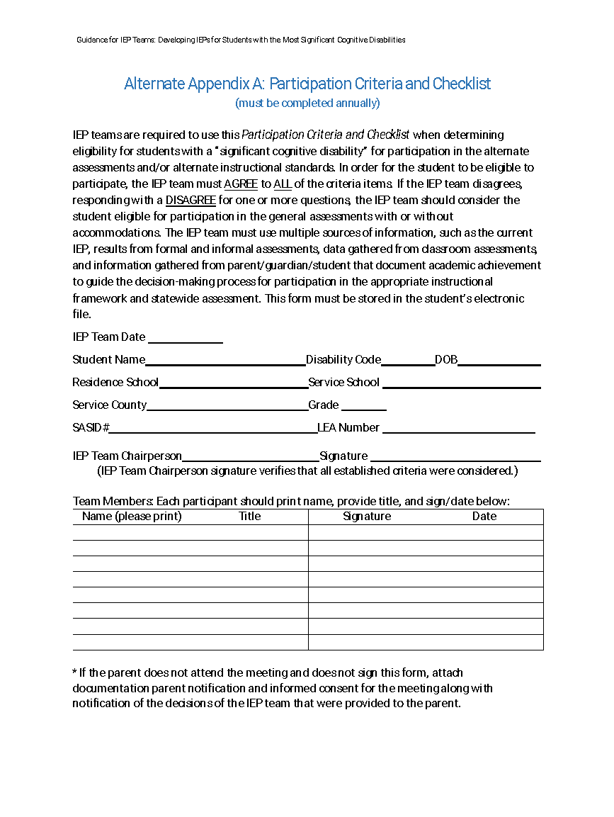

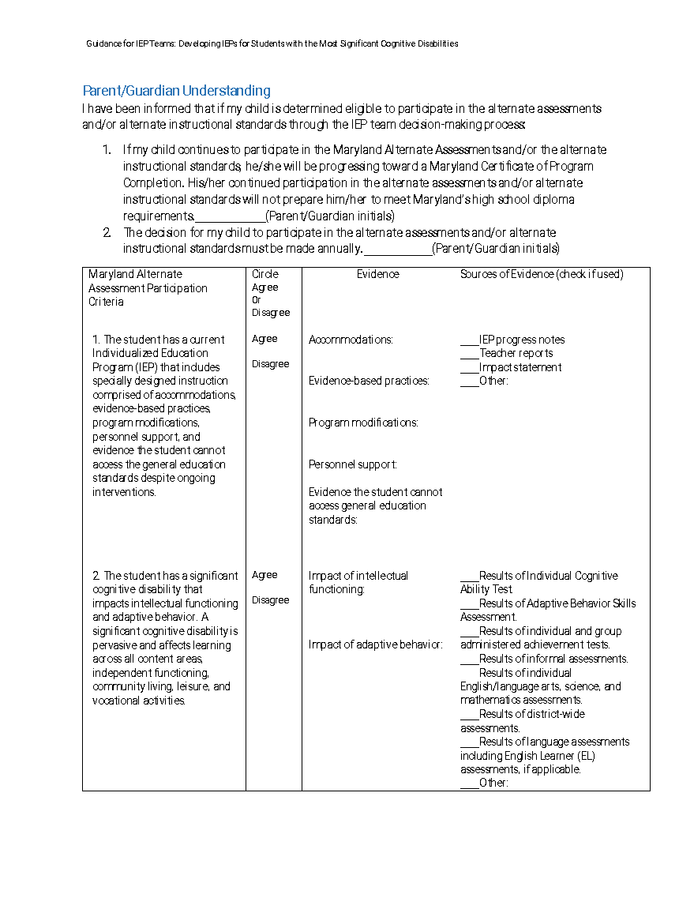
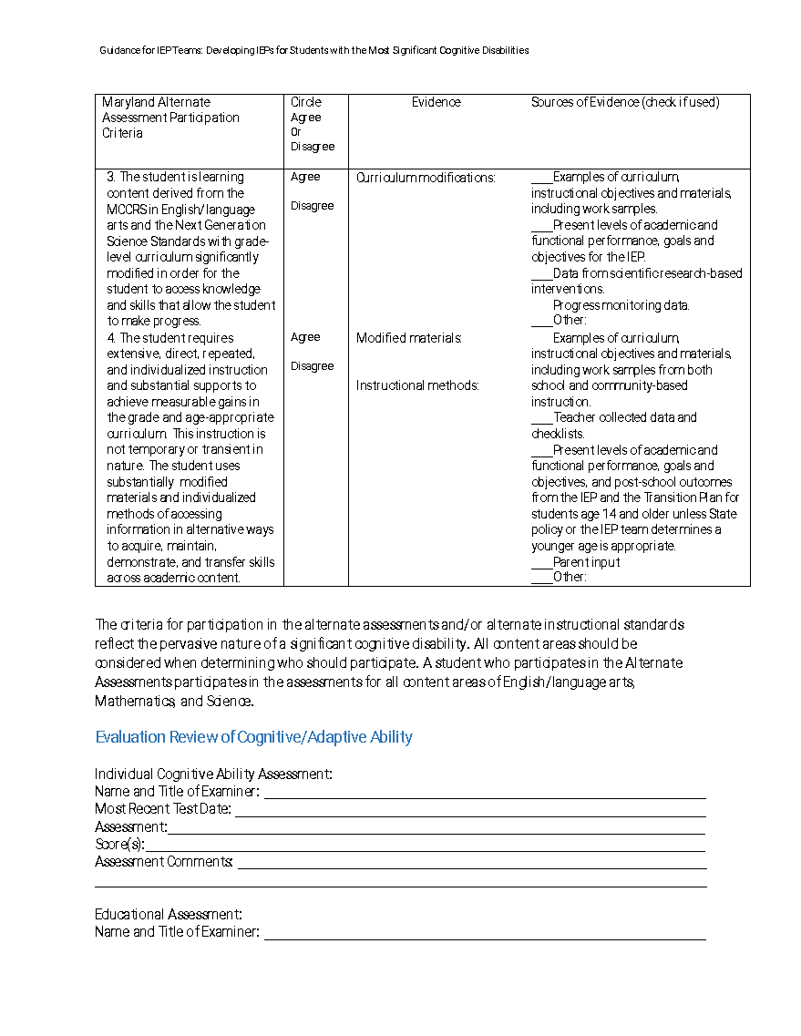
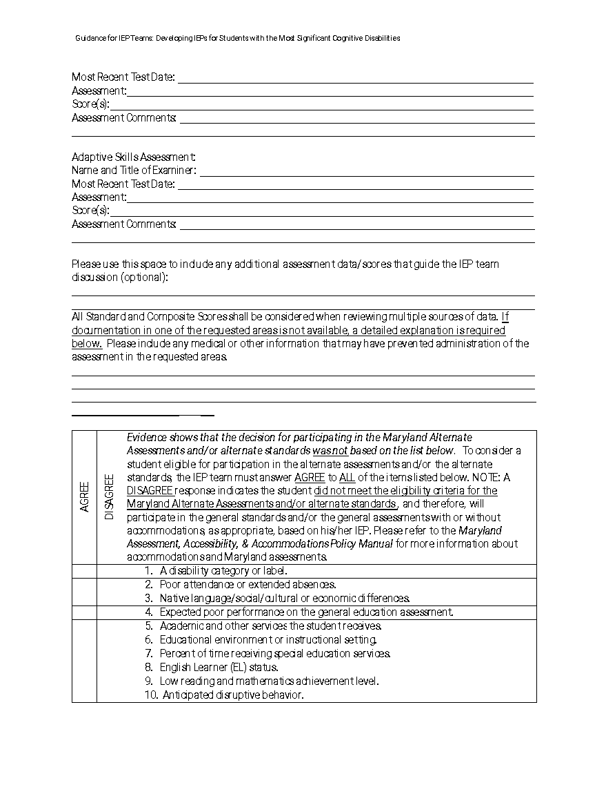
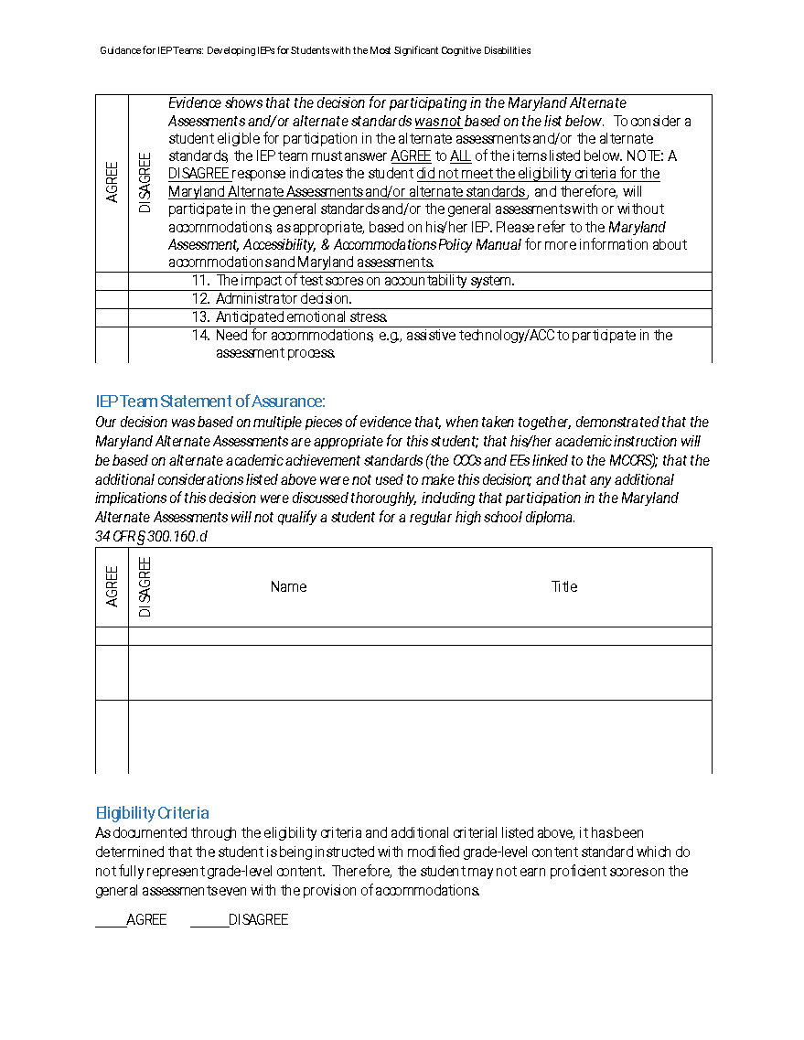

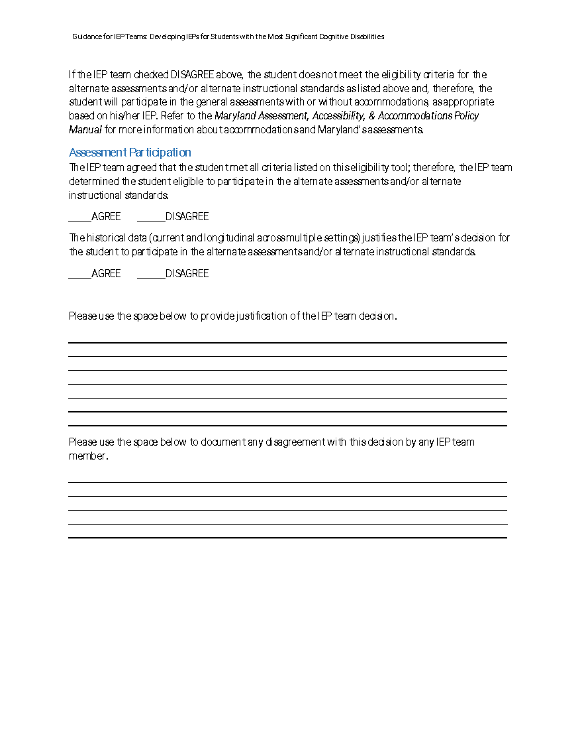

Appendix B: Eligibility Decision-Making Flowchart
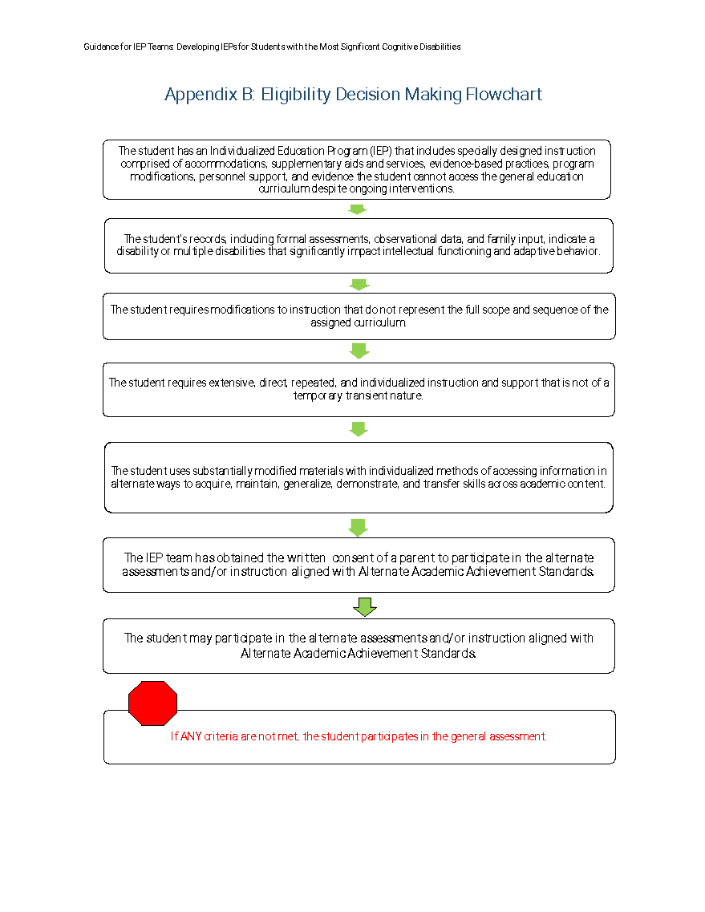
Alternate Appendix C: Parental Consent Form
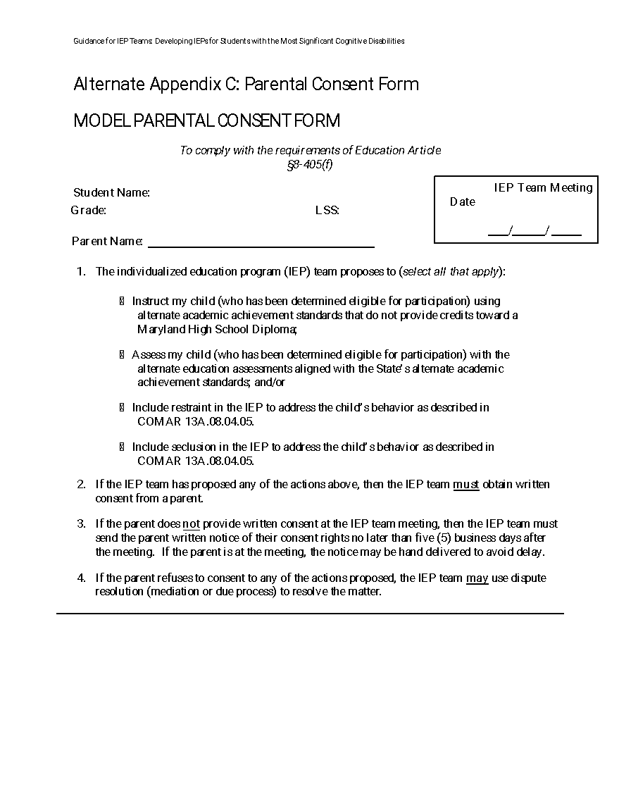

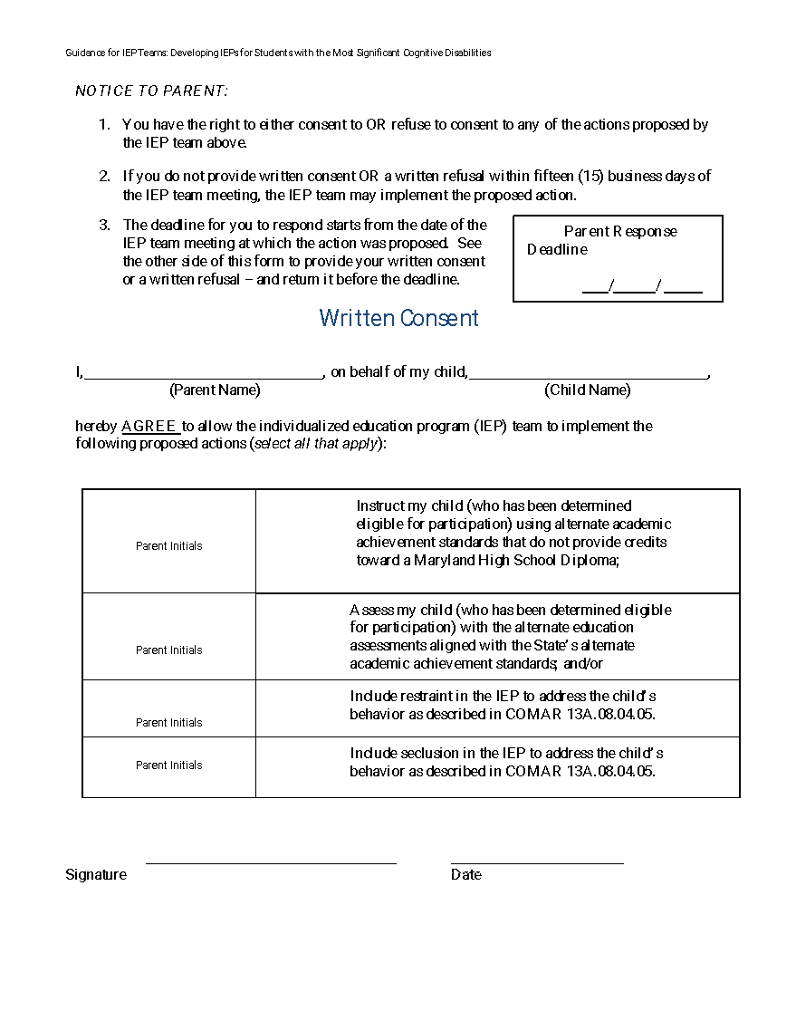

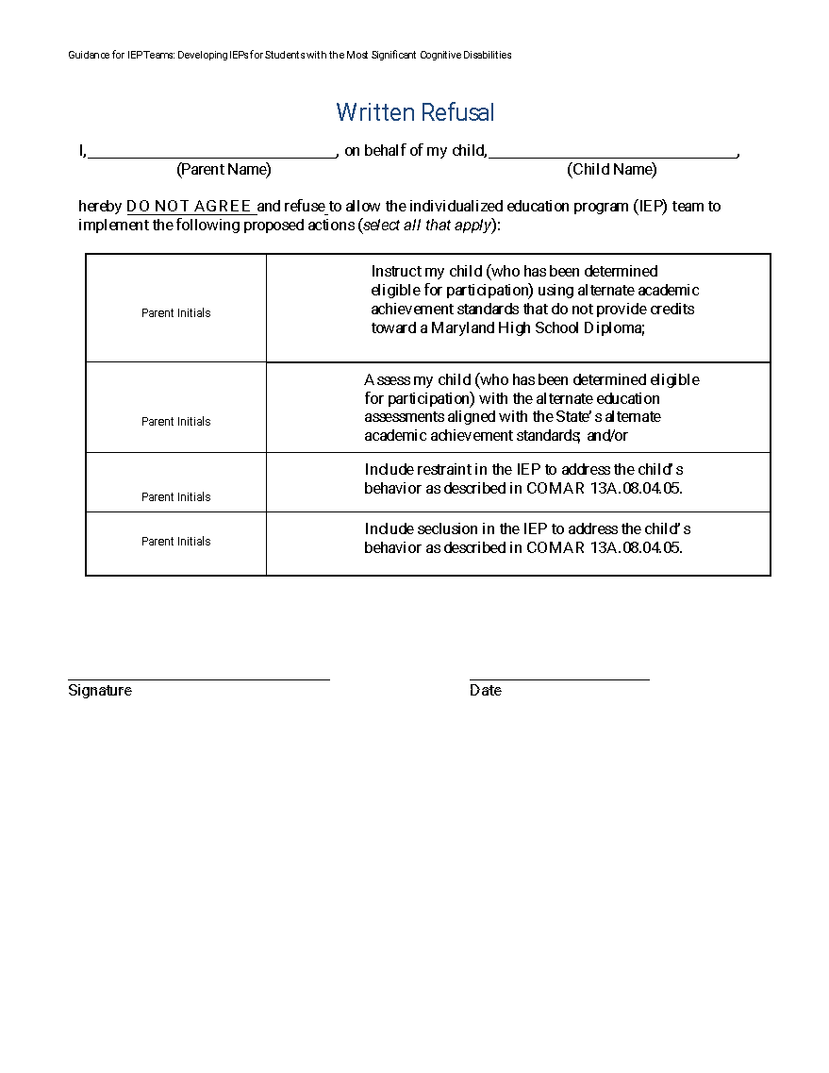

© 2022 Maryland State Department of Education.

Produced under the guidance of Marcella E. Franczkowski, Assistant State Superintendent, Division of Early Intervention and Special Education Services. Please include reference to the Maryland State Department of Education, Division of Early Intervention and Special Education Services on any replication of this information. To request permission for any use that is not “fair use” as that term is understood in copyright law, contact: Maryland State Department of Education, Division of Early Intervention and Special Education Services, 200 West Baltimore Street, Baltimore, Maryland 21201, 410-767-0249 voice.

Mohammed Choudhury, State Superintendent of Schools

Clarence C. Crawford, President, Maryland State Board of Education

Larry Hogan, Governor

Deanne M. Collins, Ed.D., Deputy State Superintendent for Teaching and Learning

Marcella E. Franczkowski, M.S., Assistant State Superintendent, Division of Early Intervention and Special Education Services

200 West Baltimore Street
Baltimore, Maryland 21201
MarylandPublicSchools.org

