

***Maryland State Department of Education***

**Service-Learning Unit**

Supporting America’s Military

**Primary Subject:** Social Studies

**Grade Level:** 7th & 8th

**Additional Subject Area Connections:** Language Arts & Math

**Unit Title:** Supporting America’s Military

**Type(s) of Service:** Indirect

**Unit Description:** Students will research conflicts involving American military. Students will research cultures of the regions and send care packages containing appropriate items and friendly letters to soldiers.

**Potential Service-Learning Action Experiences:** Provide service and comfort for military men and women. Write letters to acquire funding for postage and organize a collection of appropriate materials to send. *(indirect)*

**Maryland Curriculum Standards Met**

**Social Studies:**

*Standard 6.0*

*Social Studies Skills and Processes:* Students shall use reading, writing, and thinking, processes and skills to gain knowledge and understanding of political, historical and current events using chronological and spatial thinking, economic reasoning, and historical interpretation, by framing and evaluating questions from primary and secondary sources.

**Soldiers in green uniforms planting the American flag into the ground.**

**Alignment with Maryland’s**

**Best Practices of Service-Learning:**

***Supporting America’s Military***

1. **Meet a recognized community need**

This project provides much needed support for our American military men and women serving our country.

1. **Achieve curricular objectives through service-learning**

Grade 8, Standard 6.0 Social Studies Skills and Processes: Students shall use reading, writing, and thinking, processes and skills to gain knowledge and understanding of political, historical and current events using chronological and spatial thinking, economic reasoning, and historical interpretation, by framing and evaluating questions from primary and secondary sources.

1. **Reflect throughout the service-learning experience**

Students can participate in discussions involving their thoughts and feelings about military service. Students would be encouraged to put themselves in the “shoes” of those serving our country and describe how they would feel about getting care packages from a group of students.

* Students could write a journal entry: What if I were _____________? (fill in the service person’s name).
* Students could put an article in the school newspaper or local newspaper explaining their project and asking for donations.
* Students could ask local government and businesses to set up collection sites.

1. **Develop student responsibility (Students have opportunities to make decisions about the service-learning project.)**

The Any Soldier web site allows students to see the various places the founder of the organization, Brian Horn, from LaPlata, MD, has served. The website allows students to select a specific branch of the service, or place to send items. Students can plan for what items to send, how to collect the items, and how to pay for postage.

Adult hand helping child’s hand write with a pencil

1. **Establish community partnerships**

Local veterans’ organizations (VFW, American Legion) are sources of funding for mailings. Dunkin Donuts will donate coffee.

1. **Plan ahead for service-learning**

Students need to visit the [Any Solider](http://www.anysoldier.com/index.cfm) website (http://www.anysoldier.com/index.cfm) to decide who and where to send packages. Students need to read soldier information to plan what to send and where to get the items. Visit the post office to get free mailing boxes and customs forms. This can be done on line; there is a link at the Any Soldier website. Plan how to fund postage, which is about $15.00 a box, depending on contents. Plan how to separate food and toiletries. Allow about two weeks for boxes to arrive.

1. **Equip students with knowledge and skills needed for service**

Students acquire written and verbal communication skills, planning and budgeting skills, civic awareness.

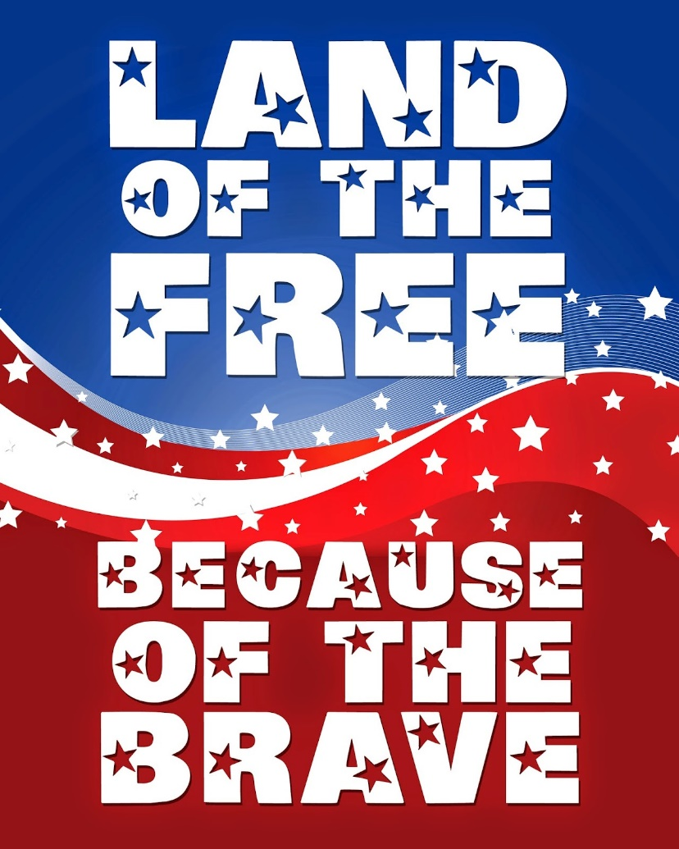

**Procedures with Resources:**

***Supporting America’s Military***

*These procedures represent an example of a service-learning lesson on this specific topic, but can be changed to meet individual classroom interests or varying community needs. You are encouraged to adapt this unit to fit your unique classroom and community and to solicit student input in planning and decision making.*

1. Introduce the service-learning project by discussing service-learning and citizenship with students and engaging in activities to explore those themes. A resource to support this topic can be found at [*Bringing Learning To Life*](https://www.youtube.com/watch?v=o2-eoEi6FCo) (https://www.youtube.com/watch?v=o2-eoEi6FCo).
2. Read and discuss material related to the impact and reality of wars, soldiers’ lives, and effects on soldiers’ families. Review data on the cost of war to countries and individuals. Research conflicts involving the American military. Research cultures and geography of the regions to develop an understanding of the conditions in which troops live.
3. Visit the [Any Soldier](http://www.anysoldier.com/index.cfm) website (http://www.anysoldier.com/index.cfm) and have students navigate the tool bar across the top to decide who to mail packages to and what to send, based on service person e-mail and requests.
4. Have students determine the most effective way to collect items. They can solicit donations from local businesses, or hold a collection drive, etc.
5. Get packing boxes from the post office.
6. Using the Any Soldier website, select the tab “How to Send.” Follow the directions to complete the customs forms. Be sure to print five copies of each form. Customs forms can also be picked up at the post office.
7. Have students write personal letters to the service person to be included in the box.
8. Pack, seal, and mail the boxes.

**Additional Interdisciplinary Connections**

**MCj03713740000[1]**

Language Arts – Reading to gain information; Writing for personal expression

1. Discuss the impact of the project on the students, soldiers, and families. Read and discuss any thank you letters or emails that might be sent back by soldiers.
2. Upon completion, analyze the plan to evaluate the successful completion of the objective and overall success of the project. Also, reflect on the project using various reflection activities and evaluate the effectiveness of the project by completing the [*Rubric for Assessing the Use of the Maryland’s Seven Best Practices of Service-Learning*](http://marylandpublicschools.org/programs/Documents/Service-Learning/rubric_best.pdf)(http://marylandpublicschools.org/programs/Documents/Service-Learning/rubric_best.pdf).

*Updated: October 2019, December 2014; Created: July 2007*

Division of Student Support, Academic Enrichment, and Educational Policy

Youth Development Branch

200 West Baltimore Street

Baltimore, Maryland 21201

410-767-0357

[Maryland Public Schools Service-Learning Website](http://www.mdservice-learning.org) (www.mdservice-learning.org)

[Maryland Public Schools](http://www.marylandpublicschools.org) (www.marylandpublicschools.org)



*\*This material is based upon a template for service-learning experiences created by the Maryland State Department of Education. Opinions or points of view expressed in this document are those of the authors and do not necessarily reflect the official position of the Maryland State Department of Education or constitute an endorsement.*