Appendix A
EIR/IFSP Transfer Job Aid
Overview | This job aid includes the questions to consider and the steps to be followed when planning for and executing the transfer of the early intervention record, including steps in the online IFSP system. Files are moved electronically ONLY when the family has reached the new jurisdiction, NOT when they share their intention to move.
Transfer Type (Continuation/New) | Continue with current referral/IFSP  The referral/IFSP is current;  The family is actively involved and engaged; or  Very little time has passed between moves. | Treat as new referral  The family never completed eligibility;  The family is not receiving IFSP services; or  Significant time has passed between moves.
Steps for the Sending  Jurisdiction | - Communication and Collaboration: Transfer Plan  - Plan for the transition between jurisdictions with the family (i.e., joint phone call).  - Receive a phone call from the receiving jurisdiction, asking for the electronic file.  - Together with the receiving jurisdiction decide if the record should be transferred in a way that will allow the receiving jurisdiction to continue with the current referral/IFSP or to treat the record as a new referral.
 | Decision is to continue with current referral/IFSP  - If child has been in the sending jurisdiction for at least six months, complete interim COS with the family if possible.  - DO NOT add a new IFSP meeting to “End IFSP.”  - Update service coordination notes, service logs.  - Change current status to “Inactive” with reason “Moved to Another Jurisdiction.”  - Add inactive date and inactive comments.  - Change jurisdiction. | Decision is to treat as new referral  - If child has been in the sending jurisdiction for at least six months, complete exit COS with the family if possible.  - Update service coordination notes, service logs.  - Change current status to “Inactive” with most applicable inactive reason EXCEPT “Moved to Another Jurisdiction.”  - Add inactive date and inactive comments.  - AFTER joint decision-making with the receiving jurisdiction, change the jurisdiction.
Steps for the Receiving Jurisdiction | - Communication and Collaboration: Transfer Plan  - Receive a phone call from the family or from the sending jurisdiction.  - Plan for a transition between jurisdictions with the family (i.e., joint phone call).  - Together with the sending jurisdiction, decide if the record should be transferred in a way that will allow the receiving jurisdiction to continue with the current referral/IFSP or to treat the record as a new referral.
 | Decision is to continue with current referral/IFSP  - Change the family’s address/contact information in the referral.  - If a family has an IFSP, change category to “Eligible.”  - Assign SC in the child profile.  - If “Exit COS” has been entered, change it via the COS link in the child profile to “Interim COS.”  - Assign Provider in the EI Service page.  - Notify family of IFSP Review Meeting, which might be an “other review” meeting type.  - Upon first visit, service coordinator/provider(s) review IFSP, make changes (if applicable) and make the draft IFSP, Active. | Decision is to treat as new referral  - Update the Referral date, family’s address/contact information, and any other changes.  - Keep the child’s category as “New Child.”  - Assign SC and evaluation team.  - Conduct an evaluation to determine eligibility.  - If COS has been entered by the previous jurisdiction, delete this information via the COS link in the child profile.  - Complete Initial IFSP, including new Entry COS.

Sample Scenarios
Family says they INTEND to move, wishes to stop services, but doesn’t have a firm move date or new address:  - Change Status to “Inactive – “Parent Withdrawal” and add Inactive Date and Inactive Comments.  - DO NOT change Jurisdiction.  - Complete Exit COS |  | 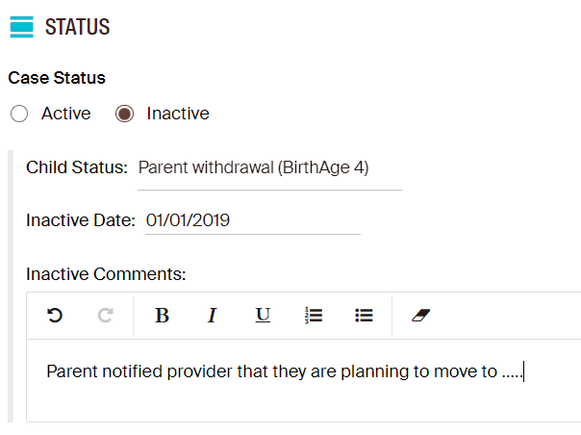
Family DOES move, within a short period of time and the IFSP should be continued:  - Change Status from “Parent Withdrawal” to “Moved to Another Jurisdiction.”  - Change Jurisdiction.  - Change Exit COS to Interim COS |  | 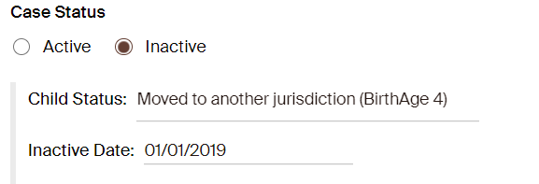
Family DOES move, but a long time has passed since the case was made inactive. The new jurisdiction would like to treat this as a new referral:
- Keep the Status as “Parent Withdrawal”
- Keep inactive date
- Change Jurisdiction

