GRANT RENEWAL APPLICATION
Fiscal Year 2023 (Year Two)
Nita M. Lowey
21st Century Community Learning Centers
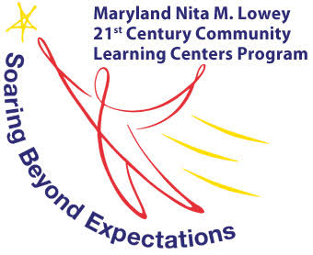

PR
Maryland State Department of Education
200 West Baltimore Street
Baltimore, Maryland 21201

Deadline
October 21, 2022
No later than 5:00 pm EST

MARYLAND STATE DEPARTMENT OF EDUCATION
Mohammed Choudhury
State Superintendent of Schools
Secretary-Treasurer, Maryland State Board of Education
Dr. Sylvia Lawson Ph.D.
Deputy Superintendent for Organizational Effectiveness
Mary L. Gable
Assistant State Superintendent, Division of Student Support, Academic Enrichment, and Educational Policy
Larry Hogan
Governor

Clarence C. Crawford
President, Maryland State Board of Education
Susan J. Getty, Ed.D. (Vice President)
Charles R. Dashiell, Jr., Esq.
Shawn D. Bartley, Esq.
Gail Bates
Chuen-Chin Bianca Chang
Vermelle Greene, Ph.D.
Jean C. Halle
Dr. Joan Mele-McCarthy
Rachel L. McCusker
Lori Morrow
Brigadier General Warner I. Sumpter (Ret.)
Holly C. Wilcox, Ph.D.
Merin Thomas (Student Member)
MARYLAND STATE BOARD OF EDUCATION

Table of Contents
Program Description 4
Name of Grant Program 4
Authorization 4
Purpose 4
Dissemination and Deadlines 5
Grant Period 5
Funding Amount 5
Grant Awards 5
Program Contact 6
Eligible Applicants 7
Use of Funds 7
Examples of Allowable Expenses (not an inclusive list) 7
Examples of Unallowable Expenses (not an inclusive list) 7
Program Requirements 8
Federal Absolute Priorities 8
State Absolute Priorities 8
Competitive Priorities 8
Required Minimum Hours of Programming 9
Performance Goals and Indicators 9
Alignment with Maryland State Education Agency Goals 10
Implementation and Governance Plan 14
Leadership Team Description 14
Steering Committee Description 14
Management Plan 14
Partners 17
Evidence of Impact 19
Evaluation and Dissemination 19
Programmatic Monitoring 21
Critical Elements Monitoring 21
Program Observation 21
Coordinating with Other Programs 21
Sustainability 21
Matching Contributions 22
Branding 22
Budget and Adequacy of Resources 22
Budget Worksheet and Narrative Template 22
Conflict of Interest 24
Audit Requirements 24
The General Education Provisions Act (GEPA), Section 427 25
Customer Service Support Session…………………………………………………………………………………………………………..25
Awarding of Funds 25
Denial of Grant Application 25
Reasons for Denial 25
Non-Discrimination Statement 26
Attachment 1: 21st CCLC Performance Report and Renewal Application Form ……………………………………….27

Program Description

Name of Grant Program
The Maryland State Department of Education (MSDE) administers the Nita M. Lowey 21st Century Community Learning Center (21st CCLC) grant program to assist local education agencies (LEAs), non-profit agencies, city or county government agencies, community and faith-based organizations, institutions of higher education, and for-profit corporations in the State to provide activities outside of school hours that:
- Provide opportunities for academic enrichment which includes providing instructional services to help students, particularly students who attend low-performing schools, to meet State and local student academic achievement standards in core academic subjects, such as language arts, mathematics, science, and social studies.
- Offer students a broad array of additional services, programs, and activities, such as youth development and engagement activities, substance abuse and alcohol prevention, service-learning, violence prevention, counseling, art, music, recreation, technology education, and character education programs that are designed to reinforce and complement the regular academic program of participating students; and
- Offer families of students served by community learning centers opportunities for literacy instruction and related educational development.

Out-of-school time programs are defined in the State of Maryland as programs that occur before school, after school, during the summer, and on Saturdays. Out-of-school time programs keep students safe, help working families, and improve academic achievement.
The 21st CCLC grant recipients are requested to complete the Grant Renewal Application to provide programmatic and fiscal outcome data for the 2021-2022 grant award period and a 2022-2023 grants management plan for review in consideration for year two funding. The applicant is requested to submit the data electronically through accessing the 21ST CCLC Performance Report and Grant Renewal Application Form: School Year or Summer Programs or 21ST CCLC Performance Report and Grant Renewal Application Form: School Year and Summer Programs. The details of the e-application are included in Attachment One. Additional information found in this document outlines grant requirements that are included in the original Request for Proposals. Upon submission, the MSDE will review the provided Grant Renewal Application and the year one performance data which includes, but is not limited to: (1) Start-up report, (2) Critical Elements Monitoring Stage I, II and III, (3) Timely reimbursement invoice submissions, and (4) Total number of amendments. Upon review, applicants approved for year two funding will receive a risk assessment level of 1-5 that will be reflected on the Year II Notification of Grant Award (NOGA).

authorization
The Every Student Succeeds Act (ESSA) signed by President Obama on December 10, 2015

PURPOSE
The purpose of the Nita M Lowey 21st CCLC is to create community learning centers that provide students with academic enrichment opportunities, as well as additional services designed to complement their regular academic program.

DISSEMINATION AND DEADLINE
The renewal application was released on Friday, October 11, 2022. The deadline for the application submission is Friday, October 21, 2022.

GRANT PERIOD
Length of Grants: Three years
- Period of Availability for Year 2: July 1, 2022, through August 31, 2023.
The initial award of the grant was for a total of 36 months which is subject to funding and successful completion of grant requirements. Following the initial award, subsequent award years will be contingent upon:
- Availability of funding from the specific funding authority;
- Satisfactory performance by the grantee as evaluated by the MSDE; and
- Compliance with all grant requirements and meeting all conditions set forth within the 21ST CCLC proposal.

FUNDING AMOUNT
Total Funds Available: $20,209,500

GRANT AWARDS
The MSDE will use the standards in the Uniform Guidance to impose specific or “high risk” conditions on applicants selected for funding, including but not limited to: applicant or recipient history or failure to comply with the general or specific terms and conditions of the grant, failure to meet expected performance goals, and may impose additional specific award conditions as needed (See Uniform Guidance section 200.207). The MSDE will assess the risks facing the applicant entity as it seeks to achieve its objectives. This assessment will provide the basis for determining awards to high-risk applicants.
Grant amounts each year will be funded at 100 percent of the original award contingent on the availability of funding and satisfactory performance divided over three years. Programs selected for funding will be level funded the same amount for all three years of programming unless a lesser amount is specified for subsequent years. In those cases, the lesser amount will be awarded. In addition, awards may be reduced based on the grantee’s inability to meet the goals and performance measures set forth in this grant. This includes participation numbers consistently lower than projected in the bidder’s application. Awards may also be reduced based on fiscal or programmatic concerns or findings during the grant period. Any award reductions will be discussed with the applicant in advance of the reduction.
The MSDE reserves the right to continue or discontinue the program(s) for the reasons defined in 2 CFR § 200.208 and for non-compliance of the requirements listed below:
- Demonstrate adequate progress toward achieving all measurable objectives;
- Meet or exceed 85 percent of the proposed level of students served, as indicated on the original 21ST CCLC application, or the Grant Renewal Application for the most recent year of operation;
- Attend required out-of-school (OST) national and regional conferences, MSDE grantee meetings and trainings;
- Submit required documentation in a timely manner during the project year as requested and/or required by MSDE, such as:
  - Monitoring components (Start-Up, Interim, Grant Renewal Application, End of Year Reports, and Critical Elements Monitoring)
  - Corrective action(s)
  - Monthly Reimbursement Expenditure Report submission
  - Detailed local narrative evaluation report reflecting the growth and progress of the program;
- Maintain and submit Government Performance and Results Act (GPRA) data to be entered into the USDE 21APR database by the established deadlines;
  - Academic Achievement
    - Percentage of students in grades 4-8 participating in 21st CCLC programming during the school year and summer who demonstrate growth in reading/language arts on state assessments.
    - Percentage of students in grades 4-8 participating in 21st CCLC programming during the school year and summer who demonstrate growth in math on state assessments.
  - Grade Point Average
    - Percentage of students in grades 7-8 and 10-12 attending 21st CCLC programming during the school year and summer with a prior-year unweighted GPA less than 3.0 who demonstrated an improved GPA.
  - School Day Attendance
    - Percentage of youth in grades 1–12 participating in 21st CCLC during the school year and summer who:
      - Had a school-day attendance rate at or below 90 percent in the prior school year AND
      - Demonstrated an improved attendance rate in the current school year.
  - Behavior
    - Percentage of students grades 1 through 12 attending 21st CCLC programming during the school year and summer who experienced a decrease in in-school suspensions compared to the previous school year.
  - Student Engagement in Learning
    - Percentage of students in grades 1–5 participating in 21st CCLC programming in the school year and summer who demonstrated an improvement in teacher-reported engagement in learning.
- Participate fully in statewide evaluation activities; and
- Comply with all applicable state statutory and regulatory requirements.
Grant funds must be expended in the grant year they were awarded. Any funds not expended prior to the expiration of such funds will no longer be available to the grantee. The MSDE does not allow 21ST CCLC grant funds to be carried over into the following grant year. Final expenditure reports are due 60 days after the end of the grant period. Expenditure reports submitted more than 60 days after the end of the grant period will not be processed.

PROGRAM CONTACT
Reginald Burke
Director, Youth Development Branch
Maryland State Department of Education
reginald.burke@maryland.gov
410-767-0313 (office)

Eligible Applicants

The MSDE will use 93 percent of the funds received under the 21st CCLC program to fund out-of-school time programs that can meet and adhere to the program. The 21st CCLC competition is open to Maryland Local Education Agencies (LEAs), non-profit agencies, city or county government agencies, community and faith-based organizations, institutions of higher education, and for-profit corporations. The statute encourages eligible organizations applying for funds to collaborate with the schools the children attend.

Use of Funds

Examples of allowable expenses (not an inclusive list)
- Intervention, strategies, and curriculum purchases (must meet ESSA evidence criteria);
- Salaries and fringe benefits for 21st CCLC out-of-school time staff;
- Professional development and 21st CCLC trainings;
- Consultants, subcontractors, and evaluators providing allowable services/activities;
- Classroom materials and supplies for 21st CCLC classes;
- Remedial education activities and academic enrichment learning programs, including providing additional assistance to students to allow the students to improve their academic achievement;
- Mathematics and science education activities;
- Arts and music education activities;
- Entrepreneurial education, college and career readiness programs.
- Tutoring services (including those provided by senior citizen volunteers) and mentoring programs;
- Programs that provide out-of-school activities for limited English proficient students that emphasize language skills and academic achievement;
- Recreational activities;
- Telecommunications and technology education programs;
- Expanded library service hours;
- Programs that promote parental involvement and family literacy;
- Drug and violence prevention programs;
- Counseling programs; and
- Character education programs.

Examples of UNallowable expenses (not an inclusive list)
- Preparation of the proposal: Costs to develop, prepare, and/or write the 21st CCLC proposal cannot be charged to the grant directly or indirectly by either the agency or contractor;
- Pre-award costs: Pre-award costs may not be charged against the grant;
- Funding for activities conducted and costs incurred before the start date of the grant;
- Entertainment, refreshments, and snacks;
- A field trip without the approved academic support (will be considered entertainment);
- End-of-year celebrations or food associated with parties or socials;
- Game systems and game cartridges;
- Unapproved out-of-state or overnight field trips, including retreats and lock-ins;
- Incentives (e.g., plaques, trophies, stickers, t-shirt, give-a-ways);
- Advertisements, promotional, or marketing items;
- Decorative items;
- Purchase of facilities, vehicles (e.g., Buses, Vans, or Cars), or Land acquisition;
- Capital improvements, permanent renovations;
- Supplanting federal, state, local funds, or other non-federal funds (e.g., using grant dollars to fund summer school classes previously offered and paid for by currently existing district or other funds);
- Direct charges for items or services that the indirect cost rate covers;
- Dues to organizations, federations or societies for personal benefit; and
- Any costs not allowable for federal programs per Uniform Guidance 2 CFR§ 200.400.

Program Requirements
The State of Maryland has identified the following Absolute and Competitive Priorities for the 21ST CCLC program. Absolute Priorities are those priorities, which must be addressed by all applicants; failure to do so will disqualify the application from receiving funding.

Federal ABSOLUTE priorities
Schools eligible for services provided by this grant are:
- Comprehensive Support and Improvement Schools (lowest 5 percent of the Title I schools; high schools with graduation rates less than 67 percent; and School Improvement Grant (SIG) IV schools) and/or;
- Title I Schools that serve a high percentage (at least 40 percent) of students from low-income families; and/or;
- Other schools determined by the LEA to be in need of intervention and support.

SPECIAL RULE: The State educational agency (SEA) shall provide the same priority to an application submitted by a LEA, if the LEA demonstrates that it is unable to partner with a community-based organization in reasonable geographic proximity, and of sufficient quality to meet the requirements of this priority.

STATE ABSOLUTE priorities
All applications must:
- Integrate character education in accordance with programs in place in the schools of the target population; and
- Integrate service-learning in accordance with the 7 Best Principles.

Competitive Priorities
Competitive Priorities are optional and may be addressed by the applicant.
- Propose a program aligned with preparing students to successfully reach Maryland’s College and Career Readiness Standards (MCCRS);
- Propose a program whose focus is science, technology, engineering, and mathematics (STEM) including the seven STEM standards of practice;
- Propose a program whose focus is ensuring the healthy development of youth providing healthy recreational enrichment that promotes positive physical, emotional and social development that better student’s health and wellness;
- Propose a program whose focus is providing students with high quality arts programming that includes hands-on experiential learning in the creative exploration of visual and performing arts; or
- Propose to serve students in a community that is served by one or more LEAs with a locale code of 32, 33, 41, 42, or 43 (rural) Note: Applicants are encouraged to retrieve locale codes from the NCES School District search tool), where LEAs can be looked up individually to retrieve locale codes.
- Application was jointly submitted with points of contact identified for both the LEA and a community-based organization or other public or private entity. In a jointly submitted application, the LEA will manage the fiscal component of the grant. In determining whether an application has been “submitted jointly,” the MSDE will look for evidence of:
      - Collaboration in the planning and design of the program;
      - Substantial roles for each partner in the delivery of services and management and oversight of the program;
      - Shared grant resources to carry out roles;
      - LEA partner serving as the fiscal agent; and
      - Integration with the regular school day program.

Required minimum Hours of Programming
The MSDE shall renew applications that demonstrate the ability to successfully implement programs that meet the established criteria:
- School Year Programs: No less than 12 hours of programming per week (can include weekdays and Saturdays) for 25 weeks during the traditional school year OR no less than 4 hours of programming on Saturdays only for 25 weeks during the traditional school year.
- School Year and Summer Programs: No less than 12 hours of programming per week (can include weekdays and Saturdays) for 25 weeks during the traditional school year OR no less than 4 hours of programming on Saturdays only for 25 weeks during the traditional school year AND; No less than 80 hours for summer to include onsite academic and enrichment programming for at least 32 hours on the calendar.
- Summer Only Programs: No less than 80 hours for summer to include onsite academic and enrichment programming for at least 32 hours on the calendar.

Performance Goals and Indicators
The MSDE identifies eight State Education Agency (SEA) performance goals to evaluate the effectiveness of the 21st CCLC grant programs. The applicant must ensure that 21st CCLC programs are aligned with the USED GPRA measures and the SEA Performance Goals. The applicant should identify a target percentage and performance activities and methods for each MSDE defined goals and indicators.
Annual renewal requires applicant reflection and analysis of performance outcomes (see Attachment 1). Evaluative findings and programmatic practice drive informative and systematic changes that enhance implementation. Applicants are to apply the programmatic and evaluative findings to their succession planning for year two implementation and therefore, conduct a review and revision of the original exhibits included in the RFP. The exhibits required as a part of the Grant Renewal include: (1) Performance Goals and Indicators, (2) Management Plan, (3) Partner Plan, and (4) Evaluation Plan. Final documents are to be submitted as a part of the Grant Renewal Application and uploaded into the 2022-2023 Critical Elements Monitoring folder by Friday, September 23, 2022.

Alignment with Maryland State Education Agency Goals
The SEA performance goals 1, 2, 3, 5, and 6 are mandatory. The applicant must select at least one additional SEA performance goal from 4, 7, and 8. The program’s activities, data sources, and measurable evaluation methods must align with the performance indicators and aim to accomplish the SEA performance goals.
SEA Performance Goals:
  - Assist every student to realize his or her potential;
  - Develop and support a strong accountability system to increase academic success for all students;
  - Promote a safe, healthy, and orderly environment for learning and teaching;
  - Ensure educator and administrative effectiveness;
  - Promote students’ physical, mental, social, and emotional well-being;
  - Expand high-quality educational opportunities for students and parents;
  - Work with districts to strengthen infrastructure; and
  - Increase communication and partnerships with stakeholders statewide.

Performance Goals and Indicators
Page 1 of 3:
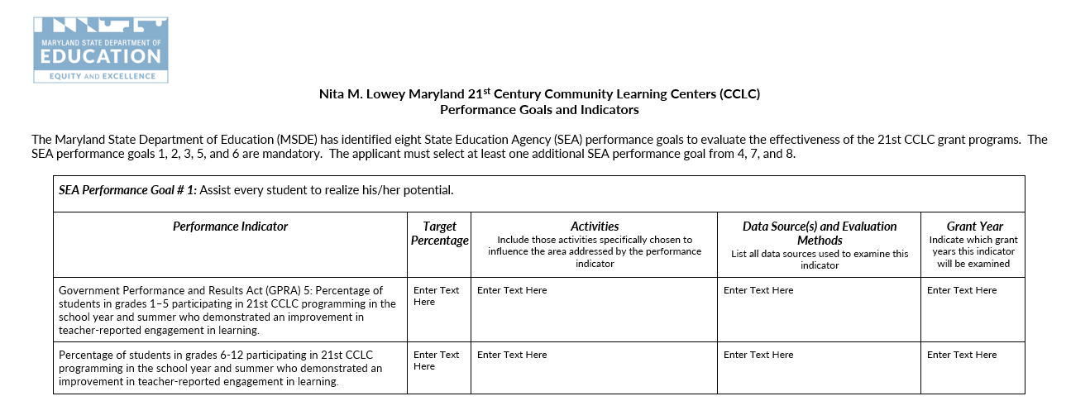

Performance Goals and Indicators
Page 2 of 3:

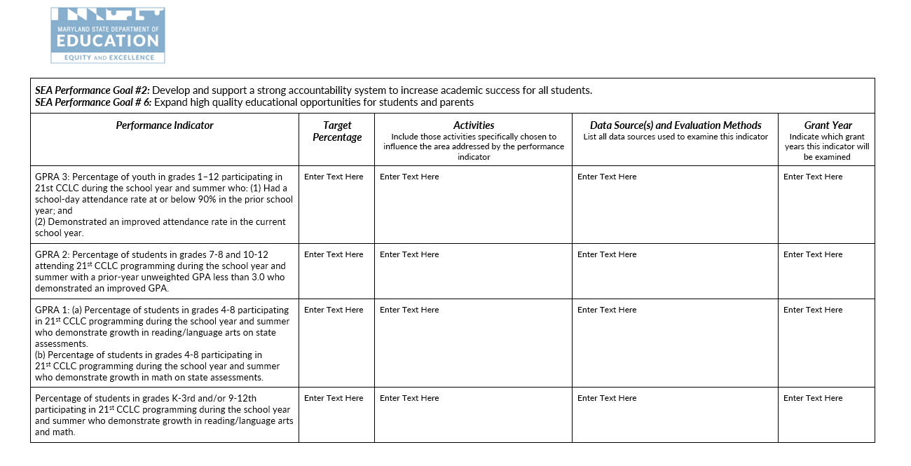

Performance Goals and Indicators
Page 3 of 3:
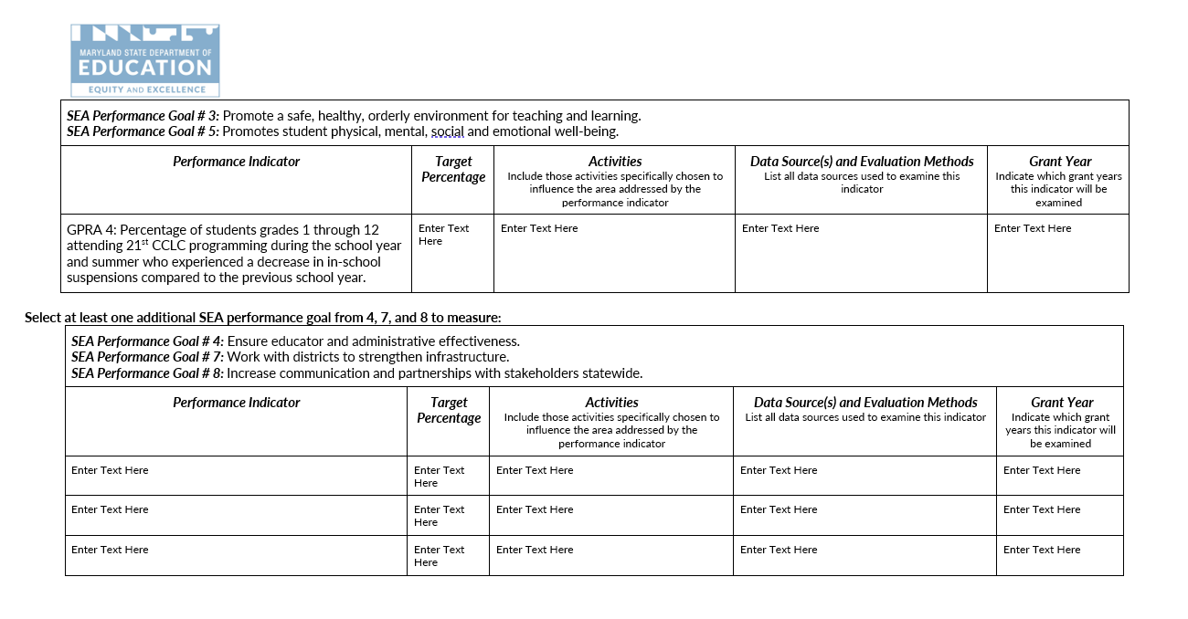

Implementation and Governance Plan

Leadership Team Description
The applicant must identify the project’s leaders, including the roles and positions, as well as, expected qualifications, and specify how much of the project director’s time will be devoted to this project, as per Uniform Guidance 2CFR 200.430. In support of salaries and wages, documentary support will be required where employees work on, “A Federal award and a non-Federal award.”
The applicant must describe who will be included on the leadership team (e.g., project director, site coordinators, board members, students, parents, etc.), how the leadership team will ensure successful implementation of the project, how often they will meet, and actions to oversee positions responsible for grant implementation.
The applicant must identify the positions that will be responsible for grant implementation (ex: Grant Manager, Bookkeeper, Academic Instruction Teachers, Enrichment Teacher, Parent Liaison, Evaluator, etc.).

Steering Committee description
The project must have a steering committee to govern the project consisting of major stakeholders and grant project directors. Duties of the steering committee include establishing major program policies, reviewing quarterly milestones and annual evaluation reports, and making recommendations for programmatic change. Steering committee members should represent the major stakeholders in the project (e.g., project partners, parents, students, principals, Board of Education members). Project directors should act as advisors to the committee. The duties, members, and meeting dates of the committee should be identified in this section of the project proposal and in the Management Plan.

Management PLan
The Management Plan section describes how and by whom the program will be managed to ensure project success.
This section must:
- Describe how, when, and by whom the program’s implementation will be monitored, including starting the project on time.
- Describe the mechanisms by which the project will clearly define and hold partners accountable to specific roles, responsibilities, contributions, and deliverables, e.g., contracts or Memoranda of Understanding.
The Management Plan Worksheet details the major management actions and the timeframe and specific persons responsible for each action. The worksheet supports the proposed Plan of Operation, but includes only management actions, not direct service activities. Examples of management actions are hiring of staff, ordering equipment, and developing curricula. Meetings with the evaluator and holding steering committee meetings must occur within 30 days of the Notice of Grant Award.
On the Management Plan Worksheet, in chronological order, the grantee needs to list all major management Specific, Measurable, Attainable, Relevant, and Time-based (SMART) actions necessary to implement the project during the second year of funding. Assign a responsible party, measurable outcome, and an approximate date for each action. If the action is ongoing, indicate the range of dates over which it will be implemented. The MSDE reporting requirements should also be included in the management plan.

Management Plan
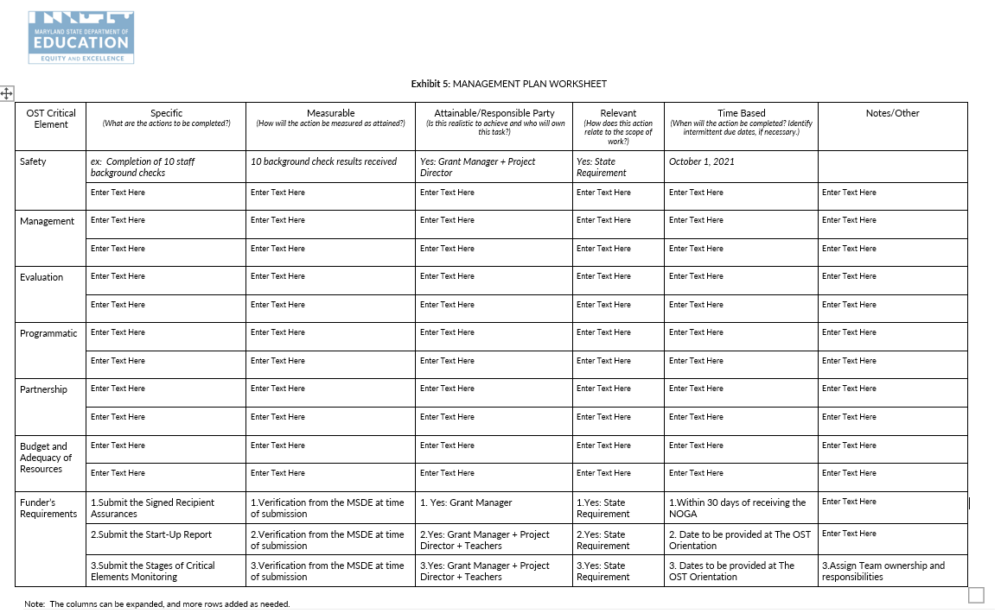

Partners
A partner is any organization other than the grantee that will actively contribute to the project. This includes the LEA(s) being served, local parks and recreation departments, recreation councils, public libraries, institutions of higher education, private sector business, and other nonprofit [501(c)(3)] organizations and foundations. Partners include subcontractors, organizations that are under contract with the grantee to provide grant-funded activities or services. If renewed, all applicants must ensure the MSDE OST Team has a record of the current contract/Memorandum of Understanding (MOU) in the applicant Budget Documents folder. New or revised contracts are to be submitted with the FY23 budget documents for the MSDE review and approval. Contracts require review and approval before funds will be released for reimbursement. Funds paid to partners by the applicant without an approved contract are subject to non-reimbursement.
The Partners Plan Worksheet shows the project’s partners, the respective roles in the project, the benefits each expects to receive, and the specific contributions each partner will make to the project in the form of financial support, equipment, personnel, or other resources. The grantee should include which objectives their services will help to achieve, as well as evaluation dates to reflect on progressing and/or achieved outcomes

Partners Plan
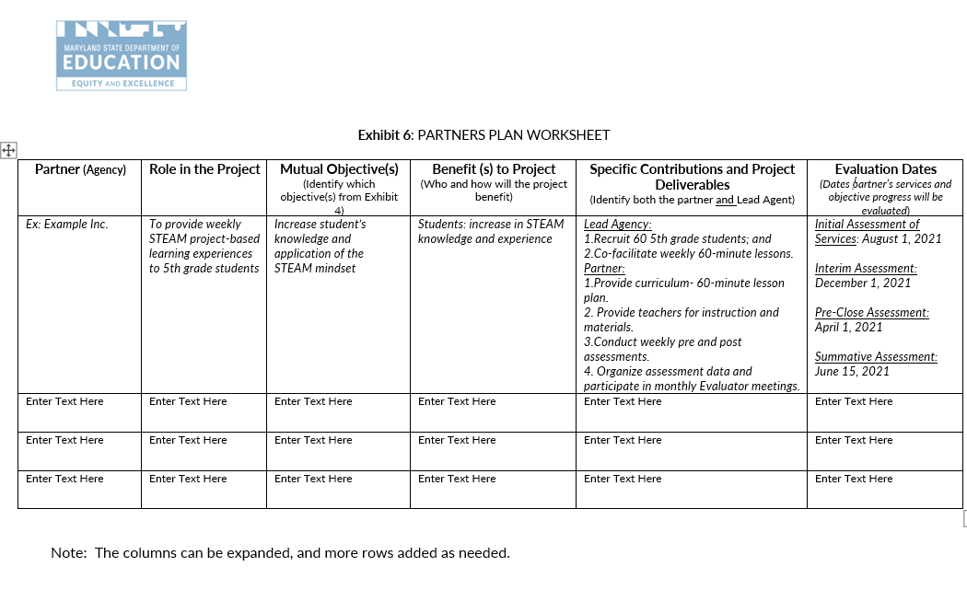

Evidence of Impact
Describe how the proposed plan and strategies being implemented are evidence-based and will lead to the desired impact. Include a description of the organization’s experience in terms of effective practices (research-based strategies) leading to the desired outcomes.

Evaluation and Dissemination
Program evaluation is a critical and essential process of program implementation. Program evaluation involves the systematic collection and analysis of information related to the design, implementation, and outcomes of a program for the purpose of assessing and subsequently modifying program activities to ensure program efficacy and effectiveness. The Evaluation Plan outlines the process by which the program will be evaluated. The evaluation must include a plan for a professional, independent evaluation of the program.
The evaluation plan must also address the following:
- Specify the questions the evaluation will seek to answer, based on the project’s objectives, and plan of operation. These questions must enable project leaders to assess progress toward objectives and milestones and enable project managers to determine which strategies and activities have been successful, and those that need to be revised;
- Describe the proposed data and measurement instruments that will be used;
- Explain how data will be collected, including who is responsible, and provide a timeline;
- Describe how the integrity and accuracy of data will be ensured;
- Specify the third-party individual or group who will conduct the external evaluation or provide a detailed job description and the selection process by which a qualified evaluator will be identified;
- Describe how and when evaluation findings will be used to make improvements in the project; and
- Describe how the evaluation findings will be disseminated to the major stakeholders and all individuals with an interest in the project. Explain how dissemination formats will be tailored to meet the needs of diverse stakeholders.

Through implementation of the Evaluation Plan, the applicant will provide a summative Evaluation Report to the MSDE following the project year implementation. An evaluation report will integrate the following components:

- Evaluation Framework/Purpose;
- Methodology;
- Evaluation Findings;
- Summary; and
- Recommendations and Limitations.

Applicants operating multiple sites are to submit one evaluation report with a summary, recommendations, and limitations for all operating sites and individual data reported for each operating site, as outlined below:

- Evaluation Framework/Purpose;
- Methodology; and
- Evaluation Findings.

Evaluation Plan
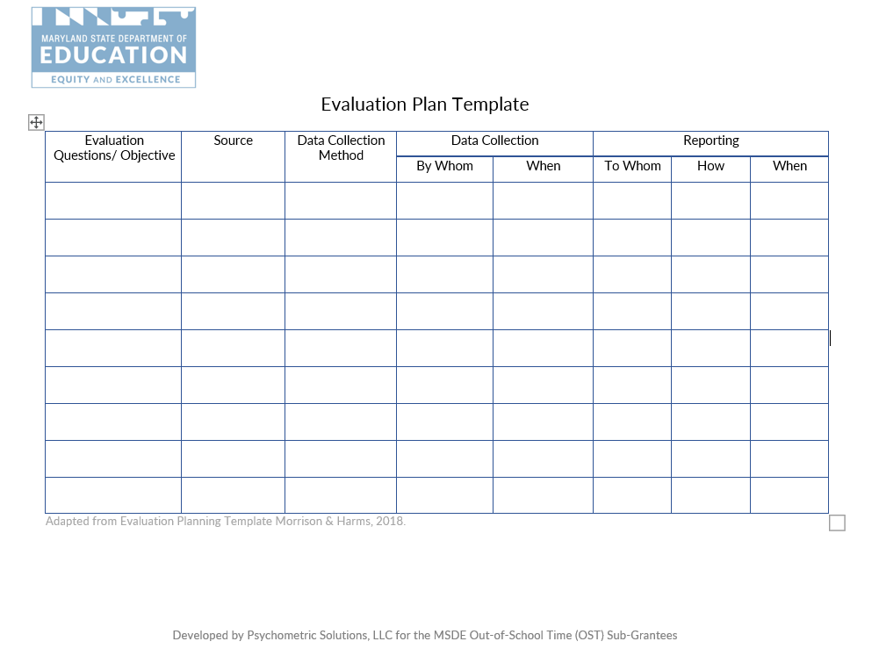

Programmatic Monitoring

Critical Elements monitoring
The applicant is required to comply with requirements of the grant program (including completion of data) on an annual basis through documentation and evidence review. The OST Critical Elements monitoring is comprised of stage evidence submission in the following areas: (1) Programmatic Compliance with Federal, State and Local Health and Safety, (2) Programmatic, (3) Evaluation, (4) Management, (5) Sustainability, and (6) Budget and Adequacy of Resources. The MSDE conducts a review of the evidence and identifies corrective actions for applicant completion, as well as priorities for technical assistance through program observation. The grantee's ability to comply will affect the monitoring risk assessment indicator, as well as advise the MSDE technical assistance.

PRogram Observation
The applicant must implement quality academic enrichment as aligned with the approved grant program. The MSDE conducts onsite observations of the following program components: (1) academically aligned objectives; (2) student engagement; (3) adherence to the grant requirements; (4) leveraging of partnerships and (5) data informed decisions. The goal of program observation is to provide positive, constructive, and immediate feedback to grantees regarding the implementation of the OST grant funded program as aligned with the original proposal or as amended.
At the conclusion of the onsite visit, the MSDE Extended Learning Specialist discusses the observation results with the grantee, provides additional guidance, as well as addresses corrective actions. The grantee will have an opportunity to provide any missing documentation within a specified timeframe.

Coordinating With Other Programs
The 21st CCLC funds awarded to local grantees must be used only to supplement the level of federal, state, local, and other non-federal funds and not to replace funds that would have been available to conduct activities if 21st CCLC funds had not been available. The applicant is encouraged to identify federal, state, and local programs that also offer out-of-school time services and combine or coordinate with the program to make the most effective use of public resources.
The MSDE encourages applicants to illustrate the ability to leverage federal, state, private and existing funding sources. If applicable, applicants should include on the Budget Worksheet and Narrative how private and existing funding sources will be combined or coordinated with the proposed grant funding to illustrate the effective use of resources.

Sustainability
The MSDE will fund all three years of the project at 100 percent, subject to continued grant compliance and federal funding. The MSDE encourages applicants to evaluate plans to expand partnerships and develop new public/private partnerships. It is expected that all programs funded will acquire other funds to assist in sustaining the program beyond Year Three.

MATCHING CONTRIBUTIONS
Proposed budgets must include in-kind contributions (including but not limited to material, personnel, financial, and other types of contributions) each year according to the following table.
Year | 21st CCLC Funding | In-Kind Contributions
1 | 100% | 10%
2 | 100% | 15%
3 | 100% | 20%
The percentage of in-kind contribution must be a percentage of the Direct Costs not the Total Requested Amount. In-kind contributions cannot be derived from other federal or state funds.

Branding
All 21st CCLC grant recipients are required to identify MSDE as the funding source for 21ST CCLC funds in all written advertisements. If a grantee receives partial funding from additional sources, they may note that funding for the 21st CCLC program is received in part from MSDE.

Budget and Adequacy of Resources
All 21st CCLC awards are reimbursement grants, whereby each program incurs costs and then invoices MSDE for those charges. Grantees must have sufficient cash flow to operate the 21ST CCLC program continuously while awaiting reimbursement receipt, which normally takes approximately six to eight weeks. Interest expense or other debt services costs cannot be charged to the 21ST CCLC grant. Check cashing fees cannot be charged to the grant. If unallowable costs are reimbursed during the grant period, corrective actions will be provided and require the funds to be repaid to the MSDE.
The grant budget consists of two components:
- The Budget Worksheet and Narrative; and
- The approved MSDE Grant Budget Forms (C-1-25).

The budget objects are: (1) Salaries & Wages; (2) Contracted Services; (3) Supplies & Materials; (4) Other Charges; (5) Equipment; and (6) Transfers. The budget object totals in the Budget Worksheet and Narrative must align with the totals identified on the MSDE Grant Form C-1-25.

BUDGET WORKSHEET AND NARRATIVE TEMPLATE
The budget narrative is a part of the Budget Worksheet and Narrative Template (Exhibit 8). The Budget Narrative must:
- Describe a clear relationship between the activities described in the application and the proposed allocation of grant funds;
- Address the necessity and rationale of proposed costs;
- The budget section must demonstrate that there are sufficient resources to successfully implement the proposed program as described in the project narrative, including, but not limited to, instructional staff, curricular materials, evaluation, professional development, background checks, and transportation, if necessary; and
- Applicants must list all budgetary costs based upon the narrative components and program design and ensure the budget includes a line-item description for every allowable cost necessary to carry out the goals and objectives of the proposed program.
The budget must:
- Detail the year of the project in an itemized budget;
- Itemize general expenses into specific line items. For example, “Meeting Expenses” can be itemized to include, “room rental” and “photocopying;”
- Clearly identify the requested funds and in-kind contributions; and
- Identify the source of each in-kind contribution, if applicable.
Identify reasonable and allowable expenses aligned with the United States Department of Education (USDE) Uniform Grant Guidance, 2 C.F.R. Part 200, (2 CFR § 200). The Electronic Code of Federal Regulations (E-CFR) is accessible at: https://www.ecfr.gov/cgi-bin/text-idx?tpl=/ecfrbrowse/Title02/2cfr200_main_02.tpl. Utilize The Maryland Financial Reporting Manual as an additional resource when categorizing allowable expenses. Utilize the Bureau of Labor and Statistics National Occupational Employment and Wage Estimates database to identify reasonable and allowable wages.
Adhere to the following guidelines when proposing expenses in the specified budget objects.
- Salaries and Wages: Expenditures incurred for personnel on the payroll.
  - Specify and detail how the expense was calculated for each line item. The calculation column must include hourly rate of pay provided based on the reasonable and allowable rates of pay aligned with the U.S. Bureau of Labor and Statistics (BLS), number of hours billed to the project, percentage of time billed to the project;
  - Program staff identified under Salaries/Wages and Contractual Services must remain in that budget object for the remainder of the grant year;
  - The budget must include a position or contracted services expense for a finance agent/bookkeeper; and
  - Program staff identified under Salaries/Wages must include paycheck withholding as supporting documentation when submitting reimbursement invoices.
- Contracted Services: Expenditures for services performed by persons who are not on the payroll.
  - Specify and detail how the expense was calculated for each line item. The calculation column must include hourly rate of pay based on the reasonable and allowable rates of pay aligned with the U.S. Bureau of Labor and Statistics, administrative fees, and number of hours billed to the project. Please provide the following in the calculation column and embed the hyperlink to the BLS reference;
  - Vendors that provide direct services to students must submit a proposed Memorandum of Understanding (MOU) outlining the deliverables and breakdown of expenses to include hourly rates and administrative costs for all providers. The MSDE acknowledges that MOUs may not be finalized at the time of the application; however, a proposed agreement is required that outlines the details of partnership; and
  - The external evaluator cost cannot exceed seven percent of the Total Requested.
- Supplies and Materials: Refer to 2 C.F.R. Part 200, The Maryland Financial Reporting Manual, Appendix D for a definition. The total object cannot exceed eight percent of the Total Requested.
  - Specify and detail how the expense was calculated for each line item. The calculation column must include quantity and cost per item.
- Equipment: Refer to 2 C.F.R. Part 200, and The Maryland Financial Reporting Manual, Appendix D for a definition. The total object cannot exceed three percent of the Total Requested.
- Other Charges: May include expenses such as travel, conferences, fringe, etc. (not an inclusive list). The total object cannot exceed 36 percent of the Total Requested.
  - Professional Development:
    - Include funds to cover travel and lodging expenses for at least two key personnel to attend one national and two regional training activities during each year of the project (actual attendance will be contingent on MSDE approval);
    - Include funds for the project director to attend three state grantee networking meetings; and
    - Include funds for the project director to attend one two-day state grantee retreat.
- Transfers: The total object cannot exceed 13 percent of the Total Requested.
- Indirect Cost Rate:
  - Indirect Costs cannot exceed 10 percent of the Total Direct Cost for Non-LEAs; and
  - Refer to Section 5.0.5 Indirect Costs for calculation guidance.

Both requested and in-kind funds must be reasonable with current market prices. Grant funds cannot be used to purchase food, facilities, vehicles, or support new construction.

Conflict of Interest
All potential conflicts of interests should be avoided. According to the general procurement standards, the non-Federal entity must maintain written standards of conduct covering conflicts of interest and governing the actions of its employees engaged in the selection, award, and administration of contracts. No employee, officer, or agent may participate in the selection, award, or administration of a contract supported by a Federal award if he or she has a real or apparent conflict of interest. Such a conflict of interest would arise when the employee, officer, or agent, any member of his or her immediate family, his or her partner, or an organization which employs or is about to employ any of the parties indicated herein, or has a financial or other interest in or a tangible personal benefit from a firm considered for a contract. The officers, employees, and agents of the non-Federal entity may neither solicit nor accept gratuities, favors, or anything of monetary value from contractors or parties to subcontracts. The standards of conduct must provide for disciplinary actions to be applied for violations of such standards by officers, employees, or agents of the non-Federal entity. (EDGAR 2 CFR §200.318).
Within the 21ST CCLC program, conflicts of interest could include:
- Employing immediate family members as contract labor for services;
- Having a program employee serve as a vendor; and
- Purchasing supplies from a company in which a program employee has a financial interest.

Audit Requirements
Any subrecipient that expends $750,000 or more of Federal awards in a fiscal year must have a single or program-specific audit conducted for that year in accordance with the provisions set forth in 2 CFR Part 200, Subpart F – Audit Requirements. Subrecipients must submit a copy of their single audit report and financial statement to the MSDE. These reports must be submitted within nine months after the end of the fiscal year, or 30 days after the auditor has signed the report, whichever comes first.
If a sub recipient did not expend $750,000 or more in Federal awards, the sub recipient must complete, sign, and submit to the MSDE the Single Audit Exemption Certification form and a copy of its financial statement. Subrecipients may contact the MSDE Office of Grants Management and Compliance for form templates and for more information.

The General Education Provisions Act (GEPA), Section 427

Each applicant must develop actions taken to ensure equitable access to, and equitable participation in, the project or activity to be conducted with such assistance, by addressing the special needs of students, teachers, and other program beneficiaries to overcome barriers to equitable participation.

Customer Service Support Session
The MSDE OST Team will hold a virtual customer service support session for subgrantees. During this session, the MSDE OST Team will provide support and answer questions regarding completing the application. Registration for the sessions with the dates and a video call link will be provided in a separate communication

Awarding of Funds
The MSDE will initiate notification of grant awards via email no later than November 4, 2022.

Denial of grant application
Each applicant whose application is denied will receive a Denial Notice that explains the reason for the denial after final award decisions are made.

Reasons for DEnial
Applicants may be denied funding for failure to meet the requirements listed under the Funding and Length of Grant section in this document.

NON-DISCRIMINATION STATEMENT
The Maryland State Department of Education does not discriminate on the basis of age, ancestry/national origin, color, disability, gender identity/expression, marital status, race, religion, sex, or sexual orientation in matters affecting employment or in providing access to programs and activities and provides equal access to the Boy Scouts and other designated youth groups.
For inquiries related to Department policy, please contact:
Equity Assurance and Compliance Office
Office of the Deputy State Superintendent for Operations
Maryland State Department of Education
200 W. Baltimore Street – 2nd Floor
Baltimore, Maryland 21201-2595
410-767-0123 - voice
410-767-0431 - fax
410-333-6442 - TTY/TD

Attachment 1: 21st CCLC Performance Report and Renewal Application Form
The details of the e-application are included in Attachment 1. Please submit the data electronically through accessing the 21ST CCLC Performance Report and Grant Renewal Application Form: School Year or Summer Programs or 21ST CCLC Performance Report and Grant Renewal Application Form: School Year and Summer Programs.
Upon submission, the MSDE will review the provided data:
- Submitted via this report (GRA);
- Year one performance data which includes, but is not limited to, the: (1) Start-up report, (2) Critical Elements Monitoring Stage I, II and III, (3) Timely reimbursement invoice submissions, and (4) Total number of amendments; and
- 2022-2023 grants management plans consisting of: (1) Performance Goals and Indicators, (2) Management Plan, (3) Partner Plan, and (4) Evaluation Plan. Final documents are to be submitted as a part of the Grant Renewal Application and uploaded into the 2022-2023 Critical Elements Monitoring folder by October 21, 2022.
A risk assessment level of 1-5 will be generated and issued on the Year II Notification of Grant Award (NOGA).

Part I: Program Information

Lead Agency Information
Provide the lead agency’s information including the type of organization, address, grant program name, grant number, organizational unique entity identifier, and grant manager’s contact information, as well as a summary of the project’s design.

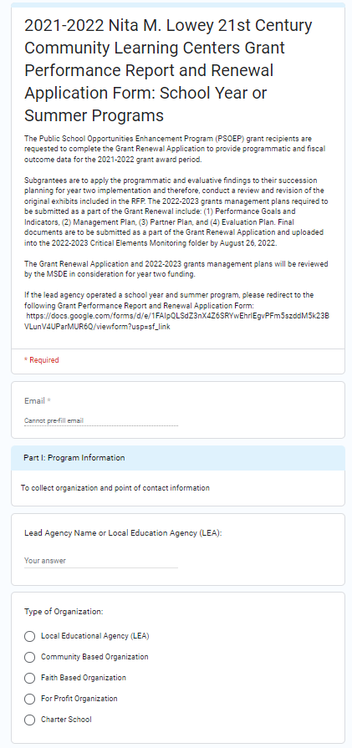

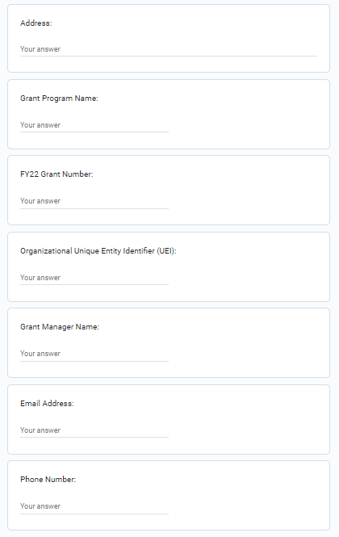

Purpose and design
The grant program purpose and design are reported to align with the Federal and State absolute priorities.

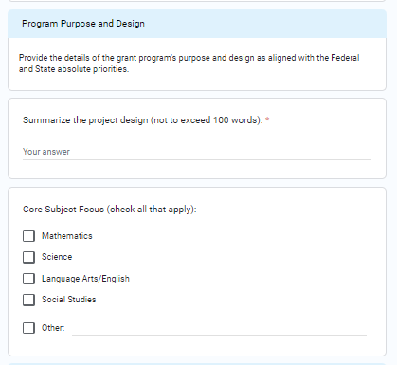

Program operating Details
The program operating details include the reporting of school year or summer operating status, days and hours of operation, and LEA or community site operations.
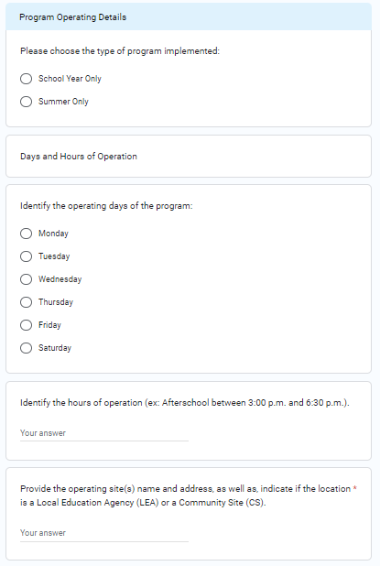

2021-2022 Program calendar
The grant program timeline includes the actual start and end dates of program implementation.
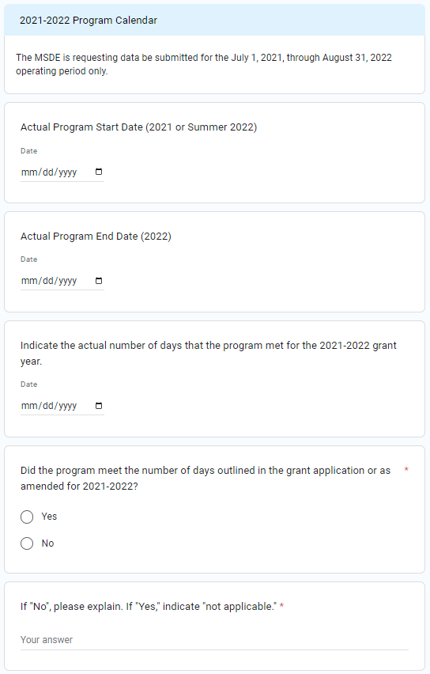

FEDERAL PriorIty
The applicant is required to uphold the federal legislative absolute priority to serve eligible schools.

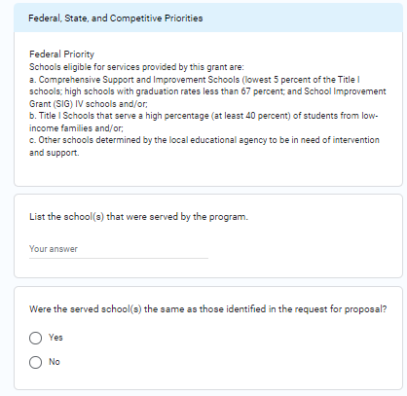

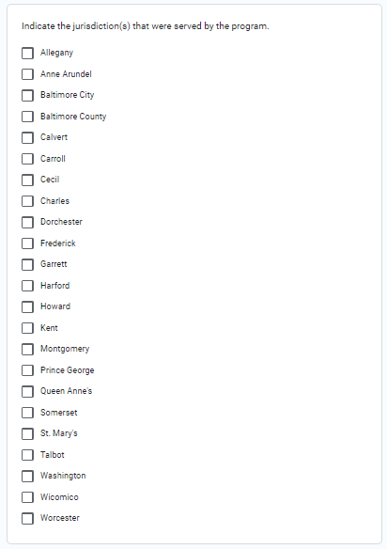

State PriorIty
The applicant is required to uphold the state absolute priority to implement character education and service-learning programming in the grant design.
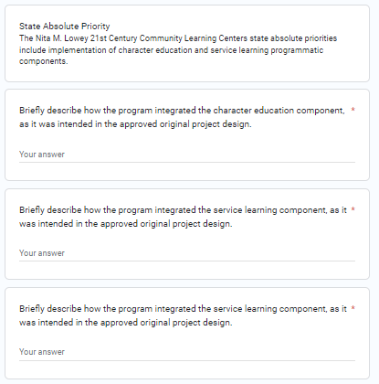

Competitive PriorIty
The applicant may have opted to integrate a competitive priority in the original application. If a competitive priority was implanted the applicant is required to report on the status of implementation.
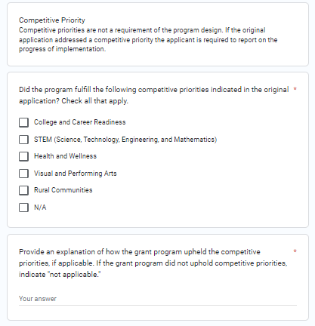

Part II: Student and Program Operations Data

Student Enrollment
The grant program is to consistently serve at or above 80 percent of the proposed number of students. The OST Critical Elements program evidence and annual collection procedures support targeted outcomes. Implementation year one data is reported for attendance and enrollment.
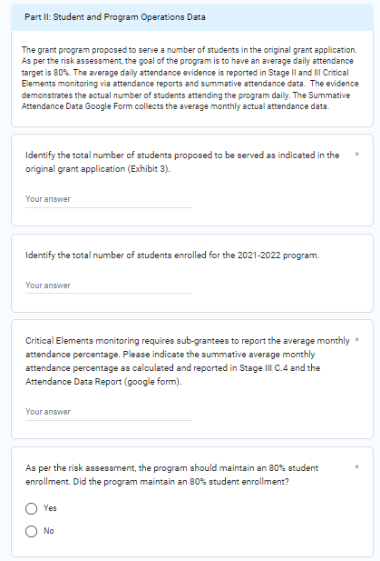
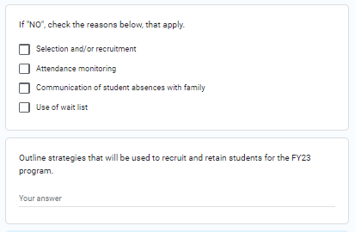

target population
The grant program proposed to serve a target grade level(s). The data collected reflects the proposed and actual grades served.
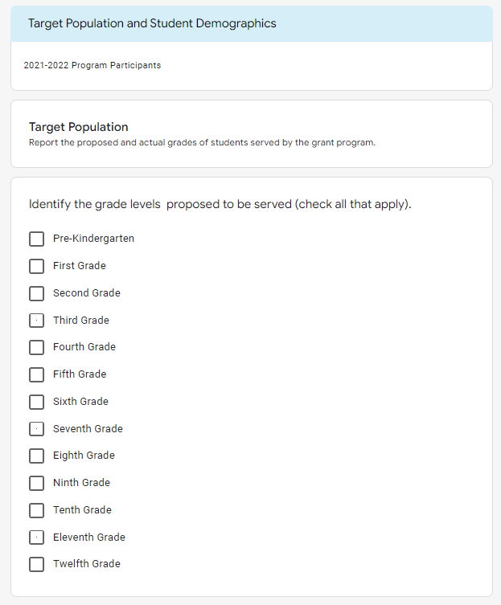
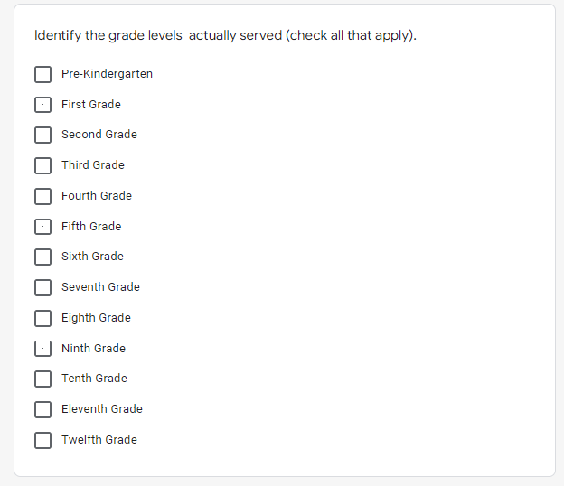

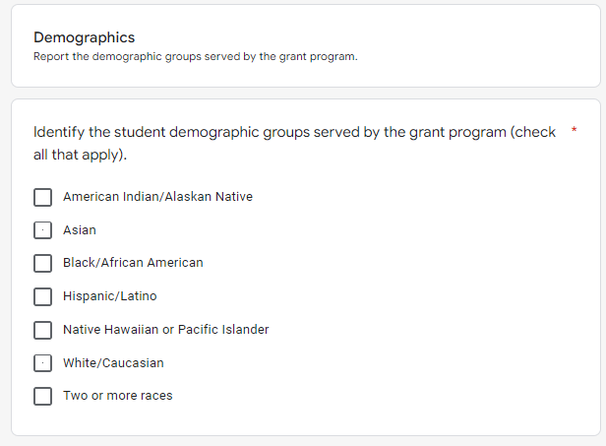
student demographics
The grant program serves an individualized student demographic.
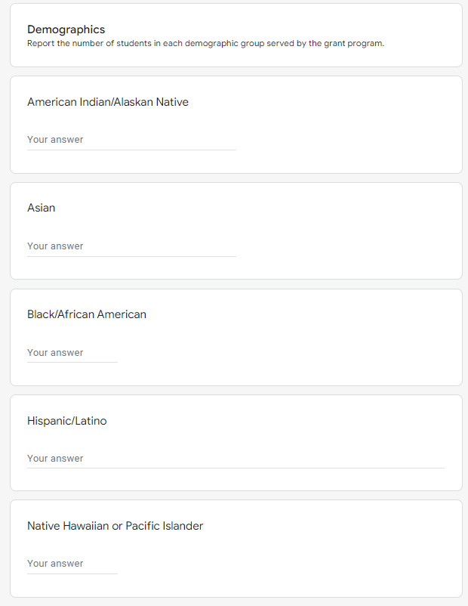
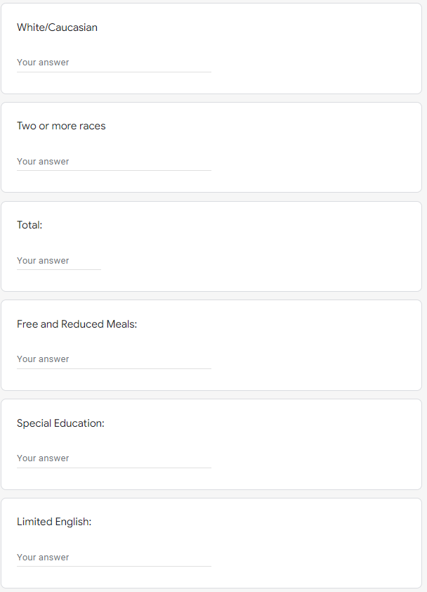

Part III: Performance Goals and Indicators
The MSDE has identified eight SEA performance goals to evaluate the effectiveness of the 21st CCLC grant programs. The SEA performance goals 1, 2, 3, 5, and 6 are mandatory. The applicant must select at least one additional SEA performance goal from 4, 7, and 8. The SEA performance goals are outlined below:
1. Assist every student to realize his/her potential;
2. Develop and support a strong accountability system to increase academic success for all students;
3. Promote a safe, healthy, orderly environment for teaching and learning;
4. Ensure educator and administrative effectiveness;
5. Promote student physical, mental, social and emotional well-being;
6. Expand high quality educational opportunities for students and parents;
7. Work with districts to strengthen infrastructure;
8. Increase communication and partnerships with stakeholders statewide.
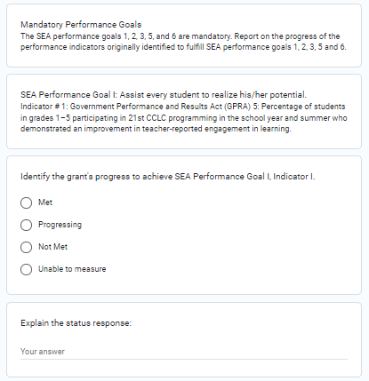
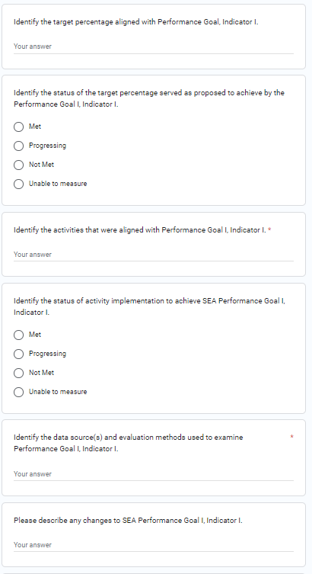
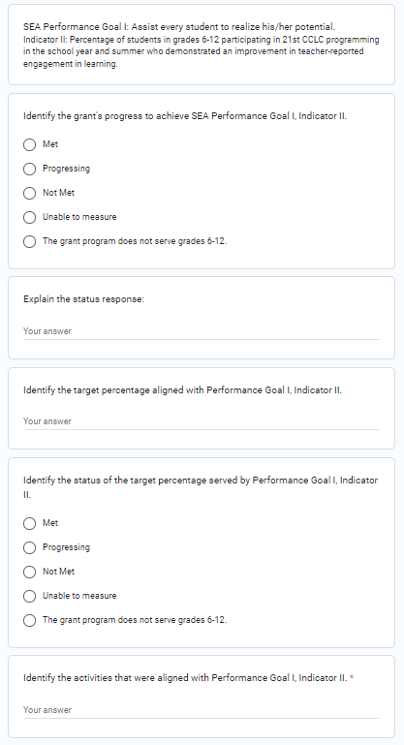

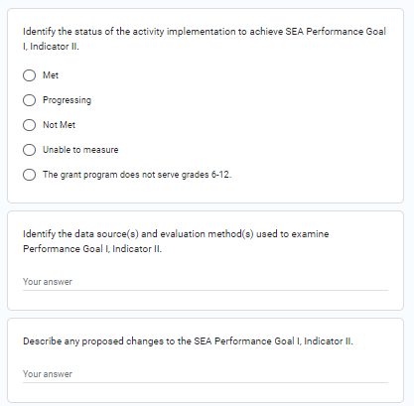
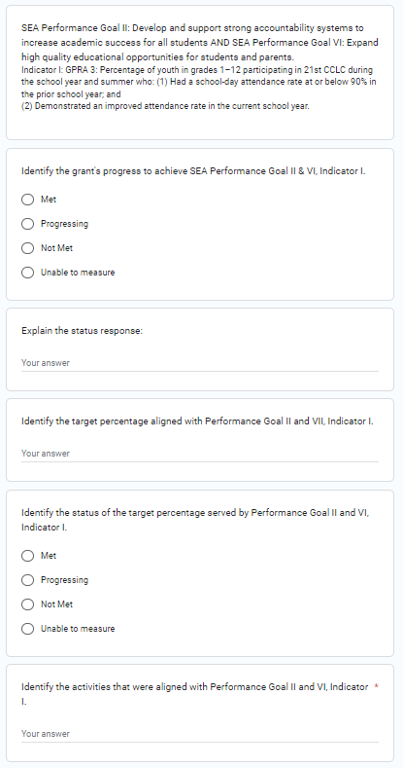

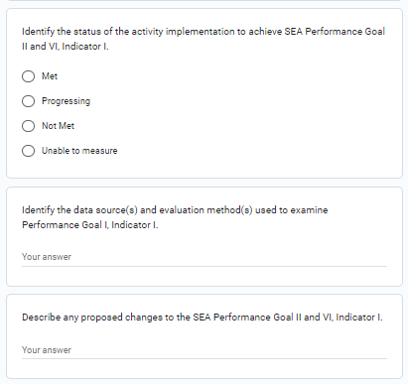

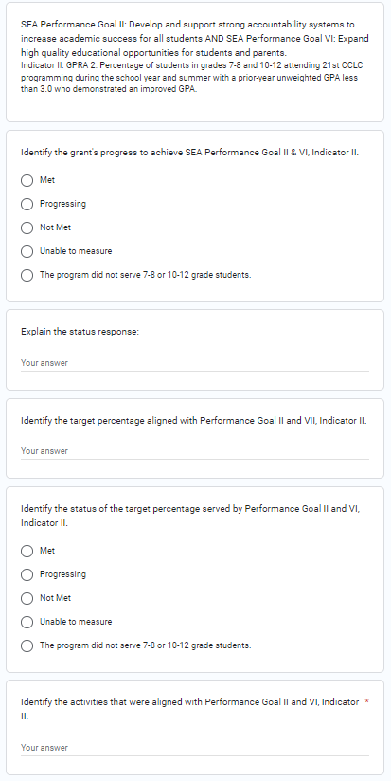

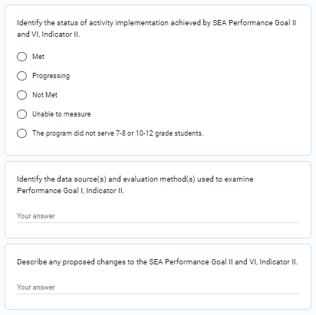

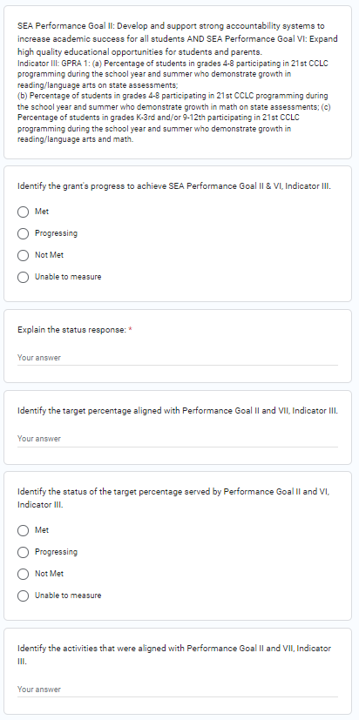
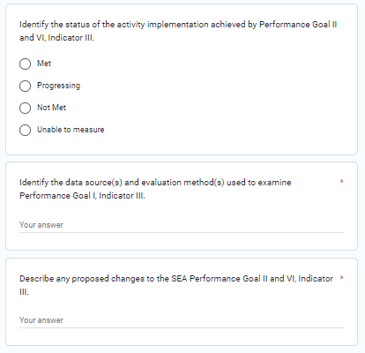
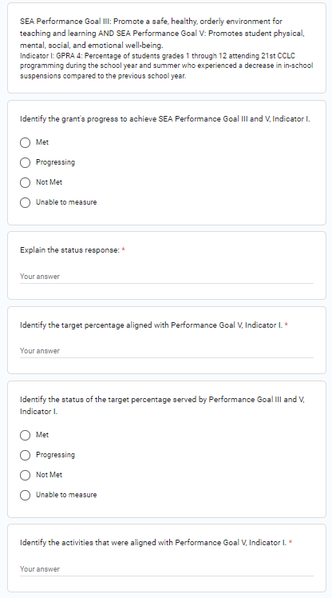

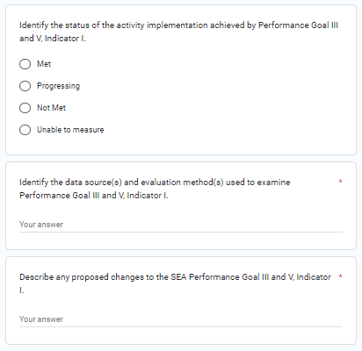
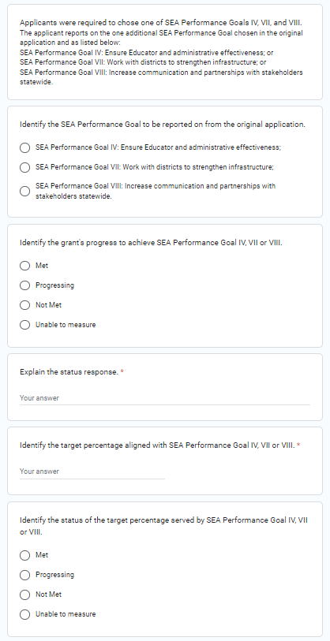
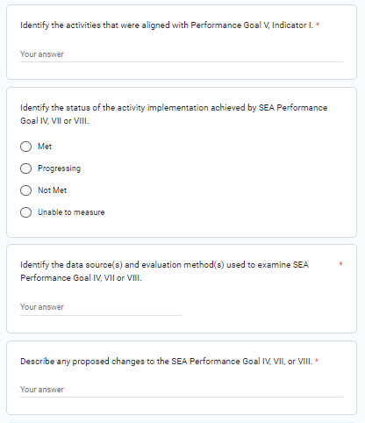

Evidence of impact
The applicant is required to report on evidence-based strategies, impact and effective practices.

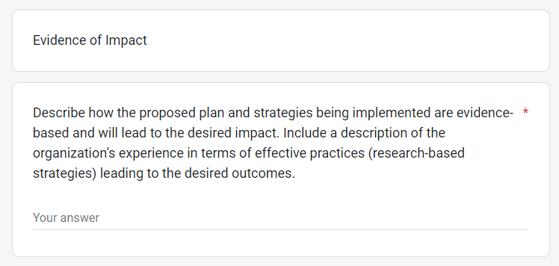

Part IV: Evaluation and Reflection

Evaluation
The applicant is required to conduct an annual evaluation of program effectiveness completed by a local external evaluator. The evaluation report including student performance data is provided to the MSDE by October 31, 2022, for final assessment of the grant program’s effectiveness. At this time, the applicant is required to provide an interim report of the evaluator’s findings regarding the grant program’s best practices.
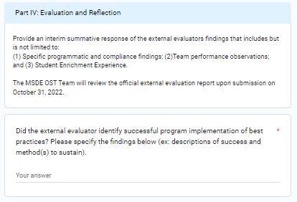

REFLECTION
The applicant is required to reflect upon the grant program’s successes, challenges, and proposals for a second year of implementation. The reflective process is critical to analyze opportunities for program enhancement and/or revision.
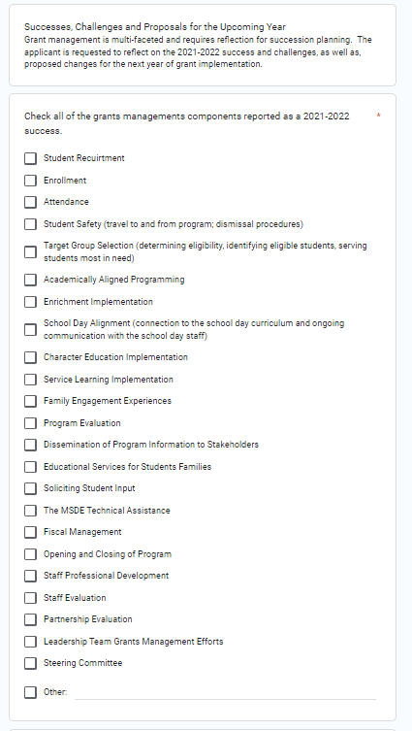
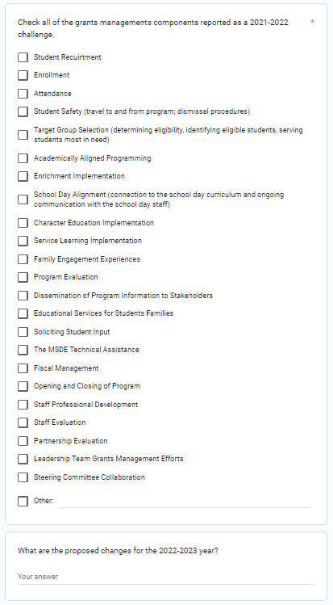

Requested REvision to Performance Indicators
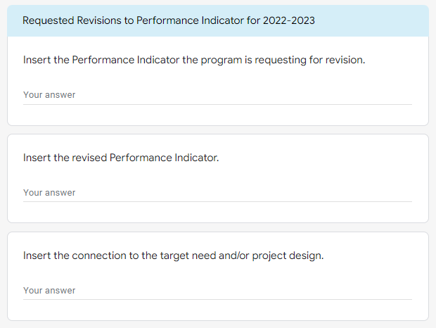
The applicant is encouraged to conduct an ongoing and annual assessment of the evaluation plan and performance indicators. At this time, the grant program is provided an opportunity to request a revision to the original program objectives. Submission of a request does not eliminate the submission of a C-1-25 A to report a programmatic change.

Part V: Collaboration Reflection and Updates

Leadership Team
An annual evaluative reflection of leadership and program staff grant management is encouraged as a best practice.

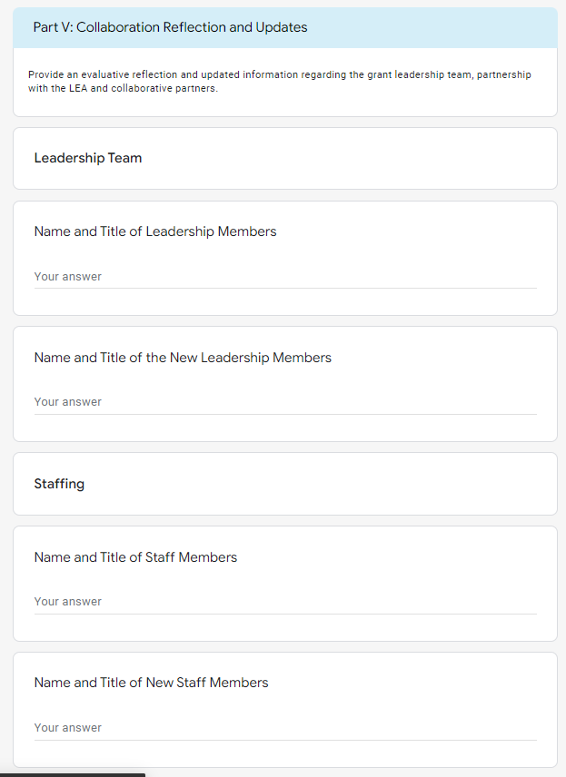

Partnership with the LEA
The data reported in this section reflects the collaborative partnership with the LEA.

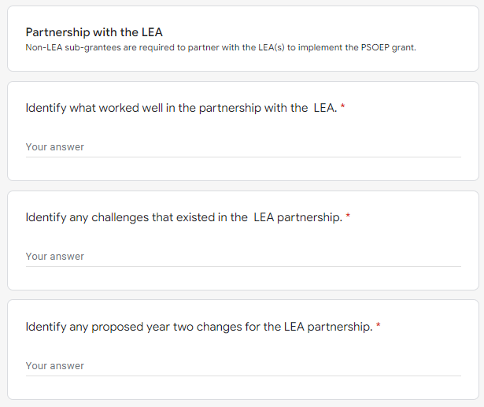

Program partners
Partnerships are an integral component of effective grant implementation. Grant programs are required to reflect and report on the effectiveness of program partners.
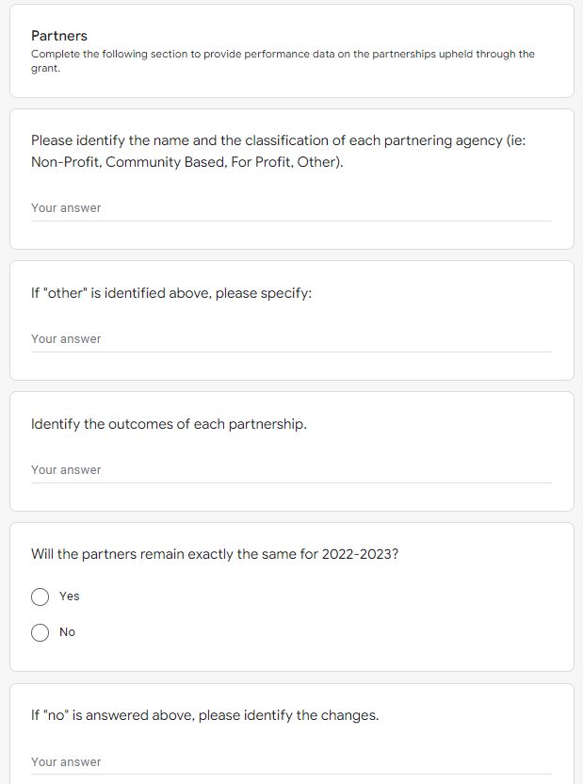

Coordinating with OTher Programs
The MSDE encourages applicants to coordinate with other programs.
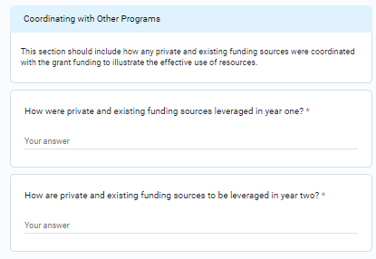

Part VI: Grant Budget Documents (Year II)
Please provide a detailed description of the requested funds that will be spent by using the categories listed below. Add more rows if needed. An MSDE Grant Budget C-1-25 form and Budget Worksheet and Narrative must also be completed, signed, and submitted. Refer to the 21ST CCLC Fiscal Grants Guidance: Budget Worksheet and Narrative for additional information.
