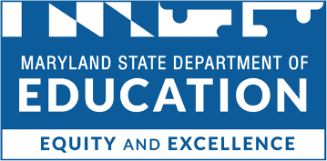

Division of Career and College Readiness

Career and Technical Education (CTE) Career Programs and Grants Specialists

Nina Roa

Director of Finance and Legislation for Career Programs

410-767-1904

Nina.Roa@maryland.gov

Traci Verzi

Coordinator of

Finance and Legislation for Career Programs

410-767-0165 Traci.Verzi@maryland.gov

Pamela Clay
410-767-0175
Pamela.Clay@maryland.gov

Lower Shore Region
Somerset County Public Schools
Wicomico County Public Schools
Wor-Wic Community College
Worcester County Public Schools

Upper Shore
Caroline County Public Schools
Chesapeake College
Dorchester County Public Schools
Kent County Public Schools
Queen Anne’s County Public Schools
Talbot County Public Schools

Dean Kendall
410-767-0164
Dean.Kendall1@maryland.gov

Baltimore City
Baltimore City Public Schools System
Baltimore City Community College

Baltimore County

Baltimore County Public Schools

Community College of Baltimore County

Carroll County

Carroll County Public Schools

Carroll Community College

Frederick County
Frederick County Public Schools
Frederick Community College

Susquehanna Region

Cecil County Public Schools

Cecil College

Harford County Public Schools

Harford Community College

Western Maryland Region
Allegany County Public Schools
Allegany College of Maryland
Garrett County Public Schools
Garrett College
Hagerstown Community College
Washington County Public Schools

Barbara Poindexter Webb
410-767-0185
Barbara.Webb@maryland.gov

Anne Arundel County
Anne Arundel Community College
Anne Arundel County Public Schools

Howard County

Howard County Public Schools

Howard Community College

Montgomery County
Montgomery County Public Schools
Montgomery College

Southern Maryland Region
Calvert County Public Schools
Charles County Public Schools
College of Southern Maryland
St. Mary’s County Public Schools

Prince George’s County

Prince George’s County Public Schools

Prince George’s Community College

