MSDE (XEROX) DOCUSHARE PROCEDURES
March 2020

Introduction
Secondary File Retrieval (Download) and Submission (Upload)
File retrieval and submission should be done using MSDE DocuShare, accessed via this link:
https://docushare.msde.maryland.gov/dsweb/
Each school system can access materials on DocuShare with an assigned user name and password. Please contact your regional specialist if you have forgotten or do not have your user name and password.
When uploading a document to DocuShare, be sure to place the document in the appropriately named folder, i.e. Perkins Grant, Reserve fund, Maryland Program of Study. Send Nina Roa (nina.roa@maryland.gov) an email and copy your regional specialist, informing them which document and into which folder it has been uploaded. Please do not attach the document(s) to the notification email.
MSDE cannot be responsible for retrieving materials about which we are not informed or to which we are not correctly directed.
General Grantee Folder Names
(Folder names may vary slightly by local school system.)
CORRESPONDENCE REPORTS
EQUIPMENT INVENTORY
FACILITIES REQUEST
IMPROVEMENT PLANS
LPAR/LAUPL
MARYLAND CTE PROGRAMS of STUDY
Program Proposals
Program Amendments
OTHER GRANTS
Maryland CTE Innovation Grants
P-TECH
PERKINS
Amendments (Budget)
Final Reports
Mid-Year Reports
Perkins V – Needs Assessment and Local Application
PQI
RESERVE FUND GRANTS
Amendments (Budget)
Final Reports
Grant Application
Mid-Year Reports

Accessing DocuShare
- Click on or paste the DocuShare URL: https://docushare.msde.maryland.gov/dsweb/. On the DocuShare home screen, enter your Username and Password and click “Login”, or just press “Enter” on your keyboard.
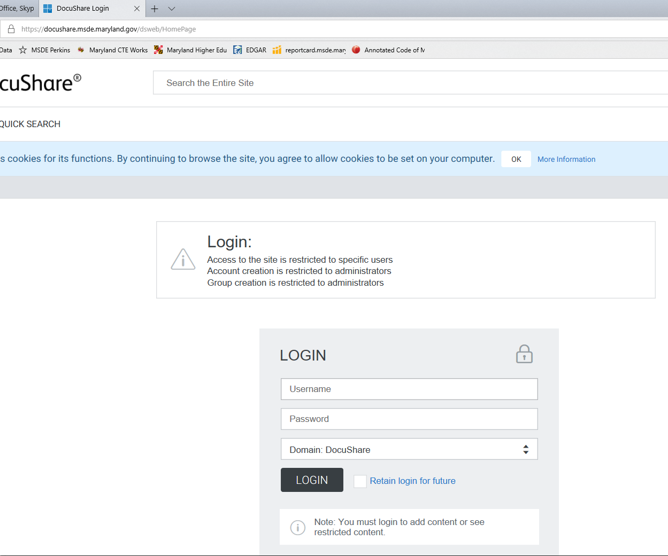

- Click on the Career and Technology Education folder, which should be the first folder under the Collections heading.
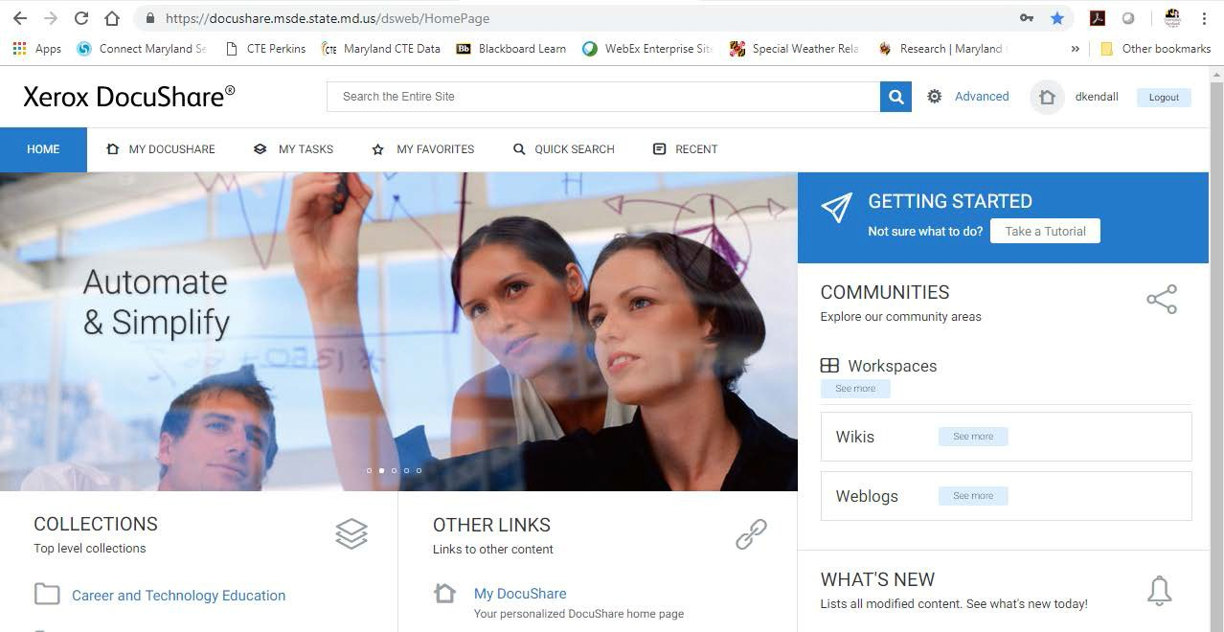

- Click on the Public School Systems CTE folder.
- Your Local School System’s folder will appear. Click on it.
- You will see two folders for your school system, the Grantee Folder and the MSDE Document Folder. The Grantee Folder is for you to submit (upload/add) documents to MSDE (with BLUE signatures when applicable). The MSDE Document Folder is for MSDE to post your school system’s Grant Approval Letters, Grant Awards, Approved Proposals, List A, PQI, Plan Approvals, etc., for you to download.
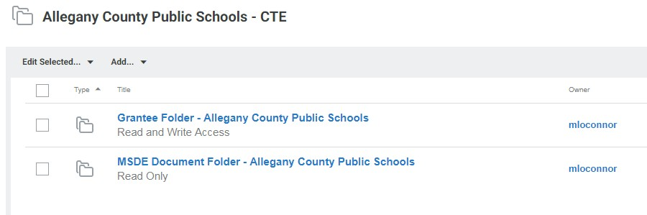

- Within the Grantee Folder are the following sub-folders, depending upon what your school system has submitted/uploaded. To add (upload) a document, first click your way into the appropriately named folder/subfolder.
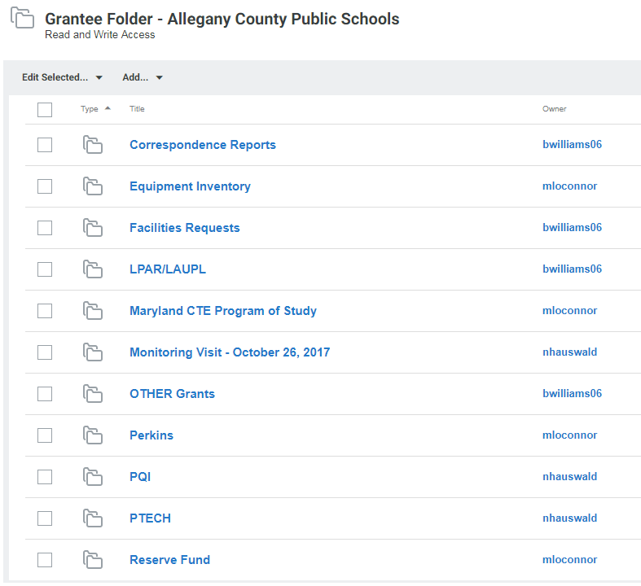

Uploading Documents
- For this example, we will add (upload) a document into the Amendments sub-folder of the main Perkins folder. To get there, we will click on Grantee Folder, Perkins, then Amendments. The grey line with blue lettering at the top of the page shows you your navigation within DocuShare:
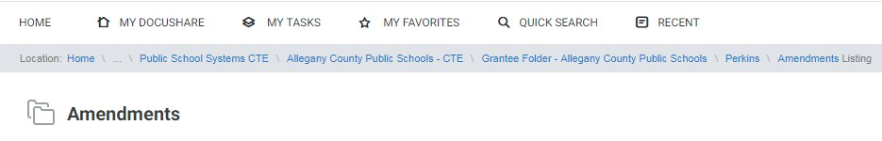
- To upload the amendment document, open the correct fiscal year folder (FY 2020 for this example).
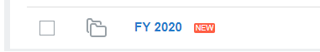
- Click on the second scroll (dropdown) box (Add…). From that dropdown box, click on Document.
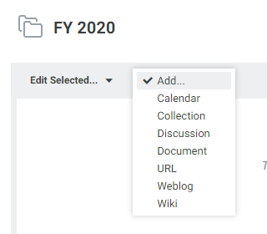

- Click on Choose File, and then search for, and select, the document in your computer that you want to upload. Once you have selected the appropriate document (double click it), click on Apply at the bottom of the screen. Your document has been uploaded.
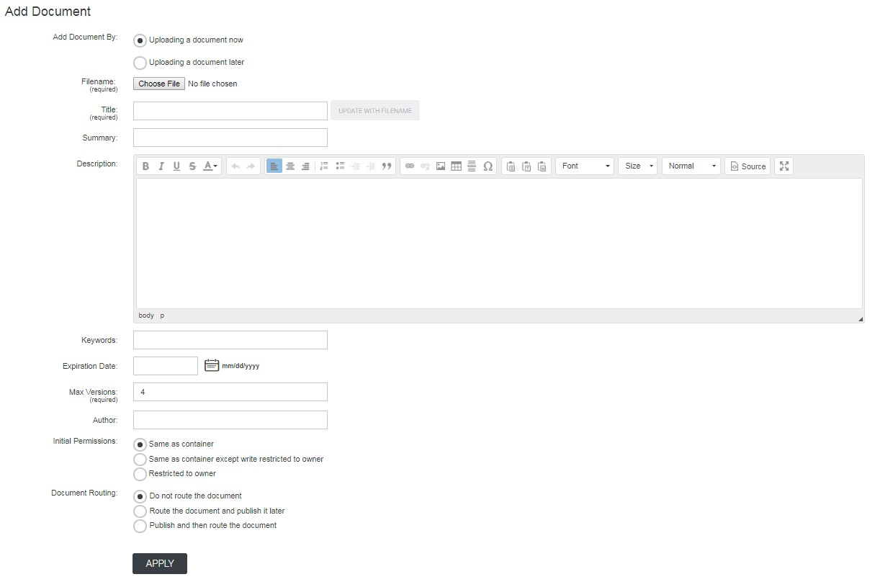

Downloading Documents
- To download a document uploaded by MSDE, click on the MSDE Document folder link, then on the folder in which the document you desire resides. For this example, we’ll download a document from the Approved Program Proposals folder.
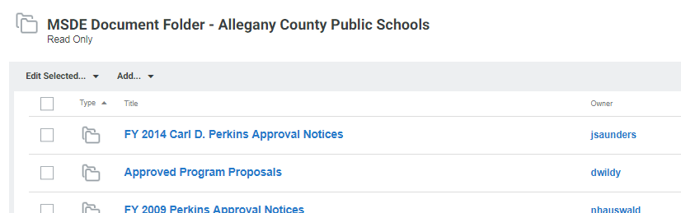
- To download the HVAC approval letter, simply double-click the document link and save the document to your computer.
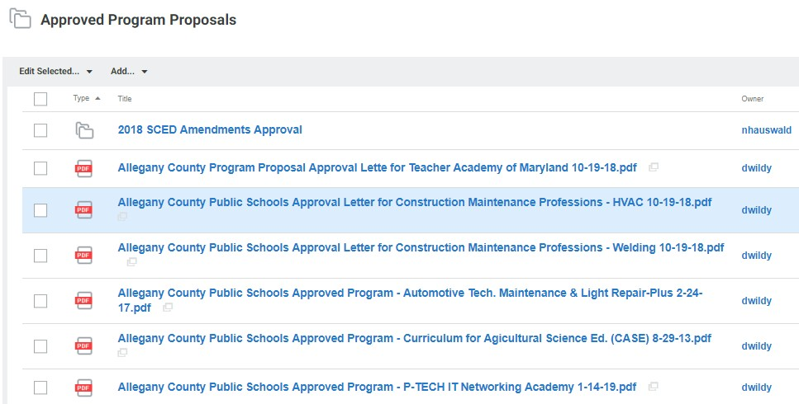

Moving Documents

  - Select the document you wish to move (put a check in the box on the far left).
  - Click on the Edit Selected box and choose cut.
  - You will be asked to confirm the cut; click confirm.
  - Now use the location/navigation bar at the top to go back to the original list of folders. Click on the folder where you want to file your document.
  - Click on the Edit Selected box and choose paste.
  - You will be asked to confirm the paste; click confirm.
  - Your document has been moved.

