

***Maryland State Department of Education***

**Service-Learning Unit**

Read to Me

**Primary Subject:** Language Arts & Reading

**Grade Level:** 6th-8th

**Additional Subject Area Connections:** Math, Visual Arts, Social Studies

**Unit Title:** Read to Me

**Type(s) of Service:** Direct, Indirect, Advocacy

**Unit Description:** Early childhood literacy is a very important part of a person’s literacy development. There is a strong link between struggling readers and weak early childhood literacy. An important component of any stage of literacy is fluency, the ability to read at an appropriate rate with expression, intonation, and high accuracy. The direct service-learning project will require students to practice reading a children’s book fluently to prepare for reading the book to a class or small group of early elementary school students. Struggling readers can increase their fluency and comprehension by reading along with a text being read out loud to them. However, to ask these struggling readers to identify themselves to their peers is insensitive and impractical. Therefore, the indirect service-learning project will ask students to read a part of their favorite novel, social studies, or science textbook onto a tape or CD to be kept as a resource for struggling readers in the school. An advocacy aspect of the service-learning project could be creating posters or writing persuasive letters urging parents and older siblings to read to young children.

**Maryland Standards Met**

**Grade 7 Reading: Informational Text**

CCSS.ELA-LITERACY.RI.7.2 Determined two or more central ideas in a text and analyze their development over the course of the text; provide an objective summary of the text.

**Math:**

Grade 3 NBT.1

Use place value understanding and properties of operations to perform multi-digit arithmetic.

**Visual Arts:**

3.2. A Experiment with visual ideas and concepts by manipulating the elements of arts in visual compositions.

**Social Studies:**

D4.6.6-8 Draw on multiple disciplinary lenses to analyze how a specific problem can manifest itself at local, regional, and global levels over time, identifying its characteristics and causes, and the challenges and opportunities faced by those trying to address the problem.

**Potential Service-Learning Action Experiences:**

* Students demonstrate fluency by reading a children’s book to a small group of children. *(direct)*
* Students collect books to donate to a charity that distributes books to underprivileged children. *(indirect)*
* Students collect money to donate to libraries to expand the children’s section. (*indirect)*
* Students record their textbooks for their peers who are struggling readers. *(indirect)*
* Create a community-wide campaign to promote reading. *(advocacy)*

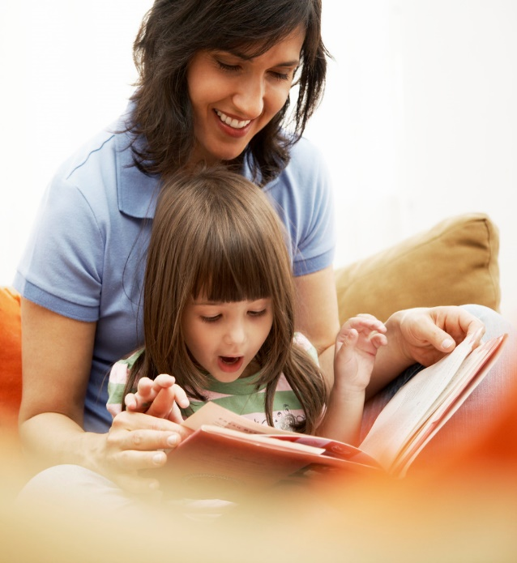

**Additional Interdisciplinary Connections**

**links of a chain**

**Social Studies** – Students are reading a portion of their social studies textbook. Students can research literacy rates and the treatment of literacy around the world.

**Science** – Students are reading a portion of their science textbook. Students can research the way the brain processes texts.

**Alignment with Maryland’s**

**Best Practices of Service-Learning:**

***Read to Me***

1. **Meet a recognized community need**

Many schools have students with reading difficulties. In order to boost student skills and performance on standardized tests, achieve Adequate Yearly Progress, and benefit students, students will participate in a fluency activity that will benefit themselves, elementary school children, and their peers.

1. **Achieve curricular objectives through service-learning**

Students will practice their grade-level fluency skills by reading a selected passage to a peer and into a recording device. They will practice their fluency skills in preparation for reading a children’s book to a small group of elementary school children.

1. **Reflect throughout the service-learning experience**

Students will log their progress with fluency and create a storyboard reflecting their experiences throughout this process.

1. **Develop student responsibility (Students have opportunities to make decisions about the service-learning project.)**

Students will choose the book they will read to the elementary school students and for which grade level it is appropriate. They will also decide which subject area they feel most comfortable reading about.

1. **Establish community partnerships**

Adult hand helping child’s hand write with a pencil

Community partnerships will be established with the media specialists, public librarians, and elementary schools.

1. **Plan ahead for service-learning**

Students will practice their reading passage frequently to increase fluency skills. They will also plan to read and record their passages from the textbooks according to a timeline set by their group. They will also plan to meet with a specific grade level according to the readability of their children’s book.

1. **Equip students with knowledge and skills needed for service**

Fluency skills will be addressed and practiced before going to the elementary schools or recording their textbook passage. This will boost student self-esteem and confidence in their reading abilities. Studying the readability levels of books will not only help them choose their own texts more carefully, but will also help them choose the appropriate grade levels to which to read their children’s book.

**Procedures with Resources:**

***Read to Me***

*These procedures represent an example of a service-learning lesson on this specific topic, but can be changed to meet individual classroom interests or varying community needs. You are encouraged to adapt this unit to fit your unique classroom and community and to solicit student input in planning and decision making.*

1. Introduce the service-learning project by discussing service-learning and citizenship with students and engaging in activities to explore those themes. A resource to support this topic can be found at [*Bringing Learning To Life*](https://www.youtube.com/watch?v=o2-eoEi6FCo) (https://www.youtube.com/watch?v=o2-eoEi6FCo).
2. Introduce students to fluency and its connection to comprehension and early childhood literacy.
   1. [National Service Resource Center](https://www.nationalservice.gov/resources) (https://www.nationalservice.gov/resources)
   2. [Scholastic](https://www.scholastic.com/home/) (https://www.scholastic.com/home/)
   3. [I AM Foundation](http://www.iamfoundation.org/) (http://www.iamfoundation.org/)
   4. [Library of Congress](https://www.loc.gov/) (https://www.loc.gov/)
3. Have students choose their favorite children’s book.
4. Have students calculate the reading level of different books using different reading scales (ex. Fry, Flesch-Kincaid).
5. Have students practice reading their children’s book fluently. Students can practice reading aloud to their peers before going to the elementary school.
6. Take students to an elementary school to read their children’s books to small groups. Students will choose an appropriate placement to read their books by using the readability scales in step 4.
7. Form committees with chairs or co-chairs: social studies committee, science committee, math committee, and language arts committee.
8. Have students practice reading chapters out of their textbooks fluently. The textbook they use will be determined by the committee for which they are members. The committees are responsible for deciding how many and which chapters students are to read.
9. Students will continue to practice for many weeks. This makes a good homework.
10. Students will record their readings on tape or CD for use by their peers. This can be kept in the library or in the teacher’s classroom.
11. Create a storyboard reflecting their experience reading to a child or reading on tape.
12. Upon completion, analyze the plan to evaluate the successful completion of the objective and overall success of the project. Also, reflect on the project using various reflection activities and evaluate the effectiveness of the project by completing the [*Rubric for Assessing the Use of the Maryland’s Seven Best Practices of Service-Learning*](http://marylandpublicschools.org/programs/Documents/Service-Learning/rubric_best.pdf)(http://marylandpublicschools.org/programs/Documents/Service-Learning/rubric_best.pdf).

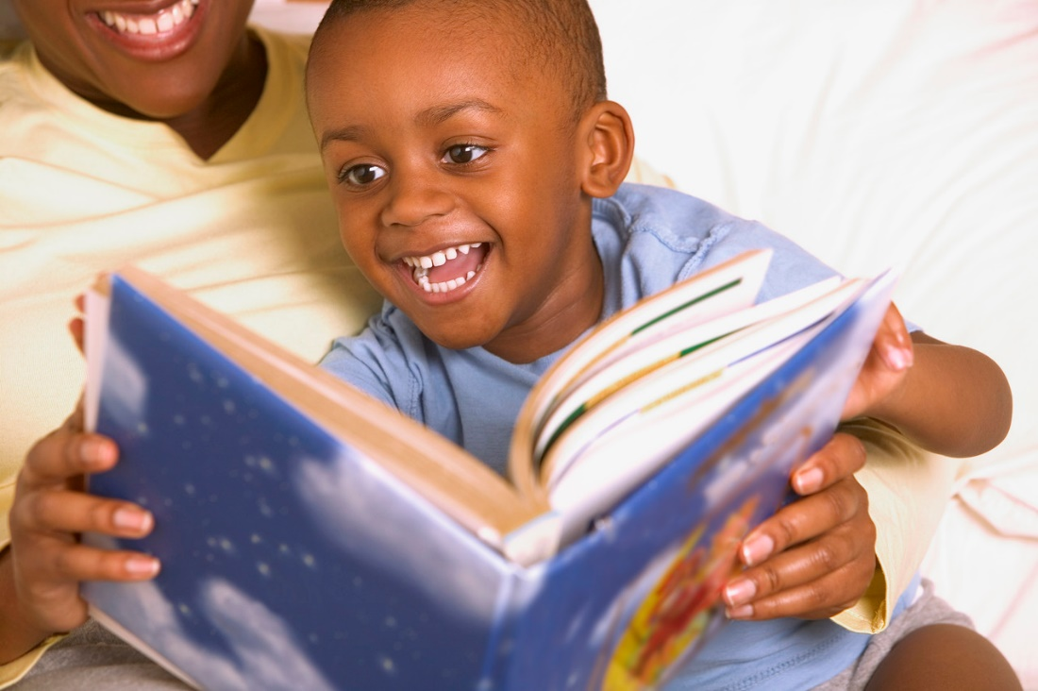

*Updated: October 2019, December 2014; Created: July 2007*

Division of Student Support, Academic Enrichment, and Educational Policy

Youth Development Branch

200 West Baltimore Street

Baltimore, Maryland 21201

410-767-0357

[Maryland Public Schools Service-Learning Website](http://www.mdservice-learning.org) (www.mdservice-learning.org)

[Maryland Public Schools](http://www.marylandpublicschools.org) (www.marylandpublicschools.org)

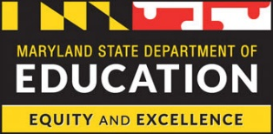

*\*This material is based upon a template for service-learning experiences created by the Maryland State Department of Education. Opinions or points of view expressed in this document are those of the authors and do not necessarily reflect the official position of the Maryland State Department of Education or constitute an endorsement.*