Maryland State Department of Education
Division of Early Intervention and Special Education Services

SFY 2022 Early Childhood
Extended IFSP Grant –
Family Engagement to Improve School Readiness Outcomes

Identify the Local System/Lead Agency:
Local Infants and Toddlers Director: Enter Name Email Address
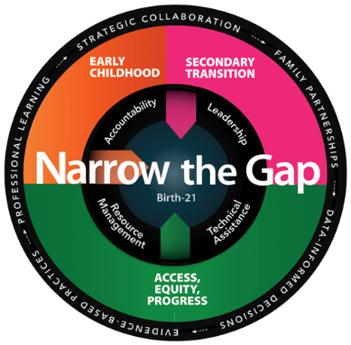

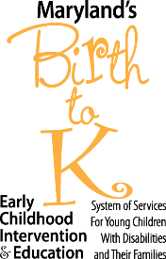

Marcella E. Franczkowski, M.S.
Assistant State Superintendent
Division of Early Intervention and Special Education Services
This page is intentionally blank.

Extended IFSP Grant – Family Engagement to Improve School Readiness
TEAM: LOCAL IMPLEMENTATION TEAM FORMATION
Identify the local implementation team including, names, titles, e-mail, and phone contact information. Teams should include family support coordinator and/or B-5 family support staff.
Enter Name & Title Enter Telephone Number Email Address
Enter Name & Title Enter Telephone Number Email Address
Enter Name & Title Enter Telephone Number Email Address
Enter Name & Title Enter Telephone Number Email Address
Additional participants to invite: Click or tap here to enter text.
DATA ANALYSIS:
Child Outcome Data (some information can be imported from your Extended IFSP Grant Application submitted 2/15/2022)

Exit COS rating for students receiving services on the Extended IFSP (progress during the extension):
 |  | SFY 2019 | SFY 2020 | SFY 2021
Positive Social-emotional skills | Substantially increased growth
 | Exited within age expectations
Acquisition and Use of Knowledge and Skills | Substantially increased growth
 | Exited within age expectations
Use of Appropriate Behavior to Meet Needs | Substantially increased growth
 | Exited within age expectations

Kindergarten Readiness Assessment (KRA):
Percent of Students Demonstrating Readiness: | 2019-20 School Year | 2020-2021 School Year | 2021-2022 School Year
Students who received Exended IFSP services and who transitioned to an IEP
All K students with disabilities
(will include the above count of students who received Ext. IFSP services)
All students (with and without disabilities)

Other data if desired (e.g., summaries and trends of ELA or other formative assessments, number of children receiving services through the extended option in community settings, etc.)

Family Engagement Data

Early Intervention Family Survey
 | SFY 2019 | SFY 2020 | SFY 2021
Percent of families who report that Early Intervention Services help their child develop and learn (SPP/APR Indicator 4C)
Percent of families who agreed with the statement: Early Intervention Services have helped me/my family do things with and for my child that are good for my child’s development (Family Survey Question 20)
Percent of families who agreed with the statement: Early Intervention Services have helped me/my family support my child to be ready for school by assisting me to teach my child pre-reading activities and pre-math activities during daily routines (Family Survey Question 26)
Response Rate

Parent Survey (Pre-School)
 | SFY 2019 | SFY 2020 | SFY 2021
Percent of families who report that schools facilitated parent involvement (SPP/APR Indicator 8A)
Percent of families who agreed with the statement: My child’s IEP goals are written in a way that I can work on them at home daily routines (Pre-School Survey Question 3)
Percent of families who agreed with the statement: People from preschool special education, including teachers and other service providers, give me information about the approaches they use to help my child learn (Family Survey Question 26)
Response Rate

Family Support Participation
 | 19-20 School Year | 20-21 School Year | 21-22 School Year (to date)
Number of families participating in the Infant-Toddler program who contacted the family support center for information or resources
Number of families participating preschool special education services who contacted the family support center for information or resources
Workshops and trainings specifically for families of children with disabilities ages Birth – 5.
Please list topics and number of participants in each column.
(e.g., Understanding the Transition from Early Intervention to Preschool – 10 participants)
Other activities specifically for families of children with disabilities ages Birth – 5
Please list topics and number of participants in each column.
(e.g., Family Picnic – 10 participants)
Resources/materials developed specifically for families of children with disabilities ages Birth – 5.

IMPLEMENTATION PLAN
Based upon your analysis of the above data, develop one or more specific, measurable goals that address the required focus on family engagement to support school readiness. Design activities to achieve the goal. Strategies may include professional learning and coaching for family support coordinators and early intervention service providers; development of resource materials for lending libraries; and family training. Consider needed supports for implementation of selected activities, such as increased staff hours for family support and childcare to increase family participation in training activities. Include measures that allow monitoring, evaluation, and data analysis of the impact on children and/or families.
Measurable Goal:

Strategies:
Activity | Person(s) Involved | Timeline | Resources (e.g., grant funds, in-kind, other funds)

Evaluation Plan
Data to be collected | Target (e.g., change in family knowledge or behavior or child outcomes) | Timeline for Data Collection | Person(s) Responsible

Include additional goal(s), activities, and evaluation plan(s) as appropriate.

LEA/Lead Agency Signatures Required for Submission

Enter Name Click or tap to enter a date.
Local Family Support Coordinator _{Signature} _{Date}
Enter Name Click or tap to enter a date.
Local Infants and Toddlers Program Director _{Signature} _{Date}
Enter Name Click or tap to enter a date.
_{Local Preschool Director} _{Signature} _{Date}
Enter Name Click or tap to enter a date.
Local Director of Special Education _{Signature} _{Date}

MSDE, DEI/SES Approvals

Click or tap to enter a date.
MSDE, DEI/SES, Early Childhood Liaison _{Signature} _{Date}

Click or tap to enter a date.
MSDE, DEI/SES, Fiscal Grants Liaison _{Signature} _{Date}

Click or tap to enter a date.
MSDE, DEI/SES, Assistant State Superintendent _{Signature} _{Date}

This page is intentionally blank.
Insert copies of the fully executed MSDE Grant Budget (C-1-25) and Budget Detail Form.

